

CSIP Telecare eNewsletter

October 2007

Welcome to the October 2007 CSIP telecare eNewsletter. The Care Services Improvement Partnership (CSIP) is responsible for providing general implementation support to organisations building their telecare and telehealth programmes.

If you are an organisation implementing telecare and have an interesting local telecare story for inclusion in a future newsletter then e-mail Mike Clark (newsletter editor, CSIP Networks) at telecare@csip.org.uk

If you or a colleague would like to receive future copies of the newsletter then all you need to do is register at http://www.icn.csip.org.uk/index.cfm?pid=12

CSIP telecare services have now moved to: www.icn.csip.org.uk/telecare

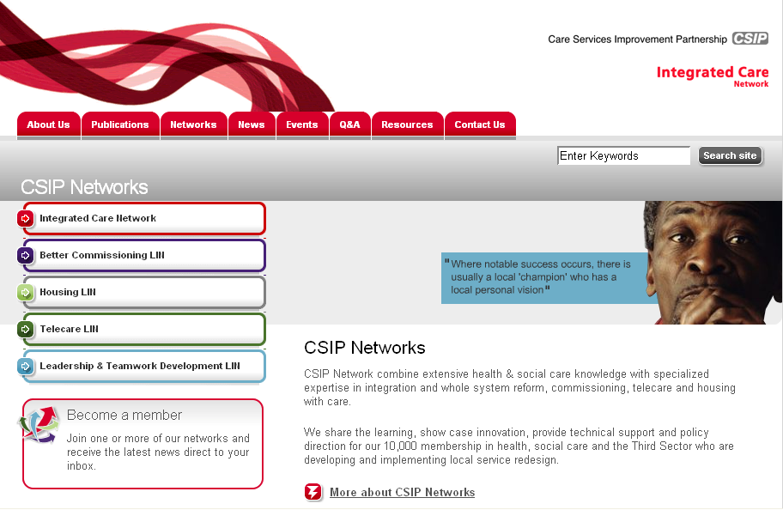

Here are some short cuts to get you to the new locations quickly:

www.icn.csip.org.uk/telecareguide
www.icn.csip.org.uk/telecarenewsletters
www.icn.csip.org.uk/telecarefactsheets
www.icn.csip.org.uk/telecareprofiles

Forthcoming CSIP 2008 telecare events – London (24 Jan), Leeds (29 Jan), Manchester (4 Feb), Taunton (7 Feb) and Birmingham (12 Feb) – registration available shortly

Contents
1 200 Outcomes for telecare and telehealth-events for 2008 2
2 Indexing telecare services ready for 2008 2
3 Technology Strategy Board – ALIP announcement 2
4 News 2
5 Telecare progress around England 2
6 News extra – keeping up to date with telecare and telehealth 2
7 Events 2
8 Appendix – telecare in district councils 2

Item 1 provides information about the CSIP telecare events for 2008

Item 2 CSIP is now indexing the telecare service providers in England – will you be included?

Item 3 provides an important announcement from the Technology Strategy Board on healthcare technology for people with long term conditions
Item 4 provides CSIP’s usual news round up that will be of interest to commissioners and service providers

Item 5 provides updates on service progress over the last month

Item 6 provides a ‘news extra’ of Web links for commissioners working at the leading edge of telecare

Item 7 is the CSIP telecare events listing – for a fuller list of AT events go to the FAST web site

The Appendix lists telecare links (where found) for district councils

Coming soon in the telecare eNewsletter:

- Charging survey results

- Telecare in housing associations and third sector organisations

- TSA and Southwark conferences

- Booking arrangements for the CSIP 2008 events

Glossary:

ALIP – Assistive Living Innovation Platform
AT – Assistive Technology
CSCI – Commission for Social Care Inspection
FACS – Fair Access to Care Services
NHS PASA – NHS Purchasing and Supply Agency
PT Grant or PTG – Preventative Technology Grant
TSA – Telecare Services Association

1 200 Outcomes for telecare and telehealth-events for 2008

Telecare LIN

Update from Mike Clark, CSIP Networks

Between now and April 2008, CSIP will be looking for 200 telecare outcomes from across England.

That is one outcome from each social care authority and another 50 from suppliers, telecare service providers and other organisations (eg NHS PASA, TSA and research organisations carrying out evaluations etc).

The scheduled events for the 200 outcomes programme are now arranged as follows:

Venue | Date
London | 24 January 2008
Leeds | 29 January 2008
Manchester | 4 February 2008
Taunton | 7 February 2008
Birmingham | 12 February 2008

The main aim of these five events is for organisations to share the impact of their services on stakeholders and hear what others are doing from neighbouring areas based on the period of the PT Grant from 2006-2008. In addition, attendees will hear more about telehealth and the best practice approaches that will take local authorities, health trusts, third sector and partner organisations into the future.

The 200 outcomes events are about:

- Redesigning and restructuring services to include telecare and telehealth options
- Developing new ways of partnership and integrated working through telecare and telehealth
- Adjusting care pathways to include cost-effective AT solutions
- Identifying implementation barriers and how they have been overcome
- Progress made with learning disability and other service users who are now benefiting from telecare solutions
- Balancing FACS-eligible, preventative, targeted and self care approaches
- Working with suppliers to develop innovative solutions to local problems
- Introducing self-assessment and supported self-care/direct payments
- Identifying sensor configurations that are effective for dementia assessment and support
- Obtaining initial evaluations on vital signs and long term condition monitoring
- Reviewing AT arrangements for preventative services to include telecare and telehealth
- Extending housing schemes with telecare support
- Identifying and overcome barriers to user acceptance of technology
- Examining impact on carers
- Establishing locally whether telecare has an impact on care home and hospital admissions
- Providing training and awareness to a wide range of stakeholders
- Identifying individual outcomes and service cost-effectiveness
We are not expecting full-blown evaluations but sometimes these can help in providing an external review and objective assessment of your work. We would like to see ‘outcomes’ for the investment you have made locally. Service redesign examples are as important as numbers of new users.

Local authorities and their partners will remember that the 2006 CSCI performance assessment covered ‘description of the service’. The descriptions are included in each local authority’s telecare profile included at www.icn.csip.org.uk/telecareprofiles. The outcomes events will be an opportunity to review progress since the 2006 statements were made.

Shortly, we will be separately advising you of the booking arrangements for the events – remember, telecare events are often over-subscribed, so do make sure that you book early.
2 Indexing telecare services ready for 2008

Telecare LIN

Update from Mike Clark, CSIP Networks

Indexing all of the telecare services in England has now commenced. In the September 2007 newsletter we included the 150 social care authorities. In this edition, we list the district councils (See Appendix). This is followed by the housing associations and third sector organisations in the November 2007 edition. By January 2008, we will have all of the telecare services fully indexed with:

- Standards
- Equipment and services provided
- TSA Codes achieved
- Identifiable telecare demonstration areas
- Charges
- Contact information
- Other information relevant to the service

The index of sites, local service standards and contact details will be an important public reference point for users, carers and other stakeholders accessing telecare information. We will be identifying some of the best sites in the ‘200 outcomes’ initiative, so take the opportunity to ensure that your local authority and service provider organisation is providing information that is up-to-date and will meet the needs of users, carers and stakeholders.

So….

- Can people find your site by typing www.yourorganisation.gov.uk/telecare?
- Is your site accessible for text size, screen readers, image annotation?
- Is it clear who is providing the service in your area?
- Can users clearly see the direct payment option for telecare where they have been assessed?
- Do service charges follow the approach provided in Building Telecare in England?
- Are demonstration facilities provided with independent advice?
- Is it possible to self-assess and make purchasing decisions using available information?
- Are your service charges for sensor systems for assessed users the same as a pendant alarm where the service response is identical?
- Are services marketed effectively to stakeholders?
- Are response standards and current performance clearly set out?
- Are services independently assessed – TSA Codes, Charter Mark, ISO 9000 series?
- Is it clear how to make compliments and complaints?
- Do users and carers have a telecare choice – equipment, suppliers, configurations, monitoring and response arrangements?

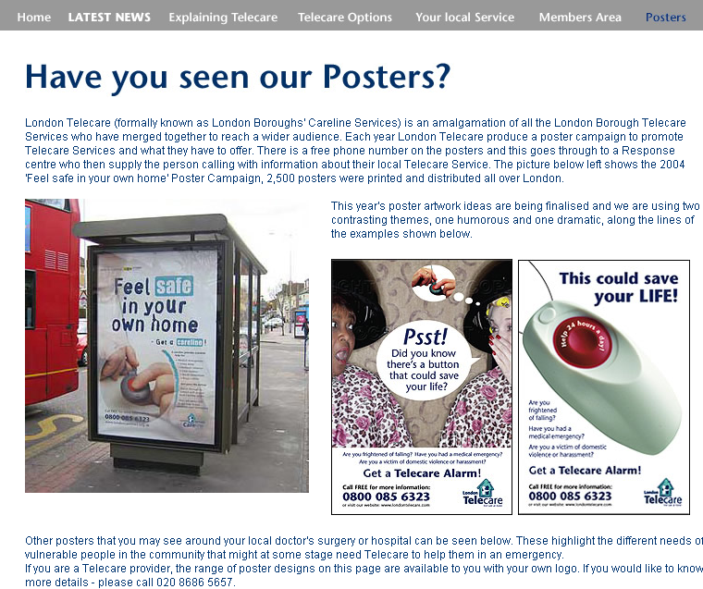

Good practice: London telecare services have a free phone number to find out your local service information and capital-wide poster programmes http://www.londontelecare.org/poster.asp - how do you market your services?

It is important to remember that social care assessed users can always have a direct payment for their service to meet their needs regardless of the local mainstreaming arrangements.

Please check you service links and let us know if you have any update information.

Barnet’s Guy Dewsbury e-mailed to advise us that their site met a simple good practice standard – you can reach it at www.barnet.gov.uk/telecare - wouldn’t it be great if all sites could be accessed as easily as that – it is not difficult to set up an ‘alias’ with local web teams – we did it for the CSIP web site to make it easier for you to get to the right place as quickly as possible. Why not take this simple step with your own service?

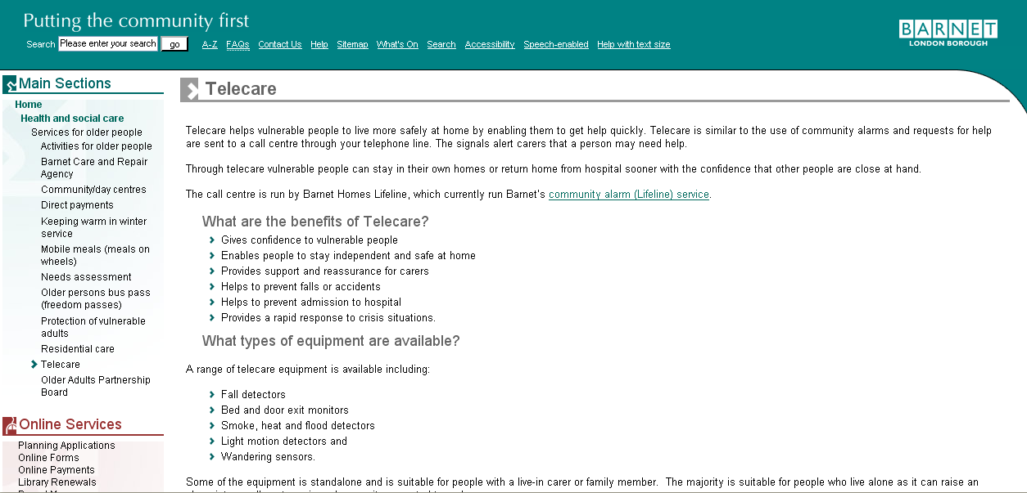

If you have a link for inclusion, please let Mike Clark know at telecare@csip.org.uk
CSIP is now updating all of the telecare profiles with CSCI information. Local authorities can include additional information in their profiles about their work and its impact on service users. This provides an opportunity for local authorities and their partners to refer to services that are not strictly covered by the CSCI count where progress is being made eg use of telecare for people with learning disabilities or care plans for people with dementia which include telecare and non-telecare items as part of an assistive technology package.

This type of information will also progress into the ‘200 outcomes from telecare programme’ (see Item 1 in this newsletter).

3 Technology Strategy Board – ALIP announcement

Telecare LIN

Important news from Graham Worsley at BERR

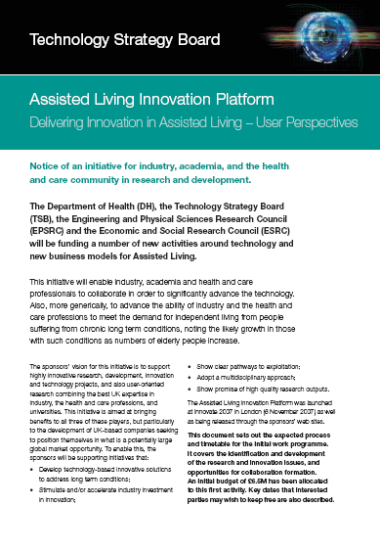

Assisted Living Innovation Platform (ALIP)

Interested parties need to check the timescales for submissions of expressions of interest.

Press Release from 8 November 2007
The Technology Strategy Board is to bring together government, business and the research community in an initiative to address healthcare challenges caused by the impact of living longer, the increasing demand for care for people with long-term conditions and the need to prevent the development of health problems such as obesity.
The impact of living longer, the quality and potentially increasing cost of care for those with chronic long term conditions, and preventing health problems like obesity, which can lead to diabetes, are all major challenges for the 21st century.
To address such challenges the Technology Strategy Board today launched the Assisted Living Innovation Platform, which will bring together Government departments and engage with business and the research community to help identify appropriate technology, action and policies.
The Assisted Living Innovation Platform will look at how technology can be harnessed to help address these societal challenges, and will support the development of new technologies.
The Innovation Platform’s work programme will range from conventional collaborative R&D, and single company support for small companies R&D, to work in standards, research fellowships in business models, specific projects in user centred design and a potentially ground breaking future care technology “test suite”.
The first phase of work has been called Delivering Innovation in Assisted Living - User Perspectives (DIAL – UP). Commencing with a competition for shorter term R&D in subjects like home based intelligent processing, and value added services for well being, and health management – the patient portal.
The work programme is supported by the Department of Health, the Engineering and Physical Sciences Research Council and the Economic and Social Research Council. Initial funding of about £12m is being made available.
Science and innovation Minister Ian Pearson said “This is one of the most interesting and important new areas of work for the Technology Strategy Board. Bringing together government, business and researchers to help address such major societal challenges is of vital importance to UK society. Finding innovative solutions through technology, while aligning policies and government procurement, is key to the success of meeting such long-term challenges.”
Professor Sally C. Davies, Director General of Research and Development at the Department of Health said “This excellent initiative fills a real need. It fits well with our existing research programmes under the National Institute for Health Research, and in particular the NIHR Invention for Innovation programme. We can follow up the links to Whole System Demonstrators for Long Term Conditions and the NHS can start to plan now for the future procurement of proven new technologies.” Professor Davies added that “there is considerable potential for these technologies to contribute to an improvement in the quality of care for our ageing society in a cost-effective manner”.
Web Links
1 BERR – Technology Strategy Board
http://www.berr.gov.uk/innovation/technologystrategyboard/index.html

2 BERR Press Release
http://www.berr.gov.uk/innovation/technologystrategyboard/page42353.html
http://www.technologyprogramme.org.uk/site/IP/ALIP/default.cfm

3 ALIP (EOI submissions by 7 December 2007)
http://www.technologyprogramme.org.uk/site/IP/ALIP/ALIP_2Page.pdf
http://www.technologyprogramme.org.uk/site/IP/ALIP/ALIP_4Page.pdf

4 Also reported at
http://www.publictechnology.net/modules.php?op=modload&name=News&file=article&sid=12579
http://www.publictechnology.net/modules.php?op=modload&name=News&file=article&sid=12578
http://news.bbc.co.uk/1/hi/technology/7085131.stm

4 News

Telecare LIN

News services provided by Mike Clark for CSIP Networks

- Local Government and Public Involvement Act 2007

The Local Government and Public Involvement in Health Bill received Royal Assent on 30 October 2007.
As of April 2008, existing Patient and Public Involvement Forums and their co-ordinating body, the Commission for Patient and Public Involvement in Health (CPPIH) will be replaced with 150 Local Involvement Networks (LINks). The legislation also updates and strengthens the duty on NHS bodies to involve and consult local communities about changes to services.
The Act also introduces a new requirement for PCTs and local authorities to produce a Joint Strategic Needs Assessment (JSNA) which will describe the future health and wellbeing needs of their local populations and will help local authorities and PCTs decide how best to meet those needs/provide those services through their next local area agreements.

http://www.gnn.gov.uk/environment/fullDetail.asp?ReleaseID=327045&NewsAreaID=2&NavigatedFromDepartment=False

- Essence of care: benchmarks for the care environment (DH, 1 November 2007)
This document sets out standards for services provided in the home as well as hospital environment.
Web Link:
http://www.dh.gov.uk/en/Publicationsandstatistics/Publications/PublicationsPolicyAndGuidance/DH_080058

- National Evaluation of Partnerships for Older People Projects: Interim report of progress

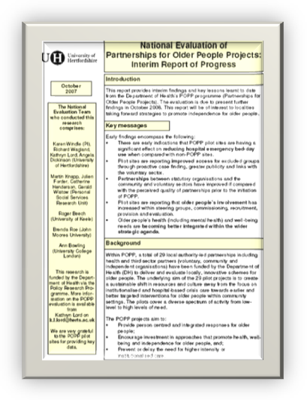 | This is an interim report of an ongoing evaluation of the National POPP programme. It is a statement of progress providing very early findings, lessons learnt and key messages from the experience of the POPP pilots to date.

Web link:
http://www.dh.gov.uk/en/Publicationsandstatistics/Publications/PublicationsPolicyAndGuidance/DH_079422

- Payment by results for 2008/09 - tariff for road-testing

Local commissioners will need to be clear about any tariff charges that can be saved through the use of telecare and telehealth solutions.

Web link:
http://www.dh.gov.uk/en/Publicationsandstatistics/Lettersandcirculars/Dearcolleagueletters/DH_079130

- Our NHS Our future: NHS next stage review - interim report


The November Telecare eNewsletter will be providing more coverage of the recently published Darzi Report.

Web link:
http://www.dh.gov.uk/en/Publicationsandstatistics/Publications/PublicationsPolicyAndGuidance/DH_079077

5 Telecare progress around England

Telecare LIN

Herefordshire
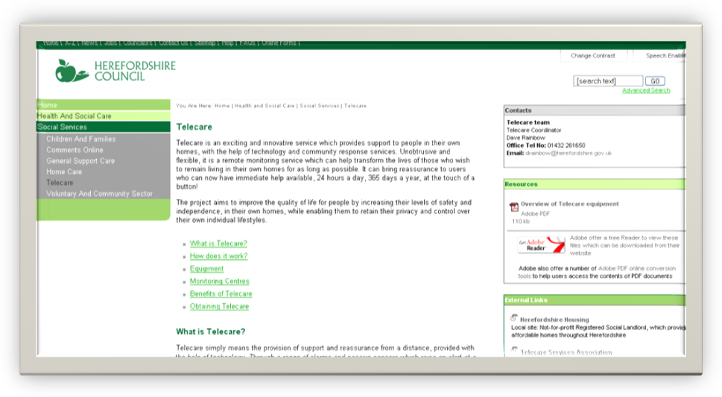
Web link:
http://www.herefordshire.gov.uk/health/social_services/32256.asp

Sunderland
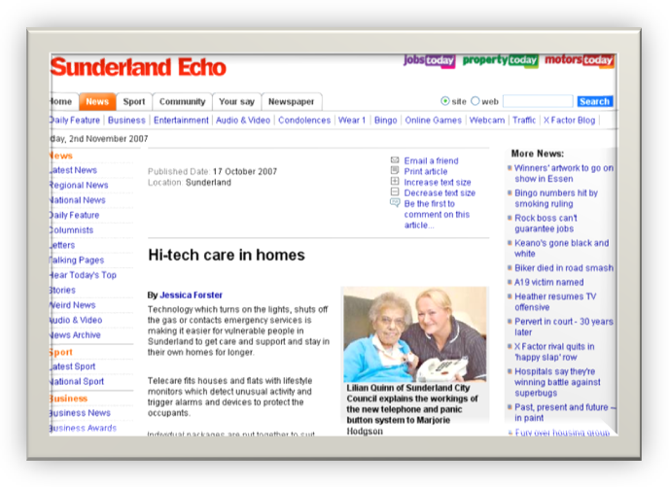

Web link:
http://www.sunderlandecho.com/news/Hitech-care-in-homes.3387641.jp

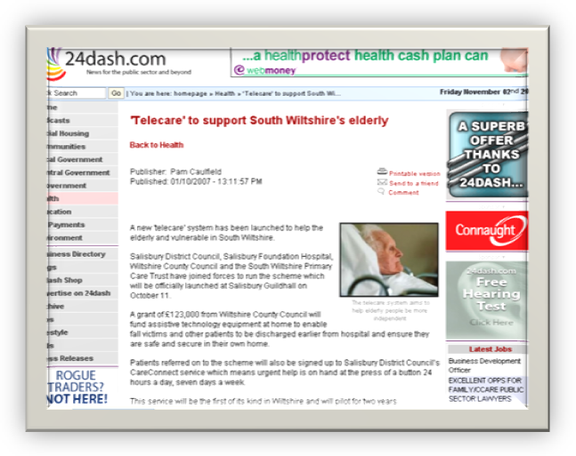
South Wiltshire
Web link:
http://www.24dash.com/news/47/28156/

Bedfordshire and Luton
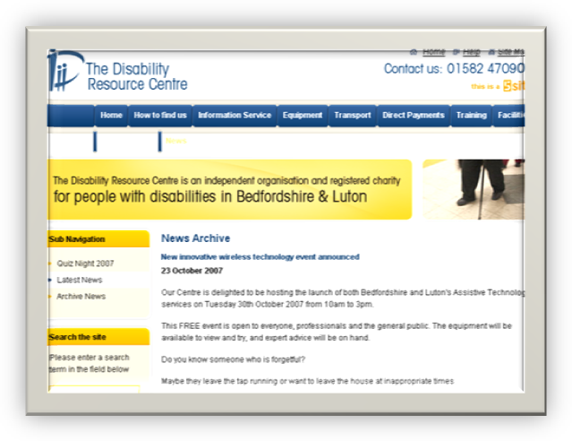
Web link:
http://www.drcbeds.co.uk/news/1/77/new_innovative_wireless_technology_event_announced.html
http://www.lutontoday.co.uk/duns-news/Gadgets-showcase-to-give-peace.3405185.jp

Cross Keys Homes
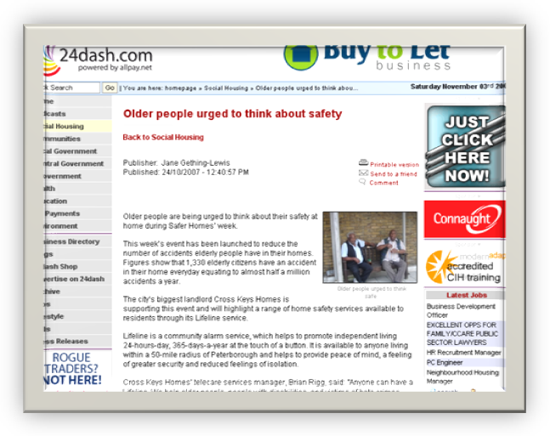
Web link:
http://www.24dash.com/socialhousing/28907.htm

Hampshire

Hampshire review telecare progress.
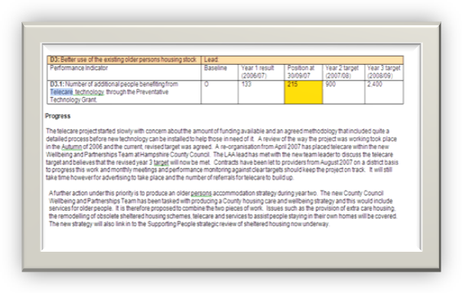

Web link:
http://www3.hants.gov.uk/item_4_priority_d_report.doc

Blackpool

Thanks to Blackpool Vitaline Service

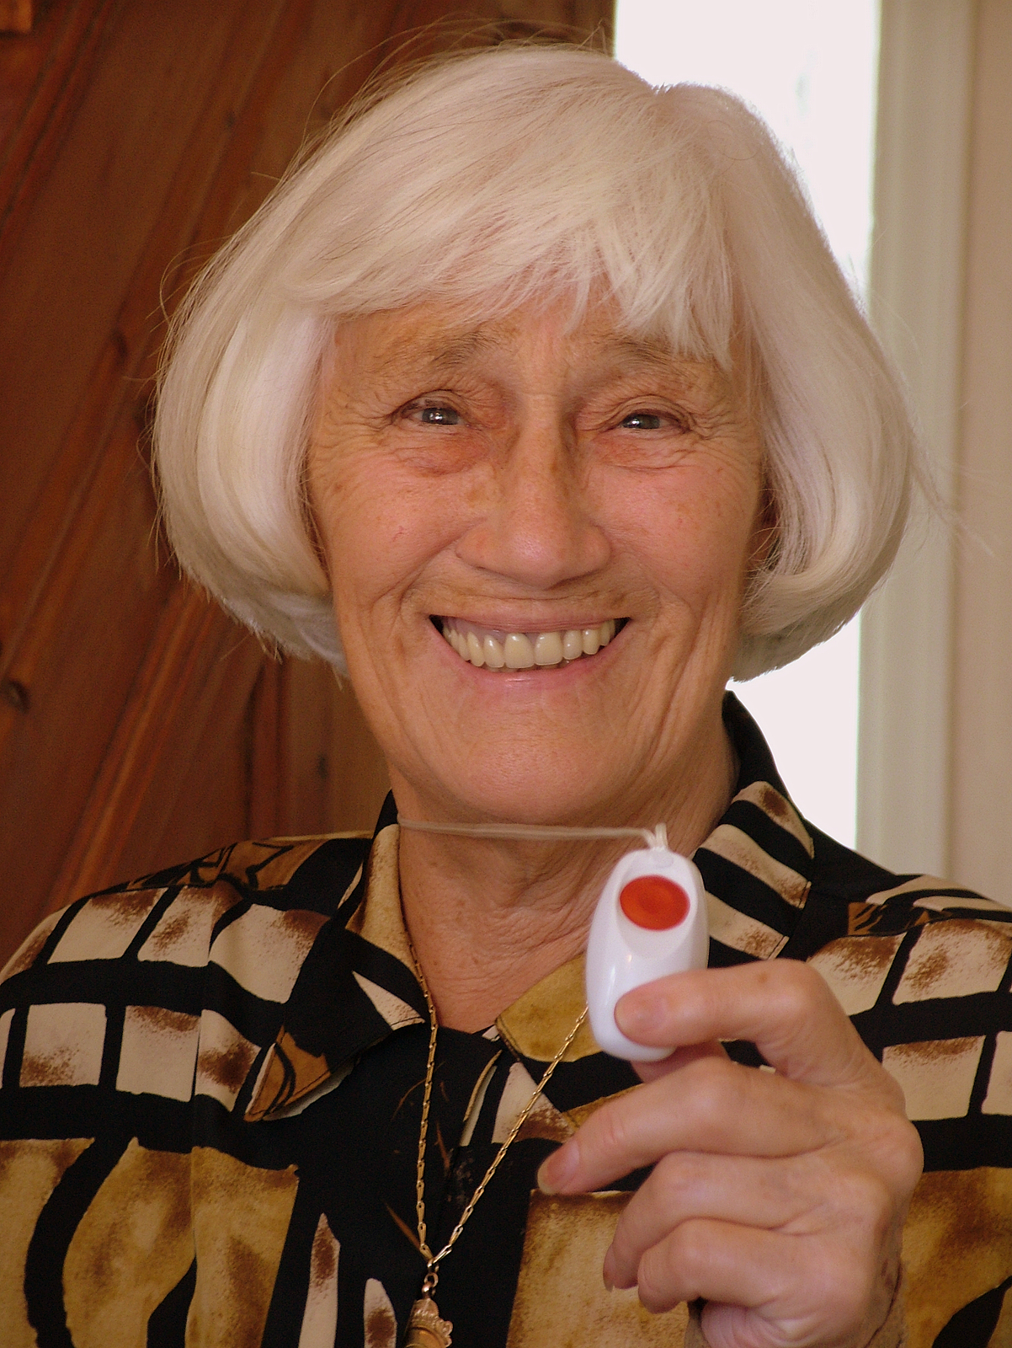

Seasoned Blackpool councillor, Lily Henderson MBE, is on the road to recovery after a spate of accidents and incidents and is making sure that help is at hand if anything happens in the future.

The former mayor of Blackpool broke her arm last month after falling in her kitchen and was on the floor for 45 minutes before being discovered by her grandson.

Now the cabinet member for adult social care, housing and health at Blackpool Council is getting a helping hand from services within her own department.

Her Blackpool home has been fitted with state-of-the-art monitoring devices by Vitaline, which automatically raise the alarm if Lily is in any danger.

If any of the devices are activated, a call is received at Vitaline’s monitoring centre at Layton. Staff would then respond and, if necessary, go to Mrs Henderson’s home or alert the ambulance if it was more serious.

One of the sensors can be discreetly worn on the body and can detect if a fall has taken place – instantly making Vitaline aware that the Highfield ward councillor needs help, without her having to say anything or press any buttons.

Councillor Henderson, who was awarded the MBE in 2005 for helping others through her voluntary work, is delighted with the system.

She said: “It’s fantastic and I think every home should have Vitaline’s monitoring system installed. It doesn’t matter how old you are!

“All the gadgets are hidden, so you can just live your life normally in your own home with the reassurance that if anything happens to me it will be detected straight away.

“I only pay about 50 pence a day but anyway help is available if people can’t afford, so no one should be put off because of cost.

“The important thing is that if I fall again, I know that I won’t be lying on the floor for long and that gives me a great deal of confidence.”

Councillor Henderson’s fall came just after she had undergone surgery on a painful shoulder soon after the election win gave the conservatives control of Blackpool Council but, despite her injuries, she has continued with her busy council schedule.

Margaret Seddon, manager at Vitaline, said: “The official term for the service we provide for Councillor Henderson is Telecare, which is a top priority at the department of health. It gives people confidence and reassurance, which means they can retain their independence.

“The crucial aspect at Vitaline is that we have staff who can attend a customer’s house to deliver quality care when an incident has occurred – we are not just a call centre.

“A fall can sometimes knock people’s confidence, so they are more likely to fall again and eventually they don’t want to go out of their house. Telecare stops that downward spiral.

“Vitaline’s services are not just for the over 65s as the monitoring service can be adapted to any scenario. It can be equally effective for home security and crime prevention as it can for supporting vulnerable people.”

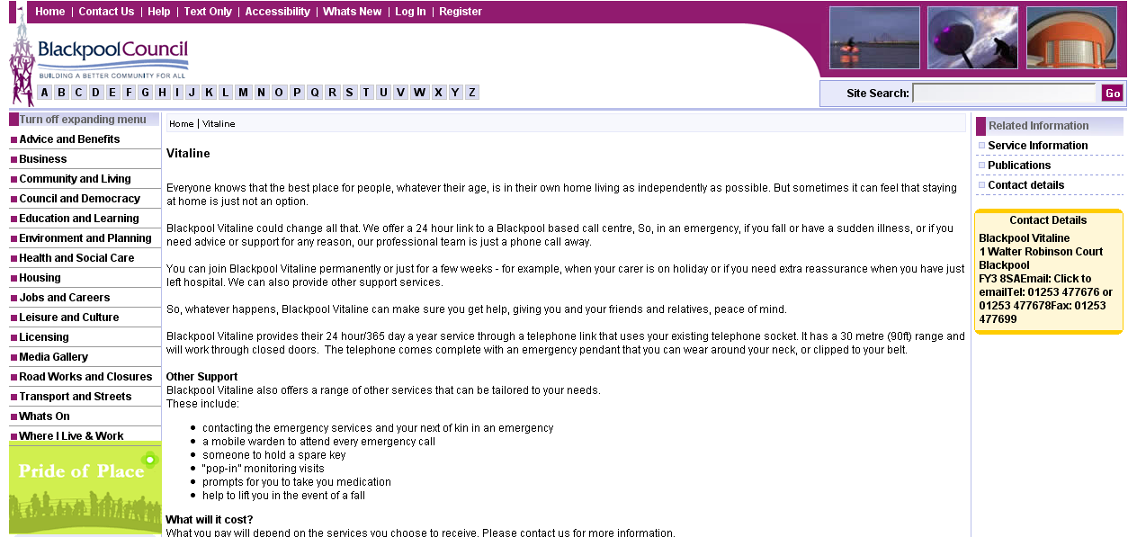

Web link:
http://www.blackpool.gov.uk/Services/S-Z/Vitaline/

6 News extra – keeping up to date with telecare and telehealth

Telecare LIN

CSIP is not responsible for the content of external web sites. CSIP does not endorse any particular products or services.

Cheshire pilots new service for people with disabilities (transforming community equipment pilot)

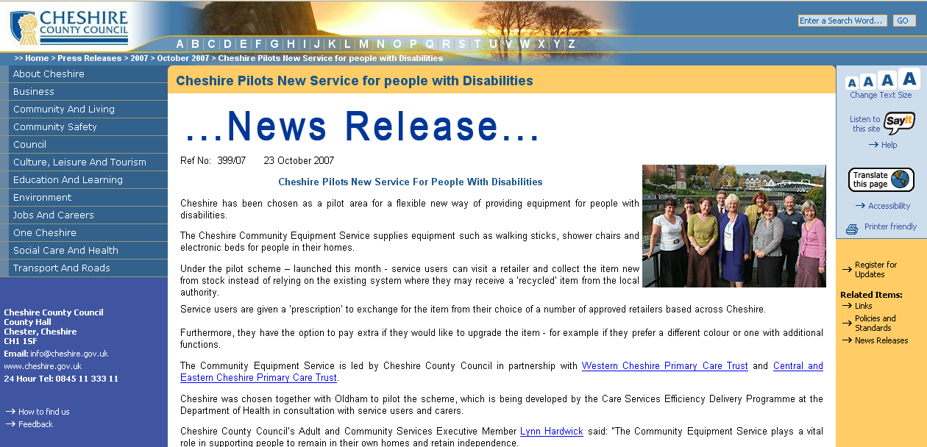

Web Links:
http://www.cheshire.gov.uk/PR/2007/october07/399-07.htm
http://www.csed.csip.org.uk/workstreams/transforming-community-equipment--wheelchair-services/community-equipment.html

HACT – Reducing the isolation of older people in rural communities

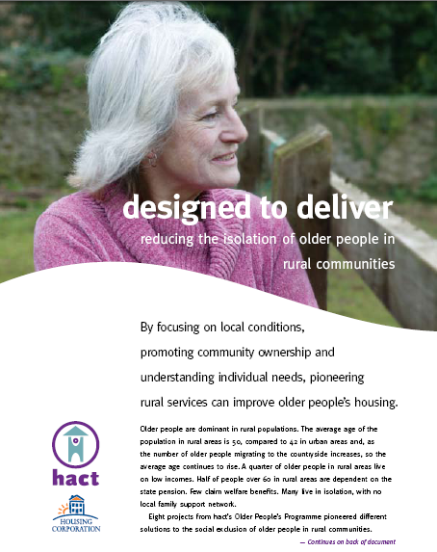

Web Link:
http://www.hact.org.uk/uploads/Designed_to_deliver.pdf
As services move into the mainstream, CSIP will be providing more cutting edge news from the UK and around the world to help with commissioning future telecare and telehealth services.

Patients at risk at night - study

“Nearly a quarter of all accidents to patients receiving NHS care in England occur at night, a survey has concluded. Analysis of National Patient Safety Agency data found 140,000 incidents in 2006/7 between 10pm and 6am.Falls, trips and slips were the most common source of problems, according to the Reader's Digest survey. Accidents such as slips, trips and falls were the most frequently reported night-time incident, accounting for 60% of the total”.

Web Link:
http://news.bbc.co.uk/1/hi/health/7067904.stm
http://www.chroniclelive.co.uk/north-east-news/uk-and-world-news/2007/10/30/140-000-patients-at-risk-at-night-84229-20029855/

Diabetes audit
http://www.diabetes.org.uk/About_us/News_Landing_Page/Largest-diabetes-audit-reveals-gaps-in-paediatric-care/

Remote Monitoring - How will Patient Information Flow to the EMR?
http://blog.canadianemr.ca/canadianemr/2007/10/remote-monitori.html

Broadband Enables Better Health Care at Reduced Cost for More Americans
“The 17-page study provides a comprehensive review of the literature about telemedicine and e-health, and notes:
- Remote home health monitoring for a single group of diabetes patients cut costs for hospital care by 69 percent according to a Penn State University study.
- A Veterans Association study of remote monitoring of patients showed a 40 percent cut in emergency room visits.
- 30 percent of all hospital, out-patient and drug expenses could be saved from remote monitoring for the chronically ill, according to the Kaufman Foundation”

http://home.businesswire.com/portal/site/google/index.jsp?ndmViewId=news_view&newsId=20071025005693&newsLang=en

Nurses use laptops for home visits in Alston, Cumbria
http://www.ehiprimarycare.com/news/3153/nurses_use_laptops_for_home_visits_in_alston

Device to keep kids with diabetes safe
http://www.eveningnews24.co.uk/content/News/story.aspx?brand=ENOnline&category=News&tBrand=enonline&tCategory=news&itemid=NOED22%20Oct%202007%2010%3A01%3A54%3A417

Google Says Its Health Platform Is Due In Early 2008
http://www.informationweek.com/news/showArticle.jhtml?articleID=202404027

New US guidelines on stable COPD
http://www.nelm.nhs.uk/Record%20Viewing/viewRecord.aspx?id=586778

Diabetes monitor linked to Microsoft Health Vault

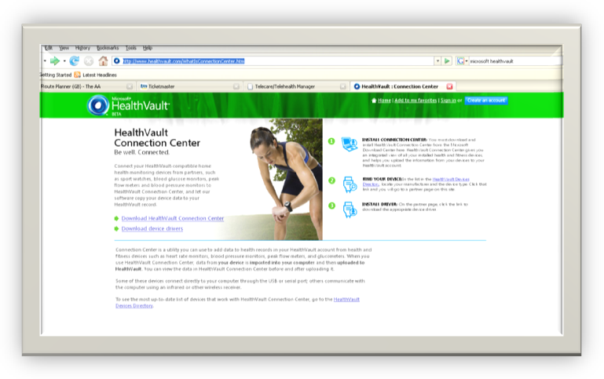
Web links:
http://www.diabeteshealth.com/read/2007/10/31/5517.html
http://www.healthvault.com/WhatIsConnectionCenter.htm
http://blogs.zdnet.com/microsoft/?p=877

New Report Says Ageing Population Drives Global Telehealth Market Forward
http://www.newswiretoday.com/news/25551/
http://www.pipelinereview.com/joomla/content/view/15518/304/
Is Telehealth Gaining Momentum?
http://hitanalyst.wordpress.com/2007/10/24/is-telehealth-gaining-momentum/

Telehealth – Kaiser Permanente
http://www.healthimaging.com/index.php?option=com_content&task=view&id=8317&Itemid=89
EU collects telehealth information
http://www.healthtechwire.com/Pressrelease.146+M517f8420f46.0.html
http://ec.europa.eu/information_society/newsroom/cf/itemdetail.cfm?item_id=3684
http://ec.europa.eu/information_society/newsroom/cf/itemdetail.cfm?item_id=3677
Report: Home care agencies to increase telehealth capabilities
http://www.healthimaging.com/index.php?option=com_content&task=view&id=8122&Itemid=89
Honeywell HomMed Launches New Telehealth Ecosystem
http://www.infobolsa.es/v2002/Noticias/noticias_titulares2.asp?Fuente=IBNW&FechaNot=20071005&Clasif=C&Numnot=104128
California Could Become National Model for Telemedicine
http://www.ihealthbeat.org/articles/2007/10/30/California-Could-Become-National-Model-for-Telemedicine.aspx?a=1
Consumerization key to telemedicine's full potential
http://www.healthcareitnews.com/story.cms?id=8034&fromRSS=true

Compliance with Home Telehealth Clinical Guidelines
http://hhc.sagepub.com/cgi/content/abstract/19/6/476
A survey in Alberta and Quebec of the telehealth applications that physicians need
http://rsm.publisher.ingentaconnect.com/content/rsm/jtt/2007/00000013/00000007/art00007;jsessionid=6g01p1wi5be8.victoria

Call handling service in Camden – contract award
http://www3.camden.gov.uk/templates/committees/documents/22340.doc

Remote monitoring first for Amsterdam hospital – Phillips Motiva
http://ehealtheurope.net/news/3183/remote_monitoring_first_for_amsterdam_hospital

SatNav for people with dementia– award for device
http://www.wirelesshealthcare.co.uk/wh/news/wk44-07-0006.htm
California Bans Forced RFID Implants For Humans
http://www.informationweek.com/industries/showArticle.jhtml?articleID=202402856
A study of the receptivity to telecare technology in a community-based elderly minority population
http://rsm.publisher.ingentaconnect.com/content/rsm/jtt/2007/00000013/00000007/art00002;jsessionid=6g01p1wi5be8.victoria

Lifestyle monitoring as a predictive tool in telecare
http://articles.icmcc.org/wpc/?p=231
Telehealth Home Care for Canada and Western Europe to Be a $225 Million Industry by 2011 - Digital Health in Western Europe and Canada
http://www.associatedcontent.com/article/356705/telehealth_home_care_for_canada_and.html
Support for the clinician in providing a regional telehealth service
http://rsm.publisher.ingentaconnect.com/content/rsm/jtt/2007/00000013/00000006/art00001;jsessionid=aapjkac87job7.henrietta
Device makers push Medicare reimbursement for remote patient care
http://www.govhealthit.com/online/news/350095-1.html
Smartphone patient monitoring showcased
http://www.ehealtheurope.net/news/3127/smartphone_patient_monitoring_showcased

Telehealth – Canada
http://www.timminspress.com/ArticleDisplay.aspx?e=731043&auth=Michael+Peeling

American Medical Alert Executes Multi-Year Contract With City Of New York, Human Resources Administration
http://www.tradingmarkets.com/.site/news/BREAKING%20NEWS/706575

Palo Alto Medical Foundation Receives $1.2 Million Grant for New Diabetes Management Study; Randomized, Controlled Clinical Trial Will Evaluate Online Disease Management
http://newswire.ascribe.org/cgi-bin/behold.pl?ascribeid=20071017.104504&time=11%2055%20PDT&year=2007&public=0

It’s good to talk: making connected personal health possible - Intel
http://www.bjhcim.co.uk/features/2007/710004.htm

ALARM-Net: Wireless Sensor Networks for Assisted Living and Residential Monitoring
http://blog.xbow.com/xblog/2007/09/alarm-net-wirel.html

New telehealth magazine to be launched in April 2008
http://oceanstarz.typepad.com/telemedicine/2007/11/new-telehealth-.html

Patient-centred care and the medical home
http://curinghealthcare.blogspot.com/2007/11/patient-centered-life-cycle-pclc-value.html

Intelligent Nebuliser Benefits Patients With Chronic Obstructive Pulmonary Disease
http://www.docguide.com/news/content.nsf/news/852571020057CCF68525735C004C8791

Smartphone patient monitoring showcased
http://www.ehealtheurope.net/news/3127/smartphone_patient_monitoring_showcased
New Journal of Assistive Technologies

http://www.pavpub.com/pavpub/journals/jat/index.asp

Health and social care bursaries for Health Computing 2008

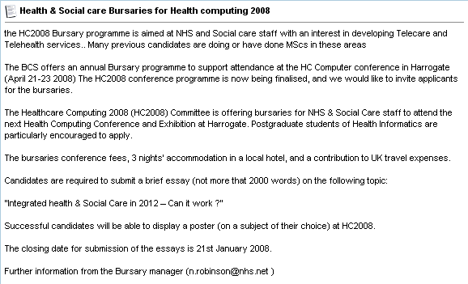

Web link
http://www.networks.nhs.uk/forums/showthread.php?p=6135#post6135

7 Events

Telecare LIN

- Regional Housing LIN dates for 2007:

Here is the list of the upcoming Housing LIN regional meetings:

North West Region LIN - 15th November 2007, Ashton-under-Lyne

To register for these events go to: http://www.icn.csip.org.uk/housing/index.cfm?pid=167

Latest Housing LIN Newsletter –September 2007

Web link:

http://www.icn.csip.org.uk/_library/Resources/Housing/Support_materials/Newsletter/Newsletter25.pdf

- Telecare Services Association (TSA) Conference – Cardiff, 6-8 November 2007

CSIP’s Nigel Walker and Judith Whittam will be speaking at the TSA Conference along with Claire Whittington (White Paper Long Term Conditions Demonstrator Programme).

The National Telecare & Telehealth Conference will take place in Cardiff, November 6th – 8th. The event which attracted almost 400 delegates last year will bring together the single largest gathering of Telecare & Telehealth professionals in the UK this year. With the interest generated by the Whole System Demonstrator Sites there will be significant focus on Telehealth with added international perspective.

Web link:

http://www.telecare.org.uk/event/42301/46596/tsa_annual_conference_2007.htm

- Fourth Annual Telecare and Assistive Technology Conference

CSIP’s Mike Clark will be presenting at the Laing and Buisson conference on 10 December 2007 in London.

Web link:

http://www.laingbuisson.co.uk/Portals/1/Assistive%20Technology%202.pdf

- CSIP Telecare events

Venue | Date
London | 24 January 2008
Leeds | 29 January 2008
Manchester | 4 February 2008
Taunton | 7 February 2008
Birmingham | 12 February 2008

The Foundation for Assistive Technology (FAST) provides a full listing of forthcoming telecare events – see http://www.fastuk.org/services/events.php?pg=2. Suppliers also run telecare and telehealth events – check their web sites regularly for dates.

All previous telecare eNewsletters are available at: www.icn.csip.org.uk/telecarenewsletters

CSIP Telecare Services

You can send comments and questions about the CSIP Implementation Guide, factsheets or other resources or contact us via telecare@csip.org.uk. Also, use this mailbox to send in good practice examples.

If you or a colleague would like to receive future copies of the newsletter then all you need to do is register at http://www.icn.csip.org.uk/index.cfm?pid=12

If you have further details please contact telecare@csip.org.uk
8 Appendix – telecare in district councils

Telecare LIN


Adur
http://www.adur.gov.uk/community-support/com-alarm.htm
Allerdale
Alnwick
Amber Valley
http://www.ambervalley.gov.uk/services/healthwell-beingandcare/disability/equipmentfordisabledpeople/alarmsforelderlyanddisabled/
Arun
http://www.arun.gov.uk/cgi-bin/buildpage.pl?mysql=851
Ashfield
Ashford
http://www.ashford.gov.uk/health_and_safety/community_safety/telecare.aspx
Aylesbury Vale
http://www.aylesburyvaledc.gov.uk/avdc/content/index.jsp?contentid=-361050811
Babergh
http://www.babergh.gov.uk/cgi-bin/MsmGo.exe?grab_id=631&EXTRA_ARG=&CFGNAME=MssFind%2Ecfg&host_id=42&page_id=4456448&query=community+alarm&hiword=ALARMING+COMMUNIT+alarm+ALARMED+ALARMS+COMMUN+COMMUNITES+COMMUNITYBASED+COMMUNITI+COMMUNITIES+community+COMMUN
Barrow in Furness
http://www.barrowbc.gov.uk/default.aspx?page=283
Basildon
http://www.sgch.org.uk/80257297003C0FCD/vWeb/wpEFEN6Z4LTR
Basingstoke and Deane
Bassetlaw
Bedford
Berwick-upon-Tweed
Blaby
Blyth Valley
http://www.blythvalley.gov.uk/default.aspx?page=8004
Bolsover
Boston
Braintree
http://www.braintree.gov.uk/Braintree/housing/elderly+services/carecall.htm
Breckland
Brentwood
http://www.brentwood.gov.uk/index.php?cid=504
Bridgenorth
Broadland
Bromsgrove
Broxbourne
Broxtowe
http://www.broxtowe.gov.uk/sheltered_lifeline
Burnley
Cambridge
http://www.cambridge.gov.uk/ccm/navigation/housing/council-housing/independent-living/community-alarm-service/
Cannock Chase
http://www.cannockchasedc.gov.uk/site/scripts/services_info.php?serviceID=788&startsWith=A
Canterbury
http://www.canterbury.gov.uk/buildpage.php?id=1717
Caradon
http://www.caradon.gov.uk/index.cfm?articleid=13063
Carlisle
Carrick
http://www.carrick.gov.uk/index.cfm?articleid=3571
Castle Morpeth
Castle Point
Charnwood
http://www.charnwood.gov.uk/housing/lifelineandwardenservices.html
Chelmsford
Cheltenham
http://www.cheltenham.gov.uk/libraries/templates/community.asp?URN=1474&FolderID=0
Cherwell
Chester
Chesterfield
Chester-le-Street
http://www.chester-le-street.gov.uk/index.cfm?articleid=7125
Chichester
http://www.chichester.gov.uk/index.cfm?articleid=5282
Chiltern
Chorley
Christchurch
no
Colchester
http://www.colchester.gov.uk/Info_page_two_pic_2.asp?sec_id=1124
Congleton
http://www.congleton.gov.uk/?t=1371
Copeland
Corby
http://www.corby.gov.uk/an/wc.exe/AO2/View/?Site=1191
Cotswold
Craven
Crawley
http://www.crawley.gov.uk/stellent/idcplg?IdcService=SS_GET_PAGE&nodeId=113&strCSS=PB1_SS_MAIN
Crewe and Nantwich
Dacorum
http://www.dacorum.gov.uk/default.aspx?page=2948
Dartford
Daventry
Derbyshire Dales
Derwentside
http://www.derwentside.gov.uk/index.cfm?articleid=2888
Dover
http://www.dover.gov.uk/careline/careline.asp
Durham City
http://www.durhamcity.gov.uk/Pid/313
Easington
East Cambridgeshire
East Devon
http://www.eastdevon.gov.uk/homesafeguard.htm
East Dorset
East Hampshire
East Hertfordshire
http://www.eastherts.gov.uk/index.jsp?articleid=653
East Lindsey
http://www.eastherts.gov.uk/index.jsp?articleid=653
East Northamptonshire
East Staffordshire
Eastbourne
http://www.eastbourne.gov.uk/health/lifeline
Eastleigh
Eden
http://www.eden.gov.uk/main.asp?page=599
Ellesmere Port and Neston
Elmbridge
http://www.elmbridge.gov.uk/atoz/detail.htm?pk_services=1039
Epping Forest
http://www.eppingforestdc.gov.uk/Council_Services/housing_services/Epping_Forest_Careline.asp
Epsom and Ewell
http://www.epsom-ewell.gov.uk/EEBC/Community+and+Living/Services+for+the+elderly+and+disabled/Community+Alarm/
Erewash
Exeter
http://www.exeter.gov.uk/index.aspx?articleid=2292
Fareham
Fenland
http://www.fenland.gov.uk/ccm/content/housing/housing/piper-lifeline.en
Forest Heath
Forest of Dean
http://www.fdean.gov.uk/content.asp?nav=574&parent_directory_id=543&positioning_article_id=&language=&sortkey=
Fylde
Gedling
Gloucester
Gosport
Gravesham
Great Yarmouth
Guildford
http://www.guildford.gov.uk/GuildfordWeb/Community/TelecareServices/National+services/CommunityAlarmMonitoring.htm
Hambleton
Harborough
http://www.harborough.gov.uk/dotGov/home.do?crumb=Lifeline%20Alarms&crumb-0=Search&menu_root-0=SysDoc-SERVICE&page_name-0=searchResults&list_search-0=community%20alarm&page_css=xDefault&view_schema=service&view_name=07HDC-Imported%20Service%20ID%2085&home
Harlow
Harrogate
Hart
Hastings
Havant
Hertsmere
High Peak
Hinckley and Bosworth
Horsham
Huntingdonshire
http://www.huntsdc.gov.uk/Housing/Safety+and+security/Community+alarms.htm
Hyndburn
Ipswich
Kennet
http://documents.kennet.gov.uk/general/website1.nsf/a4eb95dd5790686580256a1f002f7b8b/ea8a74d8b74ebb1080257177005461e7?OpenDocument
Kerrier
Kettering
King's Lynn and West Norfolk
Lancaster
http://www.lancaster.gov.uk/Category.asp?cat=219
Lewes
http://www.lewes.gov.uk/housing/1787.asp
Lichfield
http://www.lichfielddc.gov.uk/site/scripts/services_info.php?serviceID=788&startsWith=C
Lincoln
Macclesfield
http://www.macclesfield.gov.uk/standardpage.asp?pageid=6395
Maidstone
Maldon
Malvern Hills
http://malvern.whub.org.uk/home/mhcindex/mhc-housing/mhc-housing-telecare.htm?hilightTerm=community%20alarm
Mansfield
Melton
http://www.melton.gov.uk/dotGov/home.do?crumb=Emergency%20Alarm%20System%20(Melton%20Lifeline)&crumb-0=Search&menu_root-0=LGOL0&page_name-0=searchResults&list_search-0=alarm&page_css=xDefault&view_schema=service&view_name=07MBC04272154844&homepage_name=07
Mendip
Mid Bedfordshire
Mid Devon
Mid Suffolk
Mid Sussex
http://www.midsussex.gov.uk/page.cfm?pageid=1667
Mole Valley
http://www.mole-valley.gov.uk/index.cfm?articleid=266
New Forest
http://www.newforest.gov.uk/index.cfm?articleid=4381
Newark and Sherwood
Newcastle-under-Lyme
North Cornwall
North Devon
North Dorset
North East Derbyshire
http://www.ne-derbyshire.gov.uk/housing/strategic-housing-service/meeting-the-needs-of-older-people/older-peoples-housing/copy-of-care-call
North Hertfordshire
http://www.olderpeopleinnortheastlincs.co.uk/information/charities/carelink.htm
North Kesteven
http://www.n-kesteven.gov.uk/section.asp?docId=2221&catId=477&pageTitle=Care%2FCommunity+Alarm+Services
North Norfolk
http://www.northnorfolk.org/health/default_3591.asp
North Shropshire
http://www.northshropshiredc.gov.uk/WhereToGoForHelp18
North Warwickshire
http://www.northwarks.gov.uk/site/scripts/documents_info.php?documentID=48
North West Leicestershire
http://www.nwleics.gov.uk/countyservice_details/home.asp?PID=313
North Wiltshire
Northampton
Norwich
Nuneaton and Bedworth
Oadby and Wigston
Oswestry
http://www.oswestrybc.gov.uk/static/page794.htm
Oxford
Pendle
http://www.pendle.gov.uk/site/scripts/documents_info.php?categoryID=939&documentID=110
Penwith
Preston
Purbeck
http://www.purbeck-dc.gov.uk/default.aspx?page=7358
Redditch
http://redditch.whub.org.uk/home/rbcindex/rbc-community-services/rbc-comm-services-cr-agency.htm?hilightTerm=community%20alarm
Reigate and Banstead
Restormel
Ribble Valley
Richmondshire
Rochford
Rossendale
Rother
Rugby
http://www.rugby.gov.uk/site/scripts/services_info.php?serviceID=77
Runnymede
http://www.runnymede.gov.uk/portal/binary/com.epicentric.contentmanagement.servlet.ContentDeliveryServlet/Safer%2520Runnymede/Residents/Community%2520Alarm%2520Service%2520%2528Careline%2529
Rushcliffe
Rushmoor
http://www.rushmoor.gov.uk/index.cfm?articleid=3075
Ryedale
http://www.ryedale.gov.uk/scripts/htm_hl.pl?DB=ryedale&STEMMER=en&WORDS=lifelin&ALL=&ANY=&EXACTB=0&PHRASE=&EXACTP=0&CATEGORIES=&SIMPLE=lifeline&COLOUR=Fuchsia&STYLE=s&URL=http://www.ryedale.gov.uk/Default.aspx?page=9083
Salisbury
http://www.salisbury.gov.uk/housing/housing-assistance/care-connect/careconnect-lifeline.htm
Scarborough
Sedgefield
http://www.sedgefield.gov.uk/ccm/content/neighbourhood-services/neighbourhood-services/Carelink.en
Sedgemoor
http://www.sedgemoor.gov.uk/index.aspx?articleid=3956
Selby
Sevenoaks
Shepway
Shrewsbury and Atcham
South Bedfordshire
South Buckinghamshire
South Cambridgeshire
South Derbyshire
http://www.south-derbys.gov.uk/Housing/SupportedShelteredHousing/careline.htm
South Hams
South Holland
South Kesteven
South Lakeland
South Norfolk
South Northamptonshire
South Oxfordshire
South Ribble
South Shropshire
South Somerset
http://www.southsomerset.gov.uk/index.jsp?articleid=478
South Staffordshire
Spelthorne
http://www.spelthorne.gov.uk/span
St Albans
St Edmundsbury
Stafford
Staffordshire Moorlands
http://www.staffsmoorlands.gov.uk/site/scripts/services_info.php?serviceID=788&startsWith=C
Stevenage
http://www.stevenage.gov.uk/healthandsocialcare/homecare/carescancommunityalarmservices
Stratford on Avon
Stroud
http://www.stroud.gov.uk/docs/az_services.asp?doit=list&azid=440
Suffolk Coastal
Surrey Heath
http://www.surreyheath.gov.uk/services/list.htm?mode=8&pk_services=268
Swale
Tamworth
Tandridge
http://www.tandridge.gov.uk/documents/document_display.htm?pk_document=834
Taunton Deane
http://www.tauntondeane.gov.uk/tdbcsites/polperf/redcrimedis/cddeanehelp.asp
Teesdale
Teignbridge
http://www.teignbridge.gov.uk/index.cfm?articleid=1386
Tendring
http://www.tendringdc.gov.uk/TendringDC/Health/Careline/careline.htm
Test Valley
Tewkesbury
Thanet
Three Rivers
Tonbridge and Malling
Torridge
Tunbridge Wells
Tynedale
Uttlesford
http://www.uttlesford.gov.uk/news/housing/600th+lifeline+in+uttlesford.htm
Vale
Vale of White Horse
Warnsbeck
Warwick
Watford
http://www.hertsdirect.org/comdirectory/comvol/disable2y/12063632/?view=Printlist
Waveney
http://waveney.searchimprove.com/highlight.aspx?aid=516691&pckid=75758677&rn=3&sp_id=75756154&lid=7792997&highlight=community+alarm
Waverley
http://waverweb.waverley.gov.uk/live/wbc/newcomdb.nsf/26f84eb45abc1ffb002565ee00448e28/80256d260038203880256f35003cf12d?OpenDocument
Wealden
http://www.wealden.gov.uk/Housing/Housing_for_Older_People/Lifeline/
Wear Valley
Wellingborough
Welwyn Hatfield
http://www.welhat.gov.uk/housing/supportedandshelteredhousing/thelifelinealarmsystem
West Devon
West Dorset
West Lancashire
West Lindsey
West Norfolk
West Oxfordshire
West Somerset
West Wiltshire
http://www.westwiltshire.gov.uk/az-313-care-scan-community-alarm
Weymouth and Portland
Winchester
http://www.winchester.gov.uk/SocialCareAndHealth/AdaptingHomes/CommunityAlarmServices/
http://www.woking.gov.uk/council/housing/general/careline2
Worcester
Woking
Worthing
Wychavon
http://wychavon.whub.org.uk/home/wdc-housing-hn-worcs-telecare?hilightTerm=alarm%20telecare
Wycombe
Wyre
Wyre Forest

