Telecare LIN eNewsletter

May 2009

Welcome to the May 2009 newsletter. The Telecare Learning and Improvement Network (LIN) is responsible for providing general implementation support to organisations building their telecare and telehealth programmes.

If you are an organisation implementing telecare or telehealth in England and have an interesting local telecare or telehealth story for inclusion in a future newsletter then e-mail Mike Clark at telecare@dhcarenetworks.org.uk

Note: DH Care Networks is not responsible for the content of external links and does not endorse any suppliers or their products. Any claims made by organisations should be carefully evaluated as part of normal commissioning and procurement arrangements.

Contents

ITEM | PAGE
HEADLINES FOR MAY 2009 | 2
1 WHOLE SYSTEM DEMONSTRATOR ACTION NETWORK (WSDAN) | 4
2 PANDEMIC FLU PLANNING – LEVEL 5 | 5
3 NHS INNOVATION EXPO – 18/19 JUNE 2009 | 7
4 A NEW COMMERCIAL OPERATING MODEL FOR THE NHS AND DEPARTMENT OF HEALTH | 8
5 TELEHEALTH MAPPING | 9
6 PREPARE HEALTH SYSTEMS FOR AGEING EU TOLD | 10
7 PUTTING THE PATIENT IN CONTROL – NEXT STAGE IN PERSONAL HEALTHCARE BUDGETS ANNOUNCED | 10
8 OTHER DEPARTMENT OF HEALTH NEWS | 11
9 NEWS | 14
10 EVENTS | 28
APPENDIX – PCTs and telehealth | 30

Headlines for May 2009

1 There are a few late cancellations left for the next public Whole System Demonstrator event on 11 June in Leeds. As well as updates from the demonstrators and the Leeds and Nottingham programmes, there will be presentations from Paul Trueman (YHEC: Scottish Telecare Evaluation), Professor John Cleland (Hull: telehealth and heart failure) and Professor Sue Yeandle (telecare research at Leeds University). Nick Goodwin, Mike Clark and John Eaglesham will be running workshops. Booking for the Bristol event on 10 September will be open later in June 2009.

2 The Department of Health has provided information and guidance in recent months on pandemic flu planning for health and social care. In the light of the current H1N1 (swine flu) situation, it is important to review the effectiveness of local plans for business continuity to support current and future alert levels. Inadequate planning at this stage may lead to possible failures in telecare services at a later date if staff are affected by flu. Involvement in local planning should ensure business continuity for service users and patients.

3 There will be an NHS Innovation Expo on 18/19 June at the Excel Centre in London. The Expo includes telehealth suppliers and an Innovation House with telecare/telehealth.

4 A new commercial operating model for the NHS and Department of Health has been published following the recent budget. This covers the position on commercial support units, NHS PASA and the Office of Government Commerce.

5 Published internet information on telehealth in PCTs has been updated – over 100 (of 152) PCTs have a documented intention, plan or pilot programme for telehealth in England. Details appear in an Appendix within the newsletter.

6 An EU report considers the costs of an ageing population. “In order to limit the expected increase in public expenditure, policy measures which can either reduce disability, limit the need for formal care or improve the cost effectiveness of long term care provision – eg through the introduction of eHealth and telecare – must be developed,” it says.

7 Patients are a step closer to getting more say over their healthcare services as plans for a national pilot project reach the next stage, the Department of Health has announced. Following a call for expressions of interest for sites across England to take part in the first trials of personal health budgets, 68 projects, involving a total of 75 PCTs, have been awarded provisional pilot status. Lord Darzi first announced personal health budgets in his report High Quality Care for All last year. Under the proposals, patients will have greater involvement in how money is spent on their healthcare needs, giving them more control over what services they use and who provides them so they will be delivered in a way that best suits them.

8 a range of recent Department of Health publications cover 2009 Heatwave Plan, the NHS Evidence web site, the vascular checks programme, innovation and the areas being examined by none Common Assessment Framework (CAF) demonstrators.

9 The most comprehensive monthly news and information summary in England covers a wide range of developments in telecare, telehealth and telemedicine of value to individuals organising local programme.

10 A range of events are provided by DH Care Networks – there may be one or two late cancellations for the Leeds Whole System Demonstrator event on 11 June. The next event will be on 10 September 2009 in Bristol.

1 Whole System Demonstrator Action Network (WSDAN)
Prepared by Mike Clark

The latest WSDAN eNewsletter was issued on 14 May covering updates on the demonstrator programme together with evidence reviews. The next newsletter is due on 11 June – don’t forget to register.

WSD Action Network News – May 2009
Update from the Department of Health's Whole System Demonstrator pilots gives the latest news on the involvement of GP practices, the importance of stakeholder sign-up and other issues.
Features examining the evidence base for the management of diabetes and issues around sustaining innovations.
Report on the second WSDAN Roadshow, which took place in Birmingham on 12 March.
You can register for WSD Action Network updates at:
http://www.wsdactionnetwork.org.uk/about_wsdan/register_for_updates.html

Over 120 people are now registered for the next WSDAN event on 11 June 2009. In addition to update information from the Whole System Demonstrator Programme, presenters will include:

- Paul Trueman, Director of York Health Economics Consortium on the recently published evaluation of the Scottish Telecare programme
- Professor John Cleland from Hull University on telehealth and heart failure
- Professor Sue Yeandle from Leeds University on ICT and telecare: researching the impact on carers and care workers

There will be updates on the NHS PASA timetable for the 2010 national framework, work being carried out by NHS Connecting for Health on capturing telehealth information in the summary health records and progress by the Assisted Living Innovation Platform. There will be presentations on telecare and telehealth from Leeds and Nottingham. John Eaglesham will be looking at telehealth developments in Yorkshire and Mike Clark will be covering the commissioning of telecare and telehealth services.

Cancellations for Leeds may be available:
http://www.dhcarenetworks.org.uk/Events/EventDetail/?eventID=462

The next event will be 10 September 2009 in Bristol – booking will open later in June 2009.

2 Pandemic Flu planning – Level 5
Prepared by Mike Clark

Since the first notifications of the new H1N1 flu strain (also known as swine flu), health trusts, local authorities and their partner agencies have increased their arrangements to meet potential flu cases in the coming months.

It is important that telecare services are well prepared to ensure business continuity if significant numbers of people are affected. Here are some important areas to look at:

- Have there been reported H1N1 cases in your area? How have services responded? What arrangements are in place? What local lessons have been learned?
- Have you reviewed the range of relevant documentation (eg policy, guidance, leaflets etc) available from Government and other sources that would help with planning and providing information to staff and service users?
- Do you know about your local flu plan arrangements? Are you up to date with recent local developments?
- Are arrangements in place to provide national and local sources of information to users and carers if they are unwell?
- Are arrangements in place to link with care providers if users call in to indicate that their care worker or personal assistant is unwell?
- Are management and service responsibilities clearly set out?
- Are staff fully briefed on a regular basis about current arrangements and future plans if Level 6 was announced?
- Are appropriate cover arrangements in place to maintain a control centre and a home visit service if staff are affected by flu? Would other staff be able to cover from the current base or another control centre location?
- Have you reviewed business continuity and resilience arrangements?

Swine Flu Resources for health and social care professionals
http://www.dh.gov.uk/en/Publichealth/Flu/Swineflu/DH_098802

Pandemic Flu – DH Site
http://www.dh.gov.uk/en/Publichealth/Flu/PandemicFlu/index.htm

Pandemic flu: managing demand and capacity in health care organisations (surge)

“Preparations for dealing with a surge of patients and service users – and how services and patients are prioritised – need to be developed, agreed and in place amongst all caring agencies before a pandemic strikes. It is important that a common set of prioritisation criteria be used across the UK. Clarity and transparency will be essential, as will consistent planning according to the national planning assumptions and principles as set out in Pandemic flu: A national framework for responding to an influenza pandemic”

http://www.dh.gov.uk/en/Publicationsandstatistics/Publications/PublicationsPolicyAndGuidance/DH_098769

Direct Gov web site – information from across government departments
http://www.direct.gov.uk/en/Swineflu/DG_177831

Health protection Agency
http://www.hpa.org.uk/

Swine Flu – DH statements
http://www.dh.gov.uk/en/Publichealth/Flu/Swineflu/index.htm

NHS Choices – will provide updated information on any changes:
http://www.nhs.uk/Pages/HomePage.aspx

Main DH Pandemic Flu site:
http://www.dh.gov.uk/en/Publichealth/Flu/PandemicFlu/DH_065006

Guidance for businesses:
http://www.dh.gov.uk/en/Publicationsandstatistics/Publications/PublicationsPolicyAndGuidance/DH_097137

Published guidance:
http://www.dh.gov.uk/en/Publichealth/Flu/PandemicFlu/DH_093202

Human resources guidance for the NHS:
http://www.dh.gov.uk/en/Publicationsandstatistics/Publications/PublicationsPolicyAndGuidance/DH_086833

Pandemic influenza: guidance for primary care trusts and primary care professionals on the provision of healthcare in a community setting in England
http://www.dh.gov.uk/en/Publicationsandstatistics/Publications/PublicationsPolicyAndGuidance/DH_091993

Planning for pandemic influenza in social care – some modules available (but not all)
http://www.dh.gov.uk/en/Publicationsandstatistics/Publications/PublicationsPolicyAndGuidance/DH_093380

An operational and strategic framework: planning for pandemic influenza in adult social care
http://www.dh.gov.uk/en/Publicationsandstatistics/Publications/PublicationsPolicyAndGuidance/DH_080755

DH Pandemic Flu FAQs
http://www.dh.gov.uk/en/Publichealth/Flu/PandemicFlu/FAQonly/DH_065088

UKHCA guidance for home care providers on Pandemic Flu
http://www.ukhca.co.uk/flu/

UK resilience (Cabinet office)
http://www.cabinetoffice.gov.uk/ukresilience/pandemicflu.aspx

UK Health Protection Agency (HPA)
http://www.hpa.org.uk/

US Centre for Disease Control
http://www.cdc.gov/swineflu/

DH web site for Statements from Secretary of State and Chief Medical Officer
http://www.dh.gov.uk/en/index.htm

3 NHS Innovation Expo – 18/19 June 2009
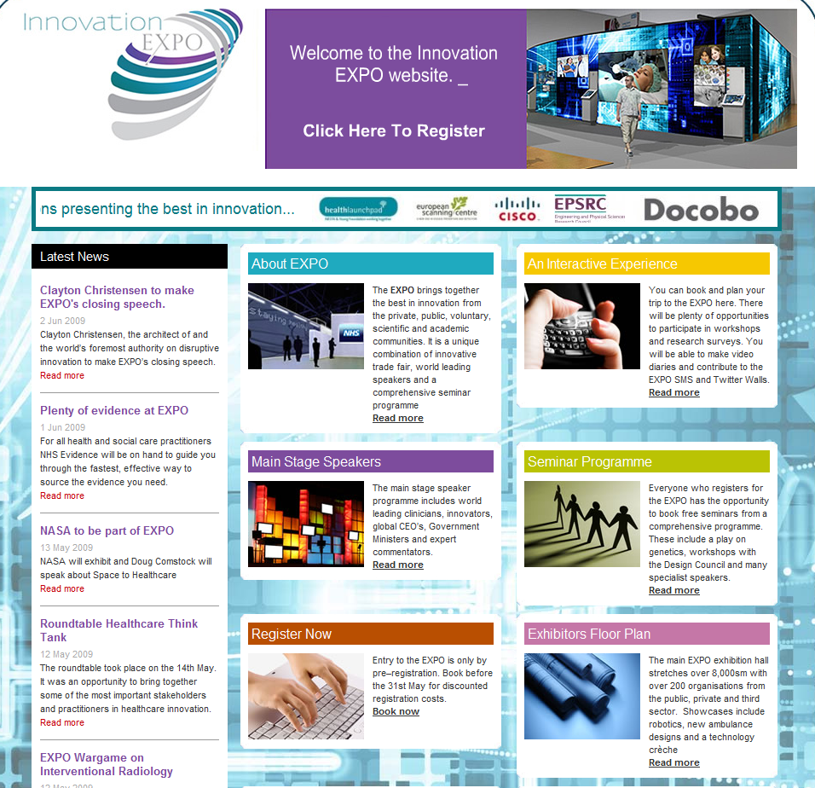

http://www.healthcareinnovationexpo.com/

There will be an NHS Innovation Expo at the Excel Centre in London on 18 and 19 June 2009. This will include a range of technology and innovation including telehealth. A number of exhibitors have been confirmed together with prominent speakers (see Expo web site for latest information including the Innovation House). There is a registration fee.

4 A new commercial operating model for the NHS and Department of Health

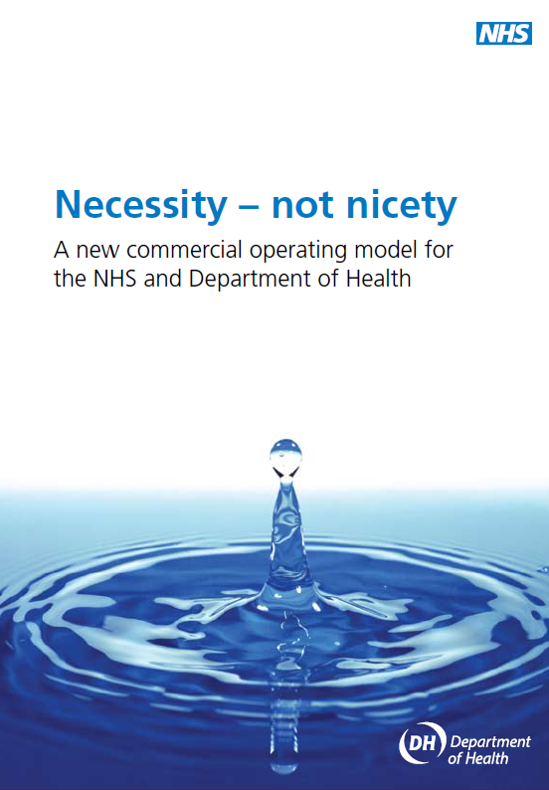

“The document sets out why commercial skills are now integral to the NHS at all levels. It describes a new operating model for commercial capability – the way commercial skills will be organised and applied at different levels across the NHS to have maximum impact.
The economic climate in which public services operate will require unprecedented levels of innovation, service responsiveness and efficiency in the future. For the NHS this means seizing the opportunity provided by reforms over recent years to realise greater value and quality for patients, the public and taxpayers alike”.

Of particular interest to readers will be the position on commercial support units (CSUs) and the NHS Purchasing and Supply Agency (NHS PASA).

Transferring the NHS Purchasing and Supply Agency’s (NHS PASA) functions to organisations that can add greater scope, scale and impact to the procurement of goods and services.

“The integration of key NHS PASA sourcing activities with OGC buying solutions (OGCbs), including the formation of an NHS-facing buying arm, will contribute to the Treasury’s requirements to aggregate public sector spending power. The move of some other NHS PASA functions to the CSUs will build regional capability. NHS PASA itself will be closed and efficiencies realised. Greater purchasing muscle will serve both providers and commissioners as they secure greater efficiencies in the provision of goods and services and drive better value through the Supply Chain”.

http://www.dh.gov.uk/en/Publicationsandstatistics/Publications/PublicationsPolicyAndGuidance/DH_098876

5 Telehealth mapping
Prepared by Mike Clark

An updated list of internet links covering PCTs in England and their involvement in telehealth is now available and appears as Appendix A to this newsletter. The links cover references to telehealth in local reports through to early results of pilot programmes. Over 100 PCTs are listed of which around half have pilots or programmes in place. The numbers per site are still relatively low apart from some early adopters who are working with more than 100 telehealth units.
If you are looking for telecare services then visit www.dhcarenetworks.org.uk/telecareservices or use the map link below.

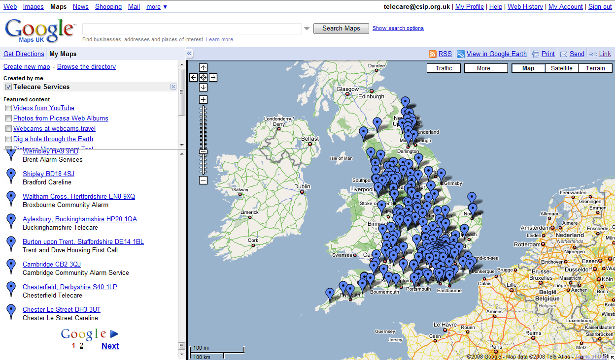

For web site links to telecare services in England go to:
http://maps.google.co.uk/maps/ms?hl=en&ie=UTF8&msa=0&msid=100406857045032193451.0004540c223f16f2d1c9d&z=6
Note: 200 service links are on Page 1 and a further 114 on Page 2 (Click ‘Next’ at the bottom of the list to see sites on the second page)

6 Prepare health systems for ageing EU told
Prepared by Mike Clark
European governments “grappling with the severe economic and financial crisis” need to prepare for the costs of an ageing population, the European Commission has warned.
In a communication dealing with the impact of an aging population in the EU, the Commission warns that if governments do not address work, pensions, health and social care issues they will face significant additional costs and even cause tensions between generations.
Countries that rely on informal care for the very elderly are likely to be particularly badly hit, as there are fewer working age people in the population and those that are available are pulled into work to maintain GDP and personal incomes.
“In order to limit the expected increase in public expenditure, policy measures which can either reduce disability, limit the need for formal care or improve the cost effectiveness of long term care provision – eg through the introduction of eHealth and telecare – must be developed,” it says.
http://www.ehealtheurope.net/news/4807/prepare_health_systems_for_ageing_eu_told

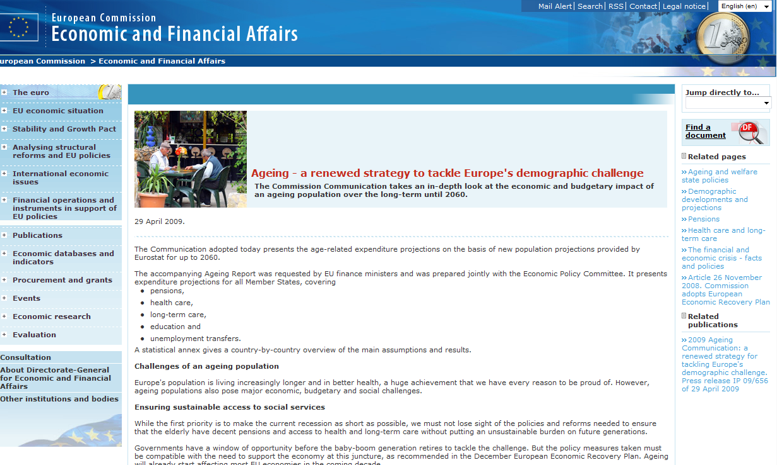

http://ec.europa.eu/economy_finance/thematic_articles/article14761_en.htm

7 Putting the Patient in Control – next stage in personal healthcare budgets announced
Patients are a step closer to getting more say over their healthcare services as plans for a national pilot project reach the next stage, the Department of Health has announced.
Following a call for expressions of interest for sites across England to take part in the first trials of personal health budgets, 68 projects, involving a total of 75 PCTs, have been awarded provisional pilot status.
Lord Darzi first announced personal health budgets in his report High Quality Care for All last year. Under the proposals, patients will have greater involvement in how money is spent on their healthcare needs, giving them more control over what services they use and who provides them so they will be delivered in a way that best suits them.
Link: http://nds.coi.gov.uk/content/detail.asp?NewsAreaID=2&ReleaseID=401129

8 Other Department of Health news

Change in measurement of HBA1C for people with diabetes
From 1 June 2009, HbA1c (long term blood glucose levels) in all people with diabetes will be measured in millimoles per mol as well as by percentage, the Department of Health said today.
Link:
http://nds.coi.gov.uk/environment/fullDetail.asp?ReleaseID=402333&NewsAreaID=2&NavigatedFromDepartment=False

2009 Heatwave Plan
Practical action to prepare for a potential heatwave is the central theme of the 2009 Heatwave Plan published by the Department of Health on 19 May 2009. The plan urges everyone to be aware of the health risks faced by elderly friends and relatives during a heatwave.
For the very young and older people or those with serious illnesses, heat can be dangerous. In particular, it can make heart and respiratory problems worse. In extreme cases, excess heat can lead to heat stroke, which can be fatal.
Links:
http://nds.coi.gov.uk/environment/fullDetail.asp?ReleaseID=401765&NewsAreaID=2&NavigatedFromDepartment=False

http://www.dh.gov.uk/en/News/Recentstories/DH_099578
http://www.dh.gov.uk/en/Publicationsandstatistics/Lettersandcirculars/Dearcolleagueletters/DH_099023

NHS Evidence
The NHS evidence web site referenced in the Darzi Report from 2008 is now operational.

Link: http://www.evidence.nhs.uk/

Vascular checks – briefing pack
This revised pack provides the ten strategic health authorities (SHAs) with an assessment of progress, opportunities and future challenges in key areas of vascular disease, namely coronary heart disease, stroke, diabetes and renal disease.
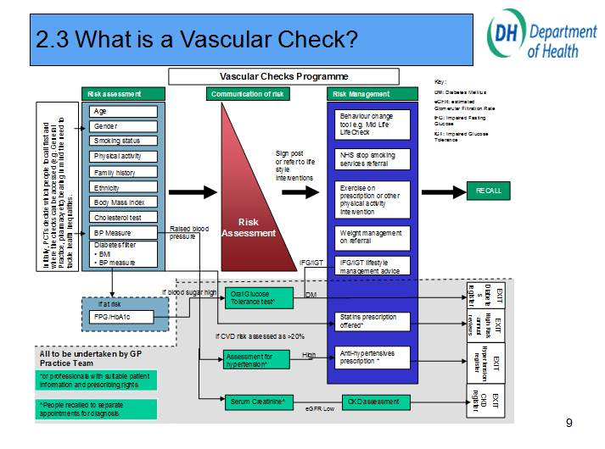

http://www.dh.gov.uk/en/Publicationsandstatistics/Publications/PublicationsPolicyAndGuidance/DH_098627

Creating an innovative culture
A new legal duty for strategic health authorities (SHAs) to promote innovation, which will act as an enabling tool for SHAs in driving innovation forward within local communities, commenced on 27th April. Best practice guidance - explaining the purpose of the duty, what it means for patients, public and staff, and where to seek further information - has also been issued.
http://www.dh.gov.uk/en/Publicationsandstatistics/Publications/PublicationsPolicyAndGuidance/DH_098540

NHS staff receive £1.5 million to help innovation in community services/over £200m announced to boost NHS Innovation
NHS staff have received awards totaling £1.5m to pursue projects that will work toward developing services in the community such as bi-lingual stroke rehabilitation programmes and diet and nutrition training, announced the Department of Health today.
A further £220 million fund has also been announced this week building on the Government's firm commitment to create an innovative health service.
England's ten Strategic Health Authorities (SHAs) will each receive £2 million this year and £5 million in each of the following four years. This will support frontline NHS staff and help ensure that great ideas get recognised, that funding is available and that the time it takes for solutions to get from design bench to NHS bedside is speeded up.
Examples include:
- Southwark PCT - Community Diabetes Project
- Redbridge PCT - Reconnect using Community Resources - Stroke rehabilitation using assistive technology through volunteers in communities using a language other than English
- Winchester & Eastleigh Healthcare Trust - Installing a telemedicine link between Andover Community Hospital & Winchester District General Hospital to reduce potentially avoidable ambulance journeys and hospital admissions
- Leicester County & Rutland Community Health Service - Provide a model of integrated streamlined care for patients with Long Term Conditions

Common Assessment Framework for Adults Demonstrator Site Programme: overview of Phase 1 sites
An overview of the activities within the nine demonstrators is now available.
The Demonstrator Site Programme will develop and test improved information sharing across health, social care and wider community support services. The sites have been chosen to lead the way forward in creating a more efficient and transparent system of information sharing, to avoid duplication in assessments and ensure that people receive the best quality care and support.
This document provides an overview for interested parties of what each site will be addressing and the organisations involved in the partnership. The sites are led by the local adult social services and involve a range of community and acute health services, mental health trusts, housing support services and IT suppliers as well as wider partners in the voluntary and private sector.

Link:

http://www.dh.gov.uk/en/Publicationsandstatistics/Publications/PublicationsPolicyAndGuidance/DH_099703

9 News

News from around the world covering telecare, telehealth and related areas of interest to commissioners, service providers, suppliers and other organisations – prepared by Mike Clark

Telecare

Ground breaking sensor scheme for elderly and vulnerable up for award (Lincs)

http://www.marketrasenmail.co.uk/news/Ground-breaking-sensor-scheme-for.5334269.jp
Domestic abuse alarm system in Angus using telecare services
http://news.stv.tv/scotland/100520-domestic-abuse-alarm-system-in-angus/
http://www.fifedirect.org.uk/news/index.cfm?fuseaction=news.display&objectid=8B95DD5D-F165-706C-5DF9A12A16E7037A

Fife trials device to help dementia sufferers
http://www.fifedirect.org.uk/news/index.cfm?fuseaction=news.display&objectid=8B95DD5D-F165-706C-5DF9A12A16E7037A
http://news.stv.tv/scotland/99856-fife-trials-device-to-help-dementia-sufferers/
Invicta Telecare throws a lifeline
An alarm unit, which automatically calls for help, proved to be a real lifeline when Jean stumbled and fell outside her home in Maidstone gashing her forehead and breaking her nose and arm.
http://www.24dash.com/news/Housing/2009-06-02-Invicta-Telecare-throws-a-lifeline

Information architecture of a telecare system
http://jtt.rsmjournals.com/cgi/content/abstract/15/4/161
Indicated benefits of bed epilepsy sensors to users of a telecare service in the Republic of Ireland
http://pavilionjournals.metapress.com/content/f88714136578xl53/

Could AT&T Prevent Falls Among the Elderly?
http://www.businessweek.com/innovate/next/archives/2009/05/how_att_could_p.html
Tameside telecare
http://www.manchestereveningnews.co.uk/news/s/1111995_spy_lifeline_for_pensioners_

South Tyneside - a community alarm service helping more than 4,600 South Tynesiders to live independently has come in for praise. South Tyneside Council has received accreditation for good practice from the Telecare Services Association.
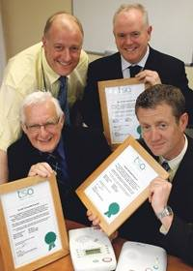
http://www.shieldsgazette.com/news/Alarm-scheme-helps-independent-living.5223683.jp

Widening the net – digital inclusion – reference to Sunderland telecare
http://www.lgcplus.com/news/news-from-the-councils/widening-the-net/5001796.article

Team's quick thinking in fire call earns praise

Operators at Doncaster-based Tunstall Response have been praised by fire chiefs for their quick thinking and cool heads when they dealt with an emergency house fire call.
Staffordshire Fire and Rescue Service Area Commander Alf Wilson visited the monitoring centre at Redhouse, Adwick-le-Street, to thank staff and present them with a certificate of commendation.
The Response centre monitors Careline telecare technology in thousands of UK homes, allowing people to call for help at any time.

http://www.thestar.co.uk/doncaster/Team39s-quick-thinking-in-fire.5283170.jp

Extra care in Burton - £10m project for the elderly includes telecare

Trent and Dove Housing and Staffordshire County Council are planning an Extra Care scheme in Anglesey Road, Burton.
Facilities are likely to include a restaurant, shop, hairdressing salon, and health facilities, as well as the scheme being wired up to high-tech computer and scanner systems for the latest in ‘Telecare’ provision, which can sense risks such as smoke, floods and gas, remind people to take pills and call for help if they fall.

http://www.burtonmail.co.uk/burtonmail-news/displayarticle.asp?id=416928

Telehealth
School-Centered Telemedicine for Children with Type 1 Diabetes Mellitus. The Journal of Pediatrics
http://www.jpeds.com/article/S0022-3476(09)00234-0/abstract

Report: Health IT central to chronic disease management
http://www.fiercehealthit.com/story/report-health-it-central-chronic-disease-management/2009-06-01?utm_medium=nl&utm_source=internal
http://www.healthdatamanagement.com/news/chronically_ill-28298-1.html

A randomized controlled trial of telephone–supported care coordination in patients with congestive heart failure
http://jtt.rsmjournals.com/cgi/content/abstract/15/4/182

Hi-tech clothes to help elderly
http://news.bbc.co.uk/1/hi/northern_ireland/8077240.stm
Office spirometry can improve the diagnosis of obstructive airway disease in primary care setting (telespirometry)
http://www.sciencedirect.com/science?_ob=ArticleURL&_udi=B6WWS-4VJBCHM-1&_user=10&_coverDate=06%2F30%2F2009&_rdoc=11&_fmt=high&_orig=browse&_srch=doc-info(%23toc%237138%232009%23998969993%231093066%23FLA%23display%23Volume)&_cdi=7138&_sort=d&_docanchor=&_ct=25&_acct=C000050221&_version=1&_urlVersion=0&_userid=10&md5=0018ab4abf27feaddfce36084cb8a253
Gadgets to the rescue - Technology can help manage chronic ailments at home
http://www.steubencourier.com/news/2009/0607/health/018.html

Hospitals in the USA Pay for Cutting Costly Readmissions
Top of Form
Millions of patients each year leave the hospital only to return within weeks or months for lack of proper follow-up care. One in five Medicare patients, for example, returns to the hospital within 30 days. Over all, readmissions cost the federal government an estimated $17 billion a year.
In one quoted example (Park Nicollet Hospital), the key to reducing readmissions is an early-warning system that signals when heart failure patients’ symptoms are starting to worsen. All the heart patients in the program weigh themselves daily at home and answer a few simple questions, like whether they are short of breath. They punch this information into their telephone keypads. If the data indicate a possible decline in a patient’s condition, the software system alerts a nurse, who follows up with the patient.
http://www.nytimes.com/2009/05/09/business/09relapse.html?pagewanted=2&_r=1&hp (Reg Reqd)

Reportlinker Adds High-Tech Patient Monitoring Systems Markets (Remote and Wireless Systems, Data Processing, EMR Data Transfer) – market research report
http://www.tmcnet.com/usubmit/2009/06/04/4211223.htm

IT Vital to Care Management – Report
http://www.healthdatamanagement.com/news/chronically_ill-28298-1.html

AT&T, other firms test 'telehealth' devices to help monitor patients from afar

http://www.dentonrc.com/sharedcontent/dws/bus/stories/DN-attmed_26bus.ART.State.Edition1.40d848e.html
Orange and Alcatel partner on e-health
http://www.ehealtheurope.net/news/4886/orange_and_alcatel_partner_on_e-health

Patients, Health Care Providers See Benefit of Online Physician Visits
http://www.ihealthbeat.org/Articles/2009/6/1/Patients-Health-Care-Providers-See-Benefit-of-Online-Physician-Visits.aspx

The doctor will see you now online - Why your next physician's visit may be just a click away
http://www.boston.com/news/health/articles/2009/06/01/why_your_next_trip_to_the_doctor_may_be_just_a_click_away/

Telemedicine
http://webconferencingcouncil.com/?p=637
Acute Illness Care Patterns Change With Use of Telemedicine http://pediatrics.aappublications.org/cgi/content/abstract/123/6/e989

States Tap Telemedicine Technology To Boost Access to Care
http://www.ihealthbeat.org/Articles/2009/5/27/States-Tap-Telemedicine-Technology-To-Boost-Access-to-Care.aspx

Fora Care Inc. to Launch Cost-Effective Solution for Diabetes Care
http://news.prnewswire.com/DisplayReleaseContent.aspx?ACCT=104&STORY=/www/story/06-04-2009/0005038398&EDATE=

New Telehealth Pilot Project to Evaluate Technology Solutions for U.S. Market

http://wireless.sys-con.com/node/988648
http://news.prnewswire.com/DisplayReleaseContent.aspx?ACCT=104&STORY=/www/story/06-03-2009/0005037842&EDATE=

Germany - 60 percent of the over-65s want to use telemedicine
http://www.pheonixhelp.com/?p=1358

LifeWatch and Verizon Wireless to Expand Healthcare Telemedicine Solutions
http://finance.yahoo.com/news/LifeWatch-and-Verizon-prnews-15432538.html?.v=1
Study finds virtual doctors visits satisfactory for both patients and clinicians
http://www.eurekalert.org/pub_releases/2009-05/mgh-sfv051409.php

FDA approves MedApps wireless remote monitoring – Healthpal
http://mobihealthnews.com/2564/fda-approves-medapps-wireless-remote-monitoring/
http://public.medapps.net/Pages/PR-MedApps-HealthPAL-FDA-Clearance.aspx

The doctor will see you now...online
http://www.wellness.com/newsfeed.asp?id=20090601/20090601Thedoctorwillseeyounowonline.xml&storyId=20225894

Individualized Treatment For Heart Failure Rarely Available Outside Hospital: New Telemonitoring Systems Could 'Radically' Change The Situation
http://www.sciencedaily.com/releases/2009/05/090530094508.htm

Tunstall RTX3371 Brings Wireless Health Monitoring To The US
http://www.gadgetreview.com/2009/04/tunstall-rtx3371-brings-wireless-health-monitoring-to-the-us.html
http://news.prnewswire.com/DisplayReleaseContent.aspx?ACCT=104&STORY=/www/story/04-30-2009/0005016407&EDATE=

Life:Wire Corp And TouchPointCare Enter Into A Strategic Agreement To Integrate And Co-Market Each Others’ Patient Management Solutions
http://insurancenewsnet.com/article.asp?a=featured_pr&id=105676
Bosch enters remote healthcare electronics market with Health Buddy
http://venturebeat.com/2009/04/28/bosch-enters-remote-healthcare-electronics-market-with-health-buddy/

A Blood Pressure Monitor to Wear on Your Wrist
http://health.usnews.com/articles/health/healthday/2009/04/16/a-blood-pressure-monitor-to-wear-on-your-wrist.html

Telehealth investment in Camden
http://www.allmediascotland.com/media_releases/4684/telehealth_investment_in_camden

Continuous Glucose Monitoring Technology: Promising New Tool For Maintaining Optimal Glucose Control
http://www.sciencedaily.com/releases/2009/05/090529112532.htm

Self-treatment results in lower overall health care costs for COPD sufferers
http://www.eurekalert.org/pub_releases/2009-05/ats-sri051209.php

School-based e-consultations can improve disease control and quality of life for children with diabetes, research suggests

http://www.healthcarerepublic.com/news/PracticeStaff/LatestNews/909408/Telemedicine-aids-diabetes-care/
Telemonitoring changes the working practice of cardiac nurses
http://www.medicalnewsbase.com/devices-technology-news/telemonitoring-changes-the-working-practice-of-cardiac-nurses/

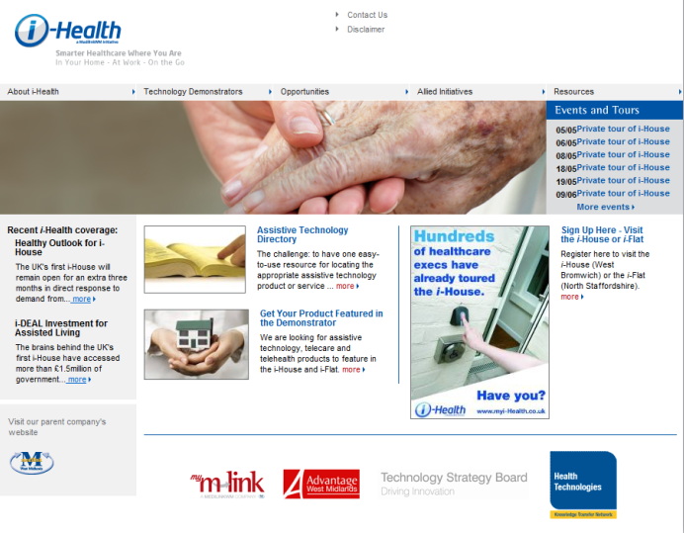

http://www.myi-health.co.uk/

IT to enhance healthcare across Europe
http://www.news-medical.net/?id=48869

ExpressMD(TM) Solutions' Remote Patient Health Monitoring Device Receives 510(K) Market Clearance Approval From FDA
http://news.prnewswire.com/DisplayReleaseContent.aspx?ACCT=104&STORY=/www/story/04-14-2009/0005005885&EDATE=
New Technology Helps Rural Hospital
http://www.nebraska.tv/Global/story.asp?S=10259243
GlobalMedia Launches Telemedicine Product for Ambulatory and Emergency Care
http://www.ehealthonline.org/news/news-details.asp?newsid=15947
VIDEO: Telemedicine Allows GPs to Treat Skin Conditions Without Referral to a Dermatologist
http://www.insidermedicine.ca/archives/VIDEO_Telemedicine_Allows_GPs_to_Treat_Skin_Conditions_Without_Referral_to_a_Dermatologist_3525.aspx
Continua Health Alliance Awarded for Innovation in Telemedicine http://www.businesswire.com/portal/site/google/?ndmViewId=news_view&newsId=20090428005414&newsLang=en
GE Launches 'Healthymagination'; Will Commit $6 Billion to Enable Better Health
http://www.fiercehealthcare.com/press-releases/ge-launches-healthymagination-will-commit-6-billion-enable-better-health?utm_medium=nl&utm_source=internal
Sweden & Finland Look to UK Telehealthcare Success to Shape Healthcare
http://www.publictechnology.net/modules.php?op=modload&name=News&file=article&sid=19869
Cambridge Consultants brings the ‘connected patient’ concept to life
http://www.cambridgenetwork.co.uk/news/article/default.aspx?objid=59056
http://www.mobile-tech-today.com/story.xhtml?story_id=66402&full_skip=1

Canada to launch e-health service using HealthVault
http://www.healthcareitnews.com/news/canada-launch-e-health-service-using-healthvault

Health Care’s Wireless Future: Vital Signs in Remote Real-time
http://singularityhub.com/2009/05/11/health-cares-wireless-future-vital-signs-in-remote-real-time/

A systematic review of the use of telehealth in Asian countries

http://jtt.rsmjournals.com/cgi/content/abstract/15/4/175
MedApps HealthPAL Connects to Microsoft HealthVault to Improve Patient Compliance and Lower Healthcare Costs
http://news.prnewswire.com/DisplayReleaseContent.aspx?ACCT=104&STORY=/www/story/05-12-2009/0005024102&EDATE=
A Review of the Evidence for the Use of Telemedicine Within Stroke Systems of Care. A Scientific Statement From the American Heart Association/American Stroke Association
http://www.mdlinx.com/NurseLinx/newsl-article.cfm/2707385/ZZ6821644550261362285079/?news_id=401&subspec_id=46
http://www.healthcareitnews.com/news/new-evidence-touts-benefits-telemedicine-stroke-patients
Hypertension Telemanagement in Black People
http://circoutcomes.ahajournals.org/cgi/content/abstract/2/3/272
The use of knowledge management in telemedicine and perceived effects on patient care activities
http://www.inderscience.com/offer.php?id=25829
Managing care with handheld technology
http://www.clinicaladvisor.com/Managing-care-with-handheld-technology/article/137243/

American Telemedicine Association (ATA) slideshow
http://mobihealthnews.com/1827/slideshow-images-from-ata-day-2/

Implementation of telehealth support for patients with type 2 diabetes using insulin treatment: an exploratory study

http://www.ingentaconnect.com/content/rmp/ipc/2009/00000017/00000001/art00007

Telehomecare project to improve delivery of services in Yukon

http://telehealthcanada.blogspot.com/2009/05/telehomecare-project-to-improve.html

Mobile health
Cardiac monitoring using a mobilephone
http://mobihealthnews.com/2535/lifewatch-posts-up-against-cardionet-with-verizon-deal/

Healthcare’s appeal and barriers for wireless operators
http://mobihealthnews.com/2516/healthcares-appeal-and-barriers-for-wireless-operators/

Six Mobile Innovations That Will Change Your Life
http://8posts.blogspot.com/2009/05/six-mobile-innovations-that-will-change.html

Designing mobiles for seniors: Lessons from Doro

http://mobihealthnews.com/2336/designing-mobiles-for-seniors-lessons-from-doro/

Get Healthier using your Mobile Phone
http://thesweetsmellofsuccess.wordpress.com/2009/06/01/get-smart-using-mobile-phone-for-wellness/

iPhone Medicine Blog

http://iphonemedicine.blogspot.com/

Implementation of telehealth support for patients with type 2 diabetes using insulin treatment: an exploratory study

http://www.ingentaconnect.com/content/rmp/ipc/2009/00000017/00000001/art00007

Telehomecare project to improve delivery of services in Yukon

http://telehealthcanada.blogspot.com/2009/05/telehomecare-project-to-improve.html
Healthcare via Cell Phones: A Systematic Review
http://www.liebertonline.com/doi/abs/10.1089/tmj.2008.0099

World Health Day: Mobile Technology Revolutionizes Healthcare Delivery In Developing World
http://www.huffingtonpost.com/2009/04/07/world-health-day-mobile-t_n_184149.html

Diabetes patients linked by BlackBerry
http://www.canada.com/Health/Diabetes+patients+linked+BlackBerry/1346708/story.html

Three ways to manage swine flu through mHealth
http://mobihealthnews.com/1767/three-ways-to-manage-swine-flu-through-mhealth/

MyGlucoHealth Uses Bluetooth Technology to Upload and Manage Blood Glucose Testing Using a Mobile Phone or PC
http://www.marketwatch.com/news/story/new-wireless-telehealth-solution-diabetics/story.aspx?guid=%7B86073D4F-64C0-4F2A-B581-5908B71A104D%7D&dist=msr_2

Mobile telehealth – some UK examples
http://3g4g.blogspot.com/2009/04/mobile-healthcare-more-on-telehealth.html

Cellphones help track patients on cardiac rehab – Australian Trial
About 200 patients and a series of medical mentors based in three Brisbane hospitals will be involved in the trial. Fewer than 20 per cent of patients treated for a heart attack complete the recommended six-week rehabilitation program.
The rsearchers are testing whether modern communications technology can be used as an assessment tool in home-based management of medical conditions.
The mobile phones include a built-in accelerator that measures physical activity such as the number of steps walked. The patients also use the phone to record data from blood pressure monitors and scales.
Participants are encouraged to take photos of meals they eat or videos of themselves exercising, and use an electronic diary on the phone to record observations about their stress levels, diet, smoking and alcohol intake.
The information is sent to a central computer where it can be viewed by a mentor, who assesses the patient's behaviour, provides feedback and sets new goals.
A small subset of the group is also testing home use of a heart-rate monitor while exercising. The data is transferred to the phone automatically via Bluetooth.
If successful, the approach could be used by patients who live in remote areas or have commitments that make hospital visits difficult.
http://www.cbc.ca/health/story/2009/05/04/cardiac-rehab-cellphone.html

Long term conditions
Tackling the heart failure inequality gap in Birmingham (video)
http://www.hsj.co.uk/5001857.article

Interim HealthCare’s “Living with Heart Failure at Home” Program Designed to Improve Patient Health, Reduce Hospital Readmissions
http://www.interimhealthcare.com/news/articles/090511-LivingWithHeartFailureProgram.aspx

Smart homes
By 2013: 39% of senior communities will be “smart homes”

http://mobihealthnews.com/2371/by-2013-39-of-senior-communities-will-be-smart-homes/
Video: UK i-house (Medilink West Midlands)
www.localgov.tv

Disease management

The Effects of a Disease Management Program on Self-Reported Health Behaviors and Health Outcomes: Evidence From the "Florida: A Healthy State (FAHS)" Medicaid Program
http://heb.sagepub.com/cgi/content/abstract/36/3/505

eHealth

KoolDocs.com, Leading Provider of Online Doctor Consultations, Launches New Website
http://www.prweb.com/releases/2009/06/prweb2485764.htm
Effects of Web– and Computer–Based Smoking Cessation Programs
http://archinte.ama-assn.org/cgi/content/abstract/169/10/929

An e–Health System for the Elderly (Butler Project): A Pilot Study on Acceptance and Satisfaction
http://www.liebertonline.com/doi/abs/10.1089/cpb.2008.0325

Designing and Testing a Web-Based Interface for Self-monitoring of Exercise and Symptoms for Older Adults With Chronic Obstructive Pulmonary Disease
http://journals.lww.com/cinjournal/Abstract/2009/05000/Designing_and_Testing_a_Web_Based_Interface_for.10.aspx

Impact of Mailed and Automated Telephone Reminders on Receipt of Repeat Mammograms: A Randomized Controlled Trial
http://www.sciencedirect.com/science?_ob=ArticleURL&_udi=B6VHT-4W207FJ-2&_user=10&_coverDate=06%2F30%2F2009&_rdoc=2&_fmt=high&_orig=browse&_srch=doc-info(%23toc%236075%232009%23999639993%231114069%23FLA%23display%23Volume)&_cdi=6075&_sort=d&_docanchor=&_ct=16&_acct=C000050221&_version=1&_urlVersion=0&_userid=10&md5=8c5814d1cf1738cc730d23ced7a2fe65

Socio-technical and organizational challenges to wider e-Health implementation
http://crd.sagepub.com/cgi/content/abstract/6/2/91

Bringing Health Care Online
http://physician-assistant.advanceweb.com/editorial/content/editorial.aspx?CC=151638

EU Project Empowers Elderly to Live Independently

Researchers in the EU-funded PERSONA (Perceptive spaces promoting independent aging) project are drawing on a range of advanced technologies to empower the elderly and support them in their efforts to maintain both their independence and a good quality of life.
Over EUR 6 million of the project's EUR 11.6 million budget comes from the 'Information Society Technologies' Thematic area of the Sixth Framework Programme (FP6). PERSONA began in 2007 and is scheduled to run until 2010.
The concept of Ambient Assisted Living (AAL) refers to the range of technologies and services, particularly those based on Information and Communication Technologies (ICTs), that can be used to help the elderly remain independent and maintain a good quality of life.
The technologies developed by PERSONA are set to undergo tests at three sites in Denmark, Spain and Italy.
http://www.ehealthnews.eu/content/view/1601/27/

Other
Study: Videos Help Prepare for End-of-Life Care
http://www.time.com/time/health/article/0,8599,1901734,00.html
The World’s Smallest Pocket Sized Ultrasound
http://trendsupdates.com/signos-the-worlds-smallest-pocket-sized-ultrasound/

Emergency Rooms Go Wireless (video)

http://gadgetmu.com/computer-gadget/emergency-rooms-go-wireless.html
It's People, Process and Technology - in That Order
http://www.ehealthserver.com/research-and-development/181-its-people-process-and-technology-in-that-order

ElderGames targets silver surfers

http://www.ehealtheurope.net/news/4876/eldergames_targets_silver_surfers

Vitality sensor for the Nintendo Wii

Nintendo have announced at the E3 Expo that they will be releasing a pulse oximetry attachment for the Wii. They are calling it the Wii Vitality Sensor and announced that the device will "initially sense the user's pulse and a number of other signals being transmitted by their bodies."



http://www.medgadget.com/archives/2009/06/wii_makes_pulse_oximetry_fun.html
http://www.businesswire.com/portal/site/home/permalink/?ndmViewId=news_view&newsId=20090602005750&newsLang=en

Use of Blackberry for community policing – secure access to records
Thames Valley Police have transformed the effectiveness of community policing with a Blackberry Smartphone solution allowing frontline workers instant access to key information whenever and wherever they are. Officers have cut travel time to and from the office by 30 minutes a day, freeing up time to spend in the community and deliver a better, more responsive service to citizens. http://www.localgov.tv/cgi-bin/details.pl?action=pre&id=598

Ideal Life Offers Bluetooth-Enabled 'Chair Scale'
http://www.tradingmarkets.com/.site/news/Stock%20News/2290537/
Pervasive Healthcare Computing
http://www.hc2d.co.uk/content.php?contentId=11062
Smart Toilets: Doctors in Your Bathroom
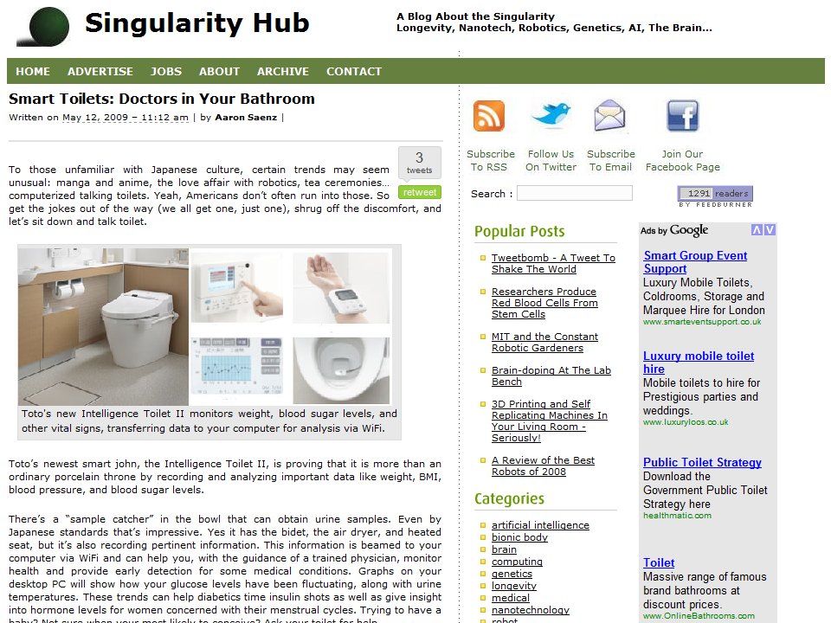

http://singularityhub.com/2009/05/12/smart-toilets-doctors-in-your-bathroom/

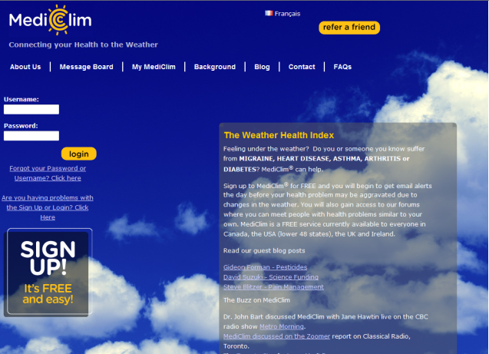

Connecting your health to the weather: http://www.mediclim.com/

Philips plans new health regime
http://www.ft.com/cms/s/0/605f078a-43c7-11de-a9be-00144feabdc0.html?nclick_check=1
Darzi quality indicators published
http://www.e-health-insider.com/news/4846/darzi_quality_indicators_published

New York City public hospitals credit IT for health boost
http://govhealthit.com/articles/2009/05/15/nyc-hospitals-health-it.aspx

House Bill (USA) Would Expand Medicare Funding for Telemedicine Services
A bipartisan group of lawmakers has introduced a bill designed to increase the availability of telemedicine service..The Medicare Telehealth Enhancement Act (HR 2068) would expand Medicare reimbursement to telemedicine facilities in urban and suburban areas.
About 80% of U.S. residents do not have access to telemedicine facilities because of restrictions that limit funding for such facilities to rural areas, according to the bill's author.
The bill also would allow doctors to monitor patients remotely and would provide $30 million in grant funding to help health care facilities purchase telehealth equipment and expand telemedicine support services.
http://www.ihealthbeat.org/Articles/2009/4/27/House-Bill-Would-Expand-Medicare-Funding-for-Telemedicine-Services.aspx
http://www.healthdatamanagement.com/news/telemedicine-28207-1.html

Self care
Does automation sacrifice patient empowerment?
http://mobihealthnews.com/2189/does-automation-sacrifice-patient-empowerment/

Events

2009 Baltic e-health conference announced

http://www.ehealtheurope.net/news/4885/2009_baltic_e-health_conference_announced

10 Events
Date | Event Title | Network | Places Remaining | Book
10/06/09 | South West Regional Housing LIN Annual Conference - 'Tools for Change' | Housing | 7 of 160 | Registration Closed
11/06/09 | Whole System Demonstrator Programme (WSDAN) - Integrated care using telecare and telehealth – Leeds | Telecare LIN | 3 of 120 | Book now
17/06/09 | Carers and personalisation - Birmingham | Personalisation | Reserve places available | Add me to the reserve list
18/06/09 to 19/06/09 | Transforming Community Equipment - Project Manager's Induction Course | Care Services Efficiency Delivery | - | N/A
23/06/09 | Resource Allocation System - Holiday Inn Camden Lock - London | Personalisation | 6 of 50 | Book now
25/06/09 | Carers and personalisation - Manchester | Personalisation | 10 of 120 | Book now
25/06/09 | North West Regional Housing LIN Meeting | Housing | 3 of 35 | Book now
26/06/09 | Lifetime Homes, Lifetime Neighbourhoods - Housing for an Ageing Society | Housing | - | N/A
30/06/09 | Carers and personalisation - London | Personalisation | FULL | FULL
30/06/09 | Eastern Regional Housing LIN Meeting | Housing | 26 of 35 | Book now
06/07/09 | East Midlands Regional Housing LIN Meeting | Housing | 22 of 45 | Book now
09/07/09 | Improving End of Life Care in Older People’s Housing - Is it that time already? | Housing | Reserve places available | Add me to the reserve list
09/07/09 | West Midlands Regional Housing LIN Meeting | Housing | 34 of 35 | Book now
06/08/09 to 07/08/09 | Transforming Community Equipment - Project Managers' Induction Course | Care Services Efficiency Delivery | - | N/A
22/09/09 | Resource Allocation System - Holiday Inn Camden Lock - London | Personalisation | 26 of 50 | Book now
22/10/09 | West Midlands Regional Housing LIN Meeting | Housing | 35 of 35 | Book now

Latest events as at 7 June 2009 http://www.dhcarenetworks.org.uk/events/s/.

WSDAN Events:
11 June 2009 – Leeds (see events planner)
10 September 2009 – Bristol (booking opens later in June 2009)

The Foundation for Assistive Technology (FAST) provides a full listing of forthcoming telecare events – see http://www.fastuk.org/services/events.php?pg=2. Suppliers also run telecare and telehealth events – check their web sites regularly for dates.

All previous telecare eNewsletters are available at: www.dhcarenetworks.org.uk/telecarenewsletters

Glossary:

ALIP – Assisted Living Innovation Platform
AT – Assistive Technology
BERR – Business Enterprise and Regulatory Reform
CSCI – Commission for Social Care Inspection
CQC – Care Quality Commission
DCLG – Department for Communities and Local Government
FACS – Fair Access to Care Services
IB- Individualised budgets
i4i – Invention for Innovation
LIN – Learning and Improvement Network
NHS CfH – NHS Connecting for Health
NHS PASA – NHS Purchasing and Supply Agency
POPP – Partnership for Older Peoples Projects
PT Grant or PTG – Preventative Technology Grant
SCIE – Social Care Institute for Excellence
TSA – Telecare Services Association
TSB – Technology Strategy Board
WSDAN – Whole System Demonstrator (Long Term Conditions) Action Network

Appendix – PCTs and Telehealth links
PCTs in England (n=152) with telehealth links on the internet.

PCT Area | Link
Ashton, Leigh and Wigan PCT | http://www.alwpct.nhs.uk/Publications/Other%20publications/Board/Operating%20Plan%20Final%2009.pdf
Barking and Dagenham PCT | http://www.supply2health.nhs.uk/5NA/Lists/Advertisements/DispForm.aspx?ID=1
Barking and Dagenham PCT | http://www.localgov.co.uk/view/docs/awards2008/partneringhealth/commends/Barking.pdf
Barking and Dagenham PCT | http://www.dhcarenetworks.org.uk/_library/Resources/Telecare/Telecare_Outcomes/Performance2008/Telecare_-_mainstreaming_and_outcomes_-_29_December_2008_Telehealth.doc
Barnet PCT
Barnsley PCT | http://www.barnsleyrd.nhs.uk/downloads/press%20release.pdf
Barnsley PCT | http://www.medicalnewstoday.com/articles/127498.php
Barnsley PCT | http://www.mtbeurope.info/news/2006/603025.htm
Barnsley PCT | http://www.youtube.com/watch?gl=GB&hl=en-GB&v=E2W6V6_xL6s
Barnsley PCT | http://www.connectingforhealth.nhs.uk/factsandfiction/patientcases/telehealth
Barnsley PCT | http://www.wsdactionnetwork.org.uk/news/wsdan_progress/the_telecare_and.html
Barnsley PCT | http://www.chmi.port.ac.uk/sihi/sihi2006/proceed/AdrianFlowerday.ppt
Barnsley PCT | http://www.nrr.nhs.uk/2007AnnualReports/Section2A.asp?O=715
Barnsley PCT | http://www.jitscotland.org.uk/downloads/1219664895-99-Telecare%20Factsheet%20-%20Telehealth.pdf
Barnsley PCT | http://www.ehiprimarycare.com/news/4654/telehealthcare_project_details_published
Barnsley PCT | http://www.laboratorymedicine.nhs.uk/labmedicine/Portals/0/PathITConference/MainProgramme/Pathology%20Summit_AndrewFlowerday.ppt
Barnsley PCT | http://www.dhcarenetworks.org.uk/_library/Resources/Telecare/Support_materials/Telecare_Supplement_March_2009.pdf
Barnsley PCT | http://www.youtube.com/watch?v=E2W6V6_xL6s
Bassetlaw PCT
Bath and North East Somerset PCT | http://www.dhcarenetworks.org.uk/_library/Resources/Telecare/Telecare_Outcomes/Performance2008/Telecare_-_mainstreaming_and_outcomes_-_29_December_2008_Telehealth.doc
Bedfordshire PCT | http://www.dhcarenetworks.org.uk/_library/Resources/Telecare/Telecare_Outcomes/Performance2008/Telecare_-_mainstreaming_and_outcomes_-_29_December_2008_Telehealth.doc
Berkshire East PCT | http://www.dhcarenetworks.org.uk/_library/Resources/Telecare/Telecare_Outcomes/Performance2008/Telecare_-_mainstreaming_and_outcomes_-_29_December_2008_Telehealth.doc
Berkshire West PCT | http://www.dhcarenetworks.org.uk/_library/Resources/Telecare/Telecare_Outcomes/Performance2008/Telecare_-_mainstreaming_and_outcomes_-_29_December_2008_Telehealth.doc
Bexley Care Trust
Birmingham East and North PCT | http://www.jitscotland.org.uk/downloads/1219664895-99-Telecare%20Factsheet%20-%20Telehealth.pdf
Birmingham East and North PCT | http://www.ehiprimarycare.com/news/4654/telehealthcare_project_details_published
Birmingham East and North PCT | http://www.wsdactionnetwork.org.uk/news/wsdan_progress/the_telecare_and.html
Birmingham East and North PCT | http://www.hiicsg.bcs.org/~careadmin/16_October_Telehealth_Seminar_Pfizer.ppt
Birmingham East and North PCT | http://www.ehiprimarycare.com/news/swindon_takes_telehealth_to_mainstream
Birmingham East and North PCT | http://www.medetel.lu/download/2008/parallel_sessions/presentation/day2/telehealth_support.pdf
Birmingham East and North PCT | http://www.blackpool.gov.uk/democracy/members/admin/files/a4034a9b-6843-481e-8486-c42bb5035d90/Leader%20of%20the%20Council%20Report.doc
Birmingham East and North PCT | http://www.ehealth.ed.ac.uk/presentations/jun2008/Matt%20Marshall%20(Tunstall)%20Implementing%20Telecare.ppt
Blackburn With Darwen PCT | http://www.dhcarenetworks.org.uk/_library/Resources/Telecare/Telecare_Outcomes/Performance2008/Telecare_-_mainstreaming_and_outcomes_-_29_December_2008_Telehealth.doc
Blackpool PCT | http://www.vitaline.org.uk/telehealth.htm
Blackpool PCT | http://www.blackpoolgazette.co.uk/daily-feature/Home-comforter.4955663.jp
Blackpool PCT | http://www.blackpool.nhs.uk/images/uploads/latest-publications/CSP_1.0_FINAL_.pdf
Blackpool PCT | http://www.ehealth.ed.ac.uk/presentations/jun2008/Matt%20Marshall%20(Tunstall)%20Implementing%20Telecare.ppt
Blackpool PCT | http://www.dhcarenetworks.org.uk/_library/Resources/Telecare/Telecare_Outcomes/Performance2008/Telecare_-_mainstreaming_and_outcomes_-_29_December_2008_Telehealth.doc
Bolton PCT | http://democracy.bolton.gov.uk/CMISWebPublic/Binary.ashx?Document=3617
Bolton PCT | http://www.ontargetmag.com/article.aspx?issueID=117&articleID=846
Bolton PCT | http://democracy.bolton.gov.uk/CMISWebPublic/Binary.ashx?Document=5749
Bolton PCT | http://www.dhcarenetworks.org.uk/_library/Resources/Telecare/Telecare_Outcomes/Performance2008/Telecare_-_mainstreaming_and_outcomes_-_29_December_2008_Telehealth.doc
Bournemouth and Poole Teaching PCT | http://www.dhcarenetworks.org.uk/_library/Resources/Telecare/Telecare_Outcomes/Performance2008/Telecare_-_mainstreaming_and_outcomes_-_29_December_2008_Telehealth.doc
Bradford and Airedale Teaching PCT | http://www.jitscotland.org.uk/downloads/1219664895-99-Telecare%20Factsheet%20-%20Telehealth.pdf
Bradford and Airedale Teaching PCT | http://www.teis.port.ac.uk/jsp/search/activity.jsp;jsessionid=05238AEDF0E0661C3148C6C9DDEB8F67?project=1386
Bradford and Airedale Teaching PCT | http://www.dhcarenetworks.org.uk/_library/Resources/Telecare/Telecare_Outcomes/Performance2008/Telecare_-_mainstreaming_and_outcomes_-_29_December_2008_Telehealth.doc
Brent Teaching PCT | http://www.chmi.port.ac.uk/sihi/sihi2006/proceed/AdrianFlowerday.ppt
Brighton and Hove City PCT | http://www.southdowns.nhs.uk/downloads/sdhWeb/patients_and_carers/Telehealth_Newsletter_SDHT_CRDS_01.2009_v1.pdf
Brighton and Hove City PCT | http://www.dhcarenetworks.org.uk/_library/Resources/Telecare/Telecare_Outcomes/Performance2008/Telecare_-_mainstreaming_and_outcomes_-_29_December_2008_Telehealth.doc
Bristol PCT
Bromley PCT
Buckinghamshire PCT
Bury PCT | http://www.tunstall.co.uk/assets/literature/Bury%20case%20study.pdf
Bury PCT | http://www.dhcarenetworks.org.uk/_library/Resources/Telecare/Telecare_Outcomes/Performance2008/Telecare_-_mainstreaming_and_outcomes_-_29_December_2008_Telehealth.doc
Calderdale PCT | http://www.slideshare.net/3GDR/engineering-better-health
Calderdale PCT | http://www.dhcarenetworks.org.uk/_library/Resources/Telecare/Telecare_Outcomes/Performance2008/Telecare_-_mainstreaming_and_outcomes_-_29_December_2008_Telehealth.doc
Cambridgeshire PCT | http://www.dhcarenetworks.org.uk/_library/Resources/Telecare/Telecare_Outcomes/Performance2008/Telecare_-_mainstreaming_and_outcomes_-_29_December_2008_Telehealth.doc
Camden PCT | http://www.allmediascotland.com/allnewswire/4684/Telehealth_Investment_in_Camden
Camden PCT | http://www.ehealth.ed.ac.uk/presentations/jun2008/Matt%20Marshall%20(Tunstall)%20Implementing%20Telecare.ppt
Camden PCT | http://www.dhcarenetworks.org.uk/_library/Resources/Telecare/Telecare_Outcomes/Performance2008/Telecare_-_mainstreaming_and_outcomes_-_29_December_2008_Telehealth.doc
Central and Eastern Cheshire PCT | http://www.ehiprimarycare.com/news/item.cfm?ID=2152
Central and Eastern Cheshire PCT | http://www.dhcarenetworks.org.uk/_library/Resources/Telecare/Telecare_Outcomes/Performance2008/Telecare_-_mainstreaming_and_outcomes_-_29_December_2008_Telehealth.doc
Central and Eastern Cheshire PCT | http://www.ehealth.ed.ac.uk/presentations/jun2008/Matt%20Marshall%20(Tunstall)%20Implementing%20Telecare.ppt
Central Lancashire PCT | http://www.ehiprimarycare.com/news/4654/telehealthcare_project_details_published
Central Lancashire PCT | http://www.wsdactionnetwork.org.uk/news/wsdan_progress/the_telecare_and.html
Central Lancashire PCT | http://www.dhcarenetworks.org.uk/_library/Resources/Telecare/Telecare_Outcomes/Performance2008/Telecare_-_mainstreaming_and_outcomes_-_29_December_2008_Telehealth.doc
Central Lancashire PCT | http://www.lancashire.gov.uk/corporate/news/press_releases/y/m/release.asp?id=200807&r=PR08/0462
City and Hackney Teaching PCT | http://www.chooseindependence.org/forum/news.asp
City and Hackney Teaching PCT | http://www.chubbcommunitycare.co.uk/case-studies/telecare-in-hackney/
City and Hackney Teaching PCT | http://www.laboratorymedicine.nhs.uk/labmedicine/Portals/0/PathITConference/MainProgramme/Pathology%20Summit_AndrewFlowerday.ppt
City and Hackney Teaching PCT | http://www.dhcarenetworks.org.uk/_library/Resources/Telecare/Support_materials/Telecare_Supplement_March_2009.pdf
City and Hackney Teaching PCT | http://www.youtube.com/watch?v=KRVfVAWg5Bg
City and Hackney Teaching PCT | http://www.dhcarenetworks.org.uk/_library/Resources/Telecare/Telecare_Outcomes/Performance2008/Telecare_-_mainstreaming_and_outcomes_-_29_December_2008_Telehealth.doc
Cornwall and Isles Of Scilly PCT | http://www.jitscotland.org.uk/downloads/1219664895-99-Telecare%20Factsheet%20-%20Telehealth.pdf
Cornwall and Isles Of Scilly PCT | http://www.hsj.co.uk/telehealth-takes-off/93656.article
Cornwall and Isles Of Scilly PCT | http://www.openpr.com/news/44478/Cornish-patients-to-lead-way-in-UK-s-largest-Telehealth-trial.html
Cornwall and Isles Of Scilly PCT | http://www.openpr.com/pdf/44478/Cornish-patients-to-lead-way-in-UK-s-largest-Telehealth-trial.pdf
Cornwall and Isles Of Scilly PCT | http://www.cornwallandislesofscilly.nhs.uk/CornwallAndIslesOfScillyPCT/PatientAndVisitors/Initiatives/WholeSystemDemonstratorPilot/HowItWorks.aspx
Cornwall and Isles Of Scilly PCT | http://www.tunstall.co.uk/assets/literature/Telehealth%20Event%20Flyer%20-%20Wales.pdf
Cornwall and Isles Of Scilly PCT | http://www.e-health-insider.com/comment_and_analysis/278/2008:_the_year_telecare_grows_up_tcq
Cornwall and Isles Of Scilly PCT | http://www.publications.parliament.uk/pa/cm200708/cmhansrd/cm080507/text/80507w0029.htm
Cornwall and Isles Of Scilly PCT | http://www.dhcarenetworks.org.uk/_library/Resources/Telecare/Telecare_Outcomes/Performance2008/Telecare_-_mainstreaming_and_outcomes_-_29_December_2008_Telehealth.doc
Cornwall and Isles Of Scilly PCT | http://hubola.kingsfund.org.uk/document.rm?id=8255
Cornwall and Isles Of Scilly PCT | http://hubola.kingsfund.org.uk/document.rm?id=8265
County Durham PCT | http://www.dhcarenetworks.org.uk/_library/Resources/Telecare/Telecare_Outcomes/Performance2008/Telecare_-_mainstreaming_and_outcomes_-_29_December_2008_Telehealth.doc
Coventry Teaching PCT
Croydon PCT
Cumbria Teaching PCT | http://www.alstonhealthcare.co.uk/Resource/CMS/Assets/1eec3c0c-7d2c-102b-81f8-003005bbceb4/alston%20healthcare%20newsletter%20sept%2008%20v2.pdf
Cumbria Teaching PCT | http://www.ict-ageing.eu/?page_id=427
Cumbria Teaching PCT | http://www.ehealth.ed.ac.uk/presentations/jun2008/Matt%20Marshall%20(Tunstall)%20Implementing%20Telecare.ppt
Darlington PCT | http://www.darlington.gov.uk/PublicMinutes/Health%20and%20Well%20Being%20Scrutiny%20Committee/January%2020%202009/Item%208.pdf
Darlington PCT | http://www.darlingtonpct.nhs.uk/newsStory.asp?newsId=571
Darlington PCT | http://www.dhcarenetworks.org.uk/_library/Resources/Telecare/Telecare_Outcomes/Performance2008/Telecare_-_mainstreaming_and_outcomes_-_29_December_2008_Telehealth.doc
Derby City PCT
Derbyshire County PCT | http://www.housingexcellence.co.uk/features/keeping-telecare-line
Devon PCT | http://www.devonsp.org.uk/sustainablecommunitystrategy/outcomes/draftlaapriorities/laa10-telecare.doc
Devon PCT | http://www.dhcarenetworks.org.uk/_library/Resources/Telecare/Telecare_Outcomes/Performance2008/Telecare_-_mainstreaming_and_outcomes_-_29_December_2008_Telehealth.doc
Devon PCT | http://www.devon.gov.uk/es/doc-tunnel-4.pdf?url=/dcc/committee/reports/acs0822.pdf
Doncaster PCT | http://www.rcplondon.ac.uk/clinical-standards/ceeu/Current-work/ncrop/Documents/Report-of-the-National-COPD-Audit-2008-UK-Primary-Care-Organisations-Resources-and-Organisation-of-Care.pdf
Doncaster PCT | http://www.doncasterpct.nhs.uk/documents/DoncasterPCTCompetencysummarybullets.doc
Doncaster PCT | http://www.ehealth.ed.ac.uk/presentations/jun2008/Matt%20Marshall%20(Tunstall)%20Implementing%20Telecare.ppt
Dorset PCT
Dudley PCT | http://www.dhcarenetworks.org.uk/_library/Resources/Telecare/Telecare_Outcomes/Performance2008/Telecare_-_mainstreaming_and_outcomes_-_29_December_2008_Telehealth.doc
Ealing PCT
East and North Hertfordshire PCT | http://www.telecareaware.com/index.php/chorleywood-video.html
East Lancashire Teaching PCT | http://www.institute.nhs.uk/index.php?option=com_mtree&task=viewlink&link_id=4187&Itemid=1876
East Lancashire Teaching PCT | http://www.dhcarenetworks.org.uk/_library/Resources/Telecare/Telecare_Outcomes/Performance2008/Telecare_-_mainstreaming_and_outcomes_-_29_December_2008_Telehealth.doc
East Riding Of Yorkshire PCT | http://www.wsdactionnetwork.org.uk/news/wsdan_progress/the_telecare_and.html
East Riding Of Yorkshire PCT | http://www.ehealth.ed.ac.uk/presentations/jun2008/Matt%20Marshall%20(Tunstall)%20Implementing%20Telecare.ppt
East Riding Of Yorkshire PCT | http://www.institute.nhs.uk/index.php?option=com_mtree&task=viewlink&link_id=4383&Itemid=3295
East Riding Of Yorkshire PCT | http://www.dhcarenetworks.org.uk/_library/Resources/Telecare/Telecare_Outcomes/Performance2008/Telecare_-_mainstreaming_and_outcomes_-_29_December_2008_Telehealth.doc
East Sussex Downs and Weald PCT | http://www.institute.nhs.uk/index.php?option=com_mtree&task=viewlink&link_id=4383&Itemid=3295
East Sussex Downs and Weald PCT | http://www.dhcarenetworks.org.uk/_library/Resources/Telecare/Telecare_Outcomes/Performance2008/Telecare_-_mainstreaming_and_outcomes_-_29_December_2008_Telehealth.doc
East Sussex Downs and Weald PCT | http://www.eastsussexdownswealdpct.nhs.uk/about-us/news/press-releases/2008-press-releases/telehealth/
Eastern and Coastal Kent PCT | http://www.connectingforhealth.nhs.uk/factsandfiction/patientcases/telehealth
Eastern and Coastal Kent PCT | http://www.kent.gov.uk/SocialCare/health-and-wellbeing/telehealth/kent-telehealth-pilot.htm
Eastern and Coastal Kent PCT | http://www.jitscotland.org.uk/downloads/1219664895-99-Telecare%20Factsheet%20-%20Telehealth.pdf
Eastern and Coastal Kent PCT | http://www.kent.gov.uk/SocialCare/health-and-wellbeing/telehealth/
Eastern and Coastal Kent PCT | http://www.hsj.co.uk/telehealth-takes-off/93656.article
Eastern and Coastal Kent PCT | http://www.viterion.com/web_docs/TelehealthInKent.pdf
Eastern and Coastal Kent PCT | http://chain.ulcc.ac.uk/chain/event/telehealth/presentation_Rye.ppt
Eastern and Coastal Kent PCT | http://www.e-health-insider.com/comment_and_analysis/278/2008:_the_year_telecare_grows_up_tcq
Eastern and Coastal Kent PCT | http://www.kenttv.com/programmes.php?CID=27&SCID=63&PID=111&Title=The+Kent+Telehealth+Project
Eastern and Coastal Kent PCT | http://www.networks.nhs.uk/uploaddb/kentcountycounciltelehealthandtelecare.doc
Eastern and Coastal Kent PCT | http://www.medetel.lu/download/2007/parallel_sessions/presentation/0419/Delivering_Telehealth_in_Kent.pdf
Eastern and Coastal Kent PCT | http://news.bbc.co.uk/1/hi/england/kent/4322041.stm
Eastern and Coastal Kent PCT | http://www.kent.ac.uk/news/stories/telehealthtopstheagendaatuniversityofkentconference/2008
Eastern and Coastal Kent PCT | http://www.idea.gov.uk/idk/core/page.do?pageId=7328980
Eastern and Coastal Kent PCT | http://www.telecare.org.uk/files/47413/FileName/kentdemonstrator.ppt
Eastern and Coastal Kent PCT | http://www.egovmonitor.com/node/264
Eastern and Coastal Kent PCT | http://www.lgcplus.com/news/innovation-action/911605.article
Eastern and Coastal Kent PCT | http://www.dh.gov.uk/en/Publicationsandstatistics/Publications/PublicationsPolicyAndGuidance/Browsable/DH_5753946
Eastern and Coastal Kent PCT | http://www.worldhealthcareblog.org/2007/09/07/tele-medicine-tele-monitoring-and-tele-health/
Eastern and Coastal Kent PCT | http://212.58.226.17:8080/1/low/england/kent/4322041.stm
Eastern and Coastal Kent PCT | http://www.publications.parliament.uk/pa/cm200708/cmhansrd/cm080507/text/80507w0029.htm
Eastern and Coastal Kent PCT | http://www.thiis.co.uk/news-snippets-telecare-kent.aspx
Eastern and Coastal Kent PCT | http://www.improvementnetwork.gov.uk/imp/core/page.do?pageId=1068557
Eastern and Coastal Kent PCT | http://www.dhcarenetworks.org.uk/_library/Resources/Telecare/Telecare_Outcomes/Performance2008/Telecare_-_mainstreaming_and_outcomes_-_29_December_2008_Telehealth.doc
Eastern and Coastal Kent PCT | http://hubola.kingsfund.org.uk/document.rm?id=8265
Eastern and Coastal Kent PCT | http://hubola.kingsfund.org.uk/document.rm?id=8255
Enfield PCT
Gateshead PCT | http://www.dhcarenetworks.org.uk/_library/Resources/Telecare/Telecare_Outcomes/Performance2008/Telecare_-_mainstreaming_and_outcomes_-_29_December_2008_Telehealth.doc
Gloucestershire PCT | http://www.rcplondon.ac.uk/clinical-standards/ceeu/Current-work/ncrop/Documents/Report-of-the-National-COPD-Audit-2008-UK-Primary-Care-Organisations-Resources-and-Organisation-of-Care.pdf
Gloucestershire PCT | http://www.dhcarenetworks.org.uk/_library/Resources/Telecare/Telecare_Outcomes/Performance2008/Telecare_-_mainstreaming_and_outcomes_-_29_December_2008_Telehealth.doc
Gloucestershire PCT | http://www.ehealth.ed.ac.uk/presentations/jun2008/Matt%20Marshall%20(Tunstall)%20Implementing%20Telecare.ppt
Great Yarmouth and Waveney PCT | http://www.norfolk.gov.uk/consumption/idcplg?IdcService=SS_GET_PAGE&ssDocName=NCC059633&ssSourceNodeId=&ssTargetNodeId=3870
Great Yarmouth and Waveney PCT | http://www.norfolk.gov.uk/consumption/idcplg?IdcService=SS_GET_PAGE&ssDocName=NCC057478&ssSourceNodeId=&ssTargetNodeId=3572
Greenwich Teaching PCT | http://www.ehealth.ed.ac.uk/presentations/jun2008/Matt%20Marshall%20(Tunstall)%20Implementing%20Telecare.ppt
Greenwich Teaching PCT | http://www.dhcarenetworks.org.uk/_library/Resources/Telecare/Telecare_Outcomes/Performance2008/Telecare_-_mainstreaming_and_outcomes_-_29_December_2008_Telehealth.doc
Halton and St Helens PCT | http://www.dhcarenetworks.org.uk/_library/Resources/Telecare/Telecare_Outcomes/Performance2008/Telecare_-_mainstreaming_and_outcomes_-_29_December_2008_Telehealth.doc
Hammersmith and Fulham PCT | http://www.iplato.net/news-appointment-reminders-and-mobile-health-promotion/press-releases/2007-press-releases/iplato-text-messaging-to-cover-165000-patients-in-hammersmith-fulham.html
Hammersmith and Fulham PCT | http://www.ehiprimarycare.com/News/2867/iplato_deploy_sms_to_hammersmith_and_fulham_pct
Hammersmith and Fulham PCT | http://www.publictechnology.net/modules.php?op=modload&name=News&file=article&sid=10421
Hampshire PCT
Haringey Teaching PCT | http://www.rcplondon.ac.uk/clinical-standards/ceeu/Current-work/ncrop/Documents/Report-of-the-National-COPD-Audit-2008-UK-Primary-Care-Organisations-Resources-and-Organisation-of-Care.pdf
Haringey Teaching PCT | http://www.dhcarenetworks.org.uk/_library/Resources/Telecare/Telecare_Outcomes/Performance2008/Telecare_-_mainstreaming_and_outcomes_-_29_December_2008_Telehealth.doc
Harrow PCT
Hartlepool PCT | http://www.dhcarenetworks.org.uk/_library/Resources/Telecare/Telecare_Outcomes/Performance2008/Telecare_-_mainstreaming_and_outcomes_-_29_December_2008_Telehealth.doc
Hastings and Rother PCT
Havering PCT | http://www.supply2health.nhs.uk/5NA/Lists/Advertisements/DispForm.aspx?ID=1
Havering PCT | http://www.haveringpct.nhs.uk/ngen_public/default.asp?id=114
Havering PCT | http://www.haveringpct.nhs.uk/docimages/205.pdf
Heart Of Birmingham Teaching PCT
Herefordshire PCT
Heywood, Middleton and Rochdale PCT | http://www.dhcarenetworks.org.uk/_library/Resources/Telecare/Telecare_Outcomes/Performance2008/Telecare_-_mainstreaming_and_outcomes_-_29_December_2008_Telehealth.doc
Hillingdon PCT
Hounslow PCT | http://www.hounslowpct.nhs.uk/documents/E2DraftOlderPeopleCommissioningStrategy20072010.pdf
Hounslow PCT | http://ec.europa.eu/information_society/events/telehealth_2007/docs/telehealh2007flowerday.pdf
Hounslow PCT | http://www.laboratorymedicine.nhs.uk/labmedicine/Portals/0/PathITConference/MainProgramme/Pathology%20Summit_AndrewFlowerday.ppt
Hull Teaching PCT | http://www.chmi.port.ac.uk/sihi/sihi2006/proceed/AdrianFlowerday.ppt
Hull Teaching PCT | http://www.wsdactionnetwork.org.uk/news/wsdan_progress/the_telecare_and.html
Hull Teaching PCT | http://www.tunstall.co.uk/assets/literature/Telecare%20Times%20issue%2028.pdf
Hull Teaching PCT | http://www.laboratorymedicine.nhs.uk/labmedicine/Portals/0/PathITConference/MainProgramme/Pathology%20Summit_AndrewFlowerday.ppt
Hull Teaching PCT | http://ec.europa.eu/information_society/events/telehealth_2007/docs/telehealh2007flowerday.pdf
Hull Teaching PCT | http://www.broadbandcapital.co.uk/index.php?option=com_content&task=view&id=31&Itemid=51
Hull Teaching PCT | https://web5.hullcc.gov.uk/akshull/images/att3203.doc
Hull Teaching PCT | http://www.ehiprimarycare.com/news/walsall_and_hull_begin_mass_telehealth_deployment
Hull Teaching PCT | http://www.prlog.org/10040888-walsall-and-hull-launch-mainstream-deployments-of-telehealth-for-copd-and-congestive-heart-failure.html
Hull Teaching PCT | http://www.connectyorkshire.org/news/general/305632
Hull Teaching PCT | http://www.hchfh.org.uk/index.php?option=com_content&task=view&id=15&Itemid=30
Hull Teaching PCT | http://www.bjhcim.co.uk/features/2008/811003.htm
Hull Teaching PCT | http://www.hoise.com/vmw/08/articles/vmw/LV-VM-01-08-15.html
Hull Teaching PCT | http://www.ehealth.ed.ac.uk/presentations/jun2008/Matt%20Marshall%20(Tunstall)%20Implementing%20Telecare.ppt
Hull Teaching PCT | http://www.reuters.com/article/pressRelease/idUS113647+06-Dec-2007+BW20071206
Hull Teaching PCT | http://www.dhcarenetworks.org.uk/_library/Resources/Telecare/Support_materials/Telecare_Supplement_March_2009.pdf
Hull Teaching PCT | http://www.youtube.com/watch?v=eCJ0tCCraOQ
Hull Teaching PCT | http://www.dhcarenetworks.org.uk/_library/Resources/Telecare/Telecare_Outcomes/Performance2008/Telecare_-_mainstreaming_and_outcomes_-_29_December_2008_Telehealth.doc
Isle Of Wight NHS PCT
Islington PCT
Kensington and Chelsea PCT | http://www.dhcarenetworks.org.uk/_library/Resources/Telecare/Telecare_Outcomes/Performance2008/Telecare_-_mainstreaming_and_outcomes_-_29_December_2008_Telehealth.doc
Kingston PCT
Kirklees PCT | http://www.digitv.gov.uk/site/content/view/124/60/
Kirklees PCT | http://www.digitv.gov.uk/wiki/download/attachments/8552494/DigiTV+Telehealth-Telecare+projects.pptx
Kirklees PCT | http://www.kirklees.nhs.uk/fileadmin/documents/meetings/march09/KPCT-09-62%20Minutes%20of%20the%20Goverance%20Committee%20held%2027.01.09%20_Final_.pdf
Kirklees PCT | http://www.ehiprimarycare.com/News/4162/new_government_funding_for_telecare
Kirklees PCT | http://www.dhcarenetworks.org.uk/_library/Resources/Telecare/Telecare_Outcomes/Performance2008/Telecare_-_mainstreaming_and_outcomes_-_29_December_2008_Telehealth.doc
Knowsley PCT | http://wikid.wikispaces.com/file/view/Carole+Bayliss.ppt
Knowsley PCT | http://www.knowsley.gov.uk/pdf/Accommodation_support_strategy.pdf
Knowsley PCT | http://www.ehealth.ed.ac.uk/presentations/jun2008/Matt%20Marshall%20(Tunstall)%20Implementing%20Telecare.ppt
Knowsley PCT | http://www.dhcarenetworks.org.uk/_library/Resources/Telecare/Telecare_Outcomes/Performance2008/Telecare_-_mainstreaming_and_outcomes_-_29_December_2008_Telehealth.doc
Lambeth PCT | http://www.dhcarenetworks.org.uk/_library/Resources/Telecare/Telecare_Outcomes/Performance2008/Telecare_-_mainstreaming_and_outcomes_-_29_December_2008_Telehealth.doc
Leeds PCT | http://www.wsdactionnetwork.org.uk/news/wsdan_progress/the_telecare_and.html
Leeds PCT | http://www.tunstall.co.uk/assets/literature/Leeds%20case%20study.pdf
Leeds PCT | http://www.ehealth.ed.ac.uk/presentations/jun2008/Matt%20Marshall%20(Tunstall)%20Implementing%20Telecare.ppt
Leeds PCT | http://www.dhcarenetworks.org.uk/_library/Resources/Telecare/Support_materials/Telecare_Supplement_March_2009.pdf
Leicester City PCT | http://www.slideshare.net/3GDR/engineering-better-health
Leicestershire County and Rutland PCT | http://www.dhcarenetworks.org.uk/_library/Resources/Telecare/Telecare_Outcomes/Performance2008/Telecare_-_mainstreaming_and_outcomes_-_29_December_2008_Telehealth.doc
Lewisham PCT
Lincolnshire Teaching PCT | http://www.wsdactionnetwork.org.uk/news/wsdan_progress/the_telecare_and.html
Lincolnshire Teaching PCT | http://www.dhcarenetworks.org.uk/_library/Resources/Telecare/Telecare_Outcomes/Performance2008/Telecare_-_mainstreaming_and_outcomes_-_29_December_2008_Telehealth.doc
Liverpool PCT | http://vip.doc.ic.ac.uk/saphe/public/SAPHE_28_May_09_Flyer.pdf
Luton PCT
Manchester PCT
Medway PCT | http://www.medwaypct.nhs.uk/Our_services/Telehealth_service/index.html
Medway PCT | http://www.medwaypct.nhs.uk/NetsiteCMS/pageid/140/rec/more/offset/60/releaseid/64/Press/Press.html
Medway PCT | http://www.tunstall.co.uk/assets/literature/Telehealthcare%20Medway%20PCT.pdf
Medway PCT | http://www.publictechnology.net/modules.php?op=modload&name=News&file=article&sid=4667
Medway PCT | http://jtt.rsmjournals.com/cgi/content/abstract/13/suppl_3/86
Medway PCT | http://www.ehealth.ed.ac.uk/presentations/jun2008/Matt%20Marshall%20(Tunstall)%20Implementing%20Telecare.ppt
Medway PCT | http://www.dhcarenetworks.org.uk/_library/Resources/Telecare/Support_materials/Telecare_Supplement_March_2009.pdf
Medway PCT | http://www.tunstall.co.uk/assets/Literature/Telehealthcare%20Medway%20PCT.pdf
Mid Essex PCT | http://www.essexcc.gov.uk/vip8/ecc/ECCWebsite/content/binaries/documents/Telehealth_in_Mid_Essex.ppt
Middlesbrough PCT | http://www.dhcarenetworks.org.uk/_library/Resources/Telecare/Telecare_Outcomes/Performance2008/Telecare_-_mainstreaming_and_outcomes_-_29_December_2008_Telehealth.doc
Milton Keynes PCT | http://www.rcplondon.ac.uk/clinical-standards/ceeu/Current-work/ncrop/Documents/Report-of-the-National-COPD-Audit-2008-UK-Primary-Care-Organisations-Resources-and-Organisation-of-Care.pdf
Milton Keynes PCT | http://www.ukprwire.com/Detailed/Technology/Milton_Keynes_Launches_Advanced_Telehealth_Service_to_Improve_Care_for_People_with_COPD_7466.shtml
Milton Keynes PCT | http://www.publictechnology.net/modules.php?op=modload&name=News&file=article&sid=13880
Milton Keynes PCT | http://www.ehiprimarycare.com/news/2811/tunstall_deploy_telehealth_for_copd_at_milton_keynes
Milton Keynes PCT | http://www.tunstall.co.uk/assets/literature/Telecare%20Times%20Issue%2026.pdf
Milton Keynes PCT | http://www.publictechnology.net/modules.php?op=modload&name=News&file=article&sid=13880&mode=thread&order=0&thold=0
Milton Keynes PCT | http://www.publictechnology.net/print.php?sid=9808
Milton Keynes PCT | http://www.ehealtheurope.net/news/4419/newham_and_milton_keynes_win_european_awards
Milton Keynes PCT | http://www.ehealth.ed.ac.uk/presentations/jun2008/Matt%20Marshall%20(Tunstall)%20Implementing%20Telecare.ppt
Milton Keynes PCT | http://www.dhcarenetworks.org.uk/_library/Resources/Telecare/Support_materials/Telecare_Supplement_March_2009.pdf
Milton Keynes PCT | http://www.tunstall.co.uk/assets/Literature/658%20Milton%20Keynes%20telehealthcare.pdf
Milton Keynes PCT | http://www.dhcarenetworks.org.uk/_library/Resources/Telecare/Telecare_Outcomes/Performance2008/Telecare_-_mainstreaming_and_outcomes_-_29_December_2008_Telehealth.doc
Newcastle PCT
Newham PCT | http://www.jitscotland.org.uk/downloads/1219664895-99-Telecare%20Factsheet%20-%20Telehealth.pdf
Newham PCT | http://www.hsj.co.uk/telehealth-takes-off/93656.article
Newham PCT | http://www.slideshare.net/3GDR/engineering-better-health
Newham PCT | http://www.publications.parliament.uk/pa/cm200708/cmhansrd/cm080507/text/80507w0029.htm
Newham PCT | http://www.institute.nhs.uk/index.php?option=com_mtree&task=viewlink&link_id=3328&Itemid=165
Newham PCT | http://www.e-health-insider.com/comment_and_analysis/278/2008:_the_year_telecare_grows_up_tcq
Newham PCT | http://www.epractice.eu/en/workshops/learningjourney
Newham PCT | http://www.newham.gov.uk/News/2007/May/MillionstohelpNewhamsvulnerable.htm
Newham PCT | http://www.newhampct.nhs.uk/services/telecare/
Newham PCT | http://www.epractice.eu/files/documents/workshops/13771-1216631947.pdf
Newham PCT | http://www.fastuk.org/research/projview.php?id=1436
Newham PCT | http://newhamwsdtrial.org/telehealth.php
Newham PCT | http://www.ukauthority.com/Portals/0/lgitu/SepOct/LGITU_SepOct_08_Telehealth.pdf
Newham PCT | http://www.telecare.org.uk/files/47417/FileName/newham.ppt
Newham PCT | http://www.newhampct.nhs.uk/docs/pressreleases/millions_to_help_newhams_vulnerable.pdf
Newham PCT | http://www.prlog.org/10157114-newham-and-milton-keynes-receive-prestigious-european-awards-for-pioneering-use-of-telehealthcare.html
Newham PCT | http://pavilionjournals.metapress.com/content/95v18447170526g5/
Newham PCT | http://www.dhcarenetworks.org.uk/_library/Resources/Telecare/Telecare_Outcomes/Performance2008/Telecare_-_mainstreaming_and_outcomes_-_29_December_2008_Telehealth.doc
Newham PCT | http://hubola.kingsfund.org.uk/document.rm?id=8255
Newham PCT | http://hubola.kingsfund.org.uk/document.rm?id=8265
Norfolk PCT | http://www.wsdactionnetwork.org.uk/news/wsdan_progress/the_telecare_and.html
Norfolk PCT | http://www.norfolk.nhs.uk/news/2008/apr/awards2.html
Norfolk PCT | http://www.institute.nhs.uk/index.php?option=com_mtree&task=viewlink&link_id=3260&Itemid=1876
Norfolk PCT | http://www.norfolk.nhs.uk/news/2008/dec/projectsuccess.html
Norfolk PCT | http://www.eoe.nhs.uk/page.php?page_id=109
Norfolk PCT | http://www.slideshare.net/3GDR/engineering-better-health
Norfolk PCT | http://www.dhcarenetworks.org.uk/_library/Resources/Telecare/Telecare_Outcomes/Performance2008/Telecare_-_mainstreaming_and_outcomes_-_29_December_2008_Telehealth.doc
North East Essex PCT | http://www.slideshare.net/3GDR/engineering-better-health
North East Essex PCT | http://www.northeastessexpct.nhs.uk/default.aspx.locid-0cjnew06i.Lang-EN.htm
North East Essex PCT | http://www.dhcarenetworks.org.uk/_library/Resources/Telecare/Telecare_Outcomes/Performance2008/Telecare_-_mainstreaming_and_outcomes_-_29_December_2008_Telehealth.doc
North East Essex PCT | http://www.ehiprimarycare.com/News/4746/north_east_essex_runs_pilot_with_tunstall
North East Lincolnshire | http://www.youtube.com/watch?v=5bSwFkX8Ggs
North Lancashire Teaching PCT
North Lincolnshire PCT | http://www.youtube.com/watch?v=5bSwFkX8Ggs
North Somerset PCT
North Staffordshire PCT
North Tyneside PCT
North Yorkshire and York PCT | https://www3.northyorks.gov.uk/n2cabinet_cc/reports_/20070718_/9gstatementofth/9gstatementofth.pdf
Northamptonshire Teaching PCT | http://www.ehealth.ed.ac.uk/presentations/jun2008/Matt%20Marshall%20(Tunstall)%20Implementing%20Telecare.ppt
Northamptonshire Teaching PCT | http://www.dhcarenetworks.org.uk/_library/Resources/Telecare/Telecare_Outcomes/Performance2008/Telecare_-_mainstreaming_and_outcomes_-_29_December_2008_Telehealth.doc
Northumberland Care Trust | http://www.tunstall.co.uk/assets/literature/Telecare%20Times%20issue%2028.pdf
Northumberland Care Trust | http://www.ehealth.ed.ac.uk/presentations/jun2008/Matt%20Marshall%20(Tunstall)%20Implementing%20Telecare.ppt
Nottingham City PCT | http://www.eman.org.uk/db/documents/EM%20DoHealth%20new%20schemes%20pdf.pdf
Nottingham City PCT | http://www.ehiprimarycare.com/news/4654/telehealthcare_project_details_published
Nottingham City PCT | http://www.wsdactionnetwork.org.uk/news/wsdan_progress/the_telecare_and.html
Nottingham City PCT | http://www.ehiprimarycare.com/news/swindon_takes_telehealth_to_mainstream
Nottingham City PCT | http://www.24dash.com/news/Local_Government/2008-03-13-Nottingham-City-PCT-Launches-Mainstream-Telehealth-Deployment
Nottingham City PCT | http://www.computerweekly.com/Articles/2008/03/14/229857/nottingham-primary-care-trust-rolls-out-telecare-system-to-reduce-hospital.htm
Nottingham City PCT | http://www.publictechnology.net/modules.php?op=modload&name=News&file=article&sid=14741&mode=thread&order=0&thold=0
Nottingham City PCT | http://www.ehiprimarycare.com/News/2758/nottingham_telehealth_pilot_underway
Nottingham City PCT | http://www.nottinghamcity-pct.nhs.uk/EasySite/lib/serveDocument.asp?doc=14585&pgid=8679
Nottingham City PCT | http://www.hhmglobal.com/knowledge-bank/articles/telehealth-a-keystone-for-future-healthcare-delivery
Nottingham City PCT | http://www.connectednottingham.org.uk/News/News/Nottingham-NHS-PCT-launches-large-scale-telehealth-operation
Nottingham City PCT | http://www.ehealth.ed.ac.uk/presentations/jun2008/Matt%20Marshall%20(Tunstall)%20Implementing%20Telecare.ppt
Nottingham City PCT | http://www.tunstall.co.uk/assets/literature/Managing%20Long-Term%20Conditions%20-%20Nottingham%20PCT.pdf
Nottingham City PCT | http://www.localgovernmentexecutive.co.uk/news/news/nottingham-city-pct-launches-telehealth-deployment-1053.html
Nottingham City PCT | http://www.computerweekly.com/Articles/2008/03/14/229857/nottingham-primary-care-trust-rolls-out-telecare-system-to-reduce-hospital.htm
Nottingham City PCT | http://www.bjhcim.co.uk/news/2008/n803034.htm
Nottingham City PCT | http://clinicaltrials.gov/ct2/show/NCT00789100
Nottingham City PCT | http://tie.telemed.org/news/archive.asp?ID=1638
Nottingham City PCT | http://www.prlog.org/10068469-nhs-trusts-across-the-country-win-innovative-technology-award-for-telehealth-solutions.html
Nottingham City PCT | http://news.bbc.co.uk/1/hi/england/nottinghamshire/7285032.stm
Nottingham City PCT | http://www.nottinghamcity-pct.nhs.uk/EasySite/lib/serveDocument.asp?doc=23467&pgid=13795
Nottingham City PCT | http://www.microsoft.com/uk/nhs/content/articles/drop-the-pilots-is-telemedicine-going-mainstream-at-last.aspx
Nottingham City PCT | http://www.dhcarenetworks.org.uk/_library/Resources/Telecare/Support_materials/Telecare_Supplement_March_2009.pdf
Nottingham City PCT
Nottinghamshire County Teaching PCT
Oldham PCT
Oxfordshire PCT | http://www.oxfordradcliffe.nhs.uk/forclinicians/gpbulletin/gpbulletindocs/090326diabetesresearch.pdf
Oxfordshire PCT | http://www.slideshare.net/3GDR/engineering-better-health
Peterborough PCT | http://www.rcplondon.ac.uk/clinical-standards/ceeu/Current-work/ncrop/Documents/Report-of-the-National-COPD-Audit-2008-UK-Primary-Care-Organisations-Resources-and-Organisation-of-Care.pdf
Plymouth Teaching PCT | http://www.dhcarenetworks.org.uk/_library/Resources/Telecare/Telecare_Outcomes/Performance2008/Telecare_-_mainstreaming_and_outcomes_-_29_December_2008_Telehealth.doc
Portsmouth City Teaching PCT
Redbridge PCT | http://www.supply2health.nhs.uk/5NA/Lists/Advertisements/DispForm.aspx?ID=1
Redbridge PCT | http://www.redbridge.nhs.uk/newsandpublications/news.asp?id=210
Redcar and Cleveland PCT | http://www.dhcarenetworks.org.uk/_library/Resources/Telecare/Telecare_Outcomes/Performance2008/Telecare_-_mainstreaming_and_outcomes_-_29_December_2008_Telehealth.doc
Richmond and Twickenham PCT
Rotherham PCT | http://www.ehealth.ed.ac.uk/presentations/jun2008/Matt%20Marshall%20(Tunstall)%20Implementing%20Telecare.ppt
Rotherham PCT | http://www.rotherhampct.nhs.uk/corporate/BoardPapers/200704/N1%20-%20Assistive%20Technology%20Strategic%20Capital%20Grant%20Cover%20Doc.doc
Rotherham PCT | http://www.dhcarenetworks.org.uk/_library/Resources/Telecare/Telecare_Outcomes/Performance2008/Telecare_-_mainstreaming_and_outcomes_-_29_December_2008_Telehealth.doc
Salford PCT | http://www.salford-pct.nhs.uk/documents/COPDStrategy08-13.pdf
Salford PCT | http://www.dhcarenetworks.org.uk/_library/Resources/Telecare/Telecare_Outcomes/Performance2008/Telecare_-_mainstreaming_and_outcomes_-_29_December_2008_Telehealth.doc
Sandwell PCT | http://www.dhcarenetworks.org.uk/_library/Resources/Telecare/Telecare_Outcomes/Performance2008/Telecare_-_mainstreaming_and_outcomes_-_29_December_2008_Telehealth.doc
Sefton PCT
Sheffield PCT | http://www.tunstall.co.uk/assets/literature/Telecare%20Times%20issue%2028.pdf
Sheffield PCT | http://fadelibrary.wordpress.com/2008/06/25/sheffield-pct-reduces-hospital-admissions-and-supports-self-care-with-telehealth/
Sheffield PCT | http://www.ehealth.ed.ac.uk/presentations/jun2008/Matt%20Marshall%20(Tunstall)%20Implementing%20Telecare.ppt
Sheffield PCT | http://www.publictechnology.net/modules.php?op=modload&name=News&file=article&sid=12693
Sheffield PCT | http://www.prlog.org/10037714-telehealth-specialist-tunstall-teams-up-with-sheffield-pct-to-celebrate-world-copd-awareness-day.html
Sheffield PCT | http://www.openpr.com/pdf/41853/Sheffield-PCT-Telehealth-Project-Wins-Prestigious-NHS-Award.pdf
Sheffield PCT | http://www.sheffield.nhs.uk/news/award040408.php
Sheffield PCT | http://www.ict-ageing.eu/?page_id=427
Sheffield PCT | http://www.ehealthnews.eu/content/view/1129/26/
Sheffield PCT | http://www.thiis.co.uk/telecare-research-cc.aspx
Sheffield PCT | http://www.dhcarenetworks.org.uk/_library/Resources/Telecare/Support_materials/Telecare_Supplement_March_2009.pdf
Sheffield PCT | http://www.tunstall.co.uk/assets/Literature/Chronic%20Disease%20Management%20-%20Sheffield%20PCT.pdf
Sheffield PCT | http://www.dhcarenetworks.org.uk/_library/Resources/Telecare/Telecare_Outcomes/Performance2008/Telecare_-_mainstreaming_and_outcomes_-_29_December_2008_Telehealth.doc
Sheffield PCT | http://www.tunstall.co.uk/assets/literature/SheffieldCOPD.wmv
Shropshire County PCT
Solihull Care Trust | http://www.dhcarenetworks.org.uk/_library/Resources/Telecare/Telecare_Outcomes/Performance2008/Telecare_-_mainstreaming_and_outcomes_-_29_December_2008_Telehealth.doc
Somerset PCT
South Birmingham PCT
South East Essex PCT | http://www.echo-news.co.uk/news/4030441.Patients_able_to_get_test_results_from_home/
South East Essex PCT | http://www.dhcarenetworks.org.uk/_library/Resources/Telecare/Telecare_Outcomes/Performance2008/Telecare_-_mainstreaming_and_outcomes_-_29_December_2008_Telehealth.doc
South Gloucestershire PCT | http://www.ehealth.ed.ac.uk/presentations/jun2008/Matt%20Marshall%20(Tunstall)%20Implementing%20Telecare.ppt
South Gloucestershire PCT | http://www.dhcarenetworks.org.uk/_library/Resources/Telecare/Telecare_Outcomes/Performance2008/Telecare_-_mainstreaming_and_outcomes_-_29_December_2008_Telehealth.doc
South Staffordshire PCT
South Tyneside PCT | http://www.dhcarenetworks.org.uk/_library/Resources/Telecare/Telecare_Outcomes/Performance2008/Telecare_-_mainstreaming_and_outcomes_-_29_December_2008_Telehealth.doc
South West Essex PCT | http://www.ehealth.ed.ac.uk/presentations/jun2008/Matt%20Marshall%20(Tunstall)%20Implementing%20Telecare.ppt
Southampton City PCT | http://www.chmi.port.ac.uk/sihi/sihi2006/proceed/AdrianFlowerday.ppt
Southampton City PCT | http://www.ehiprimarycare.com/news/4654/telehealthcare_project_details_published
Southampton City PCT | http://www.wsdactionnetwork.org.uk/news/wsdan_progress/the_telecare_and.html
Southampton City PCT | http://www.ontargetmag.com/article.aspx?issueID=117&articleID=846
Southampton City PCT | http://www.slideshare.net/3GDR/engineering-better-health
Southampton City PCT | http://www.laboratorymedicine.nhs.uk/labmedicine/Portals/0/PathITConference/MainProgramme/Pathology%20Summit_AndrewFlowerday.ppt
Southampton City PCT | http://www.broomwellhealthwatch.com/index.php?idy=161
Southampton City PCT | http://www.southamptonhealth.nhs.uk/news/archivednews/?EntryId4=10108
Southampton City PCT | http://www.telemedicine-europe.net/fileadmin/TELEMEDICINE/Documents/final_conference/Presentation_20Project_20Southampton_20TeleMedicine_20Project_20November_202007.pdf
Southampton City PCT | http://www.dhcarenetworks.org.uk/_library/Resources/Telecare/Support_materials/Telecare_Supplement_March_2009.pdf
Southampton City PCT | http://www.dhcarenetworks.org.uk/_library/Resources/Telecare/Telecare_Outcomes/Performance2008/Telecare_-_mainstreaming_and_outcomes_-_29_December_2008_Telehealth.doc
Southwark PCT
Stockport PCT | http://www.dhcarenetworks.org.uk/_library/Resources/Telecare/Telecare_Outcomes/Performance2008/Telecare_-_mainstreaming_and_outcomes_-_29_December_2008_Telehealth.doc
Stockton-on-Tees Teaching PCT | http://www.dhcarenetworks.org.uk/_library/Resources/Telecare/Telecare_Outcomes/Performance2008/Telecare_-_mainstreaming_and_outcomes_-_29_December_2008_Telehealth.doc
Stoke On Trent PCT
Suffolk PCT | http://www.dhcarenetworks.org.uk/_library/Resources/Telecare/Telecare_Outcomes/Performance2008/Telecare_-_mainstreaming_and_outcomes_-_29_December_2008_Telehealth.doc
Sunderland Teaching PCT | http://www.dhcarenetworks.org.uk/_library/Resources/Telecare/Telecare_Outcomes/Performance2008/Telecare_-_mainstreaming_and_outcomes_-_29_December_2008_Telehealth.doc
Surrey PCT | http://www.chmi.port.ac.uk/sihi/sihi2006/proceed/AdrianFlowerday.ppt
Surrey PCT | http://www.ehealth.ed.ac.uk/presentations/jun2008/Matt%20Marshall%20(Tunstall)%20Implementing%20Telecare.ppt
Surrey PCT | http://www.dhcarenetworks.org.uk/_library/Resources/Telecare/Telecare_Outcomes/Performance2008/Telecare_-_mainstreaming_and_outcomes_-_29_December_2008_Telehealth.doc
Sutton and Merton PCT
Swindon PCT | http://www.rcplondon.ac.uk/clinical-standards/ceeu/Current-work/ncrop/Documents/Report-of-the-National-COPD-Audit-2008-UK-Primary-Care-Organisations-Resources-and-Organisation-of-Care.pdf
Swindon PCT | http://www.ehiprimarycare.com/news/swindon_takes_telehealth_to_mainstream
Swindon PCT | http://www.nursinginpractice.com/default.asp?article.id=15379&page=article.display&title=TelehealthatSwindonPCT%3Aimprovingoutcomes
Swindon PCT | http://www.ehiprimarycare.com/comment_and_analysis/381/reducing_admissions_with_telehealth
Swindon PCT | http://www.ehealth.ed.ac.uk/presentations/jun2008/Matt%20Marshall%20(Tunstall)%20Implementing%20Telecare.ppt
Swindon PCT | http://www.swirl.nhs.uk/resource/203/
Swindon PCT | http://www.swindonpct.nhs.uk/the_board/board06/board_may06/Paper45_AssistiveTechnology.pdf
Swindon PCT | http://www.thiis.co.uk/news-snippets-swindon-copd.aspx
Swindon PCT | http://www.publictechnology.net/modules.php?op=modload&name=News&file=article&sid=17164&mode=thread&order=0&thold=0
Swindon PCT | http://www.publicnet.co.uk/features/2009/02/06/telehealth-keeps-patients-out-of-hospital/
Swindon PCT | http://www.openpr.com/news/52287/Swindon-PCT-Launches-Mainstream-Telehealth-Monitoring-Service-for-COPD-Patients.html
Swindon PCT | http://www.telecare.org.uk/files/47409/FileName/jantretheway.ppt
Swindon PCT | http://healthcareitnews.eu/content/view/1179/41/
Swindon PCT | http://www.hospitaliteurope.com/default.asp?title=TelehealthmonitoringforCOPDpatients&page=article.display&article.id=13291
Swindon PCT | http://www.ukprwire.com/Detailed/Health_Wellbeing/Swindon_PCT_Launches_Mainstream_Telehealth_Monitoring_Service_for_COPD_Patients_22477.shtml
Swindon PCT | http://www.burnscarlton.com/uploaddocuments/SwindonCaseStudy.pdf
Swindon PCT | http://www.prlog.org/10111255-swindon-pct-launches-mainstream-telehealth-monitoring-service-for-copd-patients.html
Swindon PCT | http://www.bjhcim.co.uk/news/2008/n809001.htm
Swindon PCT | http://healthcareitnews.eu/index2.php?option=com_content&do_pdf=1&id=1179
Swindon PCT | http://www.voluntarypages.net/print.php?sid=17164
Swindon PCT | http://www.publictechnology.net/modules.php?op=modload&name=News&file=article&sid=17151
Swindon PCT | http://www.microsoft.com/uk/nhs/content/articles/drop-the-pilots-is-telemedicine-going-mainstream-at-last.aspx
Swindon PCT | http://www.dhcarenetworks.org.uk/_library/Resources/Telecare/Support_materials/Telecare_Supplement_March_2009.pdf
Swindon PCT | http://www.tunstall.co.uk/assets/Literature/Swindon%20case%20study.pdf
Swindon PCT | http://www.dhcarenetworks.org.uk/_library/Resources/Telecare/Telecare_Outcomes/Performance2008/Telecare_-_mainstreaming_and_outcomes_-_29_December_2008_Telehealth.doc
Swindon PCT | http://www.tunstall.co.uk/assets/literature/MrsG2_VCD_PAL.wmv
Tameside and Glossop PCT | http://www.manchestereveningnews.co.uk/news/s/1111995_spy_lifeline_for_pensioners_
Telford and Wrekin PCT | http://www.dhcarenetworks.org.uk/_library/Resources/Telecare/Telecare_Outcomes/Performance2008/Telecare_-_mainstreaming_and_outcomes_-_29_December_2008_Telehealth.doc
Torbay Care Trust | http://www.dhcarenetworks.org.uk/_library/Resources/Telecare/Telecare_Outcomes/Performance2008/Telecare_-_mainstreaming_and_outcomes_-_29_December_2008_Telehealth.doc
Tower Hamlets PCT
Trafford PCT | http://www.dhcarenetworks.org.uk/_library/Resources/Telecare/Telecare_Outcomes/Performance2008/Telecare_-_mainstreaming_and_outcomes_-_29_December_2008_Telehealth.doc
Wakefield District PCT | http://www.dhcarenetworks.org.uk/_library/Resources/Telecare/Telecare_Outcomes/Performance2008/Telecare_-_mainstreaming_and_outcomes_-_29_December_2008_Telehealth.doc
Walsall Teaching PCT | http://www.slideshare.net/3GDR/engineering-better-health
Walsall Teaching PCT | http://www.tunstall.co.uk/assets/literature/Telecare%20Times%20issue%2028.pdf
Walsall Teaching PCT | http://www.ehiprimarycare.com/news/walsall_and_hull_begin_mass_telehealth_deployment
Walsall Teaching PCT | http://www.prlog.org/10040888-walsall-and-hull-launch-mainstream-deployments-of-telehealth-for-copd-and-congestive-heart-failure.html
Walsall Teaching PCT | http://www.medicalnewstoday.com/articles/91001.php
Walsall Teaching PCT | http://www.ontargetmag.com/article.aspx?issueID=108&articleID=751
Walsall Teaching PCT | http://www.hoise.com/vmw/08/articles/vmw/LV-VM-01-08-15.html
Walsall Teaching PCT | http://www.reuters.com/article/pressRelease/idUS113647+06-Dec-2007+BW20071206
Walsall Teaching PCT | http://www.walsall.nhs.uk/Library/Corporate/Boardpapers/2008/January/Enc%201-Minutes%20Dec%2020%2007-Public%20Board.doc
Walsall Teaching PCT | http://www.ehiprimarycare.com/news/swindon_takes_telehealth_to_mainstream
Walsall Teaching PCT | http://www.tplusmedical.co.uk/news/diabetes.html
Walsall Teaching PCT | http://www.dhcarenetworks.org.uk/_library/Resources/Telecare/Telecare_Outcomes/Performance2008/Telecare_-_mainstreaming_and_outcomes_-_29_December_2008_Telehealth.doc
Waltham Forest PCT | http://www.supply2health.nhs.uk/5NA/Lists/Advertisements/DispForm.aspx?ID=1
Waltham Forest PCT | http://www1.walthamforest.gov.uk/ModernGov/Published/C00000287/M00001811/AI00009675/$10AppendixA2008ICTStrategyFinal.docA.ps.pdf
Waltham Forest PCT | http://www.dhcarenetworks.org.uk/_library/Resources/Telecare/Telecare_Outcomes/Performance2008/Telecare_-_mainstreaming_and_outcomes_-_29_December_2008_Telehealth.doc
Wandsworth PCT | http://www.ehealth.ed.ac.uk/presentations/jun2008/Matt%20Marshall%20(Tunstall)%20Implementing%20Telecare.ppt
Wandsworth PCT | http://www.dhcarenetworks.org.uk/_library/Resources/Telecare/Telecare_Outcomes/Performance2008/Telecare_-_mainstreaming_and_outcomes_-_29_December_2008_Telehealth.doc
Warrington PCT | http://www.dhcarenetworks.org.uk/_library/Resources/Telecare/Telecare_Outcomes/Performance2008/Telecare_-_mainstreaming_and_outcomes_-_29_December_2008_Telehealth.doc
Warwickshire PCT | https://www.warwickshire.gov.uk/Web/corporate/pages.nsf/Links/3CCE674E809B90DD8025743A002CA506/$file/prime+time+4+final+proof.pdf
Warwickshire PCT | http://www.ehealth.ed.ac.uk/presentations/jun2008/Matt%20Marshall%20(Tunstall)%20Implementing%20Telecare.ppt
Warwickshire PCT | http://www.warwickshire.nhs.uk/trustboardenclosures/july08/Enc%2013%20IMT%20Plan%2008-09.pdf
Warwickshire PCT | https://www.warwickshire.gov.uk/Web/corporate/pages.nsf/Links/3CCE674E809B90DD8025743A002CA506/$file/prime+time+4+final+proof.pdf
Warwickshire PCT | http://www.dhcarenetworks.org.uk/_library/Resources/Telecare/Telecare_Outcomes/Performance2008/Telecare_-_mainstreaming_and_outcomes_-_29_December_2008_Telehealth.doc
West Essex PCT | http://www.westessexpct.nhs.uk/ournews/news2009item.php?id=135
West Hertfordshire PCT
West Kent PCT | http://www.connectingforhealth.nhs.uk/factsandfiction/patientcases/telehealth
West Kent PCT | http://www.hsj.co.uk/telehealth-takes-off/93656.article
West Kent PCT | http://www.e-health-insider.com/comment_and_analysis/278/2008:_the_year_telecare_grows_up_tcq
West Kent PCT | http://www.kent.gov.uk/SocialCare/health-and-wellbeing/telehealth/kent-telehealth-pilot.htm
West Kent PCT | http://www.kent.gov.uk/SocialCare/health-and-wellbeing/telehealth/
West Kent PCT | http://www.viterion.com/web_docs/TelehealthInKent.pdf
West Kent PCT | http://chain.ulcc.ac.uk/chain/event/telehealth/presentation_Rye.ppt
West Kent PCT | http://www.kenttv.com/programmes.php?CID=27&SCID=63&PID=111&Title=The+Kent+Telehealth+Project
West Kent PCT | http://www.networks.nhs.uk/uploaddb/kentcountycounciltelehealthandtelecare.doc
West Kent PCT | http://www.medetel.lu/download/2007/parallel_sessions/presentation/0419/Delivering_Telehealth_in_Kent.pdf
West Kent PCT | http://news.bbc.co.uk/1/hi/england/kent/4322041.stm
West Kent PCT | http://www.kent.ac.uk/news/stories/telehealthtopstheagendaatuniversityofkentconference/2008
West Kent PCT | http://www.idea.gov.uk/idk/core/page.do?pageId=7328980
West Kent PCT | http://www.telecare.org.uk/files/47413/FileName/kentdemonstrator.ppt
West Kent PCT | http://www.egovmonitor.com/node/264
West Kent PCT | http://www.lgcplus.com/news/innovation-action/911605.article
West Kent PCT | http://www.dh.gov.uk/en/Publicationsandstatistics/Publications/PublicationsPolicyAndGuidance/Browsable/DH_5753946
West Kent PCT | http://www.worldhealthcareblog.org/2007/09/07/tele-medicine-tele-monitoring-and-tele-health/
West Kent PCT | http://www.westkentpct.nhs.uk/NetsiteCMS/pageid/7/offset/0/newsarticleid/17/News/News.html
West Kent PCT | http://212.58.226.17:8080/1/low/england/kent/4322041.stm
West Kent PCT | http://www.publications.parliament.uk/pa/cm200708/cmhansrd/cm080507/text/80507w0029.htm
West Kent PCT | http://www.thiis.co.uk/news-snippets-telecare-kent.aspx
West Kent PCT | http://www.improvementnetwork.gov.uk/imp/core/page.do?pageId=1068557
West Kent PCT | http://www.dhcarenetworks.org.uk/_library/Resources/Telecare/Telecare_Outcomes/Performance2008/Telecare_-_mainstreaming_and_outcomes_-_29_December_2008_Telehealth.doc
West Kent PCT | http://hubola.kingsfund.org.uk/document.rm?id=8255
West Kent PCT | http://hubola.kingsfund.org.uk/document.rm?id=8265
West Sussex PCT | http://www.westsussex.gov.uk/ccm/cms-service/stream/asset/?asset_id=3338715
West Sussex PCT | http://www.dhcarenetworks.org.uk/_library/Resources/Telecare/Telecare_Outcomes/Performance2008/Telecare_-_mainstreaming_and_outcomes_-_29_December_2008_Telehealth.doc
Western Cheshire PCT | http://www.rcplondon.ac.uk/clinical-standards/ceeu/Current-work/ncrop/Documents/Report-of-the-National-COPD-Audit-2008-UK-Primary-Care-Organisations-Resources-and-Organisation-of-Care.pdf
Western Cheshire PCT | http://www.tunstall.co.uk/assets/literature/Chronic%20Disease%20Management%20-%20ChesterCare.pdf
Western Cheshire PCT | http://www.chestercare.org/telehealth.html
Western Cheshire PCT | http://www.dhcarenetworks.org.uk/_library/Resources/Telecare/Telecare_Outcomes/Performance2008/Telecare_-_mainstreaming_and_outcomes_-_29_December_2008_Telehealth.doc
Western Cheshire PCT | http://www.ehealth.ed.ac.uk/presentations/jun2008/Matt%20Marshall%20(Tunstall)%20Implementing%20Telecare.ppt
Western Cheshire PCT | http://www.dhcarenetworks.org.uk/_library/Resources/Telecare/Support_materials/Telecare_Supplement_March_2009.pdf
Westminster PCT
Wiltshire PCT
Wirral PCT | http://www.ehealth.ed.ac.uk/presentations/jun2008/Matt%20Marshall%20(Tunstall)%20Implementing%20Telecare.ppt
Wirral PCT | http://www.wirral.gov.uk/Minute/public/cabssv070920rep6a_24977.pdf
Wirral PCT | http://www.wirral.gov.uk/minute/public/cabssv060425rep1a_20148.pdf
Wirral PCT | http://www.dhcarenetworks.org.uk/_library/Resources/Telecare/Telecare_Outcomes/Performance2008/Telecare_-_mainstreaming_and_outcomes_-_29_December_2008_Telehealth.doc
Wolverhampton City PCT | http://www.rcplondon.ac.uk/clinical-standards/ceeu/Current-work/ncrop/Documents/Report-of-the-National-COPD-Audit-2008-UK-Primary-Care-Organisations-Resources-and-Organisation-of-Care.pdf
Wolverhampton City PCT | http://www.wolverhamptonhealth.nhs.uk/Library/Documents/Corporate/BoardPapersFeb2009/Agenda%20Item%206%20Report%20of%20Pec.pdf
Wolverhampton City PCT | http://www.ehealth.ed.ac.uk/presentations/jun2008/Matt%20Marshall%20(Tunstall)%20Implementing%20Telecare.ppt
Wolverhampton City PCT | http://www.microsoft.com/uk/nhs/content/articles/drop-the-pilots-is-telemedicine-going-mainstream-at-last.aspx
Wolverhampton City PCT | http://www.dhcarenetworks.org.uk/_library/Resources/Telecare/Telecare_Outcomes/Performance2008/Telecare_-_mainstreaming_and_outcomes_-_29_December_2008_Telehealth.doc
Wolverhampton City PCT | http://www.wolvespct.nhs.uk/Library/Documents/Corporate/Wolverhampton%20City%20%20PCT%20%20Long%20Term%20Conditions%20Commissioning%20Strategy%20Executive%20Summary.pdf
Worcestershire PCT | http://www.rcplondon.ac.uk/clinical-standards/ceeu/Current-work/ncrop/Documents/Report-of-the-National-COPD-Audit-2008-UK-Primary-Care-Organisations-Resources-and-Organisation-of-Care.pdf
Worcestershire PCT | http://www.dhcarenetworks.org.uk/_library/Resources/Telecare/Telecare_Outcomes/Performance2008/Telecare_-_mainstreaming_and_outcomes_-_29_December_2008_Telehealth.doc

Note: DH Care Networks is not responsible for the content of external links and does not endorse any suppliers or their products. Any claims made by organisations should be carefully evaluated as part of normal commissioning and procurement arrangements.

