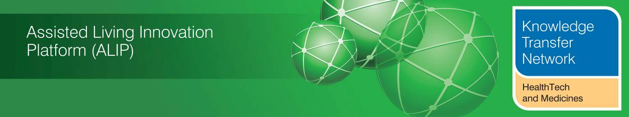
USEFUL LINKS - UK Health & Care Programmes from April 2015
Supplement to March 2015 Newsletter

Welcome to an additional supplement from the Technology Strategy Board (TSB), Knowledge Transfer Network and the Telecare Learning and Improvement Network.

This supplement covers a number of UK health and care programmes commencing April 2015.

1 Care Act 2014

(i) Many sections of the Care Act 2014 come into effect in England in April 2015.

(ii) Guidance associated with the Care Act sets out how the Act will work in practice when the first phase of the reforms come into effect in April 2015. They were produced as a result of extensive consultation.
- Care and support statutory guidance
- The Care Act: easy read version

Also:
The Department of Health’s response to the consultation including proposed final regulations.
(iii) The Department of Health has published a number of factsheets covering Part 1 of the Act. These provide an overview and the duties and powers local authorities will have in the future.
- Care Act factsheets (HTML)
- Factsheet 1: General responsibilities
- Factsheet 2: Who is entitled to care and support
- Factsheet 3: Assessments and eligibility
- Factsheet 4: Care and support planning
- Factsheet 5: Charging
- Factsheet 6: Funding reform
- Factsheet 7: Safeguarding
- Factsheet 8: Carers
- Factsheet 9: Continuity of care
- Factsheet 10: Market oversight and provider failure
- Factsheet 11: Transition
- Factsheet 12: prisoners and people resident in approved premises
- Factsheet 13: appeals policy proposals

There is a ‘Care and Support and you’ website.

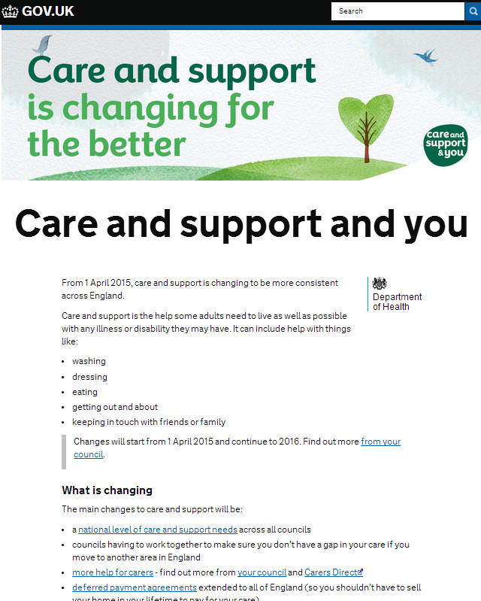
(iv) A range of resources are available from the Social Care Institute for Excellence (SCIE) including useful maps and guides on assessment and eligibility.

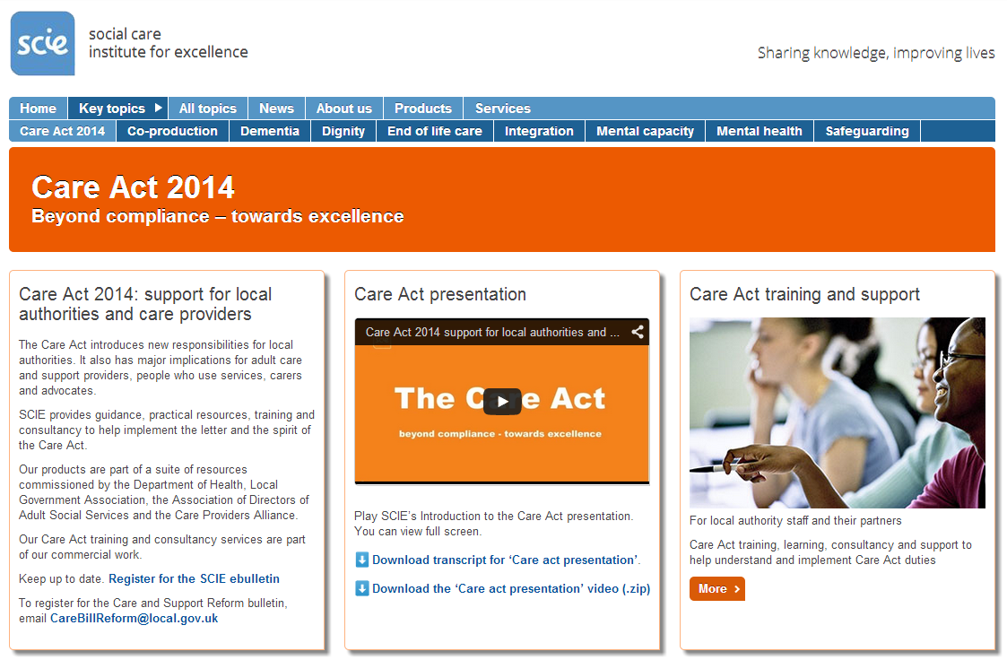

SCIE Guide 33 covers Fair Access to Care Services – prioritising Eligibility for care and support.

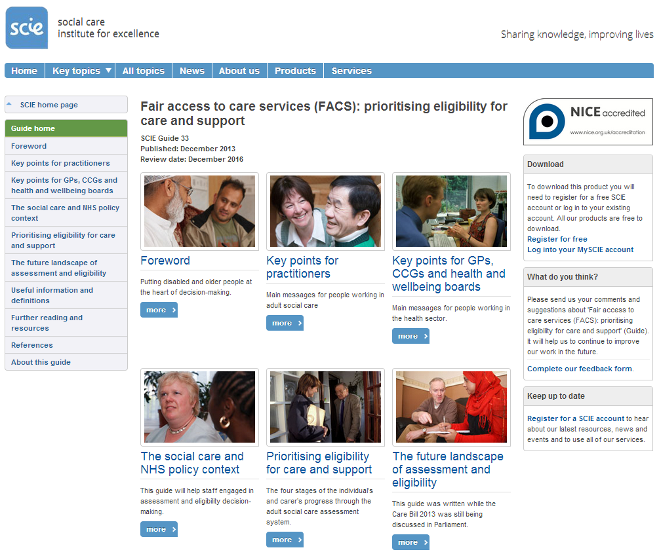
(v) Resources are also available via the Local Government Association website.

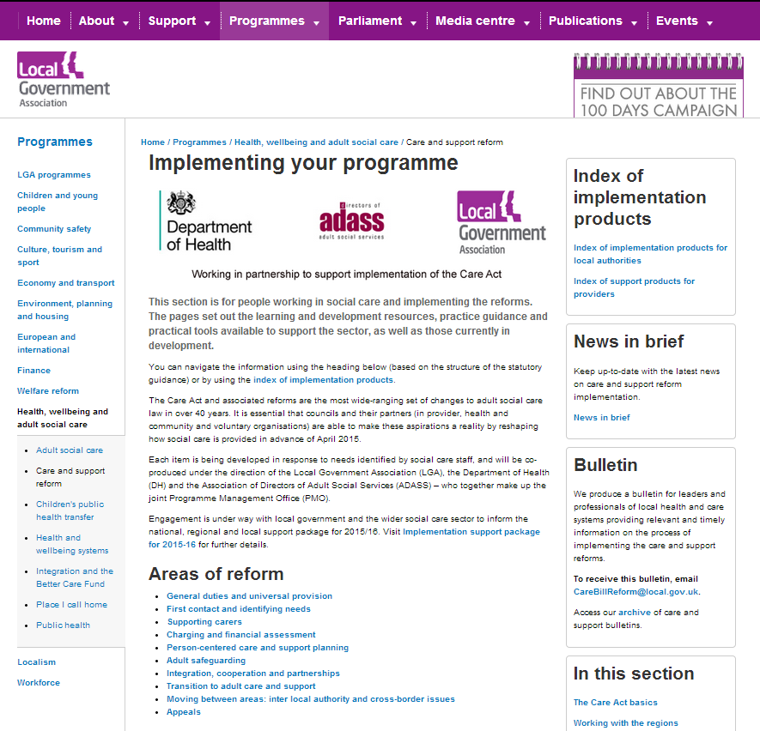

(vi) Skills for Care looks at some of the workforce issues.

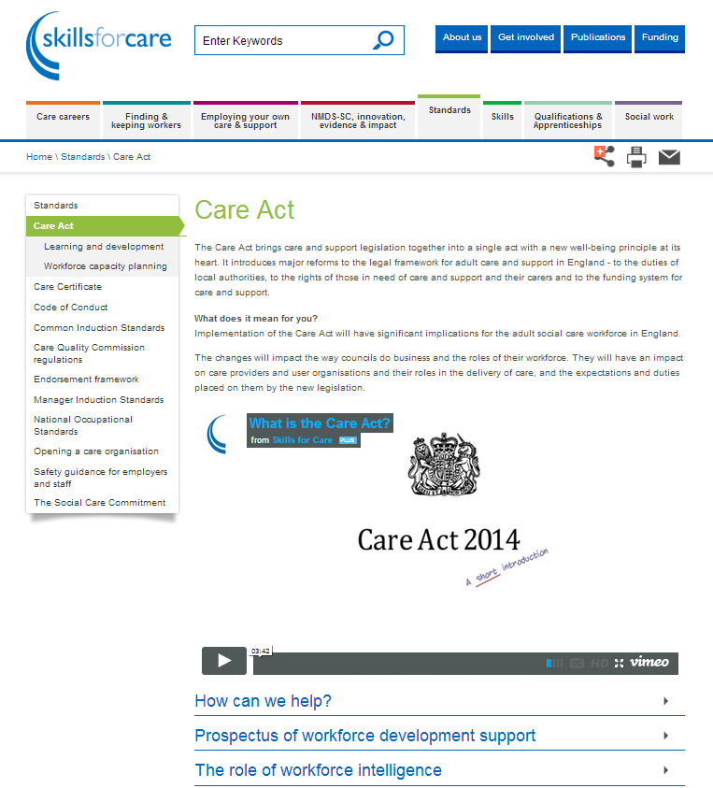
(vii) Community Care provides some useful coverage for health and care professionals involved in the Care Act.

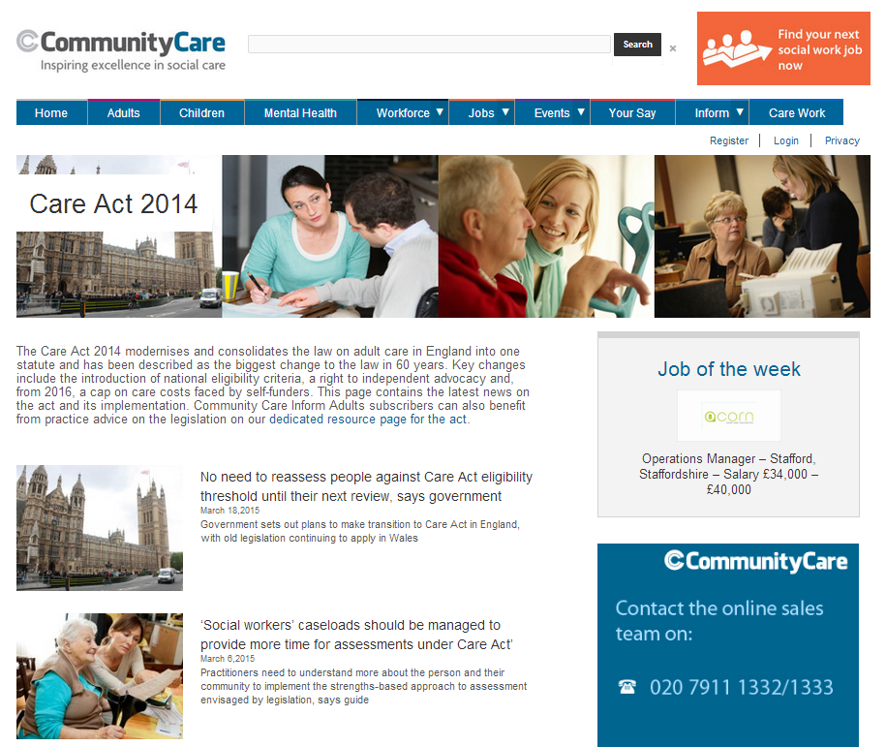

(viii) Resources are also available from Carers UK, Age UK.

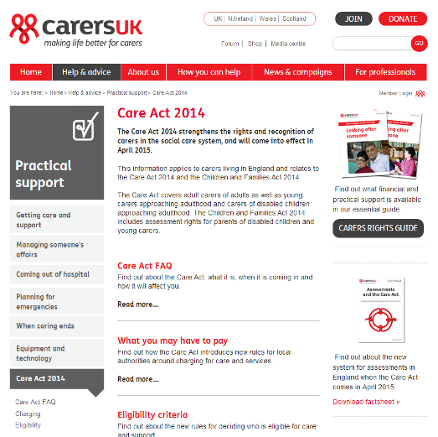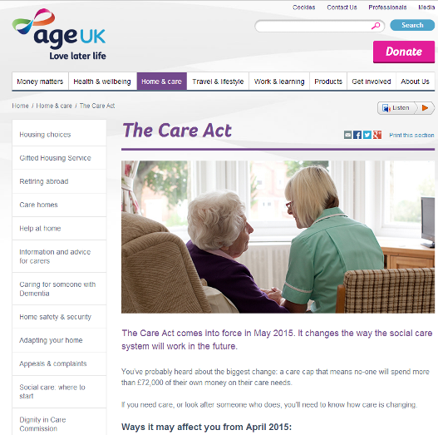

Further reading:
Discussion round up: what the social care sector can do to prepare for the Care Act
Early self-funder assessments vital to avoid 'unmanageable' Care Act burden, says DH
'Social workers' caseloads should be managed to provide more time for assessments under Care Act' - Community Care
The development of online services for information and advice supporting the Care Act 2014
Consultation on social care costs and appeals system – ends 30 March 2015

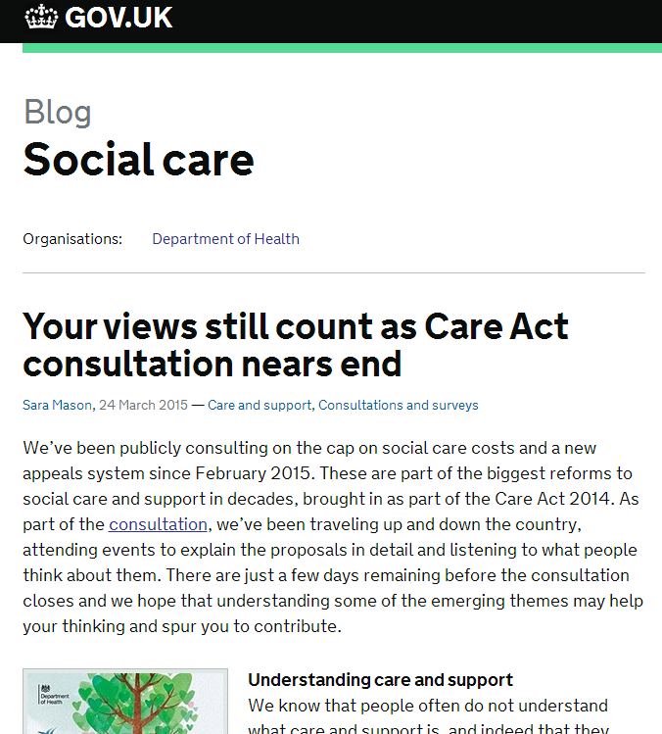
2 Manchester Devolution

At the end of February 2015, Greater Manchester and NHS England announced groundbreaking plans around the future of health and social care with a signed memorandum agreeing to bring together health and social care budgets – a combined sum of £6bn.
The new arrangement sees NHS England, 12 NHS Clinical Commissioning Groups, 15 NHS providers and 10 local authorities agree a framework for health and social care – with plans for joint decision-making on integrated care to support physical, mental and social wellbeing.
The Memorandum of Understanding has been approved and countersigned by the Chancellor and the Health Secretary.
The plan is for integrated care in Greater Manchester to focus more on preventative work in the community – putting strategies in place to keep people well and as independent as possible. For example, people with long-term conditions like asthma or heart conditions will be treated by specialists in the community as much as possible – only going to hospital when necessary.
This place-based approach will help to realise the vision set out in the NHS’s Five Year Forward View.
This historic agreement does not require any reorganisation of the NHS or its principles. It also builds on the work of Greater Manchester Combined Authority (GMCA) and the devolution settlement with Government on 3 November 2014.
The scope of the Memorandum of Understanding includes the entire health and social care system in Greater Manchester, including adult, primary and social care, mental health and community services and public health. The second part of the agreement provides a framework for strategies around governance and regulation, resources and finances, the property estate, health education, workforce and information sharing and systems being brought together.
A transitional plan – or roadmap – will come into effect from April 2015. This roadmap will provide the foundations for joined up business and investment proposals, along with a joint Greater Manchester Health and Social Care Strategy – until full devolution of health and care services is in place by April 2016.
Almost 600,000 (up to 20 per cent) of the city’s nearly three million people who have been identified as most at risk of disease progression and hospitalisation will be offered an annualised care package. It will be personalised and directly targeted at the person’s lifestyle and underlying conditions, with their GP as the accountable doctor. The city’s goal is to eliminate at least 60,000 hospital admissions per year.
Greater Manchester (GM) anticipates that it will still be left with a recurring annual budget deficit for health and social care of over £500 million by 2017-18. If the benefits of NHS devolution are realised, the city could save £250 million each year through reduced admissions to hospital and the benefits of health and social care integration.
In 2015/16 GM will develop a five-year comprehensive Strategic Sustainability Plan for health and social care in partnership with NHS England and other national partners. Accountability arrangements will also be developed.

The GM Strategic Sustainability Plan will be based on the following objectives to:
- Improve health and wellbeing of all residents of Greater Manchester, with a focus on prevention and public health, and providing care closer to home
- Make fast progress on addressing health inequalities
- Promote integration of health and social care as a key component of public sector reform
- Contribute to growth , in particular through support employment and early years services
- Build partnerships between health, social care, universities, science and knowledge sectors for the benefit of the population
The partnership will be underpinned by principles of:
- Maintaining national standards for health and social care and retaining the statutory duties of the NHS and local government in respect of social care and public health
- Basing decision making on better outcomes for citizens
- Co-production between commissioners, providers, patients and carers, with regular patient and public engagement
- Place based commissioning with a commitment to subsidiarity, whereby decisions are taken at the most appropriate level
- Transparency and information sharing, with clear accountability arrangements
- A safe and phased transition, with GM and NHSE identifying and sharing risks
- Addressing funding inequalities within the GM area and a commitment to fully fund GM to take any new responsibilities
- A commitment to "all decisions about Greater Manchester will be taken with Greater Manchester"

From April 2016 onwards, Greater Manchester Strategic Health and Social Care Partnership Board (GMHSPB) will set priorities and strategies aligned to the 5 Year Forward View and provide system-wide management and leadership. The Joint Commissioning Board will commission all Greater Manchester (GM)-wide services, and all locality health and social care plans will be aligned to the Greater Manchester Strategic Sustainability Plan. A chief officer will be appointed to lead the programme.
For local areas, the Health and Wellbeing Boards will continue to agree strategies and priorities but they will need to be aligned to the GM-wide Strategic Sustainability Strategy. All local plans will be submitted to GMHSPB to ensure coherence across GM.
CCGs and local authorities will commission services in line with local plans to pool resources for health and social care, building on existing arrangements.
Further reading:
Discussions in Greater Manchester around a new partnership for health and social care are underway
The Five-Year Forward View into action: NHS England and Greater Manchester announce shared plan for £6billion health and social care funding
E-Health Insider :: IT issues for Manchester NHS devolution
Greater Manchester councils to control £6bn of health spending - report
Greater Manchester to be new care models 'trailblazer'
Greater Manchester: The start of something big?
Manchester authority is set to take control of £6bn worth of health and social care spending
Manchester must seize the £6bn opportunity to improve care
Manchester NHS calls for regulation shake-up after devolution deal
Manchester plan for 'joined-up' NHS and social care could go national
Manchester's plan has implications for the whole NHS
LGA briefing - Greater Manchester Health and Social Care Partnership
Devolution: Now Greater Manchester gets control of its entire £6bn NHS budget
Can the city of Manchester save the NHS?
Caring for Greater Manchester together : GMCA Devolution Agreement
Could Manchester pioneers save NHS?
Council holding NHS budget for Manchester could fragment care, GPs warn
Councils 'to control 6bn NHS budget'
Councils 'to control NHS budget'
'Devo Manc' and the NHS
Revealed: Details of £6bn Manchester health devolution plan
Start date for 'Devo Manc' NHS plan
What Devo Manc could mean for health, social care and wellbeing in Greater Manchester
The Greater Manchester experiment: will the rewards be worth the risk?
The Manchester experiment is not the way to integration
On the NHS, where Manchester leads, England's other cities must follow
Osborne's dramatic Manchester NHS plan is a dangerous distraction
Our response to the proposed new partnership for health and social care in Greater Manchester
Devo Manc': Small steps, great leaps - The Nuffield Trust
Letting Go: How English devolution can help solve the NHS care and cash crisis
Devo Manc: five early lessons for the NHS
All London CCGs and NHS England join forces on city-wide vision (HSJ – subscription)
3 Vanguard Sites

From NHS England: On 10 March 2015, The NHS announced the first 29 ‘vanguard’ geographies that will take the national lead on transforming care for patients in towns, cities and counties across England.

269 groups of nurses, doctors and other health and social care staff from across the country put forward their ideas for how they want to redesign care in their areas, and then helped choose the
first 29 of the most innovative plans.

Drawing on a new £200 million transformation fund and tailored national support, from April 2015 the vanguards will develop local health and care services to keep people well, and bring home care, mental health and community nursing, GP services and hospitals together for the first time since 1948.
For patients, this will lead to a significant improvement in their experience of health services. It is estimated more than five million patients will benefit from this first wave. For example, this could mean:
- Fewer trips to hospitals as cancer and dementia specialists and GPs work in new teams
- A single point of access for family doctors, community nurses, social and mental health services
- Access to tests, dialysis or chemotherapy much closer to home

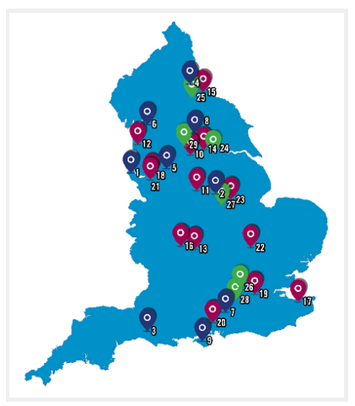
The vanguards will take the national lead on the development of a number of game-changing care models outlined in the Five Year Forward View:
- multispecialty community providers (MCPs) – moving specialist care out of hospitals into the community
- integrated primary and acute care systems (PACS) – joining up GP, hospital, community and mental health services, and
- models of enhanced health in care homes – offering older people better, joined up health, care and rehabilitation services
From April 2015, the national NHS will work with local vanguard sites to develop dedicated support packages to enable and accelerate change, and an intensive evaluation programme will seek evidence on what works so that this can be spread to other parts of the country.
Support will be tailored to the needs of each area, but could be a combination of peer learning and expertise in areas such as patient empowerment and community engagement, leadership, clinical workforce redesign, using digital technology to redesign care, devising new legal forms and new contractual models; and joined up procurement.
All areas will benefit from a wider support and learning package which will be rolled out later this year, based on the learning from the vanguard sites. Additionally, as a result of the many examples of excellent models up and down the country, a wider programme of support is being put in place for some of the health and social care systems that applied to be part of the programme. This is being supported by the Kings Fund.
The sites

(i) Integrated Primary and Acute Care Systems – joining up GP, hospital, community and mental health services
- Wirral University Teaching Hospital NHS Foundation Trust
- Mansfield and Ashfield and Newark and Sherwood CCGs
- Yeovil Hospital
- Northumbria Healthcare NHS Trust
- Salford Together
- Lancashire North
- Hampshire and Farnham CCG
- Harrogate and Rural District CCG
- Isle of Wight

(ii) Multispecialty Community Providers – moving specialist care out of hospitals into the community
- Calderdale Health and Social Care Economy
- Derbyshire Community Health Services NHS Foundation Trust
- Fylde Coast Local Health Economy
- Vitality
- West Wakefield Health and Wellbeing Ltd
- NHS Sunderland CCG and Sunderland City Council
- NHS Dudley CCG
- Whitstable Medical Practice
- Stockport Together
- Tower Hamlets Integrated Provider Partnership
- Southern Hampshire
- Primary Care Cheshire
- Lakeside Surgeries
- Principia Partners in Health

(iii) Enhanced health in care homes – offering older people better, joined up health, care and rehabilitation services
- NHS Wakefield CCG
- NHS Gateshead CGG
- East and North Hertfordshire CCG
- Nottingham City CCG
- Sutton CCG
- Airedale NHS Foundation
You can view the presentations from each of the final sites explaining their care models:
- Integrated Primary and Acute Care Systems
- Multispecialty Community Providers
- Enhanced Health in Care Homes

Further reading:
5YFV: finding different ways to deliver care - CC4C
A starting gun or shot in the dark?
Avoiding the pilot pitfalls: how can the Vanguards help others in the NHS to succeed too? Five million patients to benefit from new era of patient care 29 geographies lead nhs forward view into action
Biggest hospital trusts absent from care model 'vanguard'
Can NHS vanguard areas point the way to new models for care?
New care models explained: How the NHS can successfully integrate care
E-Health Insider :: Vanguard areas given marching orders
Exclusive: CQC unveils new approach to regulating forward view care models
Samantha Jones on Vanguard Sites
Samantha Jones on You Tube
Starting gun 'fired' on new NHS
The NHS is at a pivotal moment: we must do something different
NHS chief details radical plans to end 'like it or lump it' care
NHS chief unveils 29 vanguard areas in his new reforms
NHS England reveals £200m 'vanguard' areas trialling NHS integration GPonline
NHS England approves GP and hospital bids for £200m funding to develop 'new models of care'
NHS revamp - rhetoric into reality?
Nuffield Trust responds to announcement of 29 'vanguard' areas to implement the Five Year Forward View
4 Integrated Personal Commissioning

NHS England has launched ‘Integrated Personal Commissioning (IPC). The first wave of the Integrated Personal Commissioning (IPC) programme across eight sites will go live on 1 April 2015, providing some 10,000 people with complex needs with greater power to decide how their own combined health and social care budget is spent.
The start of the programme is a key first stage in the delivery of the NHS Five Year Forward View that was set out in October 2014. Four groups of high need individuals – older people with long term conditions, children with disabilities and their families, people with learning disabilities, and people living with serious mental illness – will be able to take control of their budget to deliver an agreed care plan. As part of the programme, local voluntary organisations will help patients with personal care planning and advocacy.
The successful demonstrator sites include Barnsley, Cheshire West and Cheshire, Luton, Stockton on Tees, Tower Hamlets, Hampshire, Portsmouth and South West Consortium.
IPC makes a triple offer to service users, local commissioners and the voluntary sector to bring health and social care spend together at the level of the individual. These are:
- Service users will be offered power and improved support to shape care that is meaningful to them in their lives
- Local authorities and NHS commissioners and providers will be offered dedicated technical support and regulation and financial flexibilities to address systemic barriers to change
- The voluntary sector will be a key partner in designing effective approaches, supporting individuals and driving cultural change
The goals of the programme are:
- People with complex needs and their carers have better quality of life and can achieve the outcomes that are important to them and their families through greater involvement in their care, and being able to design support around their needs and circumstances
- Prevention of crises in people’s lives that lead to unplanned hospital and institutional care by keeping them well and supporting self-management as measured by tools such as ‘patient activation’– so ensuring better value for money
- Better integration and quality of care, including better user and family experience of care.
The programme is aimed at groups of individuals who have high levels of need, who often have both health and social care needs, where a personalised approach would address acknowledged problems in current care provision, help prevent people from becoming more unwell, and enabling people to retain their independence. This will include:
- Children and young people with complex needs, including those eligible for education, health and care plans
- People with multiple long-term conditions, particularly older people with frailty
- People with learning disabilities with high support needs, including those who are in institutional settings or at risk of being placed in these settings
- People with significant mental health needs, such as those eligible for the Care Programme Approach or those who use high levels of unplanned care

Also:

True integration must bridge the divide between services and the people they serve – Luke O’Shea
Frequently asked questions: Introducing personal health budgets beyond NHS Continuing Healthcare - NHS England
TLAP - Being in charge of your own services
New person-centred models of care in the pipeline, NHS England announces

5 Better Care Fund Plans
From NHS England: The £5.3bn Better Care Fund (was announced by the Government in the June 2013 spending round, to ensure a transformation in integrated health and social care. It creates a local single pooled budget to incentivise the NHS and local government to work more closely together around people, placing their well-being as the focus of health and care services.
The main operational documents for local authorities, CCGs and Health and Wellbeing Boards are:
- Guidance for the Operationalisation of the BCF in 2015-16
- BCF Quarterly Report Template
- BCF metrics analytical tool
These documents cover:
- The Care Act legislation underpinning the BCF
- The accountability arrangements and flows of funding
- The reporting and monitoring requirements for 2015-16
- Arrangements for the operation of the payment for performance framework
- How progress against plans will be managed and what the escalation process will look like
- The role of the BCF Task Force / Better Care Support Team

The programme will also:
- Gather insight and good practice aimed at helping areas overcome the barriers to successful implementation of BCF plans
- Share and disseminate good practice across the country, targeted around topics where support is most needed or local areas are facing barriers
- Facilitate collaborative discussions between areas across the country
A series of ‘How to’ guides will focus on key topics where local areas have requested support, including:
- Leadership and management
- Aligning system incentives
- Joint working
- Data sharing
Several areas will become Better Care Learning Partners. They will receive support and coaching, and the learning from these areas will be shared and disseminated through the Better Care Exchange (to be established).
The Better Care Exchange will enable organisations to:
- Take part in collaborative discussions and share learning as part of a social network
- Access insight and good practice aimed at helping areas overcome the barriers to successful provision of better care
- Access ‘How-to’ Guides to provide practical steps to progress delivery
- Interact with national experts, some of the leading thinkers on integrating health and social care, including Professor Paul Corrigan, Nigel Edwards, Hannah Miller, Sir John Oldham, Lord Michael Bichard, and Professor Angela Coulter
- Find out how to benefit from regional workshops to find out how to progress delivery
- Ask for support from national experts, the Better Care Fund Task Force and peers
Further Reading:
Resource Guide
How to’ Guide: The BCF Technical Toolkit
Risk Sharing / S.75 agreement
Better Care Fund Allocations spreadsheet (revised)
Better Care Fund statistical significance calculator
Online Metrics atlas

Also:
LGA – Better Care Fund website
NAO – Planning for the Better Care Fund
Public Accounts Committee – Better Care Fund
LGA response to the PAC report into planning for the Better Care Fund

Newsletter supplement prepared by Mike Clark (@clarkmike) and brought to you by the Telecare LIN on behalf of Innovate UK. Newsletters and supplements are archived at www.telecarelin.org.uk
Disclaimer: “We provide this newsletter supplement for information purposes only and neither the Technology Strategy Board nor the authors accept any liability whatsoever for inaccuracies, errors or omissions therein or for any consequences arising therefrom.”



