Telecare LIN eNewsletter
July 2010
Welcome to the July 2010 newsletter. The Telecare Learning and Improvement Network (LIN) is responsible for providing general implementation support to organisations building their telecare and telehealth programmes in England. Registered DH Care Networks telecare membership is around 6300. The June newsletter email alert had over 8500 click-throughs.

All telecare newsletters are archived at:
www.dhcarenewtworks.org.uk/telecarenewsletters

If you are an organisation implementing telecare or telehealth in England and have an interesting local telecare or telehealth story for inclusion in a future newsletter then e-mail Mike Clark at telecare@dhcarenetworks.org.uk

PCT Telehealth Map:
http://maps.google.co.uk/maps/ms?hl=en&ie=UTF8&msa=0&msid=100406857045032193451.00047bfad6341183c8523&ll=54.329338,-1.604004&spn=8.052625,18.676758&z=6

Telecare and Telehealth Evaluation Map:
http://maps.google.co.uk/maps/ms?hl=en&ie=UTF8&msa=0&msid=100406857045032193451.000481bfda3b6cc58babe&ll=52.66972,-1.955566&spn=8.373034,18.676758&z=6

Telecare Services Map:
http://maps.google.co.uk/maps/ms?hl=en&ie=UTF8&msa=0&msid=100406857045032193451.0004540c223f16f2d1c9d&ll=52.842595,-1.867676&spn=8.339986,18.676758&z=6
If you would like up to date information about the Whole System Demonstrator Programme and the development of the evidence base for telecare and telehealth then go to www.wsdactionnetwork.org.uk

There is free registration on both web sites:
www.wsdactionnetwork.org.uk/telecare
www.wsdactionnetwork.org.uk

Note: DH Care Networks is not responsible for the content of external links and does not endorse any suppliers or their products. Any claims made by organisations should be carefully evaluated as part of normal commissioning and procurement arrangements.
Contents

Item | Page
1 Recent DH announcements and publications | 2
2 Whole System Demonstrator Action Network (WSDAN) – Newcastle event | 4
3 News and links | 6
4 Diary for telecare and telehealth events and conferences | 27

Headlines for July 2010
Item 1 provides an updated list of important Department of Health announcements about the recent White Paper together with related consultation documents. The proposed changes will have an impact on the commissioning and provision of telecare and telehealth in England.

Item 2 Presentations are now available from the recent Whole System Demonstrator Event in Newcastle together with a new WSDAN briefing paper on “Sustaining Innovation in Telehealth and Telecare”

Item 3 provides a comprehensive listing of news links from the past month covering telecare, telehealth, telemedicine and related areas.

Item 4 provides a diary for telecare and telehealth events and conferences

1 Recent DH announcements and publications

Prepared by Mike Clark

There have been a number of recent announcements from the Department of Health that will start to have an impact on the future arrangements for telecare and telehealth provision in England.
Equity and excellence; Liberating the NHS (White Paper, 12 July 2010)
The NHS White Paper, Equity and excellence: Liberating the NHS, sets out the Government's long-term vision for the future of the NHS. The vision builds on the core values and principles of the NHS - a comprehensive service, available to all, free at the point of use, based on need, not ability to pay. It sets out how the Government will:
- put patients at the heart of everything the NHS does;
- focus on continuously improving those things that really matter to patients - the outcome of their healthcare; and
- empower and liberate clinicians to innovate, with the freedom to focus on improving healthcare services
The Department is consulting on elements of these proposals. Details on how to respond can be found in the White Paper.
http://www.dh.gov.uk/en/Publicationsandstatistics/Publications/PublicationsPolicyAndGuidance/DH_117353

Equity and excellence: Liberating the NHS (press release, 12 July 2010)
http://www.dh.gov.uk/en/MediaCentre/Pressreleases/DH_117360

Oral Statement on the NHS White Paper by the Secretary of State for Health, Andrew Lansley (16 July 2010)
http://www.dh.gov.uk/en/MediaCentre/Speeches/DH_117366

Department of Health draft Structural Reform Plan (12 July 2010)
http://www.dh.gov.uk/en/Publicationsandstatistics/Publications/PublicationsPolicyAndGuidance/DH_117371

Liberating the NHS: managing the transition (Sir David Nicholson letter and timeline, 13 July 2010)

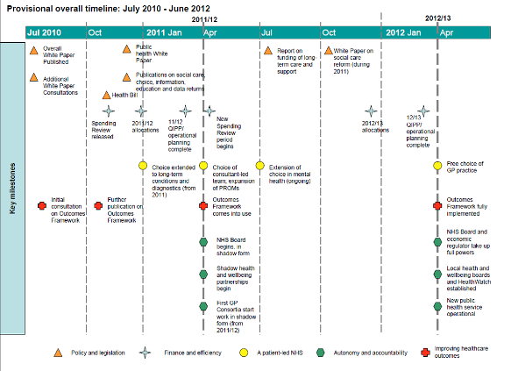
http://www.dh.gov.uk/en/Publicationsandstatistics/Lettersandcirculars/Dearcolleagueletters/DH_117405
Transparency in outcomes - a framework for the NHS (19 July 2010)
http://www.dh.gov.uk/en/Consultations/Liveconsultations/DH_117583
Liberating the NHS: Improving outcomes for patients (19 July 2010)
http://www.dh.gov.uk/en/MediaCentre/Pressreleases/DH_117628
First step to sustainable care and support system
http://www.dh.gov.uk/en/MediaCentre/Pressreleases/DH_117636
Written ministerial statement on the NHS White Paper consultation (22 July 2010)
http://www.dh.gov.uk/en/MediaCentre/Statements/DH_117743

Liberating the NHS: Increasing democratic legitimacy in health (22 July 2010)
http://www.dh.gov.uk/en/Consultations/Liveconsultations/DH_117586

Liberating the NHS: commissioning for patients - consultation on proposals (22 July 2010)
http://www.dh.gov.uk/en/Consultations/Liveconsultations/DH_117587

Greater Freedom for the NHS (26 July 2010)
http://www.dh.gov.uk/en/MediaCentre/Pressreleases/DH_117848

Liberating the NHS: regulating healthcare providers
http://www.dh.gov.uk/en/Consultations/Liveconsultations/DH_117782

Care Quality Commission's investigation into GP out-of-hours provider, Take Care Now, reveals serious failings
http://www.cqc.org.uk/newsandevents/newsstories.cfm?FaArea1=customwidgets.content_view_1&cit_id=36433

DH Response to report on out-of-hours services
http://www.dh.gov.uk/en/Publicationsandstatistics/Lettersandcirculars/Dearcolleagueletters/DH_117522

Direct payments for health care: Information for pilot sites
http://www.dh.gov.uk/en/Publicationsandstatistics/Publications/PublicationsPolicyAndGuidance/DH_117477

2 Whole System Demonstrator Action Network (WSDAN) – Newcastle event – presentations now available (30 June 2010)
Prepared by Mike Clark

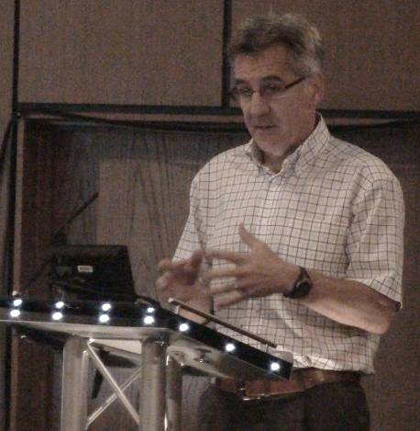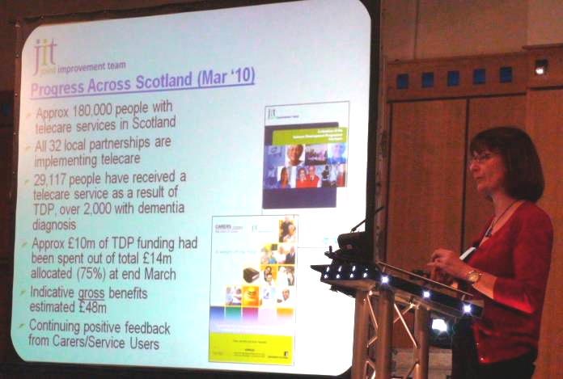

Professor Martin Knapp (London School of Economics) and Moira MacKenzie (Joint Improvement Team, Scotland) at the recent event.

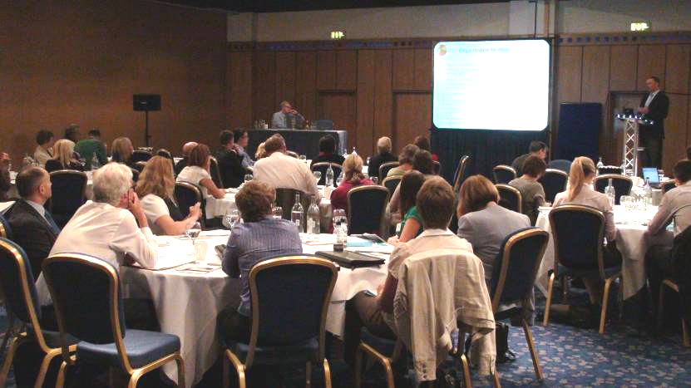
Slide presentations are now available from the WSDAN web site together with the first in a series of WSDAN briefing papers on ‘Sustaining Innovation in Telehealth and Telecare’.

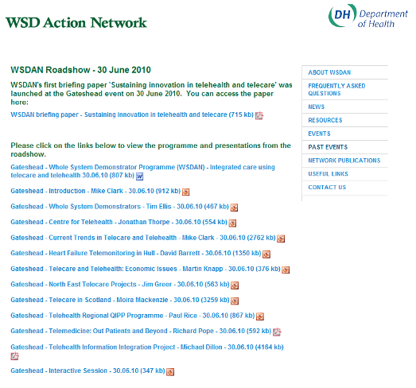

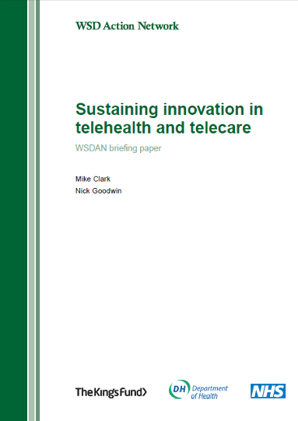

http://www.wsdactionnetwork.org.uk/past_events/wsdan_roadshow_30.html

If you are registered with the WSDAN web site, you can get monthly newsletter information about features and presentations from previous events. The site also hosts the searchable evidence database for telecare and telehealth with over 340 journal articles.

Evidence database: http://kingsfundlibrary.co.uk/wsdan/

Web site: www.wsdactionnetwork.org.uk
eMail: wsdnetwork@kingsfund.org.uk
Twitter: clarkmike
Hashtag: #WSDAN

3 News and links

News from around the world covering telecare, telehealth and related areas of interest to commissioners, service providers, suppliers and other organisations – prepared by Mike Clark

Calls/Awards
SBRI (NHS South East Coast) – Living well with dementia
Open Date: 30 June 2010
Deadline: 09 September 2010
http://www.innovateuk.org/content/competition/sbri/living-well-with-dementia.ashx
Health Innovation Challenge Fund
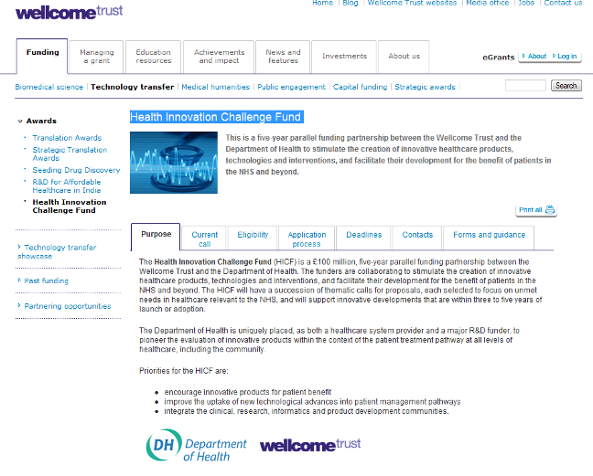
- Preliminary application deadline: 1 October 2010 (17.00)
- Shortlisting of proposals: early November 2010
- Full applications submitted: 10 January 2011 (17.00)
- Funding decisions: April 2011
http://www.wellcome.ac.uk/Funding/Technology-transfer/Awards/Health-Innovation-Challenge-Fund/index.htm

Telecare
MP Queries Angus Increase in Community Alarms
http://dundeesnp.org/index.php/archives/1483

Cardiff Community Alarm Team Praised for their Success
http://www.welshicons.org.uk/news/cardiff/cardiff-community-aleam-team-praised-for-their-success/
Camden Careline You Tube Video

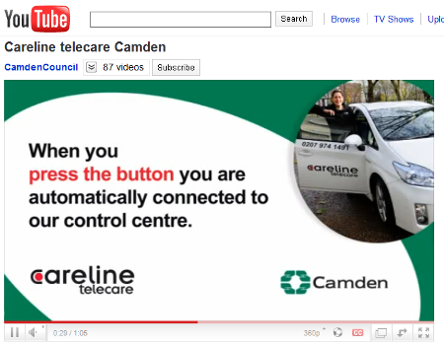

http://www.youtube.com/watch?v=aV434lorFCA&feature=youtube_gdata

Guardian angel gadgets

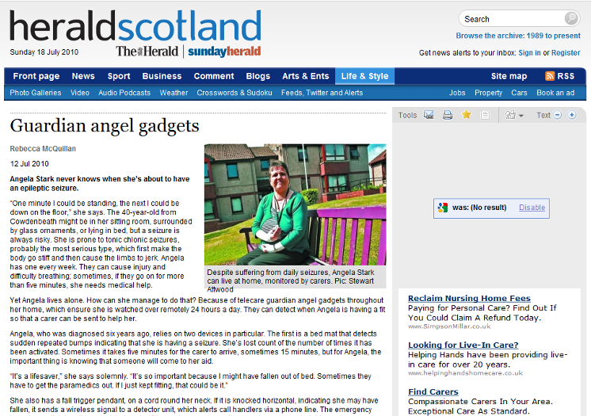

http://www.heraldscotland.com/life-style/real-lives/guardian-angel-gadgets-1.1040628

Good News All Around for Telehealth Projects
http://www.itbusinessedge.com/cm/blogs/weinschenk/good-news-all-around-for-telehealth-projects/?cs=42275

TELECARE AND TELEHEALTH DRIVERS OF CHANGE – TSA Conference
http://www.prfire.co.uk/press-release/telecare-and-telehealth--drivers-of-change-18585.html

Hft’s smart house showcased at International Carer's Conference
http://tunstall-telehealthcare.blogspot.com/2010/07/hfts-smart-house-showcased-at.html

Telehealth
Telehealth Device Improves Patient Compliance
http://www.informationweek.com/news/healthcare/patient/showArticle.jhtml?articleID=225701358

Study: GlowCaps up adherence to 98 percent
http://mobihealthnews.com/8069/study-glowcaps-up-adherence-to-98-percent/

Telehealth Device Improves Patient Compliance (Glowcap)
http://www.informationweek.com/news/healthcare/patient/showArticle.jhtml?articleID=225701358&cid=RSSfeed_IWK_All

Telehealth on Facebook

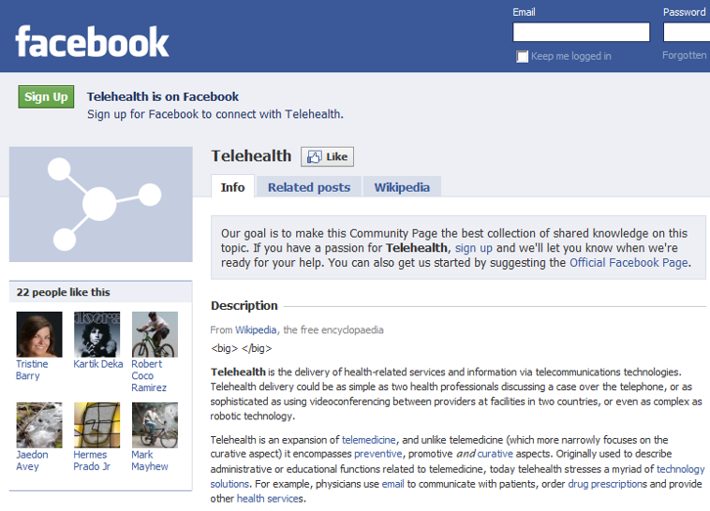

http://www.facebook.com/pages/Telehealth/112375692111264

2000 additional telehealth systems for North Yorkshire and York patients
http://epractice.eu/en/news/322485

Patients get a helping hand from Telehealth
http://www.scarborougheveningnews.co.uk/news/Patients-get-a-helping-hand.6391548.jp

2 000 Additional Telehealth Systems For North Yorkshire And York Patients
http://www.egovmonitor.com/node/37259

Telehealth Tools Seen as Key to VA's Rural Health Care Strategy
http://www.ihealthbeat.org/articles/2010/6/24/telehealth-tools-seen-as-key-to-vas-rural-health-care-strategy.aspx
Blackburn and NHS Direct pilot wellness - NHS Direct is to pilot its first web and telephone-based support service targeted at patients at risk of developing long term conditions
http://www.ehiprimarycare.com/news/6049/blackburn_and_nhs_direct_pilot_wellness

Another example of telehealth benefits (UK)
http://tunstall-telehealthcare.blogspot.com/2010/07/another-example-of-telehealth-benefits.html

Taking telehealth from pilot to mainstream in Scotland
http://tunstall-telehealthcare.blogspot.com/2010/06/taking-telehealth-from-pilot-to.html

Argyll telehealth scheme highly commended
http://argyllfreepress.com/2010/07/04/argyll-telehealth-scheme-highly-commended/

Breakthroughs in Medication Management – Automatic Pill Dispensers and Medication Compliance
http://www.jabeja.org/medical/breakthroughs-in-medication-management-automatic-pill-dispensers-and-medication-compliance/

Norfolk conference hears of telemedicine revolution
http://www.edp24.co.uk/content/edp24/news/story.aspx?brand=EDPOnline&category=News&tBrand=EDPOnline&tCategory=xDefault&itemid=NOED28%20Jun%202010%2020%3A58%3A50%3A157

Telehealth stories (Isle of Bute)
http://www.patientvoices.org.uk/telehealth.htm

Bosch Healthcare launches independent telehealth project in the UK
http://www.hospitaliteurope.com/default.asp?title=BoschHealthcarelaunchesindependenttelehealthprojectintheUK&page=article.display&article.id=22050

Argyll telehealth scheme highly commended
http://argyllfreepress.com/2010/07/04/argyll-telehealth-scheme-highly-commended/

NHS Lothian deploys Intel's Health Guide
http://www.e-health-insider.com/Features/item.cfm?appTimeOut=yes&docId=284

Detect Your Heart Beat from a Meter Away...
http://www.medgadget.com/archives/2010/06/detect_your_heart_beat_from_a_meter_away.html

Dealing with the downturn: using the evidence
http://www.nhsconfed.org/Publications/Documents/Dealing_downturn180610.pdf

Can technology help with the ageing population crisis? (White Paper)
http://www.sourcewire.com/releases/rel_display.php?relid=57258

Will Smart Phones disrupt the telehealth market?
http://blog.cambridgeconsultants.com/wireless-medical/will-smart-phones-disrupt-the-telehealth-market/

Healthvault in the UK


http://www.healthvault.co.uk/

Devices that work with Healthvault:
http://www.healthvault.co.uk/Industry/devices.aspx?type=device

New Smart Meter Telecare project
http://www.lsscommunity.com/group/medtech/forum/topics/new-smart-meter-telecare?xg_source=activity

Non-contact sensors set to transform telecare heart monitoring
http://www.sinc.co.uk/news/?p=590

Study protocol: home-based telehealth stroke care: a randomized trial for veterans
http://7thspace.com/headlines/349432/study_protocol_home_based_telehealth_stroke_care_a_randomized_trial_for_veterans.html

Colorado makes big push for telehealth
http://www.govhealthit.com/newsitem.aspx?nid=74052

Positive impacts of telecare – RTE video
http://www.slideshare.net/Netwell/rte-telehealth

Telehealth Tools Seen as Key to VA's Rural Health Care Strategy
http://www.ihealthbeat.org/articles/2010/6/24/telehealth-tools-seen-as-key-to-vas-rural-health-care-strategy.aspx

Telehealth technology is increasingly important to US Veterans
http://www.eweek.com/c/a/Health-Care-IT/Telehealth-Technology-Is-Increasingly-Important-to-US-Veterans-397177/?kc=rss

Continua Health Alliance Promotes the Use of In-Home Healthcare to the House Committee on Veterans Affairs Subcommittee on Health
http://www.businesswire.com/portal/site/home/permalink/?ndmViewId=news_view&newsId=20100701005343&newsLang=en
Telehealth Access Centre (Quebec)
http://www.telehealthaccess.com/english.html

Dunbar Medical Centre launches First Patient Care Messaging in Scotland
http://www.ehealthnews.eu/iplato/2142-dunbar-medical-centre-launches-first-patient-care-messaging-in-scotland

Telehealth Program Mitigates Depression, Pain for Cancer Patients
http://www.ihealthbeat.org/articles/2010/7/15/telehealth-program-mitigates-depression-pain-for-cancer-patients.aspx

A telehealth integrated asthma-COPD service for primary care: a proposal for a pilot feasibility study in Crete, Greece
http://7thspace.com/headlines/350737/a_telehealth_integrated_asthma_copd_service_for_primary_care_a_proposal_for_a_pilot_feasibility_study_in_crete_greece.html

NHS Central Lancashire pioneers new home health monitoring technology for chronically ill patients
http://www.ehealthserver.com/ge/550-nhs-central-lancashire-pioneers-new-home-health-monitoring-technology-for-chronically-ill-patients

NHS Central Lancashire Pioneers New Home Health Monitoring Technology for Chronically Ill Patients
http://www.newswiretoday.com/news/72913/

The first iPhone medical device: Jazz meter?

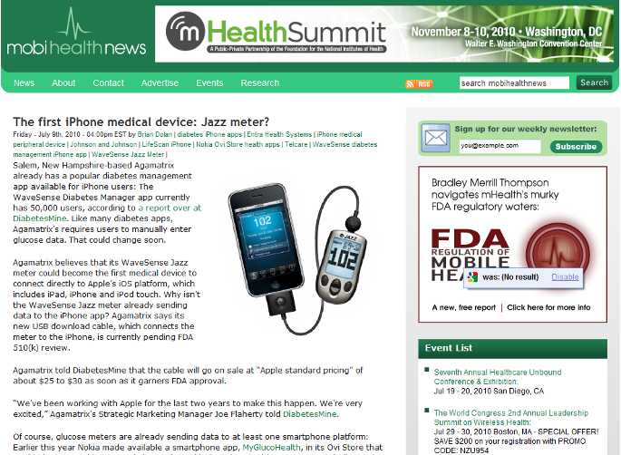

http://mobihealthnews.com/8316/the-first-iphone-medical-device-jazz-meter/

Switch on - the case for telehealth (KPMG)
http://www.kpmg.co.uk/pubs/beforepdf.cfm?PubID=3303

Nursing Times – telehealth articles
The Nursing Times of 6 July 2010 covered Cornwall/WSD Programme and the Orchard Medical Centre in Bristol (subscription required)
Health Guide gets first English trial – Central Lancashire
http://www.e-health-insider.com/news/6055/health_guide_gets_first_english_trial

General

White House Announces $795M for Broadband, Telemedicine
http://www.ihealthbeat.org/articles/2010/7/2/white-house-announces-795m-for-broadband-telemedicine.aspx

Forbes - Nine Technologies To Ease Pain Of Getting Old
http://www.forbes.com/2010/07/01/technology-for-the-elderly-entrepreneurs-technology-mit.html?boxes=techchanneltopstories

CMS Telehealth Partners with MedApps® for Personalized Healthcare Management of Chronic Conditions
http://www.pr.com/press-release/248735

Brain 'pacemaker': Smarter Parkinson's care?
http://news.cnet.com/8301-17938_105-20010154-1.html

Health-care overhaul includes pilot program of house calls for elderly patients
http://www.washingtonpost.com/wp-dyn/content/article/2010/07/12/AR2010071204185.html

Telefónica opens global e-health unit to curb expenses in Europe, Latin America
http://cl.exct.net/?qs=d605e9d8df4b2d1c1c26319d9382d4a82d605e0b3292ca200bb4a899b51cb48e
UK does well on end of life care - Technology will be an increasingly important element in delivering end-of-life care at home, according to an analysis which found the UK has one of the best systems for palliative care in the world.
http://www.ehiprimarycare.com/news/6086/uk_does_well_on_end_of_life_care

VA mobile gets boost from House panel, advances plans for patient Wi-Fi
http://www.fiercemobilehealthcare.com/story/va-mobile-gets-boost-house-panel-advances-plans-patient-wi-fi/2010-06-29#ixzz0u1ntAZsf

ValueOptions® and David Lawrence Center Bring Tele-Psychiatry to Remote Florida Residents; Verizon Business Selected to Provide Telehealth Collaboration Services
http://www.prnewswire.com/news-releases/valueoptions-and-david-lawrence-center-bring-tele-psychiatry-to-remote-florida-residents-verizon-business-selected-to-provide-telehealth-collaboration-services-98110859.html

Telemedicine Trialed for Obstetric Consultations
http://www.healthleadersmedia.com/content/TEC-253489/Specialists-use-telemedicine-for-pregnancy-consultations##

A Healthy Approach - Technology for Personalised, Preventative Healthcare
http://www.ehealthnews.eu/publications/latest/2130-a-healthy-approach-technology-for-personalised-preventative-healthcare

Mobile phone application to support self-management of health and well-being
http://www.news-medical.net/news/20100705/Mobile-phone-application-to-support-self-management-of-health-and-well-being.aspx

Translation and a 'home hub'
http://www.smarthealthcare.com/mics-passivsystem-07jul10

Diabetes Risk Higher Among Overweight
http://www1.voanews.com/english/news/health/Diabetes-Risk-Higher-Among-Overweight-97380569.html

Apps for health issues
http://www.delawareonline.com/article/20100706/HEALTH/7060309/1006/NEWS

No Clear Consensus on Telemedicine Market Size
http://lifestyletom.com/path/rao10925686858ros/roin59012541846

Better Glucose Control Achieved With Medtronic's Sensor-Augmented Insulin Pump Therapy Than Daily Insulin Injections For In Patients With Diabetes
http://www.medicalnewstoday.com/articles/193292.php

People with diabetes are living longer, but death rates still outpace the general population (USA)
http://latimesblogs.latimes.com/booster_shots/2010/06/diabetes-death-rates-mortality-improving-.html

An app a day keeps the doctor away
http://www.dailymail.co.uk/health/article-1289864/An-app-day-keeps-doctor-away-First-aid-BMI-readings-hearing-checks-mobile.html?ITO=socialnet-twitter-mailonline

Raising the Quality of Care - Primary Care leadership in Milton Keynes
http://www.qualitymk.nhs.uk/default.asp?ContentID=4498

Tobii eye tracking glasses may find application in assistive technology
http://www.medgadget.com/archives/2010/07/tobii_eye_tracking_glasses_may_find_application_in_assistive_technology.html

The Ultimate Telemedicine Tweak to dSLRs: Cancer Detection
http://www.medgadget.com/archives/2010/06/the_ultimate_aftermarket_trick_on_dslrs_cancer_detection.html

It’s mHealth but will it be a Revolution?
http://americantelemed.blogspot.com/2010/06/its-mhealth-but-will-it-be-revolution.html

Barking Up A New Tree - Changes in the way healthcare services are paid from fee-for-service to single payment mechanisms create vast new opportunities for telemedicine but shift the decision makers that govern adoption and market expansion. (John Linkous, ATA)
http://americantelemed.blogspot.com/2010/07/barking-up-new-tree.html

Why social media is good medicine for healthcare
http://smartblogs.com/socialmedia/2010/07/02/why-social-media-is-good-medicine-for-health-care/

Backing for single legal framework for adult care assessment
http://www.communitycare.co.uk/Articles/2010/07/02/114830/backing-for-single-legal-framework-for-adult-care-assessment.htm

Study protocol: home-based telehealth stroke care: a randomized trial for veterans
http://www.trialsjournal.com/content/11/1/74

Webinar presents telehealth data and recommendations
http://broadbandbreakfast.com/2010/07/webinar-presents-telehealth-data-and-recommendations/

How Personal Health Budgets keep Sandie "dancing on the stars" - A Norfolk woman has told how her Personal Health Budget has enabled her to regain control of her life.
http://www.norfolk.nhs.uk/node/1728

Healthcare Mobile Devices Forecast To Gain 7%
http://www.informationweek.com/news/healthcare/mobile-wireless/showArticle.jhtml?articleID=225702193

Some doctors join Facebook, Twitter; others wary
http://www.usatoday.com/news/health/2010-07-08-SOCIALDOCS08_ST_N.htm

Introducing HealCam
http://www.medgadget.com/archives/2010/07/introducing_healcam.html

Please Don't Squeeze The Handles: Newly Patented Electronic Braking System Prevents Slips On Walkers
http://www.medicalnewstoday.com/articles/193909.php

X PRIZE Foundation Aims to Put Virtual Physician in Every Pocket
http://www.medgadget.com/archives/2010/06/x_prize_foundation_aims_to_put_virtual_physician_in_every_pocket.html

New tool to rule out coronary heart disease in primary care
http://www.eurekalert.org/pub_releases/2010-07/cmaj-ntt062910.php

Biosensors Comfortable Enough to Wear 24-7 - A new kind of sensor could allow for long-term medical monitoring--without direct skin contact.
http://www.technologyreview.com/biomedicine/25701/

Efficiency Savings, Not Cuts in Healthcare
http://ablemagazine.co.uk/efficiency-savings-not-cuts-in-healthcare/

Map of medicine - Diabetes - suspected in adults
http://eng.mapofmedicine.com/evidence/map/diabetes1.html

Map of medicine – falls
http://healthguides.mapofmedicine.com/choices/map/falls1.html

Frost and Sullivan - A Paradigm Shift in Healthcare: Changing Business Models and the Impact of Technology, global healthcare
http://www.slideshare.net/FrostandSullivan/a-paradigm-shift-in-healthcare-changing-business-models-and-the-impact-of-technology-global-healthcare

NEJM: Sensor-Augmented Pump Therapy Shows Promise in Diabetes Study http://www.medgadget.com/archives/2010/06/nejm_sensoraugmented_pump_therapy_shows_promise_in_diabetes_study.html

New OneTouch Delica Lancing System for More Comfortable and Gentle Glucose Testing
http://www.medgadget.com/archives/2010/06/new_onetouch_delica_lancing_system_for_more_comfortable_and_gentle_glucose_testing.html

Officials, Health Care Providers Working To Reduce Patient Readmissions in California
http://www.californiahealthline.org/special-reports/2010/officials-health-care-providers-working-to-reduce-patient-readmissions-in-california.aspx

Two million more Britons come online in last 12 months
http://news.bbc.co.uk/1/hi/technology/10448204.stm

Apps for health issues
http://www.delawareonline.com/article/20100706/HEALTH/7060309/1006/NEWS

iBreathe: T2 Develops Mobile Application for Stress Reduction
http://www.dcoe.health.mil/blog/article.aspx?id=1&postid=117

Excessive treatment of COPD increases health risks, costs for patients http://www.fiercehealthcare.com/story/excessive-treatment-copd-increases-health-risks-costs-patients/2010-06-17#ixzz0rl4EZQ6Z
COPD to become third largest cause of death
http://www.nursingtimes.net/specialist-news/respiratory-news/copd-to-become-third-largest-cause-of-death/5015979.article

Broadband investments to boost 900 healthcare facilities (USA)
http://www.healthcareitnews.com/news/broadband-investments-boost-900-healthcare-facilities

Families at risk as full-time carers numbers double (Carers UK)
http://www.carersuk.org/Newsandcampaigns/News/Familiesatriskasfull-timecarersnumbersdouble

Elderly carers: how will the state cope when they are gone? - More than 150,000 learning disabled adults are living with carers aged 70-plus
http://www.guardian.co.uk/society/2010/jun/30/learning-disabled-adults-elderly-carers

Philips tests home health care devices - research efforts explore heart, elderly falls
http://www.eetimes.com/news/latest/showArticle.jhtml?articleID=225700041
Response to the UCL Evaluation report on Summary Care Records
http://www.dh.gov.uk/en/MediaCentre/Statements/DH_116775?utm_source=twitterfeed&utm_medium=twitter
The perils of privatised health records
http://www.guardian.co.uk/commentisfree/libertycentral/2010/jun/22/dangers-privatisation-online-health-records?CMP=twt_gu

Philips Innovation Facilitates Development Of Wireless Home Healthcare Devices
http://healthimaginghub.wordpress.com/2010/07/01/philips-innovation-facilitates-development-of-wireless-home-healthcare-devices/

A Kitchen Countertop with a Brain
http://www.technologyreview.com/computing/25694/?a=f

Mobile Telemedicine Health Solution GluCoMo to be Launched by Artificial Life
http://healthcare.tmcnet.com/topics/healthcare/articles/90740-mobile-telemedicine-health-solution-glucomo-be-launched-artificial.htm

UnitedHealth tries to catch the telemedicine wave
http://www.massdevice.com/news/unitedhealth-tries-catch-telemedicine-wave

UnitedHealth bets big on building national telemedicine network
http://www.medcitynews.com/2010/06/unitedhealth-bets-big-on-building-national-telemedicine-network/

TeleCare 3.0TM a Telemedicine Platform for Health Plans is launched by Consult A Doctor
http://www.energysavingweekly.com/telecare-3-0tm-a-telemedicine-platform-for-health-plans-is-launched-by-consult-a-doctor/

Life expectancy gap 'is widening'
http://news.bbc.co.uk/1/hi/health/10475835.stm

NHS Great Yarmouth and Waveney awarded for supporting long-term illness
http://www.hospitalhealthcare.com/default.asp?title=NHSGreatYarmouthandWaveneyawardedforsupportinglong-termillness&page=article.display&article.id=21969

The potential of the Internet for health communication: The use of an interactive on-line tool for diabetes risk prediction
http://www.pec-journal.com/article/PIIS0738399110001928/abstract?rss=yes

Mayo Clinic, University Of Illinois Announce Research Alliance - The collaboration will focus on technology-based healthcare, individualized medicine, telehealth and point-of-care clinical tools
http://www.informationweek.com/news/healthcare/patient/showArticle.jhtml?articleID=225701044&subSection=News

'Smart' Implantable Devices Could Transform Heart Disease Care
http://www.ihealthbeat.org/articles/2010/6/23/smart-implantable-devices-could-transform-heart-disease-care.aspx

VA mobile health apps empower vets, improve outcomes
http://www.govhealthit.com/newsitem.aspx?nid=74053

Dr Foster has looked at the readmission to hospitals issue. Number one area for readmissions within 28 days is COPD - 22.7% end up back in hospital.
http://www.guardian.co.uk/society/2010/jun/23/hospitals-nhs-readmissions-penalise-funding

NICE Guidance on COPD - GPs must confirm a diagnosis of COPD with post-bronchodilator spirometry, and the NICE grading of COPD, into patients with mild, moderate, severe and very severe disease, has been updated to bring it into line with the GOLD classification system.
http://guidance.nice.org.uk/CG101
http://www.pulsetoday.co.uk/story.asp?sectioncode=35&storycode=4126383&c=2
$8 million project to test telemedicine for elderly http://www.startribune.com/lifestyle/health/97030804.html?elr=KArks7PYDiaK7DUvDE7aL_V_BD77:DiiUiD3aPc:_Yyc:aULPQL7PQLanchO7DiUr
Giving GPs budgets for commissioning: What needs to be done?
http://www.kingsfund.org.uk/publications/giving_gps_budgets.html
Health Select Committee to look at funding of long term care
http://www.communitycare.co.uk/Articles/2010/06/24/114785/mps-to-probe-long-term-care-funding.htm

ViSi Mobile Wireless Vitals Monitoring System
http://www.medgadget.com/archives/2010/06/visi_mobile_wireless_vitals_monitoring_system.html

Personalized Medicine: Are We There Yet?
http://www.prnewswire.com/news-releases/personalized-medicine-are-we-there-yet-96995554.html
Falls amongst the elderly cost the NHS millions daily
http://news.bbc.co.uk/1/hi/health/10353642.stm
Population continues to age - There were 12 million men and women aged over 65 and 60 respectively in 2009, according to the Office for National Statistics. It means there are more pensioners than young people aged under 16, which stands at 11.5 million, as the country's population continues to age. The number of people aged 85 or over has more than doubled since 1981 to stand at 1.4 million.http://www.telegraph.co.uk/news/uknews/law-and-order/7852423/Population-continues-to-age.html
Magnets can improve Alzheimer's symptoms, study finds
http://www.telegraph.co.uk/health/healthnews/7850789/Magnets-can-improve-Alzheimers-symptoms-study-finds.html
NICE: Type 2 diabetes (partially updated by CG87)
http://www.nice.org.uk/guidance/index.jsp?action=byId&o=11983
Health Secretary speech to NHS Confederation (24 June 2010)
http://www.dh.gov.uk/en/MediaCentre/Pressreleases/DH_117005?utm_source=twitterfeed&utm_medium=twitter
Medicines vending machine dispenses prescriptions
http://www.dailymail.co.uk/health/article-1288434/Medicine-vending-machine-dispenses-prescriptions-pharmacist-launched.html?ITO=socialnet-twitter-mailonline
Summer heat may mean trouble for diabetics (USA)
http://latimesblogs.latimes.com/booster_shots/2010/06/diabetes-diabetics-heat-survey-awareness-precuations.html
Emergency hospital admissions 'unsustainable' for NHS
http://news.bbc.co.uk/1/hi/health/10490508.stm

Patients to receive NHS cash payments in personal budget pilots
http://www.healthcarerepublic.com/news/1012851/Patients-receive-NHS-cash-payments-personal-budget-pilots/
http://www.dh.gov.uk/en/MediaCentre/Pressreleases/DH_117040

Andrew Lansley's speech to the BMA (1 July 2010)
http://www.pulsetoday.co.uk/story.asp?sectioncode=19&storycode=4126451&c=1&utm_source=twitterfeed&utm_medium=twitter

Building high-quality commissioning - What role can external organisations play? (King’s Fund)
http://www.kingsfund.org.uk/publications/building.html

What future for world class commissioning?
http://www.kingsfund.org.uk/blog/what_future_for.html

NICE Quality Standards announced
NICE quality standards are a set of specific, concise statements that act as markers of high-quality, cost-effective patient care, covering the treatment and prevention of different diseases and conditions.
- Stroke
- Dementia
- Venous thromboembolism (VTE) prevention
More NICE quality standards are in development and will be published during 2010/11.
http://www.nice.org.uk/aboutnice/qualitystandards/qualitystandards.jsp

DH Response to reports that many people are unknowingly suffering from type 2 diabetes
http://www.dh.gov.uk/en/MediaCentre/Statements/DH_117107?utm_source=twitterfeed&utm_medium=twitter

More than a million people do not know they have diabetes
http://www.dailymail.co.uk/health/article-1290704/More-million-know-diabetes.html?ITO=socialnet-twitter-mailonline

NHS Information Centre - Personal Social Services Survey of Adult Carers in England - 2009-10
http://www.ic.nhs.uk/statistics-and-data-collections/social-care/adult-social-care-information/personal-social-services-survey-of-adult-carers-in-england--2009-10

Ageing in the European Union: where exactly? - Issue number 26/2010
http://epp.eurostat.ec.europa.eu/portal/page/portal/product_details/publication?p_product_code=KS-SF-10-026

Five million adults 'act as carers'
http://www.nursingtimes.net/whats-new-in-nursing/news-topics/public-health/five-million-adults-act-as-carers/5016665.article?referrer=RSS

Tackling inequalities in life expectancy in areas with the worst health and deprivation (NAO report)
http://www.nao.org.uk/publications/1011/health_inequalities.aspx

Response to the Nuffield Trust report about the rise in emergency admissions (DH, 7 July 2010)
In response to a report from the Nuffield Trust suggesting there has been a 12% rise in hospital admissions over the last 5 years, costing the NHS an additional £330m per year, Health Secretary Andrew Lansley said:
'We need a more integrated approach to NHS care. It's better for patients and it's also cost effective. It's an approach which would ensure patients are not treated like drones in a production line but are given the best care at every point of their journey.
'That's why we are introducing changes to the tariff to cover re-ablement and post-discharge support, including social care. This creates real opportunities for hospitals to work with GPs and Local Authorities and requires the full engagement of the wider health and care economy before discharging patients. It will encourage the use of services such as community health services; social care; home adaptations (including telecare), and extra-care housing. This will contribute to improved patient outcomes and significantly reduce the risk of emergency re-admission into hospital.'
http://www.dh.gov.uk/en/MediaCentre/Statements/DH_117264
Health Secretary sets out future of public health (7 July 2010)
http://www.dh.gov.uk/en/MediaCentre/Pressreleases/DH_117228?utm_source=twitterfeed&utm_medium=twitter

Parliamentary Question on Direct Payments (8 July 2010)
Jessica Lee: To ask the Secretary of State for Health what options will be available to patients for the receipt of payments under the Direct Payment Scheme.
Mr Burstow: Under the personal health budget pilot programme, individuals either have a bank account to receive payment or are given a pre-paid card. Most pilot sites plan to offer one method of payment but some may decide to offer a choice of these two payment options.
If individuals already receive social care direct payments or other similar funds, such as money from the independent living fund, they may use the same bank account for their direct payment for healthcare. Otherwise, a separate bank account will need to be set up to ensure the money is kept separate from the person's other resources.
http://www.publications.parliament.uk/pa/cm201011/cmhansrd/cm100708/text/100708w0002.htm#10070884000109

The European files – the telemedicine challenge in Europe
http://www.ehealthnews.eu/publications/latest/2148-the-european-files-the-telemedicine-challenge-in-europe

Andrew Lansley - ‘The principles of social care reform’
Health Secretary Andrew Lansley speaks to the 5th International Carers Conference, The Royal Armouries, Leeds, 9 July 2010
“Today there are around 6 million adults in the UK providing unpaid care and support to family members or friends – that’s one in ten people.
In 30 years time that number will be 9 million. A 50 per cent increase.
In England, 1 million people provide care for 50 or more hours per week – a third of those carers are themselves over 65 years old.
Already one in six carers – again, a million people – have given up work to care.
And the situation is not going to get better. Today for every one person in retirement there are four people working – in 20 years time that ratio will fall to just one for three.
The system must be reformed – and in doing so we must be clear about the principles on which reform should be based.
First – prevention. We must place renewed emphasis on keeping people as independent as possible, for as long as they feel able, not least by providing earlier support. People need to feel help is there as soon as problems occur.
And we’ve made some good progress on this. We’ve changed the rules already so that hospitals are responsible for patients for 30 days after discharge – integrating the care that is provided in hospitals and in the community, giving the hospital a stake in the quality of reablement support for people as they return home.
Second – protection. We have to ensure that people do not have to worry about becoming vulnerable – that the support they need is there, that they will be safe and secure – so they don’t feel that everything they’ve worked for throughout their lives can be compromised by the care needs they could develop.
Third – partnership. We must ensure patients carers, families and communities can work together with health, care and support services – so that services can respond to the whole picture of a family's circumstances, rather than just considering their own specific area of expertise or responsibility. We need a partnership between the family and the state – balancing collective solidarity with state support.
Fourth – personalisation. We must give people control of their own care, so they can choose services that best meet their needs. So that carers, and the people they care for, feel they are in charge”.
http://www.dh.gov.uk/en/MediaCentre/Speeches/DH_117331?utm_source=twitterfeed&utm_medium=twitter
Martha Lane Fox plan to get all Britons online
http://news.bbc.co.uk/1/hi/technology/10575266.stm
http://www.telegraph.co.uk/technology/internet/7884842/Everyone-of-working-age-online-by-2015-says-Martha-Lane-Fox.html

£4 million boost to give patients control of their health care – personal health budgets
http://www.dh.gov.uk/en/MediaCentre/Pressreleases/DH_117476

Direct payments for health care: Information for pilot sites
http://www.dh.gov.uk/en/Publicationsandstatistics/Publications/PublicationsPolicyAndGuidance/DH_117477

DH Response to report on out-of-hours services
http://www.dh.gov.uk/en/Publicationsandstatistics/Lettersandcirculars/Dearcolleagueletters/DH_117522

Quality, Innovation, Productivity and Prevention (QIPP) – link to White Paper
http://www.dh.gov.uk/en/Healthcare/Qualityandproductivity/index.htm

Building the evidence base in pre-hospital urgent and emergency care: a review of research evidence and priorities for future research
http://www.dh.gov.uk/en/Publicationsandstatistics/Publications/PublicationsPolicyAndGuidance/DH_117194

Housing benefits – information for local authority staff
http://www.dwp.gov.uk/local-authority-staff/housing-benefit/

Ageing Well web site

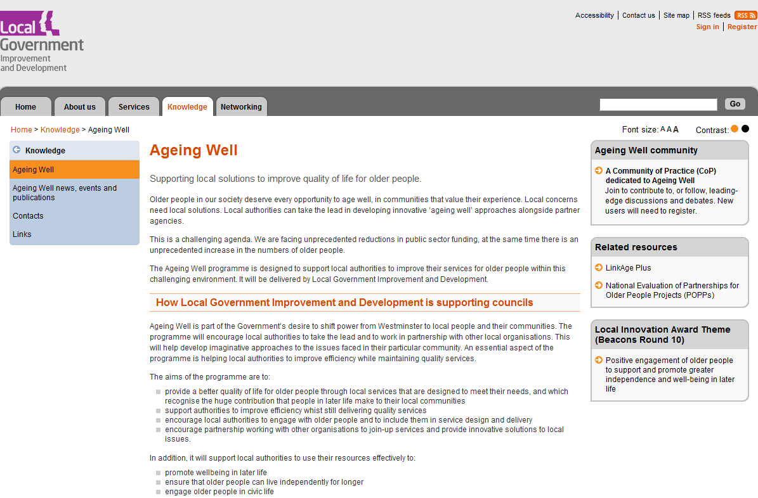
http://www.idea.gov.uk/idk/core/page.do?pageId=20344655

Journals
Study targets patient safety (COPD)
http://www.masslive.com/springfield/republican/index.ssf?/base/news-29/127667297623740.xml&coll=1

Association of Corticosteroid Dose and Route of Administration With Risk of Treatment Failure in Acute Exacerbation of Chronic Obstructive Pulmonary Disease
http://jama.ama-assn.org/cgi/content/abstract/303/23/2359

Diabetes patients admitted for acute exacerbations of COPD have longer hospital stay
http://www.eurekalert.org/pub_releases/2010-06/w-dpa062110.php

Obesity and diabetes: the links and common approaches
http://www.primary-care-diabetes.com/article/PIIS1751991810000495/abstract?rss=yes

Cell Phone + PHR = Diabetes Management
http://www.healthdatamanagement.com/news/cell-phone-phr-diabetes-pilot-40477-1.html

Poor Control of Diabetes May Be Linked to Low Vitamin D
http://www.sciencedaily.com/releases/2010/06/100621091209.htm

Use and utility of a 24-hour Telephone Support Service for ‘high risk’ patients with COPD
http://www.thepcrj.org/journ/view_article.php?article_id=721

Telephone calls from a nurse case manager helped reduce medical costs and hospital admissions for older type 2 diabetes patients
http://www.medpagetoday.com/MeetingCoverage/ENDO/20769

Daily mood, shortness of breath, and lung function in asthma: Concurrent and prospective associations
http://www.jpsychores.com/article/PIIS0022399910002199/abstract?rss=yes

Pharmacists reduce CV risk in diabetes
http://www.pulsetoday.co.uk/story.asp?sectioncode=23&storycode=4126457&c=2

GPs worried about effect of therapy in older diabetes patients
http://www.pulsetoday.co.uk/story.asp?storycode=4126440

Pulmonary Hypertension in Heart Failure
http://www.onlinejcf.com/article/PIIS1071916410000175/abstract?rss=yes

Hemoglobin A1c between 5.7 and 6.4% as a marker for identifying pre-diabetes, insulin sensitivity and secretion, and cardiovascular risk factors: The Insulin Resistance Atherosclerosis Study (IRAS)
http://care.diabetesjournals.org/content/early/2010/06/22/dc10-0679.short?rss=1

Intensively lowering glucose: Possible benefits must be weighed against risks
http://www.eurekalert.org/pub_releases/2010-06/uhcm-ilg062910.php

Cardiac Resynchronization Therapy in Mild Heart Failure: A Review of the REVERSE and MADIT-CRT Trials
http://www.metapress.com/content/t2x01n0350610087/

Current treatment of chronic heart failure in primary care; still room for improvement
http://www3.interscience.wiley.com/journal/123398881/abstract?CRETRY=1&SRETRY=0

Telemedicine may improve care in ICU
http://www.pharmacist.com/AM/Template.cfm?Section=Pharmacy_News&template=/CM/ContentDisplay.cfm&ContentID=23591
Use and utility of a 24-hour Telephone Support Service for ‘high risk’ patients with COPD (UK)
http://www.thepcrj.org/journ/view_article.php?article_id=721

Telerehabilitation Wheeled Mobility and Seating Assessments Compared With In Person
http://www.archives-pmr.org/article/PIIS0003999310000857/abstract?rss=yes

Is web interviewing a good alternative to telephone interviewing? Findings from the International Tobacco Control (ITC) Netherlands Survey
http://www.biomedcentral.com/1471-2458/10/351

Family Centred Care—A way to connect patients, families and nurses in critical care: A qualitative study using telephone interviews http://www.sciencedirect.com/science?_ob=ArticleURL&_udi=B6WGN-4YYVCM1-2&_user=10&_coverDate=06%2F30%2F2010&_rdoc=6&_fmt=high&_orig=browse&_srch=doc-info(%23toc%236827%232010%23999739996%231997743%23FLA%23display%23Volume)&_cdi=6827&_sort=d&_docanchor=&_ct=11&_acct=C000050221&_version=1&_urlVersion=0&_userid=10&md5=4fe13539337eef79d1b0fe655b580932

ADA: Diabetes Screening Cost Effective
http://www.medpagetoday.com/MeetingCoverage/ADA/20970

Nurse practitioner provided home telemonitoring and medication management improves glycemic control in primary care patients with type 2 diabetes more than monthly care coordination telephone call
http://ebn.bmj.com/content/13/3/74.short?rss=1&related-urls=yes&legid=ebnurs;13/3/74

Clinical effects of home telemonitoring in the context of diabetes, asthma, heart failure and hypertension: a systematic review
http://www.ncbi.nlm.nih.gov/pubmed/20554500

Introducing telemonitoring for diabetic patients: Development of a telemonitoring ‘Health Effect and Readiness’ Questionnaire http://www.sciencedirect.com/science?_ob=ArticleURL&_udi=B6T7S-50BBT28-1&_user=10&_coverDate=06%2F18%2F2010&_rdoc=1&_fmt=high&_orig=search&_sort=d&_docanchor=&view=c&_acct=C000050221&_version=1&_urlVersion=0&_userid=10&md5=5e592bae1374aaccbf2e617c53e125e1

Better Glucose Control Achieved With Medtronic's Sensor-Augmented Insulin Pump Therapy Than Daily Insulin Injections For In Patients With Diabetes
http://www.medicalnewstoday.com/articles/193292.php

Predictors of nursing home admission of individuals without a dementia diagnosis before admission - results from the Leipzig Longitudinal Study of the Aged (LEILA 75+)
http://www.biomedcentral.com/1472-6963/10/186/abstract
Telehealth enhances self care and independence in people with long term conditions (Cornwall)
http://www.hsj.co.uk/nursing-practice-clinical-research/long-term-conditions/telehealth-enhances-self-care-and-independence-in-people-with-long-term-conditions/5016822.article

Obesity, hypertension and home sphygmomanometer cuffs
http://www.ejinme.com/article/PIIS0953620510000907/abstract?rss=yes

Frailty and disability in the elderly: A diagnostic dilemma
http://www.aggjournal.com/article/PIIS0167494310001664/abstract?rss=yes

Doctor-Patient E-Mails Are a Healthy Addition, Research Shows - California study finds patients with better care and outcomes after the online exchanges
http://consumer.healthday.com/Article.asp?AID=640912

High Blood Sugar May Predict Future Diabetes
http://www.ivanhoe.com/channels/p_channelstory.cfm?storyid=24717

Home-Based Control By Patients With Hypertension Results In Greater Blood Pressure Drop
http://www.ivanhoe.com/channels/p_channelstory.cfm?storyid=24718

Depression may raise risk of dementia, Alzheimer's, study says
http://edition.cnn.com/2010/HEALTH/07/05/depression.dementia/index.html?fbid=snu4dtz7Ba0

Prevention of Overuse of Wheelchairs in Nursing Homes
http://www.annalsoflongtermcare.com/content/prevention-overuse-wheelchairs-nursing-homes

Study Sees Improved Outcomes for Patients Who E-Mail Doctors
http://www.ihealthbeat.org/articles/2010/7/8/study-sees-improved-outcomes-for-patients-who-email-doctors.aspx

Heart disease patients with anxiety 'at greater risk'
http://news.bbc.co.uk/1/hi/health/10507686.stm

Depression may double dementia risk, say researchers
http://news.bbc.co.uk/1/hi/health/10507074.stm

Obesity among over 65s in UK reflects "lifetime of gaining weight"
http://www.bmj.com/cgi/content/extract/341/jul05_1/c3585

A telephone hotline for transient ischaemic attack and stroke: prospective audit of a model to improve rapid access to specialist stroke care
http://www.bmj.com/cgi/content/extract/341/jul02_1/c3265

Diabetes May Complicate COPD Hospital Admissions - Diabetes patients admitted for COPD exacerbations have trends toward longer stay, higher mortality
http://www.modernmedicine.com/modernmedicine/Endocrinology/Diabetes-May-Complicate-COPD-Hospital-Admissions/ArticleNewsFeed/Article/detail/676017?contextCategoryId=40172

Safety assessment of a home-based telecare system for adults with developmental disabilities in Indiana: a multi-stakeholder perspective
http://jtt.rsmjournals.com/cgi/content/short/16/5/265?rss=1

Blood Pressure and Diabetes: How Low Should You Go?
http://diabetes.webmd.com/news/20100706/blood-pressure-and-diabetes-how-low-should-you-go

Do Diabetic Veterans Use the Internet? Self-Reported Usage, Skills, and Interest in Using My HealtheVet Web Portal
http://www.liebertonline.com/doi/abs/10.1089/tmj.2009.0164

Remote Health Monitoring Using Mobile Phones and Web Services
http://www.liebertonline.com/doi/abs/10.1089/tmj.2009.0165

Exploring Perceptions of Healthcare Professionals in the Implementation of a New Professional Role of Clinical Telehealth Coordinator Within a University Integrated Healthcare Network
http://www.liebertonline.com/doi/abs/10.1089/tmj.2009.0154

Development and Recent Achievements of Telemedicine in China
http://www.liebertonline.com/doi/abs/10.1089/tmj.2009.0159

Planning for Internet Connectivity in Remote Patient Monitoring
http://www.liebertonline.com/doi/abs/10.1089/tmj.2009.0137

Med-e-Tel 2010: International e-Health, Telemedicine, and Health ICT Forum
http://www.liebertonline.com/doi/abs/10.1089/tmj.2010.9963

Economic evaluation in telemedicine – still room for improvement
http://jtt.rsmjournals.com/cgi/content/abstract/16/5/229

Transcultural telepsychiatry and its impact on patient satisfaction
http://jtt.rsmjournals.com/cgi/content/abstract/16/5/237

Incident reporting in nurse-led national telephone triage in Sweden: the reported errors reveal a pattern that needs to be broken
http://jtt.rsmjournals.com/cgi/content/abstract/16/5/243

Intercontinental hearing assessment – a study in tele-audiology
http://jtt.rsmjournals.com/cgi/content/abstract/16/5/248

Home telemonitoring and quality of life in stable, optimised chronic obstructive pulmonary disease
http://jtt.rsmjournals.com/cgi/content/abstract/16/5/253

Use of a mobile phone diary for observing weight management and related behaviours
http://jtt.rsmjournals.com/cgi/content/abstract/16/5/260

Safety assessment of a home-based telecare system for adults with developmental disabilities in Indiana: a multi-stakeholder perspective
http://jtt.rsmjournals.com/cgi/content/abstract/16/5/265

Evaluation of a mobile phone-based diet game for weight control
http://jtt.rsmjournals.com/cgi/content/abstract/16/5/270

Feasibility of dynamic cardiac ultrasound transmission via mobile phone for basic emergency teleconsultation
http://jtt.rsmjournals.com/cgi/content/abstract/16/5/281

The use of text messaging to improve asthma control: a pilot study using the mobile phone short messaging service (SMS)
http://jtt.rsmjournals.com/cgi/content/abstract/16/5/286

Need and feasibility of telemedicine in non-urban day care centres
http://jtt.rsmjournals.com/cgi/content/abstract/16/5/276

Diet and exercise in the prevention of diabetes http://www3.interscience.wiley.com/journal/123328112/abstract?CRETRY=1&SRETRY=0

Effect of Telecare Management on Pain and Depression in Patients With Cancer
http://jama.ama-assn.org/cgi/content/short/304/2/163?rss=1

Alzheimer's management from diagnosis to late stage
http://www.clinicaladvisor.com/alzheimers-management-from-diagnosis-to-late-stage/article/173456/

How telehealth can increase the effectiveness of chronic heart failure management (Bristol)
http://www.hsj.co.uk/nursing-practice-clinical-research/long-term-conditions/how-telehealth-can-increase-the-effectiveness-of-chronic-heart-failure-management/5016827.article

Telemedicine for Stroke
http://loan.204.at/?p=17270

Self-management of hypertension effective measure to lower BP
http://www.cardiologytoday.com/view.aspx?rID=66677

Hypertension monitored better from home: study
http://www.cbc.ca/health/story/2010/07/08/blood-pressure-home.html

Lancet: Telemonitoring, self-care is wave of future for hypertension
http://www.cmio.net/index.php?option=com_articles&view=article&id=23052&division=cmio

Intervention May Help Relieve Cancer Patients' Pain, Depression - Combining high-tech and human interaction yielded psychological, physical benefits, study found
http://www.businessweek.com/lifestyle/content/healthday/641029.html

Multifactorial Intervention to Reduce Falls in Older People at High Risk of Recurrent Falls
http://archinte.ama-assn.org/cgi/content/abstract/170/13/1110

Telemonitoring and self-management in the control of hypertension (TASMINH2): a randomised controlled trial
http://www.thelancet.com/journals/lancet/article/PIIS0140-6736(10)60964-6/abstract

Fall injuries cost NHS Highland £11m to treat
http://www.bbc.co.uk/news/10350015

Dementia in Diabetics Differs from Dementia in Nondiabetics, Research Finds
http://www.sciencedaily.com/releases/2010/07/100714192305.htm

Diabetes Risk: Waist Circumference Gives Better Prediction Than BMI
http://www.sciencedaily.com/releases/2010/07/100715091704.htm

Wireless Technologies, Ubiquitous Computing and Mobile Health: Application to Drug Abuse Treatment and Compliance with HIV Therapies
http://www.springerlink.com/content/ltr0320304771537/

Smoking Cessation May Actually Increase Risk of Developing Type 2 Diabetes
http://www.mdlinx.com/nursing/newsl-article.cfm/3223763/ZZ6821644550261362285079/?news_id=531&newsdt=071410&subspec_id=164

Heart Failure On The Rise For Men Who Can’t Sleep
http://www.mdlinx.com/nursing/newsl-article.cfm/3224087/ZZ6821644550261362285079/?news_id=531&newsdt=071410&subspec_id=164

Blood pressure variables and cardiovascular risk in type 2 diabetes in the ADVANCE trial
http://www.john-libbey-eurotext.fr/en/revues/medecine/stv/e-docs/00/04/59/A3/resume.phtml

Approach to major depression in old people
http://journals.cambridge.org/action/displayAbstract?fromPage=online&aid=7821960

Hypertension Risk Score for Middle-Aged and Older Adults
http://www3.interscience.wiley.com/journal/123579916/abstract?CRETRY=1&SRETRY=0

4 Diary for telecare and telehealth events and conferences
September
INTERNATIONAL CONFERENCE ON THE EFORTT PROJECT Ageing with technologies 13-14 Sep 2010
http://acaia.org/content/international-conference-efortt-project-ageing-technologies-13-14sep10-bcn

Taking charge: evidence for self care in the UK
The next SDO Network interactive learning seminar will feature health service researchers and health and social care leaders sharing and discussing the latest evidence on self care. Birmingham – 21 September 2010
http://www.nhsconfed.org/Events/Pages/TakingChargeEvidenceForSelfCare.aspx?utm_source=twitterfeed&utm_medium=twitter

October
Healthcare IT Exchange 2010
3-5 October 2010 http://www.healthcareitexchange.co.uk/

NHS Innovation Expo (Excel Centre) – 6/7 October 2010 – postponed until March 2011
http://www.healthcareinnovationexpo.com/

Enabling cost-effective management of long-term conditions - Mainstreaming telecare and telehealth
The King’s Fund 19 October 2010
http://www.kingsfund.org.uk/events/enabling.html

Mobile Health Expo, Las Vegas 19-21 October 2010
http://mobilehealthexpo.com/index.htm

2010 Connected Health Symposium - October 21-22 2010
http://www.connected-health.org/events/symposium-2010.aspx

November
mHealth Summit 2010 – 8-10 November 2010, Washington
http://www.mhealthsummit.org/

Global Telehealth 2010 (GT2010) – 10-12 November 2010, Perth, WA
http://www.ehealthserver.com/conferences-and-events/429-call-for-papers-global-telehealth-2010-gt2010
UK Dementia Congress 2010, 9-11 November at the Bournemouth International Centre. http://www.careinfo.org/uk-dementia-congress.php

Evidence 2010 – 1-2 November 2010 BMA House, London http://evidence2010.com/?utm_campaign=7548437&utm_content=46681577336&utm_medium=email&utm_source=Emailvision

National Telecare & Telehealth Conference 2010 15-17 November 2010, London http://www.telecare.org.uk/information/48440/conference_10/

Raate 2010 29 November 2010, University of Warwick http://www.raate.org.uk/

2011

February
The Third International Conference on eHealth, Telemedicine, and Social Medicine
http://www.wikicfp.com/cfp/servlet/event.showcfp?eventid=10262&copyownerid=11691
http://www.iaria.org/conferences2011/eTELEMED11.html

March
International congress on Telecare and Telehealth, The King’s Fund 2-3 March 2010
http://www.kingsfund.org.uk/events/telecaretelehealth.html

The Foundation for Assistive Technology (FAST) provides a full listing of forthcoming telecare events – see http://www.fastuk.org/services/events.php?pg=2. Suppliers also run telecare and telehealth events – check their web sites regularly for dates.

All previous telecare eNewsletters are available at: www.dhcarenetworks.org.uk/telecarenewsletters

