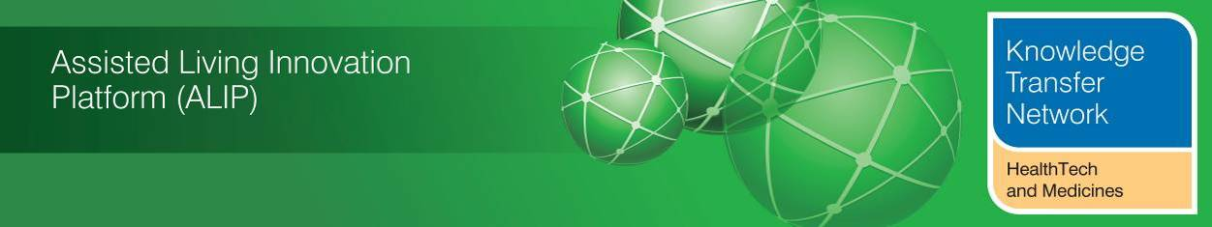
NEWSLETTER
February 2014
Welcome to the February 2014 newsletter from the Technology Strategy Board (TSB) HealthTech Knowledge Transfer Network and the Telecare Learning and Improvement Network.

Launched October 2005, our free monthly newsletter is now distributed to 48,000 subscribers in the UK and worldwide via e-mail and archived at www.telecarelin.org.uk. You can also find highlights on Rebelmouse (daily) or by following Mike Clark on Twitter (@clarkmike).

With over 800 news and events links over the last month, we hope that you find this newsletter useful. There is also an additional supplement covering some of the important journal articles from 2013.

NHS Expo in early March 2014 will be setting the scene for 2014/5 as the NHS faces a potential funding gap of £30bn, more foundation trusts are heading towards deficits, there are talks of CCG mergers and a headline project, care.data, has now been moved to an Autumn start so that public awareness can be raised. Meanwhile, local authority social care services are going through a further round of budget cuts, although some money will be transferred from the NHS during 2014/15 to maintain services. It will be a difficult period for the NHS as they look to transfer £2bn of funds from primarily hospital services into the Better Care Fund pooled budgets for 2015/2016. It is a crucial time for services that use technology to demonstrate that they are cost-effective and help to improve outcomes – services not included in local pooled funds as priorities to support people in the community could become marginalised. Meanwhile, the big tech companies (Google, Apple, Samsung, Microsoft) appear to be investing heavily in consumer, mobile health and wellbeing applications. With announcements and publications hourly it can be difficult to follow what is happening. You can keep up to date with developments in this newsletter, via the KTN and dallas groups as well as following Twitter, LinkedIn and other recommended news streams.

For weekly news, updates and information, you can register with the Technology Strategy Board, ALIP group and the dallas sub-group and follow the HealthTech KTN. You can follow the dallas programme on Twitter at @dallas_connect. 3 Million Lives is on LinkedIn. You can also access a Twitter Stream via the TelecareLIN website.

Contents

Item 1 – News from ALIP (Assisted Living Innovation Platform), the Knowledge Transfer Network (HealthTech and Medicines KTN) and dallas – Page 3
Item 2 – Latest news from Telecare Services Association (TSA) – Page 6
Item 3 – Housing LIN Conference – Page 8
Item 4 – Upcoming conferences – Page 9
Item 5 – Better Care Fund – Page 12
Item 6 – UK policy announcements – Page 13
Item 7 – Other news – Page 17
Item 8 – Summary list of recent journal articles and evaluations – Page 29
Item 9 – Learning and Events – Page 30
Item 10 – Other useful links – Page 31
The newsletter is
Prepared by Mike Clark (Twitter: @clarkmike and http://storify.com/clarkmike) for the HealthTech and Medicines KTN, ALIP Knowledge Transfer Network and Telecare Learning and Improvement Network.
There are two supplements this month – the normal monthly links supplement and a further supplement covering journal articles from 2013.

Links Supplement (pdf, doc)
Journals Supplement (pdf, doc)

You can check how 152 health and wellbeing boards plan to reinvest £3.8bn of health and care funding at #BetterCareFund Watch.
Item 1 – News from ALIP (Assisted Living Innovation Platform), the Knowledge Transfer Network (HealthTech and Medicines KTN) and dallas
(i) Scoping reports for the Long Term Care Revolution SBRI Challenge – Now Available for Members to Access
The Assisted Living Innovation Platform team is pleased to launch the availability for members to access a series of scoping reports for the Long Term Care Revolution SBRI Challenge. There are four reports in this series.
- The status of housing provisions for older adults in the UK and other EU countries
This report outlines the case for a revolution in long term care and captures some of the supporting material that has aided the development of the Technology Strategy Board's 'Long Term Care Revolution' Programme. It includes evidence about the views of older people and their carers in the UK, lessons from abroad, the implications for industry/providers and makes recommendations to government and industry leaders.
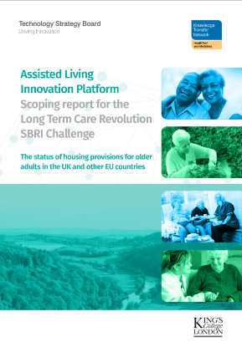
Written by Anthea Tinker, Leonie Kellaher, Jay Ginn and Eloi Ribe at the Institute of Gerontology, Department of Social Science Health and Medicine, King's College London for the Technology Strategy Board.
Reproduced here by the Health Tech and Medicines KTN
- A study of innovatory models to support older people with disabilities in the Netherlands
This study was undertaken to see what can be learned from the experience of the Netherlands about long term care in order to inform policy, research and practice in the UK. The comprehensive analysis of the two countries has also been used to help the Technology Strategy Board’s Programme - the Long Term Care Revolution – with examples of innovation and best practice in adult social care provision in a country similar to the UK in many ways. Of particular interest is that while the two countries are very similar in demographic profile and the experiences of the older generation, it is notable that according to official statistics older individuals remain disability-free for nearly half a decade longer in the Netherlands than in the UK.
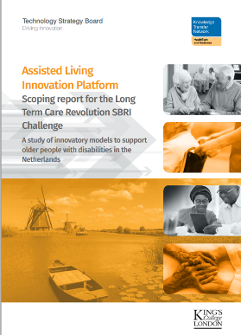
Written by Anthea Tinker, Jay Ginn and Eloi Ribe at the Institute of Gerontology, Department of Social Science, Health and Medicine, King’s College London for the Technology Strategy Board.
Reproduced here by the HealthTech and Medicines KTN
(c) Analysis of UK Long Term Care Market
This report has been prepared by Frost & Sullivan on behalf of the Technology Strategy Board and Assisted Living Innovation Platform, to support The Long Term Care Revolution programme launched on 8 April 2013. It sets out to examine the economic research in the current care market and to make some analyses/extrapolations of future market potential. It therefore forms one aspect of the business case to invest new research, development and innovation for radical change in care provision which opens up the potential for significant market growth in both products and services for the UK market and beyond.
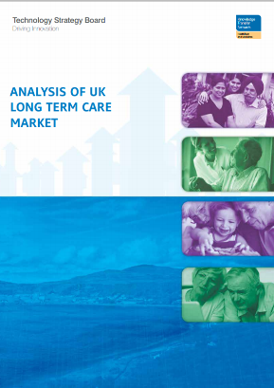
Reproduced here by the HealthTech and Medicines KTN
- The lived experience of older adults
The Lived Experience report has been produced by Experience Research and Consulting Limited and is one part of the overall social and economic research commissioned by the TSB. Intrinsic to the project was deemed to be an exploration of the lived experience of a range of people, either already in a long-term care setting, working in such a setting, or being at different life stage but with an eye to what the future might bring.
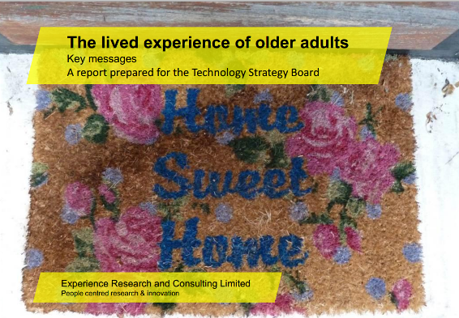
(ii) eRedbook at the UK baby and Toddler Show
The UK baby and Toddler show took place over the weekend of 1st and 2nd February 2014 at the Echo Arena and Conference centre in Liverpool. Liverpool Community Health NHS Trust took a stand at the event as it was seen as an opportunity to engage with new and expectant parents about the services and support they will receive during those crucial early months and years. The key focus was the role of the Health Visitor, information about breast feeding and encouraging parents to participate in the trial of the eRedbook.
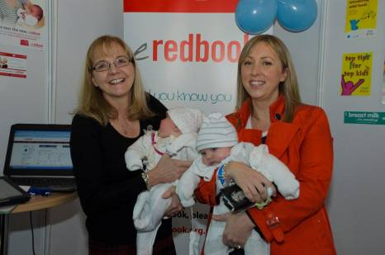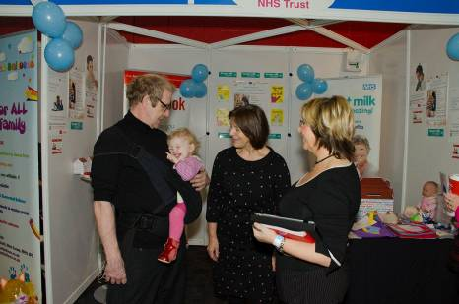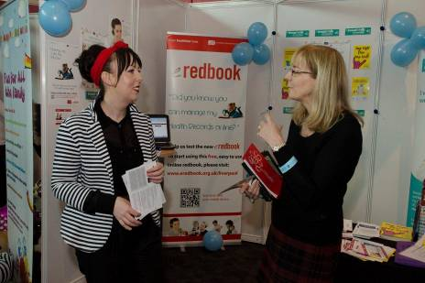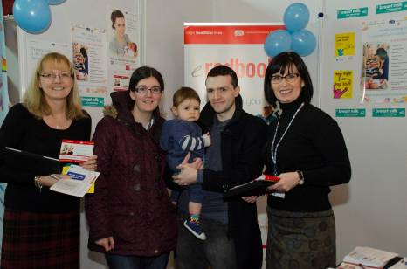
eRedbook is a new digital version of the current Personal Child Health Record (Red Book) which enables parents to manage their child’s personal health records on-line. It can be updated to provide real time information about a child’s health, growth, immunisations and development each time a child visits a health professional. In addition parents can add their own information and photos so it becomes a complete record of the first smile, steps and words providing parents with the practical solution of having all their child’s health information on hand but also an opportunity to store memories for the future.
The project to develop eRedbook is part of the Year Zero ‘dallas’ programme funded by the Technology Strategy Board and supported by the Royal College of Paediatrics and Child Health. eRedbook is being piloted in Liverpool, Sefton and South Warwickshire.
The Baby and Toddler show event was attended by over 20,000 members of the public. The Liverpool Community Health stand was staffed by Health Visitors, Nursery Nurses and the local Year Zero lead over the weekend where they spoke at length to over 200 parents. Attendance was from local parents plus many from across the North West and as far afield as West Yorkshire and the Midlands. The majority of parents expressed a real interest in eRedbook. Local parents were aware of the project as they had been provided with information and discussed eRedbook with their own Health Visitor. One parent reported she was already using the eRedbook and was really pleased with it.
Jane Banks, Year Zero Lead for Year Zero commented ‘It was great to get out and about and meet people who would be the primary users of the project. The local Health Visitors and Nursery Nurses were great at promoting the project and it was good to see at first-hand how enthusiastic parents were about the concept.
For more information please visit the eRedbook website at www.eredbook.org.uk/liverpool
For more information about health visiting and other services provided by Liverpool Community Health, please visit www.liverpoolcommunityhealth.nhs.uk
Item 2 – Latest news from the Telecare Services Association (TSA)
Contributed by Loretta MacInnes, Telecare Services Association (@teleservassoc)
(i) MOST (Model for Optimising Sustainable Telehealthcare)
Telecare Services Association (TSA) has been appointed to critique the ‘Model for Optimising Sustainable Telehealthcare’ (MOST) project on behalf of the Technology Strategy Board. A thought paper will be produced to:
- Make recommendations as to what elements of the toolkit could support the delivery of the national framework being put together as part of the 3millionlives programme with NHS England. The aim of this would be to avoid duplication and ensure it is future proof.
- Recommend how the MOST toolkit could be used to support organisations to diversify from Telecare to Telehealth.
As part of this work, TSA will review how MOST aligns with:
- Service Management Standards, including the TSA Integrated Code of Practice
- System and Technology Standards for large scale deployments - EN50134
- System and Technology standards that address quality of Service in changing communications environments – including Ofcom engagement
For more information please contact Alyson Bell: alyson.bell@telecare.org.uk
(ii) Lancashire Training contract
Our members have told us that work to raise awareness, and understanding, of how technology enabled care services can make a real difference for health and social care professionals is essential in order to achieve the much needed changes across health and social care. TSA has been awarded the contract to develop a robust bespoke training programme for social care professionals. This training will be focused on how to build telecare provision into mainstream social care provision, with the development of the assessment process a crucial element. This will be co-designed with social care workers, OTs and Reablement professionals, together with telecare providers and key stakeholders across Lancashire.
For more information please contact Alyson Bell: alyson.bell@telecare.org.uk
(iii) Stop and Go
The Stop and Go EU project has now been given approval. This project will help address the major issue of procurement by developing a European template for the procurement of telecare services. The four partners are: TSA, LSE, North West NHS and North West ASHN.
For more information please contact Trevor Single: trevor.single@telecare.org.uk
(iv) All Party Parliamentary Group (APPG) Telehealth
TSA is now secretariat for the APPG Telehealth. The Chair of this group is John Pugh MP. The next meetings have been set for this group, with the first agenda just being finalised. One focus for the agenda will be how to mandate the changes needed to enable technology enabled care and support to facilitate true change across health and social care. TSA members will be updated on the agenda, dates and invitations shortly.
For more information please contact Loretta MacInnes: loretta.macinnes@telecare.org.uk
(v) Scottish Member Event: 12 March 2014 Hampden Park, Glasgow
2014 is set to be a year of transition for technology enabled care services (TECs). Our health and social care services are facing increasing demands from an ageing population, and these demands will continue to grow. These services must evolve now if they are to continue to offer high quality services to all of us at our time of need.
TSA member events offer our members and our wider stakeholders involved in this health and social care reform, the opportunity to tackle the barriers we face to enable technology enabled services to make that much needed difference. Technology is used in most aspects of our lives and has revolutionised service levels and produced real efficiencies. Health and social care are indeed the final frontiers for this revolution and our members are at the coal face of this transition.
The first of these events is scheduled for 12 March 2014 and will be held at Hampden Park, Glasgow. Invitations have gone out to TSA members and to key stakeholders and partner organisations. Places are filling fast for this free event.
Further information, including the full programme and online booking form, can be found on our website: Scottish Member Event. You can also contact the TSA Office on 01625 520320 or email: admin@telecare.org.uk
Item 3 – Housing LIN Conference
The Housing LIN Conference on 18 February 2014 saw some excellent presentations and workshops with a range of new resources made available.
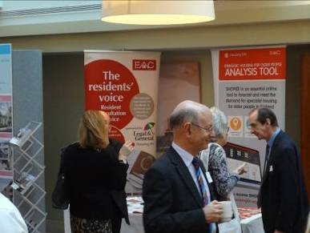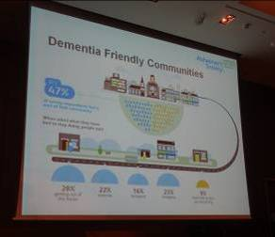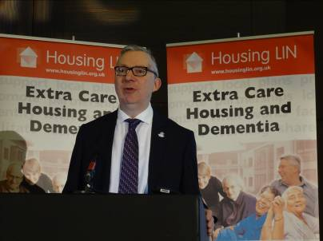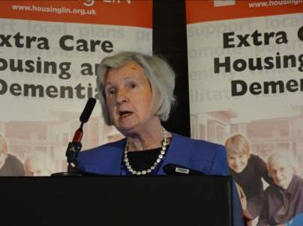
Left to Right: Jeremy Porteus (Housing LIN), Jeremy Hughes (Alzheimer’s Society), Profession Anthea Tinker (King’s College London)
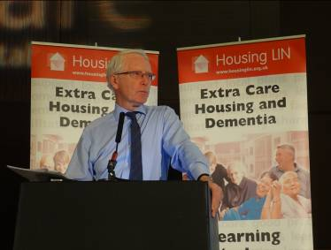 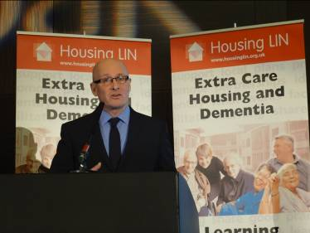 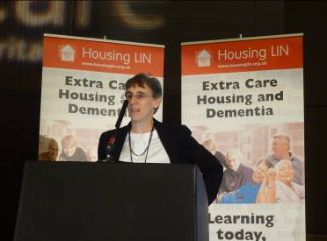
Left to Right: Lord Filkin, John Mathers (Design Council), Terrie Alafat (DCLG)
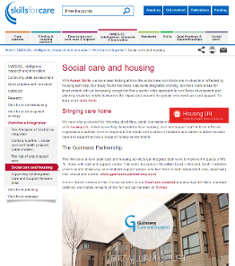
Resources currently available from the conference include: Slides, Videos (Integrated Care and Support at Home, Bringing Care Home – Guinness Partnership and SEQOL) on Skills for Care website, Storify of Twitter coverage. Read more about the conference in the upcoming March newsletter.
Item 4 – Upcoming conferences
(i) Call for papers launched for The King’s Fund’s International Digital Health and Care Congress 2014

The King’s Fund’s International Digital Health and Care Congress will bring together researchers, policy makers, practitioners and innovators interested in the design and application of technologies that will support improvements in the care of people with long-term conditions and other health and social care needs. In particular the event focuses on new ideas, new research and new innovations in:
- digital health
- mobile health
- telehealth and telecare
The call for papers has recently been launched and the congress organising committee is inviting submissions of projects, for both oral and poster presentations, related to the issues and themes of the congress:
- sustaining independence as people age
- preventing and managing chronic illness effectively
- supporting people with mental health issues
- digitally enabling service transformation
- innovations in technology
If you’re interested in finding out more about the submission process then please visit the congress webpage on The King’s Fund’s website. Papers must be submitted by 31 March 2014.
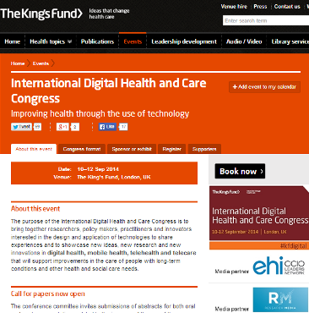
Contact: Caroline Viac, Conference Director International Digital Health and Care Congress 2014, The King’s Fund c.viac@kingsfund.org.uk Tel: 020 7307 2481
(ii) Health and Care Innovation Expo 2014 – 3 to 4 March 2014
Around 10,000 people are expected at the Health and Care Innovation Expo 2014 on 3 and 4 March 2014 in Manchester – programme details and speakers are now available.
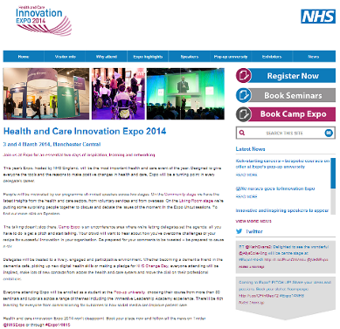
(iii) Telehealth and Telecare 2014 – 8 to 9 May 2014
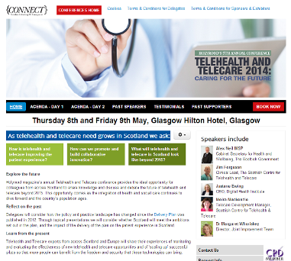
Details are now available on this year’s Holyrood telehealth and telecare event in Glasgow in May 2014.
(iv) European Knowledge Tree Technology Group (EKTG) 2014 Conference – 24 to 25 March 2014
EKTG aims to bring together key players from industry, finance, public and private stakeholders, user groups, policy makers for its next event on 24 & 25 March, 2014 at the London School of Economics.
Speakers include:
Victoria MacDonald, Channel 4 TV NEWS; Karen Taylor, Deloitte, London, UK; Alan Willis, recently National Westmister Bank; Andrew Browne, CEO, British Bankers Association; Steve Bonner, Walkerburn Watch Healthy Living Project, Lino. PAULA, EU Ethical Issues, Brussels; Peter Wintlev-Jensen, INFSO, ICT for Ageing, EU, Brussels; Peter Saraga, Advisory Board, AAL Forum; Baroness Barker, UK Parliament Mental Capacity Act 2005 Committee; Professor Martin Knapp, PSSRU, LSE; Giovanna Galasso, Price Waterhouse, Rome, Italy; Laura Herrero Urigüen, IFIMAV, Spain; Professor Heinz Wolff, Brunel University; Sofia Moreno Perez, ETICAS R&C, Madrid; Gwyn Hughes, UKCHIP; Colin Ettinger, Irwin Mitchell Personal Injury Solicitors; Ron Wheatcroft, Swiss Re Life and Health; Edwin Mermans. Senior Policy Officer, Dept. Social and Cultural Devel, Province Noord-Brabant; Gerald Bauer, University of Kaiserlautern, Germany; José Angel Martínez Usero, Funka Nu AB, Madrid; Trevor Single, CEO, TSA; Tony Hunter, GreenAccess, UK; Dr Kate Corlett, Ass Medical Director, Newham Primary Care; Jane Sylvester, National Institute for Health and Care Excellence; Melanie Doyle, NatCen Social Research, London; Dave McDaid, LSE, and WHO; Sabine Lobnig, Mobile Manufacturers Forum, Vienna; Charles Lowe, Royal Society of Medicine; Rich Walker, Shadow Robot Company Ltd.; Rebecca Malin, Head of Business Development and Investment, Airedale NHS Foundation Trust; Speakers from SCIE, BUPA, and The Law Commission.
The European Knowledge Tree Group (EKTG) has met periodically since the Ambient Assisted Living Forum in Odense in 2010. Recent meetings include sessions at AAL 2013 in Sweden and at the TSA event in Birmingham. It is an ad hoc high level group drawn from across technology, finance, service, policy and innovation sectors. It has drilled into the barriers and drivers around mainstream market uptake of independent living services.
EKTG topics include:
- Bringing effective actors together to plan real change
- Accelerating uptake of ICT & Ageing Solutions
- Determining impact indicators and methodologies for real goals
- Generic business drivers and barriers
- Health and care market reforms,
- Procurement and contract implications
- Persistence of knowledge (including real impact from research)
- Impact of the market East, West, where does that leave you?
- The real meaning of Horizon 2020, is there one or just more words?
On 24 and 25 March the EKTG will meet again in London to consider:
- How does technology and care procurement take place?
- Large numbers of pilots and demonstrators have taken place….Why not in the mainstream?
- How do we educate the people who need it?
- How do we pay for what’s needed?
- What are the costs and systems of care
- What can technology do for: Diabetes, Heart Disease, Mental Health, Sensory Deficits?
- How can we transfer technology from field to field, nano to macro technologies?
- Legal, ethical, and regulatory issues – do you meet them?
- Persuading the politicians, or are they just too short-term?
If you are interested in presenting a paper, exhibiting or sponsoring at this prestigious event please submit an abstract (no more than 800 words) by 28 February 2014 to Maggie Ellis at ELLISM1@LSE.ac.uk or Nigel Rix at nigel.rix@espktn.org
(v) Technology, Care and Ageing: Enhancing Independence (AKTIVE Project) – 8 to 9 April 2014
There are still places available for ‘Technology, Care and Ageing: Enhancing Independence’ at the University of Leeds on 8-9 April 2014. During the two days, the results of AKTIVE, a three-year research project funded by the Technology Strategy Board’s Assisted Living Innovation Platform scheme, will be presented together with other related research and industry experience from a wide range of over 60 speakers. The full programme is available online.

Some exhibitor packages are still available and start at just £200 for both days. To find out more information about registration, exhibiting opportunities or the programme, please go to http://aktive.org.uk/2014_delegates.html
Item 5 – Better Care Fund
The deadline (15 February 2014) for the first cut of 152 Better Care Fund Plans has now passed. The 152 local authorities and 211 clinical commissioning groups in England will have outlined how they will reinvest £3.8m in 2015/2016 in addition to the further NHS funding transfer to local authorities in 2014/15.
Few plans were submitted to full Health and Wellbeing Boards (HWBBs) at an advanced stage before the first deadline - many were relying on a partly-completed template. From the agenda items, much work was still to be done to get a sign-off before the deadline. Some Health and Wellbeing Boards have not met since 2013, so their first cut plans must have been signed off under delegated authority without public discussion.
In the meantime, local authorities have been passing their budgets with substantial cuts to social care budgets. These will probably be covered ultimately by the NHS transfer of money to local authorities in 2014/15. Because of the timing of the first draft plans, HWBBs are unlikely to have had final details on social care cuts. It needs to be remembered also that there will be another budget round with prospective cuts before the main 2015/2016 pooling of funds.
Examples of local authority budget decisions covered by news services:
- Essex bit.ly/1mnMVhN
- Kent bit.ly/1mnKUC7
- Lancashire bbc.in/1mnL7oO
- Leeds bit.ly/1mnNyHZ
- Manchester Councils bit.ly/1mnNWGw
- Suffolk bbc.in/1mnNfwW
- Surrey bit.ly/1mnLyzn
- Warwickshire bit.ly/1jvj95t
Also noticeably absent from the draft plans submitted to HWBBs at this early stage was a clear indication as to where the NHS money would come from eg decommissioning a specific hospital or community service to move money into the pool. There were indications that discussions were being held with service providers but no early clues as to the areas that would lose funding and the impact of moving what could be up to £80-100m in larger areas into a pooled fund. Where there are multiple CCGs in a local authority area eg Kent (7 CCGs - 17 documents submitted to HWBB meeting) there is the possibility of multiple pooled funds. The total amount of health money to be moved in 2015/16 is around £2bn.
HWBBs will continue to meet and discuss Better Care Fund Plans through to April 2014 (and beyond). There will no doubt be plenty of amendments to plans following detailed scrutiny. In addition, there are likely to be mergers of clinical commissioning groups – the first of which could be the two Newcastle CCGs with Gateshead (subject to consultation and NHS England agreement).
As we reach April/May 2014 there should be a better indication as to how health and care services will integrate technology (telecare, telehealth, mobile health, health and care records) into their plans.
Item 6 – UK policy announcements
Here is a roundup of UK policy news over the last month. A fuller listing is available in the supplement (pdf, doc).
(i) NHS England has delayed implementation of care.data until Autumn 2014. Here is an extract from the NHS England article on 18 February 2014:
“To ensure that the concerns of the BMA, RCGP, Healthwatch and other groups are met, NHS England will:
- Begin collecting data from GP surgeries in the Autumn, instead of April, to allow more time to build understanding of the benefits of using the information, what safeguards are in place, and how people can opt out if they choose to;
- Work with patients and professional groups – including the BMA, RCGP and Healthwatch – to develop additional practical steps to promote awareness with patients and the public, and ensure information is accessible and reaches all sections of the community, including people with disabilities;
- Look into further measures that could be taken to build public confidence, in particular steps relating to scrutiny of ways in which the information will be used to benefit NHS patients;
- In the meantime we will work with a small number of GP practices to test the quality of the data. This will be voluntary”
(ii) NHS England has published a new document called ‘Safe, compassionate care for frail older people using an integrated care pathway’.
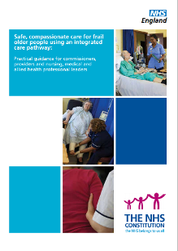
(iii) NHS England publishes a weekly report which includes statistics for A&E waiting times – here is the latest for 21 February 2014.
(iv) There are some useful examples in NHS England’s new report on ‘National Pathology Programme – Digital First’.
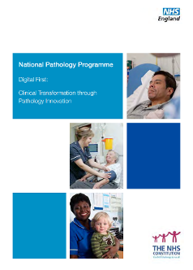
(v) It is one year on from the Francis Report – so what’s changed? Here are recent DH comments and infographic (a further report is due in November 2014).
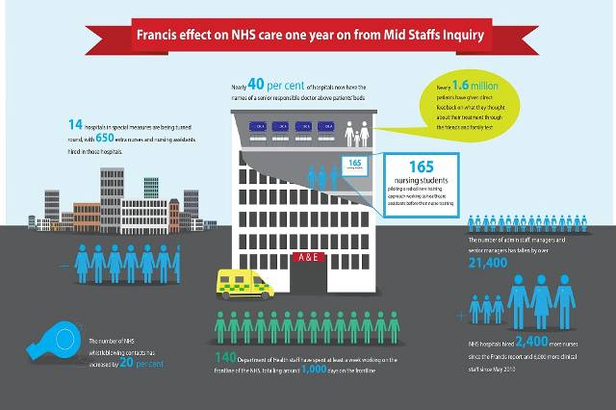
(vi) From 1 April 2014, GP practices in England will be offered the opportunity to take part in an enhanced service which is designed to reduce avoidable unplanned admissions by improving services for the most vulnerable patients and those with complex physical or mental health needs.

The key components of the enhanced service will be for practices to:
- ensure that other clinicians can easily contact the practice by telephone to support decisions relating to hospital transfers or admissions;
- carry out regular risk profiling to identify at least two per cent of adult patients – and any children with complex needs – who will benefit from more proactive care management;
- provide proactive care and support for at-risk patients through developing and regularly reviewing personalised care plans and by ensuring they have a named accountable GP and care coordinator;
- work with hospitals to review and improve discharge processes and undertake internal reviews of unplanned admissions/readmissions.
All of these elements, taken together, will lead to GPs being more ‘accountable’ for coordinating the care of patients with more complex needs.
(vii) NHS Citizen (@NHSCitizen) has launched its online forum for sharing thoughts and ideas which will feed into the NHS Assembly.
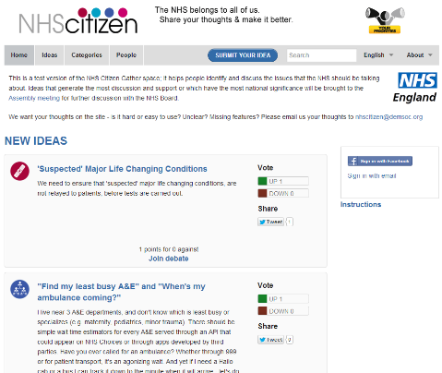
(viii) The Department of Health has issued updated guidance on NHS terms and conditions for procuring goods and services.

(ix) NHS England has issued guidance to support commissioners who are currently developing their 5 year strategic plans. The CCG Allocation Growth Projections 2016/17 to 2018/19 sets out some high level planning assumptions that CCGs can use when considering how to project growth in allocations in years 3 to 5 of the planning period. A letter regarding allocation growth assumptions to support strategic planning has been sent to CCGs.
(x) NHS England has indicated that there has been a huge response to the £100m Nursing Technology Fund. NHS England has received over 220 applications from 140 health Trusts around the country bidding for part of the £100m Fund. Funding is split between projects which can be delivered in 2013/14 (£30m) and 2014/15 (£70m). The deadline for 2013/14 funding has closed and the deadline for expressions of interest for 2014/15 is open until 26 February 2014.
(xi) On the eve of his retirement, NHS England CEO Sir David Nicholson sets out the transformational changes needed to improve care in the coming years.
“There are two big reasons why we need to do things differently. Firstly, the NHS has to transform the way it provides care in order to deliver better outcomes for patients.
We have an ageing population, with a rapidly growing number with at least one long-term condition – currently 15 million people. If the NHS is to truly serve the public, we must offer the best possible quality of life to this expanding group of patients.
Secondly, the NHS has to change because, like every major health system in the world, we face a big financial problem for the future: the sums don’t add up. If we don’t change, we face a funding gap that could be £30 billion by 2021.
Our costs are rising as people live longer and we constantly improve our ability to treat and manage conditions that were once life threatening. At the same time, we live in a time of austerity and we cannot bet on further funding increases.
Some will point out that we recently embarked on a major NHS reorganisation, which took effect only last year. But this government’s Health and Social Care Act focused, with good reason, on administrative structures.
These next changes must focus on the practical ways we deliver front-line care in our communities. They must be recommended, led and built by clinicians on behalf of patients, from the bottom up rather than top down, harnessing the innovations and ideas of our people”.
(xii) A new alerting system (NPSAS) launched by NHS England will ensure warnings of potential risks to the safety of patients can be developed much more quickly and be rapidly disseminated right across the NHS.
(xiiii) Sir Stuart Rose is to advise on NHS leadership in a ‘Super-heads’ review on how best NHS CEOs could take-on failing hospitals.
(xiv) There is a new Framework agreement between the Department of Health and NHS England which sets out their respective responsibilities.

(xv) The Department of Health in England has published a ‘Wellbeing and Health Policy’ with a number of reports:
Wellbeing and why it matters to health
A summary of key points
Starting well (pregnancy to 5 years)
Developing well: 6 to 11 years
Developing well: 11 to 19 years
Living well
Working well
Aging well
The relationship between wellbeing and health
Health behaviours and wellbeing
Wellbeing and longevity
Staff wellbeing, service delivery and health outcomes
What works to improve wellbeing?
International comparisons - where does the UK stand?
Evidence gaps and current/on-going research
(xvi) The 7th Report of the Health Committee on ‘Public expenditure on health and social care’ has been published and makes interesting reading. Here is an extract:
“..The Committee remains concerned, however, that the pressures on available resources across the whole system, but particularly in social care, are now much greater than they were a few years ago, with the result that successful integration of high-quality health and care services represents a substantial and growing challenge. We continue to believe that fragmented commissioning structures significantly inhibit the growth of truly integrated services. We have recommended in previous reports that Health and Wellbeing Boards (HWBs) should be encouraged to develop their role to provide an integrated commissioners' view of the transformative change which is necessary in the health and care system. We repeat that recommendation in this report and further recommend that NHS England and the Local Government Association should commission a review to establish the best practice method of consolidating the commissioning process through HWBs with minimum disruption of ongoing activity.”
(xvii) NHS England is asking everyone – patients, public and staff – to submit examples of ‘values in action’ against one or more of the NHS values.
(You can follow the Department of Health in England, Jeremy Hunt and Norman Lamb on Twitter at @dhgovuk, @jeremy_hunt and @normanlamb. In Scotland, you can follow the Scottish Government’s Health Department on Twitter @scotgovhealt and Alex Neil @AlexNeilSNP (also @NHS24). In Wales follow @WelshGovernment)
Item 7 – Other news
Here is a roundup of other news over the last month. A fuller listing is available in the supplement (pdf, doc).
(i) Leicester City Council has a tender for the Supply of ‘Telecare Dispersed Alarm Units and Associated Telecare Peripherals’.

(ii) Flinders University’s ‘Telehealth in the Home’ project is trialing consumer technologies such as the iPad and Fitbit devices as part of a project that is testing the remote provision of palliative care, aged care and rehabilitation therapies for older people at home.

(iii) In the US, the Aetna Foundation has announced grants for organisations using digital health to help people make healthy choices.
(iv) A Health Affairs article describes Kaiser Permanente’s experience with Internet, mobile, and video technologies and the obstacles faced by other health care providers interested in embracing them. The obstacles include the predominant fee-for-service payment model, which does not reimburse for virtual visits; the considerable investment needed to deploy these technologies; and physician buy-in. In 2008 KP in Northern California implemented an inpatient and ambulatory care electronic health record system for its 3.4 million members and developed a suite of patient-friendly Internet, mobile, and video tools. The number of virtual “visits” has grown from 4.1 million in 2008 to an estimated 10.5 million in 2013.
(v) Interested in the CASA Project? – some videos are available on You Tube. The European Interreg IVC project CASA covers the development of regional policy and exchange of knowledge around the up scaling of innovative ICT and services for independent living.

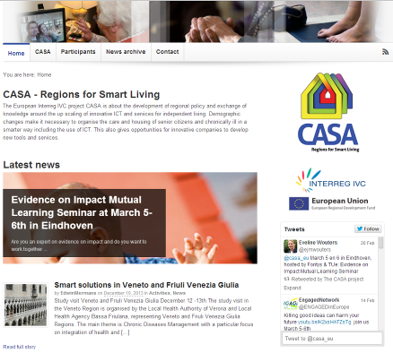
(vi) An eHealth Insider article looks at the SE Health & Social Care Trust in Northern Ireland and the development of its e-health plans.

(vii) More than 300 hospitals in more than 40 health systems across 34 US states are now using eICU services with remote monitoring support.

(viii) Three integrated digital care record exemplars (Cumbria, Bradford, Bristol) have been named by NHS England. The next round of the 'Safer Hospitals, Safer Wards: Technology Fund' will focus on integrated care. (report). EHI also reports that technology fund money could be claimed retrospectively.

(ix) Pennine Care NHS Trust has started accessing electronic patient records for community services on tablet devices. According to a report in eHealth Insider, the modules of the system already live include: referrals; waiting lists; case loads; care documentation; progress notes; appointment bookings; clinical letters and operational and statutory reports. Future modules include: mental health clustering; case note tracking; Mental Health Act administration; inpatients and clinical coding.

(x) Dr Martin McShane, NHS England’s Director for Improving the Quality of Life for People with Long Term Conditions reports on a visit to Dr Amir Hannan in his Hyde practice to understand how patients can access online records.
(xi) NICE has produced draft guidance on self-monitoring tests for people on long-term anticoagulation therapy.

(xii) The future of mHealth looks wearable - accept at Nintendo which is looking at health tech without phones (Telegraph article).

(xiii) In the U.S., the Kellogg Eye Centre is extending telemedicine to underserved communities to detect eye conditions earlier.

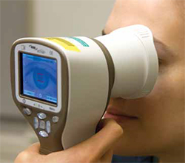
(xiv) A New EU Commission report on eHealth identifies data ownership & interoperability of systems as potential risks.

(xv) Paul Hodgkin from Patient Opinion looks at the tension between big data and big voice particularly around care.data in an eHealthInsider article.
(xvi) There is a new Wragge and Co white paper on connected care and definitions of telehealth, ehealth, digitalhealth etc.

(xvii) What shifts need to happen to achieve better care? – Care Minister, Norman Lamb explains more about the £3.8bn Better Care Fund.

(xviii) Southwark Council is expanding its Telecare service in a bid to support vulnerable people. The service is currently offered, at a small cost, to around 2,000 people who meet the FACS substantial and critical criteria, which means they have significant care needs. From April 2014, the council will be rolling this out to include anyone with a dementia diagnosis, people classed as having moderate needs and anyone over the age of 85 - and it will now be free to everyone who is eligible.

(xix) Introducing ERWIN, the robot with feelings – a study at Lincoln University looks at companion robots.

(xx) From the U.S. - Draft medical device interoperability standards could appear this spring.
(xxi) 60% of public spending cuts could still be yet to come according to IFS and Oxford Economics forecasts (Telegraph article).

(xxii) Simon Moroika & Claire Kennedy from PPL discuss the Integrated care toolkit from LGA and National Collaborative in a Guardian article.

(xxiii) Think there’s a cap on older people care costs under the new Care Bill? – ‘You could be in for a shock’ says Jackie Ashley (Guardian article) – the Care Bill will be back in the House of Commons shortly (no dates yet for report stage and third reading). James Lloyd in the Guardian argues that ministers must find a way to protect people from catastrophic care costs.

(xxiv) These 4 Companies Could Alter the Future of Telehealth - GOOG, IRBT, MDT, MSFT – find out who they are in this Motley Fool article. (Also ‘The battle for digital health begins).

(xxv) Celebrating 20 Years - The February 2014 issue of Telemedicine and e-Health is now available online.

(xxvi) There is a new £112m Big Lottery Fund investment called ‘Fulfilling Lives: Supporting people with multiple needs’.

(xxvii) The International Lymphoedema Conference in Glasgow (June 2014) has a special track on ehealth digitech & soc media. (Follow @LymphoedemaUni on Twitter).

(xxviii) In the Telegraph, NHS England’s Chief Executive, Sir David Nicholson says that hospitals need to be shrunk to give better care.

“..The health service cannot afford to keep operating its current system, which does not properly respond to the needs of an ageing population… a wholesale reorganisation of care is necessary. Like every major health system in the world, we face a big financial problem for the future: the sums don’t add up. If we don’t change, we face a funding gap that could be £30billion by 2021. We know that centralised, large units, with concentrated expertise and technology, work best in providing the most effective care. So we need to ensure this approach is applied to other parts of the health service, for people with very rare conditions, and for significant planned surgery”. He suggested that without radical change, services will not be sustainable.

(xxix) Deloitte looks at the issue of technology and apps for the over 55 age group.

(xxx) E-Health Insider has a report on the recent NHS Hack Day in Cardiff covering Neena Dugar who won the award for improving clinicians’ lives.

(xxxi) A memorandum of understanding has been signed by the US and UK to help to create the world’s largest single market for health care applications (eHealth Insider article).

(xxxii) ‘100-year-old Mary is a real health trailblazer’ – an article on telehealth in Northern Ireland – from the Fermanagh Herald.

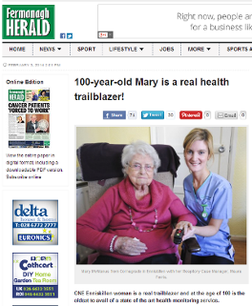
(xxxiii) Alex Neil explains why a telehealth service should be rolled out across Scotland in this Medvivo article.

(xxxiv) A Guardian article looks at whether healthcare access has been restricted through the creation of clinical commissioning groups?

(xxxv) ‘How VA is driving telemedicine’ – an interesting article at the FCW website.

(xxxvi) The health service will become “totally dependent” on electronic health records over the next five years, health secretary Jeremy Hunt said at a recent Cambridge Health Network event. (eHealth Insider article).

(xxxvii) 36,000 additional citizens have now been trained in accessing the internet for health purposes - part of NHS England’s Health Online Programme.

(xxxviii) UPMC is expanding its global reach by using video telemedicine links from US to India & other countries.

(xxxix) BBC News reports that up to 39 NHS Foundation Trusts could be in deficit based on a Monitor Report - the total deficit from the trusts identified is £180m but there is still an overall surplus in the sector.
(xl) The prospect of 3D printing parts of the human body is discussed in this Telegraph article on bioprinting.

(xli) Worrying news about long term conditions - a study has found a three-fold increase in UK insulin use between 1991 & 2010 - the number of cases of diabetes in the UK has increased to more than 3.2m (6% UK adults). Also worldwide cancer cases are expected to soar by 70% over the next 20 years.

(xlii) A report covered by the Telegraph suggests that half of the people with dementia suffer malnutrition.

(xliii) In the Wayward Research Project, doctors at Nottingham University Hospitals NHS Trust are being tracked by ‘sat nav’ during their evening and weekend shifts to identify efficiency savings and improve patient care (eHealth Insider article).

(xliv) HSCIC plans to publish a national technology and data strategy, which will also have a strong emphasis on health and social care integration.

(xlv) In 2024 your fridge, loo and shoes could save your life, says Bupa.
(xlvi) The National Cancer Institute, the New York City Health Department, and Planned Parenthood all use text message campaigns to help people live healthier lives - 5 ways mobile is improving health (Ragan article).

(xlvii) In a Guardian article, Andrew Clegg from Orion Health argues that integrated care needs people to make it happen. In a separate article, Bob Hudson looks at the six challenges of joint working in health and care.

(xlviii) Airedale NHS FT continues to extend the reach of its telehealth hub with care home links – eHealth Insider has the latest.

(xlix) On 3-4 April 2014 in Brussels, the first EU summit on chronic diseases will discuss medical, social and economic benefits of sustainable investments in health, ways to reduce the burden of chronic diseases, and how to strengthen the prevention and management of chronic diseases, with a focus on EU added value and action.

(l) In a Guardian article, Kathleen Stokes (Nesta) asks if open data can improve GP take-up of innovations? The article covers a new report Which Doctors Take up Promising Ideas? New Insights from Open Data that shows varied uptake of certain proven drugs, technologies and practices by GP surgeries. In Forbes, Henry Doss argues that risk sharing can drive healthcare innovation.

(li) American Well Finds Video is the key to telehealth consults compared with phone-based approaches.

(lii) The Royal College of GPs argue they are under pressure due to funding cuts (Guardian article).
(liii) ‘Interoperability lag is dragging mHealth down’ – standardisation is important for efficiency and innovation in this mHealth News article.

(liv) The First NICE Medtech Innovation Briefings have been published.

(lv) The Digital Health Institute in Scotland has announced a call for Innovation proposals.



(lvi) Here is the latest news from Telehealthcare provider – Welbeing.

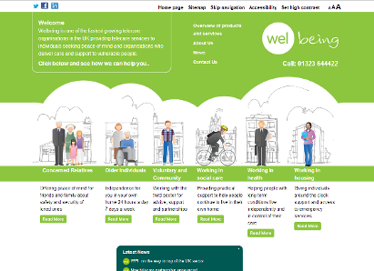

(lvii) A nation of pill poppers? - Fergus Walsh at BBC News looks at the pros and cons of the latest NICE consultation on statins.

(lviii) New research by Accenture suggests that 27 per cent of older people in England are self-tracking some aspect of their health, such as health indicators (18 per cent), weight and blood pressure, or information pertaining to their health history (11 per cent). When asked which digital services were important to them, 77 percent said online appointment scheduling, 69 per cent said electronic reminders, 64 per cent said e-prescription refill requests and 60 per cent said online access to health records. However, Accenture's research shows that only a third of healthcare providers currently offer such capabilities. (Telegraph article).

(lix) There is a new leaflet from Nottingham City Council’s telecare service & slides from Notts CC on telecare and ethics.
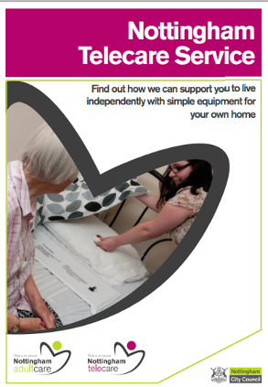
(lx) Hull and East Yorkshire Hospitals NHS Trust has created an app which shows patients real-time A&E and outpatient clinic waiting times and attendance (eHealth Insider article).

(lxi) Kaiser Permanente and Veterans Healthcare Administration are partnering on connected health best practices (mhealth News article).

(lxii) Do we (tele)care what the evidence says? - Storified Tweets from the recent event and questions for the panel (awaiting responses).

(lxiii) Cognitive decline and aging - a myth? An interesting study covered by PsyBlog.

(lxiv) A prospective 25-year long ‘quantified self’ study eventually covering up to 100,000 people commences with a 9 month pilot study by the Institute for Systems Biology in Seattle. During the 9 months, individuals in the pilot will be monitored, provided with feedback, and coached to make lifestyle changes (article from mobihealthnews).

(lxv) There are some new blogs and reports from the King’s Fund:
- Making the case for family care networks
- Making general practice fit for the future
- Commissioning and funding general practice
- Transforming community services: learning from previous mistakes
- Community services - How they can transform care

(lxvi) Not mentioned in last month’s Dementia Supplement, but covered at the recent Housing LIN conference – Chloe Meineck’s Music Memory Box (You Tube, website).
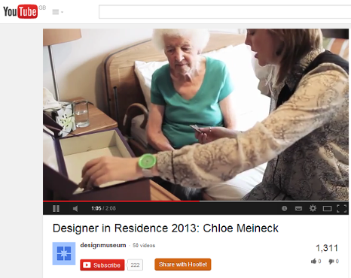

(lxvii) You can learn more about integrated Care and the work of the 14 integration pioneers at the iCASE website.

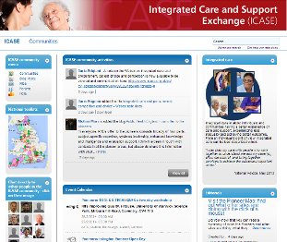

(lxviii) If you are interested in Quantified Self then learn about the gadgets and apps that guru Nicholas Felton uses to monitor his every move.

(lxix) Pulse Today reports that external consultants are to scrutinise CCG plans in 11 identified areas. There are also indications that there are likely to be CCG mergers in 2014.

(lxx) The Inaugural edition of the Journal of mHealth is now available.


(lxxi) The United Kingdom Homecare Association (UKHCA) has produced a briefing on ‘A Minimum Price for Homecare’.

(lxxii) According to a Guardian article, public sector jobs could be cut by up to 40% in some services. Suffolk County Council has cut £38m from its budget including adult social care - there will be some telecare investment. The Kent Social Care/Public Health budget is reduced by £22.55m in 2014/15 although £27m is transferred from the NHS under the Better Care Fund arrangements.
Wolverhampton City Council plans could cut up to 2,000 jobs with £66.7m of savings.

(lxxiii) From Scotland - Crown Officer lawyers are to rule over city fire death charge (telecare system involved).

(lxxiv) Loneliness could be up to twice as unhealthy as obesity for older people - a six year study of 2000 people is reported in a Guardian article.

(lxxv) Tunstall’s myworld (announced at the recent Housing LIN conference) is a suite of mobile applications running on a tablet that provides residents, with no previous experience of technology, a simple and safe means of connecting to their care provider, friends, family and other services through software and secure social media platforms.

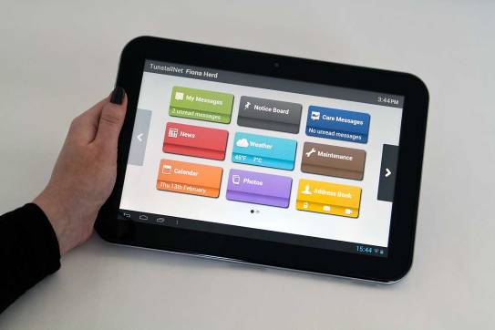

The tablet has been designed to support independent living by giving users better control over aspects of their daily life, allowing them to; schedule appointments, book meals, report property repairs, view upcoming events and send/receive messages to their carers and families.

(lxxvi) From the U.S. - Verizon, WellPoint, CVS, Walgreens ally with former senators to push telehealth policy reform through the Alliance for Connected Care.



(lxxvii) Aerotel has developed a personal mini-sized ECG monitor with an incorporated 3G cellular module

(lxxviii) A Birmingham University appraisal points to a wider understanding of telehealth and blurring with telecare (Ageing well with technology).

(lxxix) Innov-age magazine Issue 4 is looking at telehealth technologies & services helping to improve care of older people.
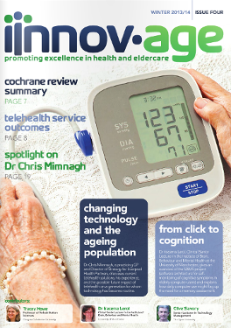

(lxxx) 15% men over 65 are acting as carers, compared to 13% women in same age group – an insight into carer statistics (Guardian article).

(lxxxi) Gizmag has an article on a new sensor system designed to help older people who have fallen and can’t get up.

(lxxxii) Denmark, a world leader in health IT tests new systems with US companies.

(lxxxiii) A new study suggests that symptoms of lung disease are frequently overlooked - early diagnosis is important (Guardian article).

(lxxxiv) With just a few days to go, NHS Change Day has surpassed last year’s total pledges – now well over 200,000.

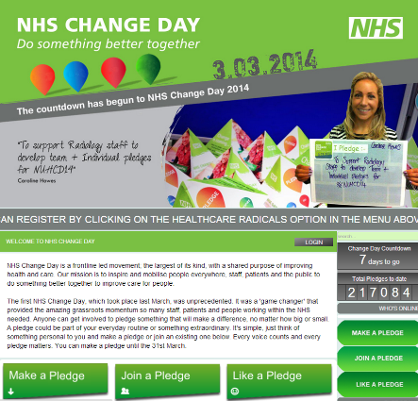

(lxxxv) Interested in digital and new organisational approaches in Housing? – the recent ‘Housing Goes Digital Conference’ tweets have been Storified with plenty of interesting presentations.

(lxxxvi) Tunstall Healthcare has partnered with ‘Putting You First’ to carry out a remote monitoring programme involving patients living with Chronic Obstructive Pulmonary Disease (COPD) in the Annan area of Dumfries and Galloway. Recorded episodes of COPD in the area have risen by almost 50% from 2007 to 2013. The Annan Remote Monitoring (ARM) test of change project is being introduced as part of the ‘Putting You First’ five-year change programme, implemented as a partnership approach between the NHS, Council and the Independent sector to transform care delivery in the region. The programme has been implemented following previous work with Heart Failure (HF) patients to determine the most appropriate model of care. It will initially run for twelve months, after which the success of the project will be evaluated and a decision made as to whether the service will be extended further.
(lxxxvii) From the United States - Partners ‘HealthCare At Home’ has strengthened services with Philips.

(lxxxviii) Ray Kurzweil (Google’s new Director of Engineering) believes that, by 2029, computers will be able to do all the things that humans do.

(lxxxix) E-Health Insider has an article on best practice guidelines for teleradiology.

(xc) What can the UK learn from overseas about an ageing population? – examples from Germany, Netherlands, France, Japan, Cyprus.

(xci) BT plans to make Cornwall its telehealth hub (HSJ - may require subscription) – arrangements are in place to build on its 12,000 user base in the county to provide telemonitoring in England.

(xcii) ‘Telehealth and telecare’ – there is a new POST Note from Parliament UK by Peter Border.

(xciii) In an interview with Healthcare Innovation Daily, Annette King, a manager with Digital Birmingham, says that acquiring the skills to access the internet and its many resources has multiple benefits for carers.
(xciv) The University of Twente has a Centre for telemonitoring and smart coaching.
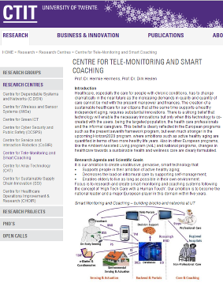
(xcv) Extra weight may add to the risk of falls in older people - an Australian Study reports.

(xcvi) Medvivo has been awarded the SEHTA Business Award for Partnership with the NHS for its telehealth work with Surrey County Council & CCGs.

(xcvii) Google is working on a 3D vision smartphone project. The Guardian has a first look at the Samsung Galaxy S5 phone with S Health 3 launched on 24 February 2014.

(xcviii) A Swansea-based diabetes management system with mobile connectivity gets a UK launch.

(xcix) The latest HealthTech and Medicine KTN News is now available (February 2014).

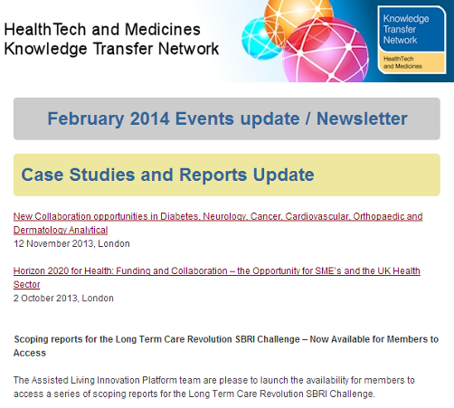

(c) A new website from Which? Includes a section on assistive technologies.

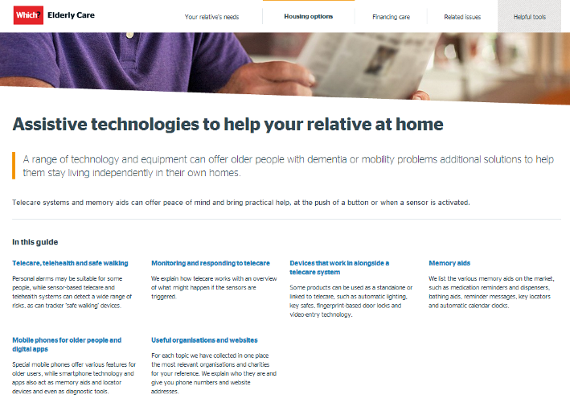
Item 8 – Summary list of recent journal articles and evaluations
Each month, our supplement (pdf, doc) provides a comprehensive list of recent journal articles. Here are a few links from this month’s list.
Health Affairs has an article on ‘Telehealth: Seven Strategies To Successfully Implement Disruptive Technology And Transform Health Care’. An interesting recently available thesis from January 2013 reviews mobile health services for people with chronic diseases. From Baltimore, a care programme keeps people with dementia at home using care coordinators. Does use of consumer health info tech improve outcomes in patient self-management of diabetes? - here is a meta-analysis. Opportunities to diagnose COPD in routine care are covered by a Lancet article. JAT has an article on assistive technology and telecare for managing fire risks in the home. A US article finds that Telemedicine can reduce hospitalisations for nursing home residents. Australia is commencing a large trial of managing chronic disease at home with telehealth. There is plenty of interest in the use of mobile health in Africa – what works and what does not work. There is another systematic review of home telemonitoring in COPD. A JMIR article has a classification scheme for analyzing mobile apps used to prevent and manage disease in late life. A systematic review looks at the effectiveness of Assistive Technology in the care of people with dementia. There is a Cochrane Review of telerehabilitation services for stroke covering 10 trials. Can tablet computers improve inpatient engagement for hospitalised patients - read a pilot study. The cost effectiveness of implantable cardioverter defibrillators is covered in a systematic review.

Further links from this month’s supplement:
A home telehealth program for patients with severe COPD: The PROMETE study
A meta-analysis of remote patient monitoring for chronic heart failure patients
A Lot of Action, But Not in the Right Direction: Systematic Review and Content Analysis of Smartphone Applications for the Prevention, Detection, and Management of Cancer
A Multi-center Study of ICU Telemedicine Reengineering of Adult Critical Care
A Randomized Trial of Weekly Symptom Telemonitoring in Advanced Lung Cancer
A telerehabilitation intervention for patients with Chronic Obstructive Pulmonary Disease: a randomized controlled pilot trial
Acceptability of NHS 111 the telephone service for urgent health care: cross sectional postal survey of users' views
Diabetes Clinic at a Distance: Telemedicine Bridges the Gap
Diabetes self-management support using mHealth and enhanced informal caregiving
Diabetes Telehealth in the 21st Century: Log In to the Future of Medicine
Effectiveness of a web-based physical activity intervention for adults with Type 2 diabetes-A randomised controlled trial
Effects and barriers to deployment of telehealth wellness programs for chronic patients across 3 European countries
Estimating the economic and social costs of dementia in Ireland
Evaluating self-management behaviors of diabetic patients in a telehealthcare program: longitudinal study over 18 months
Evaluating the impact of telepharmacy. [Am J Health Syst Pharm. 2013] - PubMed - NCBI
Implementing Home Blood Glucose and Blood Pressure Telemonitoring in Primary Care Practices for Patients with Diabetes: Lessons Learned
Increasing the medium-term clinical benefits of hospital-based cardiac rehabilitation by physical activity telemonitoring in coronary artery disease patients
Installing Telecare, Installing Users: Felicity Conditions for the Instauration of Usership
Mobile Health Applications for the Most Prevalent Conditions by the World Health Organization: Review and Analysis
Teleconsultation in vascular surgery: a 13 year single centre experience
Teledermatology for skin cancer prevention: an experience on 690 Austrian patients
Telemedicine and advances in urban and rural healthcare delivery in Africa
Telepulmonology: Effect on quality and efficiency of care
The effect of real-time teleconsultations between hospital-based nurses and patients with severe COPD discharged after an exacerbation

Item 9 – Learning and Events
Click on the following links for further conferences and learning events over the coming months:

Health and Care Innovation Expo 2014, Manchester 3-4 March 2014 http://www.healthcareinnovationexpo.com/
Telemedicine - making it work in practice, Keele 6 March 2014 http://www.keele.ac.uk/media/keeleuniversity/fachealth/fachealthmed/pdfs/Telemedicine_Conference.pdf
SXSW Interactive - 7-16 March 2014, Austin http://sxsw.com/interactive/about
Assisted Living Innovation Platform – Economic and Business Modelling – Final Workshop 12 March 20914 London http://bit.ly/1e4tZzS
Internet of Things 2014 Smart Health - Smart Cities - Smart Environment – 18 March 2014, Paris http://bit.ly/1e4tBSc
DISCOVER UK Forum: Technologies for care - the imperative for change – 18 March 2014, Birmingham https://www.eventbrite.co.uk/e/discover-uk-forum-technologies-for-care-the-imperative-for-change-registration-7995604067
The Internet of Things: Could this be the catalyst for innovation in the NHS? Health 2.0, London March 18, 2014 http://www.meetup.com/Health-2-0-London/events/149275672/
CUHTec telecare strategy course: Learning disability services Newcastle 20 March 2014 http://www.cuhtec.org.uk/wp-content/uploads/2013/04/20140320_LD.pdf
CUHTec telecare strategy course: moving to digital and mobile telecare Newcastle 21 March 2014 http://www.cuhtec.org.uk/wp-content/uploads/2013/04/20140321_mCare.pdf
European Knowledge Tree Group 2014 Conference, London 24-25 March 2014 http://bit.ly/1e4uni4
eTELEMED 2014 - The Sixth International Conference on eHealth, Telemedicine and Social Medicine Barcelona 23-27 March 2014 http://www.iaria.org/conferences2014/eTELEMED14.html

Electronic health records and IT in the NHS: implementing the ten year technology strategy – 1 April 2014, London http://www.westminsterforumprojects.co.uk/forums/event.php?eid=702

Aktive Project Conference 2014 - Technology, Care and Ageing: Enhancing Independence 8-9 April 2014 http://www.aktive.org.uk/conference2014.html

Med-e-tel – the International eHealth, Telemedicine and ICT Forum Luxembourg 9-11 April 2014 http://www.medetel.eu/index.php

Playing games, using apps, promoting wellbeing - 10 April 2014, London http://www.rsm.ac.uk/academ/tee03.php

Does giving patients more data actually increase engagement & improve outcomes? Health 2.0, London 16 April 2013 http://www.meetup.com/Health-2-0-London/events/149275892/
Naidex, Birmingham – 29 April to 1 May 2014 http://www.naidex.co.uk/

European HIMSS mHealth Summit, Berlin, 6-8 May 2014 http://www.mhealthsummit.org/eu
Telehealth 2014, Glasgow – 8 to 9 May 2014 http://telehealth2014.holyrood.com/
Interntl Lymphoedema Conference, Glasgow, 5-7 June 2014 - special track on ehealth, digitech & social media http://www.ilfconference.org/day-programme/

Item 10 – Other useful links
HealthTech and Medicines KTN - https://connect.innovateuk.org/web/healthktn
Assisted Living Innovation Platform - https://connect.innovateuk.org/web/assisted-living-innovation-platform-alip
dallas_Connect Sub Group - Join the Sub Group at: https://ktn.innovateuk.org/web/dallas
Housing Learning and Improvement Network www.housinglin.org.uk Now on Twitter: @HousingLIN

Telecare Learning and Improvement Network www.telecarelin.org.uk

King’s Fund web site – http://www.kingsfund.org.uk/topics/technology_and_telecare/index.html
Telehealth and Telecare Aware – daily news and comments www.telecareaware.com
Three Million lives - http://www.3millionlives.co.uk/ LinkedIn

Newsletter prepared by Mike Clark (@clarkmike) and brought to you by the Telecare LIN on behalf of the Technology Strategy Board and Healthcare KTN.
Disclaimer: “We provide this newsletter for information purposes only and neither the Technology Strategy Board nor the authors accept any liability whatsoever for inaccuracies, errors or omissions therein or for any consequences arising therefrom.”



