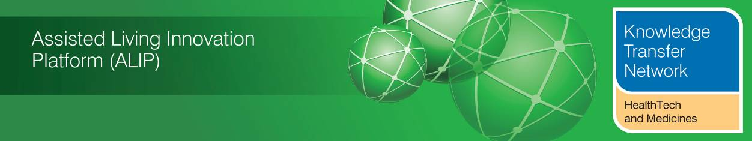
BETTER CARE FUND & TELECARE/TELEHEALTH/SELF CARE – SUPPLEMENT - JUNE 2014

Welcome to an updated supplement from the Technology Strategy Board (TSB) Knowledge Transfer Network and the Telecare Learning and Improvement Network covering extracts from draft and completed Better Care Fund Plans in England which make reference to telecare, telehealth, assistive technology or self care/self management.

Plans from 151 Health and Wellbeing Boards had to be submitted by 4 April 2014, however, some details will be revised over 2014/15 ready for April 2015.

It is now estimated that as much as £5bn could be reinvested in pooled funds to provide more integrated health and care services.

There are still many examples where the final plan has not yet surfaced through the local Health and Wellbeing Boards and been made public. There are many variations in how each local health and care economy plans to use the pooled funds in conjunction with housing and a range of providers.

There are currently 152 local social care authorities and 211 clinical commissioning groups. Bournemouth and Poole are working together and in Central/West London, the tri-borough consortium (Hammersmith and Fulham, Kensington and Chelsea, Westminster) has a joint plan.

The local authorities are listed alphabetically. The references to telecare, telehealth, assistive technology and self care/self management have been extracted – it is best to check the link provided for more information and context.

The supplement will be updated as more final plans are made public.

Newsletter supplement prepared by Mike Clark (@clarkmike) and brought to you by the Telecare LIN on behalf of the Technology Strategy Board. Newsletters and supplements are archived at www.telecarelin.org.uk


Barking and Dagenham

25 March 2014

Both telecare and telehealth can positively contribute to improved management of risks enabling
people to remain at home and help people with anxiety feel more secure.

Promote and support independence, personal responsibility and self management and personalised choice;

The provision of equipment and adaptations is a key component in helping people to manage independently at home with improved levels of self care.

The CCG and the local authority have agreed to bring these together in principle and an integrated equipment and adaptations facility will provide a key ‘enabler’ to early and effective discharge, re-ablement and improved self care and admission avoidance.

We are also promoting opportunities for improved levels of ‘self care’ through providing access through ‘active aging’, advice an information that may encourage lifestyle changes which promote improved health and wellbeing

The Integrated Care Coalition will:
• promote and support independence, personal responsibility and self-management and personalised choice;

sufficient emphasis on early intervention and engagement to support people in preventing ill health, or to manage their condition more effectively at home. This means investing in people and communities so that they are more aware of available resources and able to become more self sufficient in meeting their own needs. The voluntary sector, community groups and the statutory sector need to work in partnership to
enable this to happen.

http://moderngov.barking-dagenham.gov.uk/documents/b16791/Item%204%20Better%20Care%20Fund%20-%20Appendix%202%20Tuesday%2025-Mar-2014%2018.00%20Health%20and%20Wellbeing%20Board.pdf?T=9

Barnet

20 March 2014

Developing greater self-management - How will this be delivered? - Increasing the use of technology to support self-care in the community such as telecare and telehealth.

Multi-Disciplinary Team Meetings…..The planned co-ordination of care across health, social and voluntary care sectors, with a focus on self-care, education, early detection and intervention and the use of telecare will be the key to success.

Our care model incorporates universal preventative and self-management services, such as the Barnet Ageing Well project. This initiative develops local prevention and well-being services from the ground up, led by local people in response to needs identified by the community.

This includes plans for a workshop focussing on self-management, and using opportunities such as the CCG
public engagement mechanisms and Barnet Older People’s Assembly, to ensure that patient and user perspective is reflected in all our programmes as they develop.

Recent work to develop a Barnet Health and Social Care Integration model has strengthened this further with the Vision for Services. It consolidates existing work being undertaken and provides a clear direction of priorities and delivery for the future. This turns the Vision into a tangible reality for delivery via a 5
tiered model of care with future-proofing to meet short and longer term health and social care strategic plans including those to deliver integrated care at scale and pace. It advocates a consequential shift of activity and costs from reliance on acute care and care home placements towards prevention and self-management.

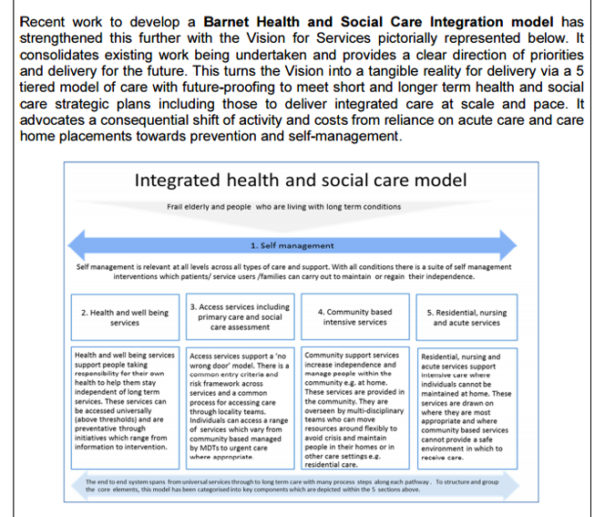

…Empowers and enables the population to access and maximise effectiveness of preventative and self-management approaches to support their own health and wellbeing…Reduces overall pressures in hospital and health budgets as we shift from high-cost reactive to lower cost prevention and self-management services.

People will be supported to be as independent of public services as possible through a local care system that encompasses prevention, self-care and supportive communities.

People and their families are supported to manage their own health and wellbeing wherever they can and for as long as possible…

…The key components of the integrated service can be consolidated as follows…Developing greater self-management…

Enhanced personalisation of health and social care through:
• Promoting and enabling independence through self-management
• Promoting the co-design and production of services with service users, patients and carers

…How will this be delivered?...

• Patient education and awareness raising on how to manage conditions, e.g. expert patient
programmes…
• Prevention coordinators to support the self-management / targeted prevention agenda. The
coordinators would be locality based and linked to the GP surgeries as a way of raising the profile
of the whole range of services available to increase self-management.
• Expanding the self-management offer to at risk groups. Developing specialist strategies aligned to
specific population needs e.g. stroke, dementia awareness.
• Enhancing professional knowledge about prevention and self-management tools and what is
available in order to reduce dependency on GPs and diverting people to more self-management
routes. This is closely linked to the offer described in tier 2, the development of a catalogue and an
education programme for professionals to highlight the range support available.
• Increasing the use of technology to support self-care in the community such as telecare and
telehealth.

It will support increased community capacity to build resilience including self-help initiatives, volunteer
support networks, local community organisations that offer assistance and non-traditional support. This
also covers preventative services.

…How will this be delivered?...

• Accessible centralised information and signposting about the whole range of services available to
increase prevention and self- management (as described above in the ‘self-management’…

…The planned co-ordination of care across health, social and voluntary care sectors, with a
focus on self-care, education, early detection and intervention and the use of telecare will be the key to
success.

…Creation of locality based prevention teams including healthcare co-ordinators to support the self-management and wellbeing agenda…

…The aligned funds will include some targeted investment from Public Health to support prevention and self-management.

http://barnet.moderngov.co.uk/documents/s13808/Appendix%201%20Better%20Care%20Fund%20Planning%20template.pdf

Barnsley

Inverted triangle model –

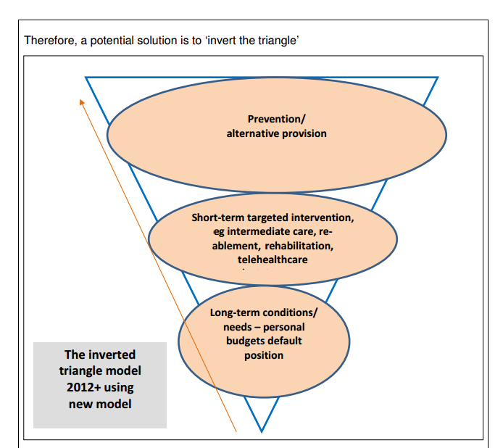

The Programme Boards will deliver a range of projects and initiatives which, although not exclusively, will support the aims of the BCF and we would specifically expect these to deliver the following improvements over the next few years…. Improved information, signposting and triage across the system and particularly at
Accident and Emergency to ensure alternatives are known, considered and accessed where appropriate including respite/temporary admissions to a care home, telecare/telehealth, rehabilitation and re-ablement.

…..An expanded and fully integrated suite of intermediate tier services, focused on preventing admission to hospital as well as speeding discharge, to include primary care interfaces; virtual ward, re-ablement services including telecare and the voluntary sector…..

….Improved access to, and take-up of, telehealth and telecare provision

….Changes to the patient mix, 7 day working and reducing the number of non-elective admissions, unless managed effectively could affect the sustainability of the hospital. To maintain sustainability there are a number of considerations including….

• Critical mass – numbers of consultants required to sustain local specialist services i.e. Stroke, Cardiology – solutions may come from Technological Solutions i.e. telemedicine

We recognise that in many cases, achieving improved health and wellbeing outcomes is a longer term ambition requiring a reorientation of current systems towards prevention and addressing the wider determinants of good health. But we are also clear that service integration can make a significant contribution to those longer term ambitions whilst delivering better outcomes for service users and a much improved patient/service user experience. We see this being most effectively achieved by completely redesigning the patient/service user pathway by placing particular evidence on providing better information, advice and signposting to alternative services to promote self-help, self-management of long term conditions as a critical enabler of future sustainability and developing more effective prevention, re-ablement and targeted time limited interventions

Our approach is therefore one of pathway integration and redesign rather than structural integration. We have set out in our Pioneer Integrated Care and Support proposal that we are seeking to fundamentally shift the focus from statutory health and care agency interventions, to more holistic engagement and a citizenship approach at individual, family and community level. The provision of information, advice and signposting, is key alongside access to flexible and integrated service pathways which support people to maintain control and enable self-management wherever possible. Based on an asset, not a deficit model to create social value, we are confident that this will bring about the change required across Barnsley communities based on engagement and behaviour change, both in professionals and those in receipt of services.

In support of delivering against those areas identified in the national conditions, as set out above, we will also focus on the provision of information, advice and sign posting to support and promote self-management and self-care by enabling people to make better informed decisions in managing their own health and social care needs.

We expect this to deliver:
• Easier access to information and advice to help people make the right choices for them about their care and support across the whole system for both service users/patients and staff to navigate services.
• Reduced reliance on traditional, statutory services, sign posting people to alternative services
• Fewer admissions to care homes and for shorter duration towards the end of life
• Improved ‘welfare’ support, particularly those who are isolated, lonely and or have poor mental well being
• Care and support needs met locally wherever possible with an enhanced choice of support options
• An increased level of self-care and people managing their own care and support needs

…Support preparation for the implementation of the Care Bill e.g. promoting and providing improved universal information and advice, self-care and management, a revised and extended approach to assessment and care management…

…A much improved, enhanced and integrated information and advice service to allow people, including those who self-fund, to manage their own care and support needs and to connect them to sources of support available within their local communities

Further work will be undertaken during 2014/15 to develop integrated care pathways that include a much stronger focus on the prevention of ill-health as well as supporting self-management and independence for those with existing conditions

http://edemocracy.barnsley.gov.uk/0xac16000b%200x00584702

Bath and North East Somerset

No current telecare/telehealth information.

Our vision is to provide care and support to the people of Bath & North East Somerset (B&NES), in their homes and in their communities, with services that support people to take control of their lives and reach their potential and are characterised by:

Innovative and widely integrated and utilised pathways of care understood for each long term condition and including self-management, transition, urgent and contingency planning elements as routine

Whilst our initial emphasis may be on those older people with the highest risk profile, we will not lose sight of the value of focusing energy and attention on prevention, early intervention, reablement and self-care. This will include provision of integrated support to carers so that they feel they are not struggling to cope alone and can take a break from their caring responsibilities.

Support patients with long term conditions to self-care and feel self-empowered in the management of their condition

The Wellbeing College Pilot is the first step in a system wide transformation project and, depending on the results of the pilot, may lead to a full open tender being released in 2016. As well as being a vehicle for increasing the levels of early intervention to address health and social care needs and increasing the capacity of the local community in self- management of long term conditions, the Wellbeing College Pilot is intended, if the model is successful following this proactive market testing and development phase, to be an essential element of the transformation of all local health, public health and social care services.

Social Prescribing can be defined as providing “a pathway to refer clients to non-clinical services, linking clients to support from within the community to promote their wellbeing, to encourage social inclusion, to promote self-care where appropriate and to build resilience within the community and for the individual” (Developing a Social Prescribing approach for Bristol, Dr Richard H Kimberlee, University of the West of England, October 2013).

http://democracy.bathnes.gov.uk/mgAi.aspx?ID=11802#mgDocuments
http://democracy.bathnes.gov.uk/documents/s29804/Agenda%20Item%2011%20-%20Appendix%202%20BNES%20Better%20Care%20Fund%20Plan.pdf

Bedford

No current telecare/telehealth information.

Our aim is to improve the quality of life for people with long-term conditions. We calculate this by using
a range of measures, such as mobility, self-care and pain/discomfort, known as the EQ-5D score.
In 2012/13, our score was 75.2. Our aim is to increase it to 78 by 2018/19 at a rate of 0.5 points per year.

http://www.councillorsupport.bedford.gov.uk/documents/s25091/Item%206%20-%20Appendix%20Bedford%20BCCG%20Final.pdf

Bexley

8 April 2014

Bexley also has a comprehensive telecare and emergency link line service, with initial discussions taking place around extension of this to include telehealth. Telecare is well embedded in local social care provision. Local evaluations suggest that this has already made savings for the council of more than £250k p.a. Integrated working offers opportunities for this to be more widely explored and extended.

….Extend opportunities for use of self-care and technology to promote wellbeing and
Independence….

Together with a strong patient / service user centred focus on self-management, use of technology and a combined risk-stratification modelling, it is expected that there will be reductions in the numbers of people whose needs are exacerbated and consequently need higher level interventions (including hospital admission or long term care).

These teams will function as cohesive units, working with GP practices in the localities to identify and manage people with a range of complex, long term conditions and co-morbidities such as diabetes, neurological conditions and dementia. Together with a strong patient / service user centred focus on self-management, use of technology and a combined risk-stratification modelling, it is expected that there will be reductions in the numbers of people whose needs are exacerbated and consequently need higher level interventions (including hospital admission or long term care).

We will:
- Extend opportunities for use of self-care and technology to promote wellbeing and independence

http://democracy.bexley.gov.uk/documents/s58365/Item%2010.3%20App%20B1%20BCF%20report.pdf

Birmingham

No public information currently available.

Blackburn with Darwen

12 March 2014

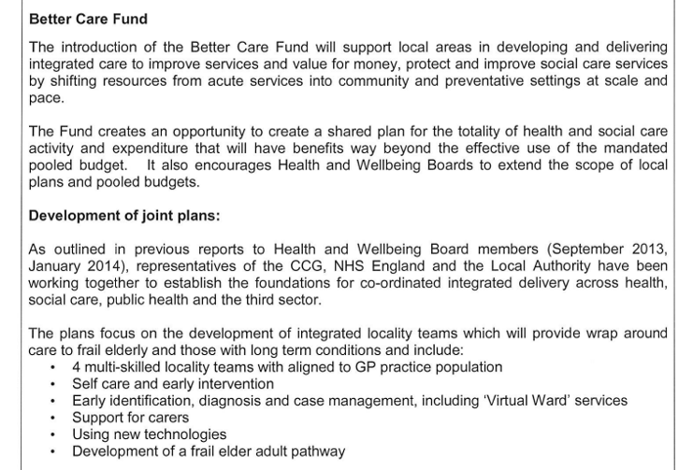
http://94.236.33.182/CmiswebPublic/Binary.ashx?Document=11510

Blackpool

No public information currently available.
Bolton

Council asked for exemption from publishing Better Care Fund information

http://www.democracy.bolton.gov.uk/cmis5/Meetings/tabid/73/ctl/ViewMeetingPublic/mid/410/Meeting/12430/Committee/3123/Default.aspx

Bournemouth

5 February 2014

Responding to need – the ‘front-end’ of support such as easy to access points of contact, improved information and advice, reablement/ intermediate care, technology, accessible homes (via district councils).

The core components of the new system will be:

a) Increasing the pace and scale of initiatives aiming to provide ‘care closer to home’ to achieve targets on shifting from institutional care to self-help and community based systems

…Investment in locality and community initiatives which seek to promote self help and divert demand.

http://www.bournemouth.gov.uk/CouncilDemocracy/Councillors/CouncillorCommitteeMeeting/BournemouthPoole,HealthWellbeingBoard/2014/02/05/Reports/Better-Care-Fund-and-Better-Together-Draft-Business-Case---Appendix-B--2-.pdf

Bracknell Forest

Use of Telecare to monitor effectively the health of individuals at risk.

No references to self care in document

http://democratic.bracknell-forest.gov.uk/documents/s71026/Executive%20-%20BCF%20v2%201%20Annex%20A%20mpeb%202.pdf

Bradford

Details of Board documents not available – as at 28 April 2014

Brent

No telecare/telehealth references – checked at 28 April 2014

The CCG’s strategy to develop services in the community and focus on self-care, early diagnosis and high quality management of long term conditions, and the diagnosis and treatment of those with ambulatory emergency conditions in the community when appropriate.
http://democracy.brent.gov.uk/documents/s23095/BCF_operating_plan.pdf
http://democracy.brent.gov.uk/documents/s22084/brent-better-care-fund-planning-template.pdf

Brighton & Hove

I am encouraged to maintain my independence: Rachel would be offered a period of intensive, re-abling homecare and identify suitable Telecare and other equipment and work with her to get used to a new way of managing her personal care to build her confidence and improve her level of independence….

….My health conditions are under control. Rachel will be provided with simple devices (Telehealth/ Telecare) and support to allow her to self-manage on a daily basis….

….Further investment in rehabilitation/re-ablement (including Telecare) to reduce hospital admissions and admissions to residential and nursing home care

http://present.brighton-hove.gov.uk/Published/C00000826/M00005071/AI00037893/$20140131105423_005420_0021425_Item43BetterCareFundPlanFINALappendix.docx.pdf

Bristol

11 February 2014

- Technology
- Telehealth for Irene
- Telecare
- Bristol CareLine
- Assistive Technology (included LA provided adaptations)
- Advice on Internet/Libraries WellAware (with better promotion)
- LinkAge
- University of Bristol developing technology that collects data within a person’s home
- Training befrienders in technology (Skype)
- iPad use / reminiscence therapies

….Telehealth, Telecare, Assistive Technology - Greater use of Assistive Technology to help users
manage their conditions more effectively such as Long Term Conditions, (Stroke, Dementia, Diabetes, Cancer,
Asthma, COPD).

Delivery of our shared vision will be challenging and will require a significant shift from current service delivery models to more integrated models of care and a joint approach to building resilient individuals and communities through prevention and self-care.

https://www.bristol.gov.uk/committee/2014/ot/ot049/0211_5.pdf

Bromley

30 January 2014

Expand the use of access to telehealth and health coaching to maximise independence and wellbeing….

….£1m Increase the utilisation of telehealth/and self-management of long term conditions to maintain independence….

….We will invest jointly in empowering local people through effective care navigation and a menu of self-management options ranging from advice and information, education, support for carers, access to telehealth and health coaching to maximise their independence and wellbeing.

Procuring care navigation and a menu of self-management options and jointly commission these services from the voluntary sector where possible…

…This should allow us to move from a reactive bed-based model (and often hospital bed-based) of provision to a proactive home and community-based model with a strong emphasis on self-care for and of the individual and their “community”, with providers working collaboratively to deliver coordinated care in partnership with local people and their carers…

http://cds.bromley.gov.uk/documents/s50017848/Appendix1BCF280114Final.pdf

Buckinghamshire

February 2014

Types of services: Prevention Matters, Telecare

Delivering this vision will:
Enable people to take greater responsibility for self-care: Ensuring integration between what practitioners do and what people and their families do themselves, as well as between primary and secondary health and social, physical and mental wellbeing services…

…Self-help advice and support, including managing conditions

http://democracy.buckscc.gov.uk/documents/s48089/Buckinghamshire_Integrated%20Care%20for%20Older%20People_Case%20for%20Change_v1%20021.pdf

Bury

30 January 2014

Embracing the potential for innovation in telehealth / telecare

Our objectives are:
Services are co-designed around an understanding of patient and customer needs
• Patients and customers are able to self-care as much as possible

The development of public health plans to improve prevention and self-care

The consultation highlighted that the priorities for patients, service users and the public are on prevention, early intervention and self care, informal support to stay well and maintain independence, joined up working between partners and professionals and asset based community development...

…The majority of participants understood and agreed with the proposed changes emphasising the need for more emphasis on prevention and self care, easy and quick access to primary care and access to senior medical opinion…

…We have established a work-stream within our governance structure focused specifically on further developing our work around patient, service user and community engagement which will focus on widening participation in consultation and planning work, and strengthening engagement in self care and service delivery though embedding of the Greater Manchester Community Based Care Standards, patient education, co-production and asset based community development approaches…

Self Care Programmes

We will expand on our highly successful and effective ‘Helping yourself to Health’ programme which builds confidence, motivation and health literacy to enable people to self care…

…Independence and autonomy – to focus on prevention, self-care/self-management strategies and independence

Supported self-management – to offer support, intervention and signposting; working with the patient's GP and other members of the multidisciplinary team

By maintaining a focus on self-care, prevention and early intervention, it is anticipated that the demand on long term health and social care support will be prevented or delayed in a number of cases. The development of a community asset register is a key factor in enabling this approach to happen.

In addition, the development of this community asset approach means that where long term support is required; people will be empowered to self -direct this support, with a focus on community and informal support so that formal care services are available for those with the highest need.

The maintenance of a community asset base requires investment to ensure the information is up to date and relevant for people, including professionals, and investment to 3rd sector to support prevention and early intervention and enable people to self-care and reduce the impact on health and social care services.

Those with Long Term Conditions will have a community care plan in place that is developed through a Multi- Disciplinary Team approach, which is centred upon the patient. This will describe individual professionals who are available to support the patient should their condition deteriorate; however the emphasis will always be on self-care as the primary response.

AQUA has a LTC programme and there are three core elements to the programme and its delivery:

• Predictive risk modelling of each GP practice population
• Provision of virtual ward care for risk stratified patients
• Empowering patients to maximise self-care, self-management and choice, through
shared decision-making and motivational interviewing.

…The overarching aim of the MDT is to support patients to ensure better self-care and management…

1. Self management and shared decision making

There is good evidence to suggest that a better understanding of a long-term condition can improve people’s understanding of their symptoms and enhance long-term health and wellbeing. The role of the care professional is to support people by promoting self confidence and self care, help them feel more in control of their lives, support problem solving, and to direct people towards the type of support and information they need. This means listening to their goals and having a more patient outcome focused approach to
planning, agreeing and reviewing their care plan…

…Development of the self-management and shared decision making aspects of this programme has been developed and will be rolled out over the coming months.

http://councildecisions.bury.gov.uk/documents/s1916/24%201%2014%20bcf-pln-template%20part%201%20v3%20wokring%20document.pdf

Calderdale

Council decision to make plan exempt from public viewing

http://www.calderdale.gov.uk/council/councillors/councilmeetings/results.jsp?committee=190&p_SQ_ID=4180655&phrase=N&type=agenda&offset=0&id=160952631

Cambridgeshire

No telecare or telehealth references – as at 28 April 2014

No self care references

http://www2.cambridgeshire.gov.uk/CommitteeMinutes/Committees/AgendaItem.aspx?agendaItemID=9021

Camden

….continued development of telecare and telehealth to prevent unnecessary hospital or care home admissions

Approximately 25% of the Better Care Fund transfer is the existing section 256 agreement which will continue as part of the overall transfer our section 256 agreement funds the following:
1. Adaptations and Equipment – continuation of additional resources to assist in limiting hospital discharge delays caused by waiting for adaptations/equipment.
2. Telecare and Telehealth – Continued development of telecare and telehealth services to prevent unnecessary hospital or care home admissions.

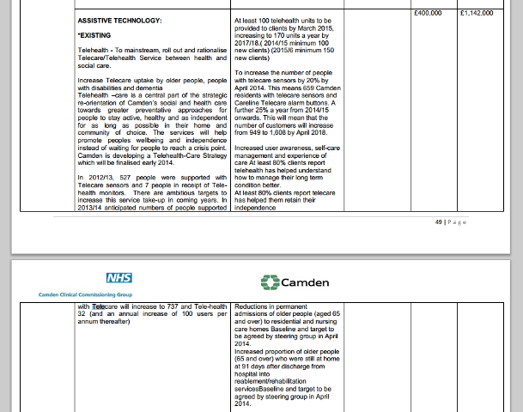
Support users to improve the self-management of their conditions and lifestyle changes safely in their homes and communities and to recover their confidence and independence following periods of crisis…

…This model of care is delivered through collaborative care planning that supports self-care, preventing deterioration and ensuring that when people are admitted to hospital their admission is planned and
they return home as quickly as possible through the identification of an accountable lead professional…

…Self-care to empower patients to manage their own conditions and not to become dependent on the care system…

…Increased user awareness, self-care management and experience of care At least 80% clients report
telehealth has helped understand how to manage their long term condition better

http://democracy.camden.gov.uk/documents/s33621/Item%209a.%20Better%20Care%20Fund%20template%20final.pdf

Central Bedfordshire

Planned changes and key success factors….
Ensure the full use of new technologies within housing schemes, such as telecare.

The Council recognises the need to maintain current arrangements of providing social care support to adults and older people assessed as having moderate, critical, or substantial needs. Maintaining its moderate eligibility criteria is critical to preventing reliance on acute/institutional care. This will continue through reablement, additional funding for Disabled Facilities Grants/Minor works, targeted provision of community
equipment, community alarms, and other telecare solutions, as well as investment in support to local communities to increase social capacity, such as, good neighbour/village care schemes.

….Funding increased capacity to meet growing demand for reablement, telecare, and associated interventions to reduce increasing demand and costs….

The agreed model of care (above) is underpinned by a new delivery framework for joint working across partners and client groups to deliver the full continuum of health and social care support. This includes
prevention and early intervention, self-management, reablement and independence

http://www.centralbedfordshire.gov.uk/modgov/documents/s49349/Better%20Care%20Fund%20-%20Final%20Submission%20-%20Part%201.pdf

Cheshire East

25 March 2014

Further exploration of assistive technology solutions for care and telehealth options will be part of this service
development in addition to seeking new and innovative care and support solutions not currently available.

Over the next five years, and starting with those individuals with complex needs, our models of care will focus on:
• empowering people to live full and healthy lives, self-manage and where required supporting people and their families with improved information and technology

Exploiting the use of new technologies to support independence, self-care and information sharing across partner organisations…
…Offering education, training and development programmes to support the implementation of new ways of working, self-care, local leadership, change management and improvement approaches...

…The focus on changing the dependency on statutory services to a culture of self help and self management will require a range of interventions from public health promotional initiatives through to community development interventions…

…The focus of support to enable self help and self management inevitably supports the social care agenda and the wider whole system support for independence and self reliance…

…It is intended that the risk profiling will be utilised to identify potential candidates who may become high risk in the future and thereby offer preventative measures linked to self help and self management techniques which will reduce the risk of condition exacerbation becoming critical…

…Similarly the Eastern Cheshire health economy is currently mapping services to be delivered across four pillars of care ranging from empowering people to self care and by transforming traditional primary, community acute and specialist care settings…

- Introduce dementia reablement service to focus on this client group at early stage of diagnosis to prevent/slow down deterioration in condition and introduce coping strategies/self management for the individual and carers

http://moderngov.cheshireeast.gov.uk/ecminutes/documents/s33628/Better%20Care%20Fund%20Submission%2004042014%20GK%20second%20draft.pdf

Cheshire West and Chester

Avoidable emergency admissions - The use of trend data highlights a small increase this year, but partners are confident that the schemes developed within our BCF submission (telecare, extra care housing, and continued use of the DFG) will help to lower this figure….

….Telecare: By utilising technology this service supports residents to live independently and securely in their
own home. We will use the BCF to support the extension of telecare across the Borough, extending the
number of customers receiving the service from 264 to nearly 2,000 - £1,674m in 2014/15 and £2,448m in 2015/16….

….Investment in the following services with a proven track record of managing demand - Extra Care Housing,
Telecare, Reablement

For our measure on service-user satisfaction partners are keen to use the Proportion of people who
feel supported to manage their long-term condition. This is an important outcome in demonstrating the ability of patients to comfortably self-care.

The schemes set out in the Better Care Fund provide a new approach to enable local residents to maintain their independence through radical changes to service delivery which involve stronger communities, self-care and integrated care teams.

http://cmttpublic.cheshirewestandchester.gov.uk/documents/s35764/BCFDraftExectemplateOneV22.pdf

City of London

The City has been adapting to the increasing demands of the aging population through increased provision in telehealth, preventing social isolation and in creating a dementia-friendly City….

….Those with long term conditions are supported to manage their condition at home and this is supported with the use of Telecare to help prevent acute admissions. Where admission is necessary, our Reablement and OT Service and our community services manage the rehabilitation processes and offer support, minimising the chances of readmission….

….Early identification - We have undertaken to identify residents who are at risk of vulnerability. We will use the risk stratification tool alongside our GP practice and those where our residents are registered in Tower Hamlets and Islington, to identify not only those residents who are at high risk and who are housebound, but those who are vulnerable to ensure that we can meet their needs at an early stage, reviewing potential housing needs to identify whether aids and adaptations, assistive technology or Telecare / Telemed may be required to support the resident to maintain their independence….

….We currently use aids and adaptations, assistive technologies and Telecare to ensure that people can stay safely in their home for longer where this is their preference and we have been able to effectively reduce the number of people being admitted to residential and nursing care following acute admissions….

….By enhancing the preventative services we offer, we will be aligning our position with the Care Bill well in advance of it being enacted and therefore increasing the opportunity of making a difference to service users in a timely way. This takes on importance particularly for those residents who might benefit from schemes such as Telecare. As the major provider of accommodation within the City, our Housing services can enhance
our use of aids and adaptations of the clients who are most in need, but also installing Telecare for those who might otherwise require a GP visit or even who might be admitted.

http://democracy.cityoflondon.gov.uk/documents/s34505/City%20of%20London%20BCF%20Draft%20Plan%20v5.pdf

Cornwall

Multiple documents with telecare, telehealth, self care references http://bit.ly/1rkmoil

County Durham

By 2018/19 we will….Ensure greater use of telecare to support people maintain independence in their own home.

The Planned Care Group is focused on transformational changes to support prevention and self-care as well
as effective elective care that is closer to home where possible.

http://democracy.durham.gov.uk/documents/s38807/Item%209%20-%20Appendix%202%20-%20County%20Durham%20BCF%20plan%20Part%201.pdf

Coventry





http://moderngov.coventry.gov.uk/documents/s15315/Better%20Care%20Funding%20Planning%20Template.pdf

Croydon

The use of telecare and telehealth technologies will continue to be key tools for G.P’s and community health services in reducing health inequalities in the borough whilst managing demand as the move from acute to primary care services gathers pace.

….These MDTs work with the voluntary and community sector to ensure that those not eligible for Council funded social care services, or not experiencing acute health needs can receive support to remain healthy and maintain their independence through signposting; with the MDTs then monitoring patients/clients to ensure that the appropriate services are being accessed in order to prevent any decline through appropriate early intervention. This will include access to reablement services and telecare which will provide targeted input with the aim of preventing the need for acute services or a longer term social care package of care….

….This will be supported through G.Ps and health professionals having access to telehealth technologies to enable the monitoring of patients without requiring them to take up surgery time, and help maximise the capacity of community nursing services by releasing them to focus on high needs patients. G.Ps will be supported through the continued development of a central telehealth triage service currently hosted by the Community Matron Service, and the Council’s local authority trading company (Croydon Care Solutions Ltd) who will undertake installation, maintenance, and recycling of equipment….

….A preventative approach is taking place alongside treatment and service provision at all levels. Patients as part of the delivery of clinical pathways are and will be involved in decisions relating to their health whenever possible. The CCG and the Local Authority have taken a progressive approach to the use of telehealth but also the use of new technologies such as Apps and websites….

….Recent review of Mental Health Older Adults (MHOA) services undertaken in Croydon highlights that the borough already has a number of both community and hospital based services for older people with mental health problems including dementia, such as memory services, community mental health teams, carer’s support, equipment services, major adaptations, telecare/telehealth, domiciliary care as well as neighbourhood luncheon clubs, faith groups etc. However, it has been concluded that a lack of integration
between health and social care is leading to duplication of work and an inefficient use of resources; which is potentially impacting on the maximisation of patient/client outcomes.

In the future many people who have long term conditions will need better organised care, closer to home, to help them self-manage their conditions and live as independently as possible…

…A joint approach to commissioning; to focus on preventing ill-health, supporting self-care including through personalisation, enhancing primary care, and providing care in people’s homes and in the community…

…In order to achieve this there is a need to shift the service culture from a reactive model where there is a dependence on higher cost acute services to a preventative model with lower cost community focused services supporting greater self-management at home. We believe this will result in a reduction in
the demand for high cost acute services and reduce demand for higher cost social care packages of care…

…Focus on prevention, health education, and effective self-management…

…Prevention, self-care and shared decision making (PSS) are part of Croydon CCG and the Local Authority shared strategies. Given the challenges that the borough faces, both in population health and financial terms, not prioritising PSS is not an option…

…The development of clinical pathways involves the creation of recommended shared decision making and self-help tools for patients. For instance the CCG is promoting the use of Apps and websites specifically targeted at back pain and recovery…

This coordinator will work closely with the Adult Community Occupational Therapy (ACOT) service which includes reablement funded OT posts, and will ensure that provider organisations deliver reablement interventions, as prescribed, to maximise the patient’s ability to regain skills and confidence to become as self-caring as possible, and will link patients/clients to other professionals and / or universal community services where appropriate

…An integrated approach between the NHS and the Council will focus on:

• Preventing mental and physical ill health;
• Supporting self-care (including through personalisation);

…The Community Pharmacy minor ailment scheme ‘Pharmacy First’ will continue to be promoted together with information on self-care for minor conditions…

…A key theme that will run through the integrated infrastructure will be the prevention of ill health and deterioration of health which is underpinned by the CCG’s prevention; Self-management and Shared decision Making Strategy.

https://secure.croydon.gov.uk/akscroydon/users/public/admin/kabatt.pl?cmte=WEL&meet=6&href=/akscroydon/images/att3432.pdf

Cumbria

Early intervention - We will support more people to retain their independence and control over their lives.
This will be achieved through robust and innovative partnerships with the third-sector, housing and other groups. Over the next five years, there will be a programme of regular review to ensure these approaches have a clear evidence-base and deliver measurable outcomes. Individuals will have their independence, safety and wellbeing maximised through integrated rehabilitation and reablement services, and access to assistive
technologies, equipment and housing adaptations, and carers’ support….

….Redesign pathways across health and social care to integrate reablement and rehabilitation services. This will enable more people to maximise their independence through therapy-led services. This will also ensure joined-up access to housing, the third sector, assistive technology and carers’ support….

….We will develop awareness across organisations of statutory duties through the pooling of resources and the investment and promotion of services to reduce the level of need - including rehabilitation and reablement, assistive technology and home adaptations to promote safety and independence.

The Cumbria Better Care Fund planning has taken place in this broader context, and is entirely consistent with the collective aims of:

• An increased focus on supporting independent living and specialist support for self-management.

http://councilportal.cumbria.gov.uk/documents/s27722/Cumbria%20Better%20Care%20Fund.pdf

Darlington

Identification of high risk patients leads to a pathway of care including the self-care tools available to moderate risk group with additional support in care planning and assistive technologies

improve routine care for all patients with long term conditions to encourage and support self-management as well as prevent deterioration in their overall condition…

…Social prescribing is one of the first interventions available in the Health and Social Care “offer” in Darlington and people have access to a range of wellbeing activities which build resilience and promote self-care…

…There are excellent Self-care support groups available to all and to which individuals can seek support and discuss with patient experts ways of coping with their long term condition. These groups also support individuals in how to best use personal health budgets and personal budgets through social care…

…Self-management, choice and control, primary and secondary prevention will be core features of our strategies and operating plans...

Self-management of LTCs

The aim of this scheme is to enable better self-management of conditions and for individuals to remain as independent as possible, avoiding unnecessary A&E admissions and reducing the burden on social care...

…The approach to risk stratification has been to develop low level support with a focus on self-care wellbeing using the “Make Every Contact Count” (MECC) framework. Moderate level of support is available for people at moderate risk consisting of disease specific education programmes and generic self-care and support...

Identification of high risk patients leads to a pathway of care including the self-care tools available to moderate risk group with additional support in care planning and assistive technologies.

http://www.darlington.gov.uk/PublicMinutes/Health%20and%20Well%20Being%20Board/April%202%202014/Item%204%20-%20Appendix%20A.pdf

Derby

No current telecare/telehealth/self care information – checked at 28 April 2014

http://bit.ly/PIbPtf

Derbyshire

No details of plans as at 28 April 2014

http://www.derbyshire.gov.uk/council/meetings_decisions/meetings/health_wellbeing_board/default.asp

Devon

A Joint approach to commissioning of community equipment, minor adaptations and telecare is already advanced and will be procured in early 2014.

Building community capacity
The strength of a community is related to wider measures of health and wellbeing and self-help which have implications for the statutory sector…

…A self-supporting and self-reliant and resilient community can deal with many challenges that would otherwise become the responsibility of statutory sector partners. Building this “social capital” needs to be an inherent part of our integration plan, and includes an active relationship between local communities and voluntary and community sector partners...

…We will embrace moves towards self-management for those with long term conditions and invest in assistive technology and develop community networks.

http://www.devon.gov.uk/loadtrimdocument?url=&filename=SCC/14/14.CMR&rn=14/WD12&dg=Public

Doncaster

No current telecare/telehealth information – checked at 28 April 2014

http://www.doncaster.gov.uk/db/chamber/default.asp?Nav=Meeting&MeetingID=6583

Dorset

Social Care Grant Schemes - Additional investment 14/15 Telecare/Joint Equipment - £200,000

The core components of the new system will be:
a) Increasing the pace and scale of initiatives aiming to provide ‘care closer to home’ to achieve targets on shifting from institutional care to self-help and community based systems

…Investment in locality and community initiatives which seek to promote self help and divert demand.

http://www1.dorsetforyou.com/COUNCIL/commis2013.nsf/6B2DCB2A779013FC80257CA200342F22/$file/05%20Better%20Care%20Fund%20and%20Better%20Together%20Business%20Plan%20with%20appendices%20attached.pdf

Dudley

No detailed information about the plan from Board agendas – as at 28 April 2014

Ealing

Wider promotion of telecare….

….Explore a number of enablers and test these such as, Care Planning, and Assisted Living Technology, and sharing of information between professional groups.

Customer and Patient Experience – service co-designed based on user feedback & improved patient outcomes; greater self-care…

…Self-care – users and carers empowered & supported
We will work closely with Public Health to align procurement plans and service specifications to support the model of prevention and self-care…

…Support systems to enable self-management/care…

…The proposed BCF strategies for care coordination, co-design, culture change and the promotion of self-care and engagement of the voluntary sector and public health will complement the priorities identified for Older People…

…The Public Health Department commission activities to encourage the promotion of self-care as well as prevention of long-term conditions and have undertaken significant primary care prevention around diabetes; and in “change for life programmes” such as “Eat Less - Move More”…

…In particular we will review opportunities to work with public health commissioners and providers on shaping the specification of services in scope for our BCF schemes, particularly in relation to the Third Sector commissioning project, the promotion of self-care, care coordination & navigation and in supporting the Council to meet statutory duties to promote prevention and wellbeing as part of the Care Bill…

…The implications of the Better Care Fund for all hospital providers will be influenced by a number of issues. There will be an increased focus on integrated community based out of hospital services, such as hospital-at-home; greater integration of the health and social care wrapped around the person's needs; greater coordination of care and system navigation, greater support for individuals around self-care; and greater engagement of the voluntary sector in support statutory service provision.

http://bit.ly/1mPNwbE

East Riding of Yorks

No current telecare/telehealth information – checked at 28 April 2014

http://www2.eastriding.gov.uk/council/committees/health-and-wellbeing-board/

East Sussex

Developments in diagnosis, treatment and assistive technology means we can do far more to support people at home and in the community rather than provide care in traditional bed based settings….

….Promoting Health and Supported Self Management –empowering clients to improve their health maximise self‐management and choice. Ensuring that patients are offered a personal care plan and have appropriate information about how to manage their condition e.g.
through education, support and assistive technology….

Our vision is to create a health and social care system that promotes health and wellbeing, prevents ill health and improves the outcomes andexperience of our population. This will be delivered through a focus on population needs, better prevention, self care, improved detection, early intervention and proactive, joined up response to people that require care and support across traditional organisational and geographical boundaries…

…Clients will be actively involved in making choices about improving their health and well being through
self management, involvement in care planning and use of personal budgets...

The long term conditions model needs to focus on pro‐active management to meet people’s care and support needs; promoting and enabling self care…

…Older people and people with LTCs empowered to self‐manage…

…We want to help more people to help themselves, as well as focusing on reablement and more proactive
support to ensure people remain well, are engaged is self management, and where ever possible are improve people’s independence so they can stay within their own home…

Priorities for the programme are to:
• Create services that inform and empower clients to manage their own condition and enable them to be treated in settings closer to home and spend less time in acute settings
• Focused on secondary prevention by empowering clients to self-manage their condition better
• Better management (including self-management) of clients with Long Term Conditions.
• Use of large scale change techniques to engage local commissioners, providers and clients to identify existing best practice and implement across East Sussex.

…This will include self help groups and community level initiatives with the voluntary sector to increase their capacity to provide preventative and upstream care...

…Our NSTs aim to deliver integrated personalised (health and social care) preventative and proactive support that equips clients, carers and their families with the knowledge and skills to facilitate self-care, well-being and promote independence…

…A shift to more self care, preventative, early intervention and care at home will reduce
demand on hospitals and enable us to meet demand within available resources

The broader 5 year strategies that will be developed by NHS partners will consider opportunities for:
- Promoting health and wellbeing, early intervention and self care

…The long term conditions model focuses on pro‐active management to meet people’s care and
support needs; promoting and enabling self care, improving access and choice through more
convenient and planned options for care, and making services more cohesive so that care is better
co‐ordinated and the system of care is less complex…

Promoting Health and Supported Self Management – empowering clients to improve their
health maximise self‐management and choice. Ensuring that patients are offered a personal
care plan and have appropriate information about how to manage their condition e.g.
through education, support and assistive technology.

We want to help more people to help themselves, as well as focusing on reablement and more proactive
support to ensure people remain well, are engaged is self management , and where ever possible are improve people’s independence so they can stay within their own home.

http://www.eastsussex.gov.uk/NR/rdonlyres/C4B5FBC6-28EF-4190-A465-82EA27C10783/36206/Agendaitem9.pdf

Enfield

Example initiatives being considered for BCF support – Assistive technologies/Tele Health

We expect to see as a result….more self-management of long term conditions through increased use of
telehealth/telecare….

….These solutions will be augmented through the deployment of assistive technology, including telecare and telehealth known to be under-utilised in Enfield, to ensure that people are as safe, healthy and live with the condition as independently and effectively as possible and an appropriate planned or urgent response is available to support people to live at home (avoiding inappropriate hospital admission). We are currently piloting this to inform the new system….

….In addition to the ongoing support described above, there is targeted provision of equipment, reablement, community alarms and other telecare, aimed to improve outcomes for local citizens and either reduce or avoid the need for ongoing care or complement ongoing support….

Funding increased capacity to meet growing demand for reablement, telecare, and associated interventions to reduce ongoing demand and cost….

Essex

Complex information from all CCGs and local authority -

Example - involving patients in co-creating a personalised self-management action plan, which could
include education programmes, medicines management advice and support, telecare and telehealth for self-monitoring, psychological interventions and patient access to their own records

http://bit.ly/1fp2oLN

Final submissions: http://cmis.essexcc.gov.uk/essexcmis5/CalendarofMeetings/tabid/73/ctl/ViewMeetingPublic/mid/410/Meeting/3078/Committee/134/SelectedTab/Documents/Default.aspx

Gateshead

Difficulties accessing website information from Health and Wellbeing Board – as at 28 April 2014

Gloucestershire

We currently provide and will continue to develop the following….Making greater use of technology to support individuals at home, such as Telehealth, Telecare and online self-management programmes….

….Over the last few years there has been an increase in placement to residential or nursing homes, particularly for people being placed in care homes following discharge from hospital. The CCG has made additional funding available for services based in the community and increased reablement capacity and new telecare arrangements are all expected to impact on this trend in the latter six months of 2013/14….

Priority areas we will be exploring over the coming months…. The use of technology in supporting home-based care including potential joint investments and benefits from Telehealth and Telecare….

….2014/15 funding - Telecare including the Telecare Change Project £384,000….

….Underpinning all of our plans is a focus on systems that support and remove barriers to
integrated care through….Using technology to develop networked, personalised health and care services….

….The service will introduce individuals to the potential of assistive technologies and, where these are to be employed, will ensure individuals are familiarised and comfortable with their use.

Self-Care - Overview

There is also more we could do to support our citizens to self-care – helping people, alongside their carers, to take more control of their own health, in particular those with long term conditions. This reduces the need for Health and Care Services. We currently provide and will continue to develop the following;

• Working with patients and citizens who have a long term condition, cancer or are approaching the end of to life to develop personal care plan. This includes developing shared goals and expectations
• Spending more money on self-management programmes, which provide information, advice and support to better manage their own health conditions and make best use of both the patient’s/citizen’s time with health and care professionals
• Ensuring that when someone experiences a period of ill health, such as following a stroke, they receive the treatment and support that is most likely to prevent the problem happening again and keeps them healthy
• Making greater use of technology to support individuals at home, such as Telehealth, Telecare and online self-management programmes

Our teams will work with the Voluntary and Community Sector to ensure those not yet experiencing acute need, but requiring support, are helped to remain healthy, independent and well. We will invest in empowering local people through effective care navigation, peer support, mentoring, self-management programmes to maximise their independence and wellbeing; and we will help identify and combat social isolation, as a major influence on overall health and wellbeing…

We will use the BCF to:

• Help people self-manage and provide peer support working in partnership with voluntary, community and long-term conditions groups.

Undertake a full review of the use of technology to support primary and secondary prevention, enable self-management, improve customer experience and access, and free up professional resources to focus on
individuals in greatest need.

http://glostext.gloucestershire.gov.uk/documents/s20601/Better%20Care%20Fund%20HWB%20-%20Final%20Submission.pdf

Greenwich

Detailed information not available as at 28 April 2014

http://committees.greenwich.gov.uk/ieListMeetings.aspx?CId=500&Year=0

Hackney

Telecare
We are relaunching Telecare to fulfil our aspiration to position Telecare at the heart of care and support, increasing opportunities for independence as well as delivering savings to benefit the system….

Telecare will deliver a local service model to increase take-up and application across a wide range of need groups, benefiting adults with disabilities as well as older people, and those who may benefit on a preventative basis….

….Work is being undertaken to….
embed Telecare within reablement and intermediate care….

….make clear Telecare requirements within future care and support specifications….

….deliver a platform alongside which Telehealth can develop, scoping further opportunities for integration.

….All the domiciliary care that we offer is based on the principles of reablement and we promote the use of assistive technology such as Telecare where these will enable people to remain safe and meet their care
Needs….

….We will utilise opportunities for sharing information through new technology to tailor services to individual need and enable those who are able to do so, to manage their own conditions with confidence

A high quality, integrated care and support system in Hackney across physical health and wellbeing, social care and mental health which…
• Enables better self-management of care and support

Social prescribing:
A primary care referral pilot social prescribing project has been established across three GP Consortia areas in Hackney. It is provided by the voluntary and community sector. A variety of community based activities are run by the voluntary sector and local authority. It is aimed at patients and service users experiencing social isolation, those over 50, and those with Type 2 diabetes. This model utilises the LBH iCare web-site and Health and Well-being Care Plan. It is intended to improve individuals’ health and well-being, enhance self-management of long-term conditions, and increase understanding of local community activities and groups by
primary care teams.

All services will be focused on prevention, promoting independence, recovery and social inclusion. Service users will be able to choose from a menu of services which will include: self-management support, health and wellbeing activities, employment support, support to access education and training, talking therapies
and personal support packages for people with more intensive needs.

http://mginternet.hackney.gov.uk/documents/s35500/Appendix%201.pdf
http://mginternet.hackney.gov.uk/documents/s35499/Draft%20Better%20Care%20Fund%20Plan.pdf

Halton

12 March 2014

The focus is on….Use of enabling technologies such as telecare and telehealth….

….The following schemes will be implemented….

ii) Further develop our approach to Telecare and Telehealth interventions to support people to live
as independently as possible within the community. Services will be tailored to individual needs
and encourage a whole system/whole person approach to care

….Providers have advised how pathways can be improved, teams reconfigured to increase quality and productivity, systems be more efficient and teams more integrated. These changes coupled with the introduction within care pathways of appropriate technology will enable people to live independently, avoid emergency admissions, benefit from reablement services if necessary and have a better patient experience….

….Technology will be central to supporting people to improve and maintain their health and well-being,
offering a range of platforms and sophistication dependent on intensity of need and desired outcomes.

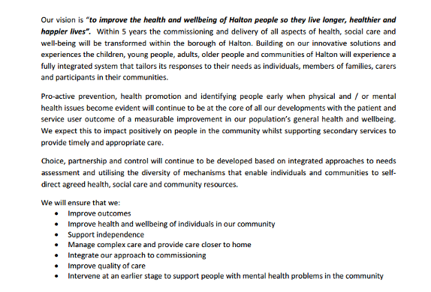

…This framework is easily accessed and understood by the public. It removes duplication, improves efficiency and builds on the strong relationships between social care, health services, self-care services and the third sector…

…PRISM Level 1 and 2 – These individuals are at medium to low risk of hospital admission and constitute
approximately 70-80% of the long-term condition population. They can self- manage their health.

http://moderngov.halton.gov.uk/documents/s32812/BCF.pdf
http://moderngov.halton.gov.uk/documents/s32740/Approval%20of%20the%20draft%20Better%20Care%20Fund.pdf

Hammersmith and Fulham

Tri-borough (with Kensington and Chelsea/Westminster)

At the heart of this will be integrated Community Independence teams that will provide a rapid response to support individuals in crisis and help them to remain at home. Community Independence will also work with individuals who have lost their independence through illness or accident and support them to build confidence, regain skills and, with appropriate information and support, to self-manage their health conditions and medication. The service will introduce individuals to the potential of assistive technologies and, where these are to be employed, will ensure individuals are familiarised and comfortable with their use….

….Undertake a full review of the use of technology to support primary and secondary prevention, enable self-management, improve customer experience and access, and free up professional resources to focus on individuals in greatest need.

People will be empowered to direct their care and support, and to receive the care they need in their homes or local community.

We will use the BCF to:
Help people self-manage and provide peer support working in partnership with voluntary, community and long-term conditions groups.
http://www.lbhf.gov.uk//Directory/Council_and_Democracy/Committee_reports_minutes_and_agendas/Committee_Archive/homepage.asp?mgpage=ieListDocuments.aspx%26amp%3BCId%3D463%26amp%3BMId%3D2782%26amp%3BVer%3D4

Hampshire

*Updated on 6 May 2014
It is proposed to build the additional resources identified in the BCF and existing pooled resources to commission services jointly to deliver enhanced personal care and reablement services which will reduce hospital readmissions and admissions to residential and nursing home care. This will include….Access to a wide range of telehealth and telecare….

The plans will delivery the following changes to ensure high quality, sustainable health and care system for Hampshire….Our Community Providers will implement new models of service delivery that they have co-produced, drawing on assistive technologies where this is appropriate to do so….

Meeting need and managing demand….Using technology to add value to care and support packages

The importance of prevention and earlier intervention are well evidenced to help people stay well, living independently and enjoying a quality of life for longer. Helping people to improve their health and well being and self manage their longer term conditions into later life is ultimately fundamental to tackling the inexorable growth in demand.

This will support our work to commission a model that transforms the current arrangements to a new model for better care in Hampshire encompassing…Supported self care

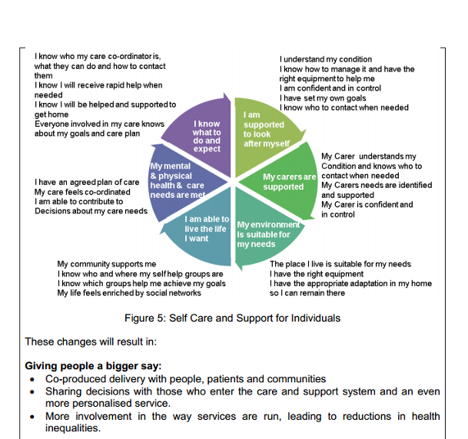

http://www3.hants.gov.uk/councilmeetings/meetingsummary.htm?date_ID=1300

Haringey

More specifically, Haringey will take forward the development of….
Telehealth and Telecare, provided 7 days a week, to enable people to remain in their own homes with an increased sense of security while providing carers with reassurance that their loved ones are being monitored;

….Mainstreaming telecare/telehealth.

It also means that we will place a strong emphasis on speed of response, enabling independence, self-management, prevention and providing services in people’s own homes…

…Objective – Prevention and increased support in the home and community: We will refocus services to offer increased support in the home and community to maximise the independence of people and enable them to
self-manage their own health and wellbeing. This means responding proactively to the needs of individuals with, as above, an emphasis on prevention and working with the Third Sector to grow the range of community
based solutions to people’s needs...

…In the course of 2014/15 we will review the integrated services that already in place and undertake the detailed planning that will underpin the enhancement of some and the launch of new initiatives focusing on frail older people, older people with dementia, end of life care, discharge planning and self-management…

…Reduced outpatient demand: better care planning and an emphasis on enabling self-management will aim to streamline, where appropriate, the numbers of outpatient appointments that patients are attending

http://www.minutes.haringey.gov.uk/Published/C00000771/M00006666/AI00036229/$APPENDIX1a.docx.pdf

Harrow

19 March 2014

Telehealth pilot – we will continue the development of telehealth pathways with the use of private provides aligned to our existing pathways i.e. STARRS. For 2014/15 we will expand the remit of the telehealth service to also include heart failure in addition to the existing COPD pathway. This will increase the impact of the services for patients at risk of exacerbations of these two clinical conditions.

The carers service is a jointly commissioned set of pathways supporting carers to manage in the community. Through the Better Care Fund we aim to prevent the breakdown of carer support networks for services users and patients to increase the impact of self-management in the community. Overall we intend for this to be part of the emerging GP Networks and community hub development as part of Harrow’s out of hospital strategy. The impact of this will be a reduced requirement for unplanned respite and hospital admissions…

…We will aim to support to carers and caring families including the provision of respite care, with an absolute focus on optimising the independence of the person and development of self-care plans in collaboration with service users and carers…

…We will extend this further to: scale it to all people with complex health and care needs; and include people with medium risk who will benefit from care planning and introduction of self-care pathways...

• An absolute focus on optimising the independence of the person and development of self-care plans in collaboration with service users and carers

• Require the GP network to provide self-management and prevention support/education

…Ensure patient involvement in developing the care plan so that they are empowered to self-direct their care

http://www.harrow.gov.uk/www2/documents/s114005/HWBB%2019%2003%2014_Appendix%203%20Harrow%20Better%20Care%20Fund%20plan.pdf

Hartlepool

26 March 2014

Funding currently allocated through the NHS Transfer to Social Care has been used to enable the local authority to sustain the current level of eligibility criteria and to maintain existing integrated services that support timely hospital discharge, delivery of reablement and telecare services, commissioning of low level support services and support for carers. Investment in these services will need to be sustained to maintain this as the social care offer for Hartlepool and to maintain current eligibility criteria and increased in order to deliver 7 day services and to address the implications of the Care Bill, which will require additional assessments to be undertaken for people who did not previously access social care and provision of further support for carers…..

Key themes and comments from people were
• Services close to home
• Improved communication
• Self-management for Long Term Conditions
• Improved access
• Improved Urgent Care
• Education and support for carers

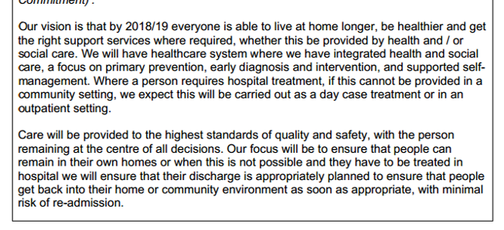

Low Level Support and Management of Long Term Conditions
People must be supported more systematically to maximise their own financial, human and community resources to achieve self-determination. We will support people to access resources in their own communities and to manage their own conditions and will work with the voluntary and community sector to ensure that those not yet experiencing acute need, but requiring support, are helped to remain healthy, independent and well…
We will invest in empowering local people through effective facilitation and signposting, carers support, self-management and low level preventative services to maximise their independence and wellbeing and we will help identify and combat social isolation, as a major influence on overall health and wellbeing...

…This tool is to be further developed to incorporate both social and health risk to enable a targeted multi disciplinary approach to support people to better self-manage their long term condition, having an appropriate identified accountable lead.

http://www.hartlepool.gov.uk/egov_downloads/26.03.14_-_Health_and_Wellbeing_Board_Agenda.pdf

Havering

It is anticipated that other priorities of the first two years (‘14-‘16) of the five year plan (’14-’19) will include…. Extending the telecare and telehealth solutions, as well as roll out across Havering. (Building Blocks 2/3)

Nearly 15,000 older residents are estimated to be unable to manage at least one self-care task on their own and more than 18,000 are estimated to be unable to manage at least one domestic task on their own (e.g. shopping, washing etc.)…

…As a result of the changes arising from our ambition, individuals will feel confident about the care being received. The (self) management of their conditions is improved and the reliance on A&E attendance in crisis and potentially hospital admission is much reduced. If there is a need for a stay in hospital then the
individual is helped to regain their independence and they are appropriately discharged as soon as ready, with certainty about the continuity of care to be delivered...

…We expect overall pressures on hospital budgets to have reduced as the shift from high cost reactive spend to spend on lower cost preventative services and greater self-management bear fruit…

…The teams will work with the voluntary and community sector to ensure those not yet experiencing acute need, but requiring support, are helped to remain healthy, independent and well. We will invest in empowering local people through effective care navigation, peer support, mentoring, self-management and time-banking programmes to maximize their independence and wellbeing; and we will help identify and combat social isolation, as a major influence on overall health and wellbeing. Co-production will be the basis for this work at a local level...

…These will provide a rapid response to support individuals in crisis and help them to remain at home. The I(H)T will also work with individuals who have lost their independence through illness or accident and support them to build confidence, regain skills and, with appropriate information and support, to self-manage their health conditions and medication. The service will introduce individuals to the potential of assistive technologies, where these are to be employed, and will ensure individuals are familiarized and comfortable with their use. This will be further enhanced by the alignment of social workers and subsequently their integration into the teams. This is already underway and will be a priority for ‘14/15…

…As a joined up health and care community Havering will have left behind the disease-based and reactive model with an agreed vision to focus on well-being, prevention, self-care and reablement – always striving for maximum independence
– so that the people of Havering can “start well, develop well, live and work well, age well and die well.”

We will have a vibrant primary care model integrated with the community in the widest sense – with the whole spectrum of health and care but also with the voluntary and community sector which can do so much to offer support for self-care and peer support and help to get services right.

http://democracy.havering.gov.uk/documents/s10872/Appendix%20finance%20removed.pdf

Herefordshire

26 March 2014

The Council has recognised the importance of a range of prevention and early intervention approaches including Telecare, community equipment and reablement in keeping people independent but due to the need to prioritise meeting its statutory responsibilities it is only able to offer these interventions to those with eligible need….

….Both in order to deliver 7 day services and implement core prevention pathways (including Telecare, information and advice and reablement) in order to reduce demand and provide long term demand management which will allow disinvestment from acute 16 and crisis social care.

Joining up pathways by working with the residents of Herefordshire is central to our broader Health and Well Being vision for Herefordshire. Our communities and volunteers theme and the engagement work that is been undertaken is based on building on what is already in place in local communities and voluntary networks that supports health and social care, and then looking how we can then transform professional pathways across
health and social care, and at a primary and secondary care in a coordinated way maximising independence and self management – and providing high quality interventions when we need to do so…

The aim is:

“To provide integrated services which promote self-management and independence across Herefordshire’s population. Robust sustainable community based services which will form part of an integrated continuum, with seamless pathways of care that integrate primary, community, secondary, mental health and
social care services around the residents of Herefordshire, their children and communities…

The objectives are:
• To provide proactive anticipatory care that promotes supported self-management and prevents crises presentations

… Supported self management and independence:
-Improvements in proportion of people feeling supported to manage long term conditions in the community

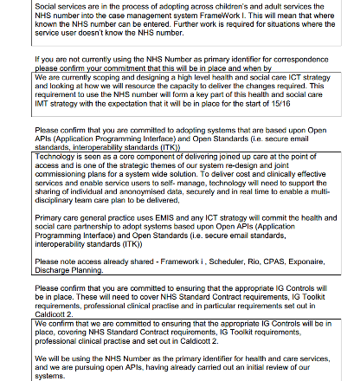

We have implemented risk stratification linked to anticipatory care planning and supported self- management within virtual wards in one locality as a pilot covering Herefordshire City GP practices.

http://councillors.herefordshire.gov.uk/documents/s50018105/BCF%20V5%20Draft%20Plan%20Hereford%2014%202%2014.pdf

Hertfordshire

No current telecare/telehealth references – checked at 28 April 2014

http://www.hertsdirect.org/your-council/civic_calendar/healthwellbeingboard/17876283/

Hillingdon

1 April 2014

Some themes emerge from these sources, including…. Telecare line is seen as important in supporting older people and in “taking away worries”….

….Pre-crisis management: Availability of rapid care bundle (includes: medical monitoring support, domiciliary care, telecare, helpline and others as necessary)….

….As part of Better Care Fund, we will develop the model further by….

Creating a joined up, single, intermediate care team which will include reablement, community
rehabilitation, equipment, telecare and homecare.

We will extend this further to: scale it to all people with complex health and care needs; and include people with medium risk who will benefit from care planning and introduction of self-care pathways…

…An absolute focus on optimizing the independence of the person and development of self care plans in collaboration with service users and carers

http://modgov.hillingdon.gov.uk/mgConvert2PDF.aspx?ID=19918

Hounslow

Underpinning all of our plans is a focus on systems that support and remove barriers to
integrated care through….Using technology to develop networked, personalised health and care services

The service will introduce individuals to the potential of assistive technologies and where these are to be employed, will ensure individuals are familiarised and comfortable with their use.

We are developing a Prevention Strategy and recognise the crucial involvement of service users and carers and neighbourhood groups such as good neighbourhood schemes in shaping this strategy but also in helping us deliver the self-management strategy that underpins the Better Care Fund.

We have already invested in an integrated community response service (ICRS) that provides rapid response to support individuals who are rapidly deteriorating, stabilising them so they can remain at home. We are now redesigning our rehabilitation and reablement service model and pathway to provide, with our ICRS, an integrated Community Recovery service model which will work with individuals who have lost their
independence through illness or accident and support them to build confidence, regain skills and with appropriate information and support, to self-manage their health conditions and medication. The service will introduce individuals to the potential of assistive technologies and where these are to be employed, will ensure individuals are familiarised and comfortable with their use…

…We will use the BCF to:
Help people self-manage and provide care navigation working in partnership with voluntary, community and long-term conditions charitable groups engaging particularly with Hounslow inter-faith groups.

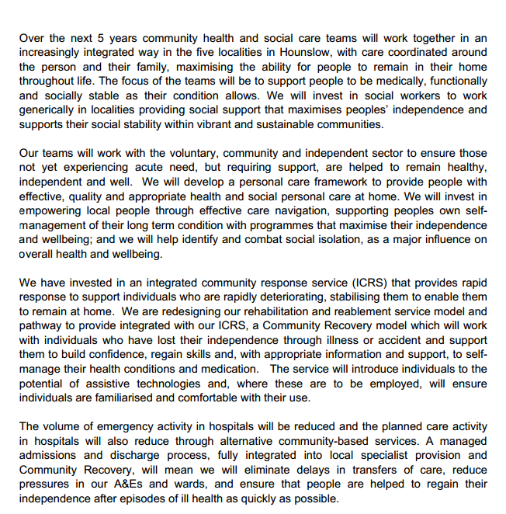

…Help people self-manage and provide care navigation working in partnership with voluntary, community and long-term conditions charitable groups particularly engaging with Hounslow inter-faith groups…

…Help people care manage and provide care navigation.
We intend to provide care navigation in all localities that supports residents and their families to navigate the health and social care environment and support self management. We will evaluate a current care navigation pilot and use that learning to develop a specification and tender for a care navigation service.

http://democraticservices.hounslow.gov.uk/documents/s88063/BCF%20PAPERS.pdf

Isle of Wight Council

No details in Board papers.

http://www.iwight.com/Meetings/committees/Health%20and%20Wellbeing%20Board/6-3-14/PAPER%20C.pdf

Isles of Scilly

Unable to locate details as at 28 April 2014

http://openlylocal.com/councils/67-Council-of-the-Isles-of-Scilly

Islington

12 March 2014

Islington has already received investment for social care where there are clear benefits to health. This has been invested broadly and includes….The development of the Council’s telecare offer that has seen the use of telecare increase year on year….

….Patient activation and self care are areas of work where we want to further develop our offer. In 2014/15 we will consider how we can develop our offer around telecare and telehealth both to support professionals to work differently, for example, consulting via skype to using mobile devises or applications to support self care….

….The work programme will include not only looking at what services will align with localities but also consider….The expansion of teleconferencing to include those identified further down the
triangle of risk

http://democracy.islington.gov.uk/download/meetings/healthandwellbeingboard/healthandwellbeingboard/12thmar2014/1a%20Better%20Care%20Fund%20Final%20submission.pdf/get.aspx

Kensington and Chelsea

24 March 2014

Tri-borough arrangements – see Hammersmith and Fulham

http://bit.ly/MnbhIh

Kent

26 March 2014
We will systematise self-care/self-management through assistive technologies, care navigation, the development of Dementia Friendly Communities and other support provided by the voluntary sector….

….Enabling Prevention and Self Care - Assistive Technology….

….West Kent: Ensuring people have anticipatory care plans in place. Enable consultant access via technology….

….Self-care and self Management-West Kent: Co-produce with patients, service users, public and voluntary and community sector improvements in self-care. Including care navigators, advanced assistive technology,
patient held records and the development of Dementia Friendly Communities….

….Protection social care services in Kent means ensuring that people are supported to maintain their independence through effective reablement (including the appropriate use of assistive technology), preventative support such as self-management, community resilience and support for carers, mental health and disabilities needs in times of increase in demand and financial pressures and the effective implementation of the Care Act.

The focus will be on supporting people to self-manage and coordinate their own care as much as possible, facilitated by integrated electronic records and care plans.

We will systematise self-care/self-management through assistive technologies, care navigation, the development of Dementia Friendly Communities and other support provided by the voluntary sector.

Protection social care services in Kent means ensuring that people are supported to maintain their independence through effective reablement (including the appropriate use of assistive technology), preventative support such as self-management, community resilience and support for carers, mental health and disabilities needs in times of increase in demand and financial pressures and the effective implementation of the Care Act.

https://democracy.kent.gov.uk/documents/s45579/Item%205%203%20Appx%20A%20Kent%20BCF%20template%20pt1%20v2.pdf

Kingston upon Hull

25 March 2014

Our Strategy identifies the need to…. implement telehealth and telecare technology for health, housing and social care use to support people in their own homes and empower them to manage their own health and wellbeing….

….Case study for Catherine: Telecare and other technology solutions are in place to ensure contact can be made with her daughter on a daily basis….

….Primary care and self care initiative - Telecare and telehealth provision – promote its use and rollout….

….Telecare and telehealth provision – promote its use and rollout. 900 people being monitored by March 2015.

Many references to self care/self-management

There is also a need to work with communities to raise the expectations and aspirations of the people living in the city for better health and support and to capitalise on their own resources to self-care…

The mortality rate from all causes under the age of 75 years is 30% higher than the mortality rate for
England; the main causes of death in Hull being cancer and coronary heart disease (CHD). These two diseases account for more than half of all deaths of people under the age of 75 years, which with the associated health needs linked to deprivation and high numbers of smokers in the City presents a challenge to the current system in terms local people who need hospital and high intensity services whilst focusing efforts on prevention, wellness and self care…

…Focusing on supported self-care, wellness and prevention can realise more benefits in terms of shifting
the reliance on hospital care and achieving better health outcomes…

…Our local vision for Better Care is described below; it is our aspiration that local health and social care services will change significantly over the next 5 years. Health and Social Care organisational boundaries will be broken down to ensure that care is co-ordinated across different care settings. There will be easier access to care at the point of need delivered in local communities. People will have more choice and control to enable them to stay in their home. They will have the resources to self-care and the information to access coordinated care when required. People will understand their local services because they will be instrumental in the development and monitoring resources in Hull.

..The Better Care Fund will be used to invest significantly in an improved, integrated health and social care system, changing the way that health and social care services are funded to drive improvements for older and disabled people. This will resource a joined-up health and social care service, shifting care away from hospital to home or community facilities, promoting self-care and independent living. It is expected that the secondary care sector will reduce as a result and that staff in all acute and community services will work differently as we progress our plans – teams without walls…

…Our Better Care resources will be targeted at schemes that can achieve a shift from acute and residential care to community and self-care…

…Over the course of the Better Care Plan prevention and self care will become the norm, integrated
community teams will be empowered to deliver whole system care and result in acute episodes of care being effectively managed and people being supported to return to independent living…

…This vision will be realised by working to deliver a transformational strategy that focuses on organising care into 4 delivery models based on need:
- Supporting resilience and wellbeing
- Self care and carer support
- Early intensive intervention
- Complex multi care need

…It is a key aim of the CCG to allow the individual to take ownership of their own care and development. This will empower them to pursue happier, healthier more independent futures and develop a sense of aspiration and hope for the future. The priority of this work stream will be to provide access to interventions to promote self-confidence and competence to self-manage…

…Hull has introduced the use of a risk profiling tool in primary care the intention is to increase the access to and use of self care programmes

http://bit.ly/1i2az0D

Kingston upon Thames

1 April 2014

We have established a substantial range of services but there is potential to do more, for example….
Expansion to increase responsiveness or environmental / adaptations / equipment support e.g. Careline, telecare, adaptations

There is a much improved use of technology to enable communication with specialists e.g. GP hotlines (telephone / Skype) to consultants, sharing of clinical records

At a high level, the implications of the vision for the pattern and configuration of services Kingston BCF Plan
over the next 5 years includes:

• Increased emphasis on prevention and proactive intervention
• More service user self-management



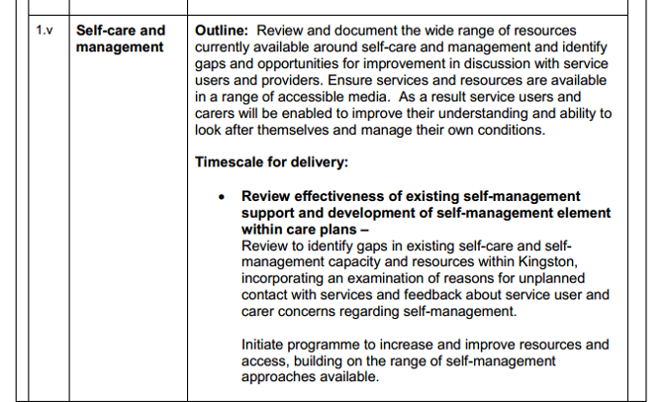
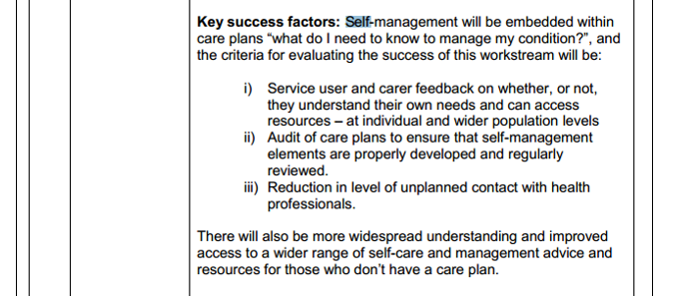

http://moderngov.kingston.gov.uk/documents/s51459/Better%20Care%20Fund%20plan%20-%20Kingston%20V5%201.pdf

Kirklees

Developing the assistive technology and telecare infrastructure, including mobile response Services.

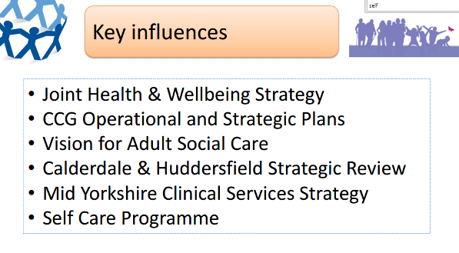

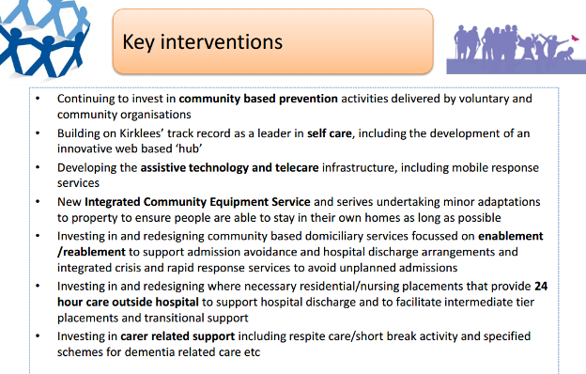

http://www.kirklees.gov.uk/Secure/meetings/pdfs/0314/HWBB27031450829D.pdf

Knowsley

2 April 2014

This transformation will ensure that residents will…. Receive assistive technology, equipment, telehealth and telecare as part of a prevention programme….

Funding currently allocated under the Social Care to Benefit Health grant has been used to enable the local authority to achieve the following….Telecare

Knowsley residents will live longer, healthier and happier lives. They will be safer and there will be a reduction in health inequalities. They will have greater independence, be able to self-manage more effectively and become active participants in ensuring their own and their family’s health and wellbeing, having more responsibility and greater involvement in decisions about any care and support they receive.

…The overall aim is of an integrated system that demonstrates the following characteristics…
Empowering: enabling independence through self-care, prevention and early detection, supporting people to remain at home…

…The protection of adult social care services means Knowsley residents will be supported to remain at home and manage their own wellbeing for as long as practicably possible. This will be achieved by not simply preserving the exiting supply of adult social care services but by refocusing all health and social care interventions on empowering residents to self-care and self-direct solutions that keep them well. In a context of reducing resources `care at home’ will be reinforced to challenge an over reliance on more expensive models of care and acute sector provision. A commitment to the value of social care within an integrated whole person model of delivery will ensure maximum benefit and impact to Knowsley residents.

http://councillors.knowsley.gov.uk/documents/s28038/BCF%20Plan%20Final%20Apr%202014%20app1.pdf?StyleType=standard&StyleSize=none

Lambeth

No recent information as at 28 April 2014

Lancashire

There will be a focus initially on the frail elderly and carers - Joint investment in Telecare to ensure it is funded for growth and health and care staff are fully deploying its potential….

….Scope potential for joint investment and expansion of Telecare services with County Council….

….Partners are also progressing IT and Technology initiatives and digital strategies that will enable change across multiple organisations – with further work to develop data sharing and infrastructure, use of technology for e.g. email and text and Skype to overcome unnecessary delays in the system, provide viable alternatives to face to face appointments and sharing of patient information to facilitate joint care….

….Undertake a full review of technology use to support primary and secondary prevention, enable self-management, improve customer experience and access and free up professional resource to focus on individuals in greatest need.

Many references to self care.

The principles of Prevention and Self Care underpin the schemes and interventions that
lie at the heart of this Better Care Fund Plan…

…Ways of working that promote the necessary empowerment for self-care and real involvement in decision making – about our own care – and about our services. Commissioners and providers need to make cultural shifts to enable these behaviours to become part of the health and care infrastructure…

…Better self-management of long-term conditions/ambulatory case sensitive conditions with the offer of accessible alternative responses to crises over 7 days. We will maximise the opportunities for people to control flexibly their support through health and social care individual budgets…

…Inextricably linked to the work of Care Closer to Home, the BCF will be used to further progress the West Lancashire Neighbourhood Team model and associated enablers which include workforce, IT, public health and wellbeing, self-care and community assets, amongst others…

…Utilisation of risk stratification and self-care within natural communities based around GP Practice lists, underpinned by case finding and an assets based approach to community development (including Lancaster District HWB Partnership)

http://council.lancashire.gov.uk/documents/s39041/BCF%20Appendix%20A.pdf

Leeds

27 March 2014
Provide high quality services in the right place, backed by excellent research, innovation and technology- including more support at home and in the community, and using hospitals for specialised care….

….These efficiencies have been delivered through a range of measures including the significant decommissioning of in-house services, service redesign and investment in preventative services, together with the implementation of innovative, jointly commissioned and provided social care schemes including the South Leeds Independence Centre, Reablement Service, Integrated Neighbourhood Teams, the Assistive Technology Hub all as part of our ongoing ‘Better Lives’ programme….

….Together with the necessary platforms for technology to support self-care and self-management, “big data” solutions will support more accurate commissioning and service provision decisions in line with people’s experiences of care – which will lead to better outcomes for the people of Leeds.

The integrated health and social care model in Leeds has been developed around three core themes:
• Supported self-management
• Risk stratification
• Integrated health and social care teams

…Self-care and self-management (supported by Leeds’ ambition to be a digital city for health and social care), and the engagement of community, independent and third sector organisations are key to achieving improved chronic disease management, social inclusion and community cohesion. The continuing close engagement with all provider organisations will remain at the centre of our transformation programme, driving innovation and efficiency…

As part of its wider ambition to become a digital city, Leeds is focussed on adopting the Public Sector Network as the technical infrastructure to support health and social care integration. Together with the necessary platforms for technology to support self-care and self-management, “big data” solutions will support more accurate commissioning and service provision decisions in line with people’s experiences of care – which will lead to better outcomes for the people of Leeds. Additionally, the establishment of an ‘interconnect’ with the existing NHS network (N3) enables much of the local aspiration to be achieved.

http://democracy.leeds.gov.uk/documents/s111603/Part%201.pdf

Leicester

3 April 2014

http://www.cabinet.leicester.gov.uk/documents/s62567/Leicester%20City%20Better%20Care%20Fund%202nd%20Draft.pdf

We will deliver better care through the digital revolution by harnessing technology and applying it to better the services we offer. This includes a truly single point of access for professionals working within our system, an electronic single assessment process to eliminate duplication and use of telehealth to keep our citizens at home and independent….

….We will use the Better Care Fund to achieve our aims....To empower our population to be both better informed and better manage their own health and wellbeing using a range of traditional and digital media and
technology….

Delivering ‘great’ experience and improving the quality of life of patients with long term conditions using available technology and patient education programmes, reducing avoidable hospital stays….

….Increase our offer of assistive technologies….

In addition, we will be monitoring more detailed key performance indicators as markers of
success. These may include, as examples….People in receipt of assistive technologies….

….We will use the Better Care Fund to….Increase our offer of assistive technologies, particularly for falls and specific conditions such as COPD and hypertension, so that patients feel safe and remain independent and manage their own health proactively.

We will work with our citizens to ensure access to information and guidance through a digital front door, empowering our citizens to self-manage or access the right service at the right time…

By ensuring proactive interventions to our target population, to support prevention, self-care and to enable people to tackle the wider determinants of poor health and poor quality of life.

http://www.cabinet.leicester.gov.uk/documents/s62567/Leicester%20City%20Better%20Care%20Fund%202nd%20Draft.pdf

Leicestershire

1 April 2014

Greater use of telecare and telehealth….

….2015/16 - IT Enablers – data sharing, care plans, telehealth & telecare - £650,000

Both local Clinical Commissioning Groups have developed effective models of care to support people with long term conditions to maintain the maximum level of independence and self care that they can.

http://politics.leics.gov.uk/documents/s91868/BCF%20Supplementary%20-%20Appendix%20A.pdf

Lewisham

Given the scale of the programme, a number of workstreams, each overseeing individual
projects, have been established to take this work forward….
II. Supporting independence - the development of effective systems and processes for the identification of need and support, diagnosis and management, including enablement, telecare, and equipment, with a specific focus to support admission avoidance and hospital discharge

Better Health, that will be delivered through…Effective advice and support for self-care

Stronger Communities - to build engaged, resilient and self-directing communities

Providing high quality information and advice – involving the co-ordination of health and wellbeing campaigns; health promotion and self-help initiatives; and access to information and signposting about services;

http://councilmeetings.lewisham.gov.uk/documents/s28167/05%20Better%20Care%20Fund%20planning%20template%20part%201.pdf

Lincolnshire

25 March 2014

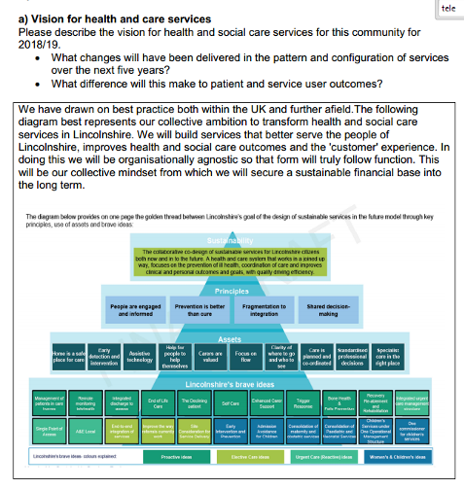

No self care references

http://lincolnshire.moderngov.co.uk/documents/s5338/6a%20Appendix%20A%20BC%20Fund%20Part%201%20Final%20110214.pdf

Liverpool
Admission to acute care: The services brought together under the bid are designed to reduce individuals’ length of stay in hospitals or hospices, facilitate their return home to lower level support and reduce readmissions. Actions will include personalised planning, ensuring that systems are in place to speed up assessments of people in hospital and facilitating supportive discharge by raising awareness of and utilising support services and homebased telemonitoring options.
The case study below describes one of the activities being undertaken through the Mi (More independent) initiative.
Assistive Technologies
Mi is an innovative collaboration between NHS, Public, Private, Third Sector and Housing organisations. Liverpool CCG (Lead Partner for Mi) allocates clinical leadership to embed and align Mi with the Integrated Care programme; this ensures that services, technologies and other solutions are fully incorporated and sustainable.
Liverpool’s Mi (More Independent) is a highly innovative £17 million ‘enabler’ to integration in the city. This nationally and internationally recognised Department of Trade and Industry (DTI) initiative (often known as ‘dallas’ – ‘delivering assisted living lifestyles at scale’) enables us to collaborate with health, housing, independent sector organisations and technology industry over a 3 year period, developing cuttingedge infrastructure and technology to improve selfcare and access to telehealth and telecare in Liverpool.
We are exploiting the vast innovation opportunities, new networks, partnerships and prospects Mi provides; for example, we have already succeeded in becoming a pathfinder site for the Department of Health’s 3millionlives technology initiative.
Mi’s aim is to change the face of health and care in Liverpool by shifting towards informed consumers of services, where people are connected and have the tools they need to take ownership of their own wellbeing; this focus on selfcare, independent living and use of technology directly enables our vision for integrated care.
Insight has been undertaken to understand people’s attitudes towards technology assisted care; a key outcome has been the development of a bespoke segmentation model which is being overlaid with IC Insight, giving Liverpool a unique picture of what our population wants from technologies to enable independence, and how to tailor to this Citywide….
The overall activity of the Mi programme is too wide to describe here, but key areas of delivery are:
Technology Key industry partners Philips and Tunstall are working alongside Liverpool Community Health (LCH), Informatics Merseyside and LCC to shape the direction of new technology that meets the needs of users including an aspiration to roll out telehealth to over 1000 people identified through Integrated Care in Liverpool in the next 2 years.

Service Design and Integration Lead partners and service providers LCH, The Riverside Housing Group, HfT and Liverpool PSS, are working alongside LCC to understand how technology can support services to achieve better outcomes with efficiency gains. The existing telecare service delivered by Liverpool City council is being integrated into the Mi offer to individuals to ensure there is one system in the city to improve access to residents.

Community Development Mi is developing community based support to enable all to benefit from technology and introduce selfcare supported by the right tools.

Training Carers Working with National Museums Liverpool, providing community internet access across the city via the installation of hubs, developing the ehealth industry), increasing access to technology for carers through Local Solutions, community asset development and ‘Active at 60’ groups through LCVS.

Extensive references to self care

…For patients, this will result in:

• More emphasis on prevention
• More emphasis on self-care…

…These principles are:
1. A focus on prevention. early detection and early help where it is needed
2. Achieving maximum on-going and effective communication and engagement with
stakeholders.
3. A commitment to sustainability for the city.
4. A recognition that there is no health without mental health and wellbeing
5. promoting and supporting individual and community concern for health by utilising
local assets to support self-care, ownership and responsibility for health

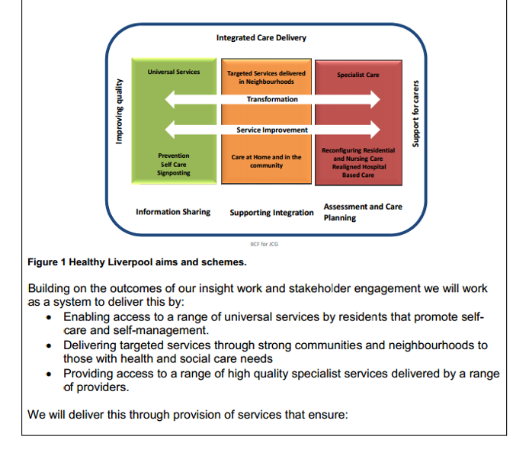

We have identified the following schemes to deliver transformational change at each of these levels…Self Care and Prevention

The Mayoral Commission for Health has identified three key priorities for health and care in the city and which the Healthy Liverpool Programme with partners will deliver:
• Creation of a pioneering, high quality sustainable integrated Health and Social Care system for Liverpool.
• Prevention and self care become the primary focus in the transformation of health outcomes of the people in Liverpool
• Integrate out of hours services across the system

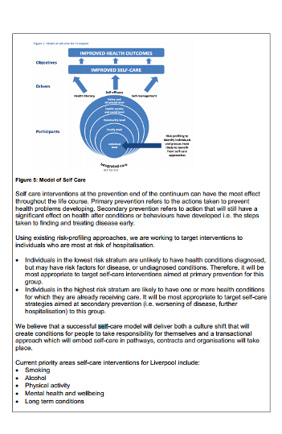

Schemes and initiatives designed to improve health outcomes are managed through the Health Improvement and Better Lifestyles Working Group as part of the wider Prevention and Self-care programme.

http://councillors.liverpool.gov.uk/documents/s132213/BCF%20Appendix%20One.pdf
Luton
No telecare/telehealth references

Luton is on a transformational journey, in which local people are increasingly influential and essential in the way commissioners and providers of health and care services design and deliver person-centred, holistic and seamless services. These services will be individually tailored, maximise independence and self-care and lead to long term sustainable improvements in health outcomes...

…A clearer and simpler system should help all professionals to signpost people towards ‘healthier’ services, strengthening the early intervention and self management model that is an important part of our shared vision.

http://democracy.luton.gov.uk/cmis5public/Meetings/tabid/70/ctl/ViewMeetingPublic/mid/397/Meeting/4598/Committee/1028/Default.aspx

Manchester

January 2014

Integrated care teams are helping people discharge more safely and sustainably from hospital, linking to specialist services such as reablement and intermediate care to help people live more independently and reduce the risk of returning to hospital. Similarly, community falls teams, an urgent response service as an alternative to ambulance and A&E attendance, are in place using innovative community alarms and
assistive technology to help people stay out of hospital….

….John is at work and self-managing his long-term conditions of Chronic Obstructive Pulmonary Disease and diabetes. He has a clear and owned care plan and has learnt how to use technology to enable him to manage his condition with knowledge. He has information about the new delivery model, and feels that, when he needs it, it is responsive to his needs with regular checks and care planning.

http://www.manchester.gov.uk/meetings/meeting/2055/health_and_wellbeing_board

Medway

2 April 2014

Community Equipment and Assistive Technology
Building on the overarching vision of promoting independence and prevention, a specific agreed priority area is the increased use of equipment and assistive technology. This will incorporate adaptations and greater utilisation of Telehealth and Telecare. There will be a review of the use and access to complex equipment
required for areas such as effective pressure management to reduce pressure sores, preventing falls and speeding up hospital discharges. This review will be across health, housing and social care, ensuring that there is an effective interface across the sectors and ensure that we are getting best value from our contracts….

….Increase uptake of telecare/telehealthcare services….

LA / CCG Review existing contracts and use of assistive technology, including Telecare/Telehealthcare and other community equipment based services….

….Service users able to remain living at home for longer with suitable assistive technology to be able to self-manage their health and social care needs. Reduction in admissions to residential and nursing care

All partners recognise that there is much more work to do, and this will mean putting in place a new and transformational service model based on integrated multi-disciplinary teams working closely with primary care and specialist services. It also means that we will place a strong focus on wellbeing, speed of response, striving for maximum independence, reablement, maximising self-management, prevention, providing services in people’s own homes.

Further transformation/redesign is required to make our ambitions a reality, with a focus on wellbeing, prevention, self-care, reablement, striving for maximum independence and breaking down barriers to health and social care.

http://democracy.medway.gov.uk/mgconvert2pdf.aspx?id=23431

Merton

Seven day working in social care
This scheme will expand the capacity to arrange care packages in the evening and on weekends, and increase capacity to support discharge from acute hospitals. The service will also be restructured to match the three
geographical localities of health (East Merton, West Merton and Raynes Park.) To facilitate this, there will be an expansion in the Mascot telecare system and the MILES reablement service (see Protecting and Modernising Social Care)….

….Occupational Therapists to implement reablement programmes and techniques and/or provide equipment, minor adaptations and Telecare prior to service packages and /or admissions to residential/nursing or
hospital beds….

….Mobile Response Officer to provide back up and immediate installation of
telecare monitoring system….

Telehealth/Telecare
This proposal will utilise telehealth for suitable patients with heart failure and/ or COPD with the overall aim of supporting these patients in their own home and being able to pick up early warning signs of a potential
deterioration or exacerbation so that early intervention may avoid further deterioration and potential admission to hospital. This scheme will be provided as a part of the existing MASCOT services….
….Expected Outcome Metrics
All patients with agreed conditions identified as suitable are being managed proactively through telehealth arrangements to avoid unplanned inappropriate attendances/admissions to hospital….

….Initial procurement and roll-out of telehealth will take place during 2014/15, to include a pilot period….
Roll-out of telehealth will take place from April 2015….

….Key success factors
• Identification of provider of telehealth equipment
• Development of SLAs with telehealth provider

….A scheme is being prepared to expand the council’s capacity to arrange care packages during the weekend (8am-5pm) and in the weekday evenings adding a care package from (5pm-8pm). This scheme is also expected to include greater responsiveness from the MASCOT Telecare service….

….Additional Resources required….Occupational Therapists to implement reablement programmes and techniques and/or provide equipment, minor adaptations and Telecare prior to service packages and /or admissions to residential/nursing or hospital beds….Additional carers to provide short term intensive home care and night sits Mobile Response Officer to provide back up and immediate installation of telecare monitoring system.

….Dependencies
A range of other health and social care services and provision will need to be available during the extended hours to enable social workers to effect safe and appropriate hospital discharge and prevention of hospital admission. These include….MASCOT (telecare provision for enhanced monitoring, safety and risk
management)….

….Telecare and Telehealth
Outputs: Expansion in the Mascot telecare system and the MILES reablement service.

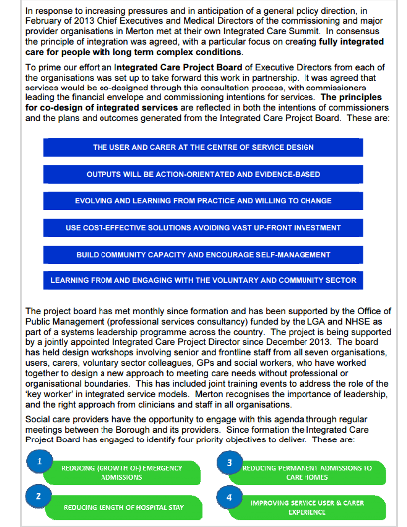

…Diverse needs with respect to accessing care and self-management resources, such as language and cultural barriers…

…Keeping our population healthy and well, focusing on prevention and self-management...

…A service model where coordination of the journey and experience of people (service users) identifies those who are vulnerable or could benefit from care, and which focuses on prevention, self-management, education and training, increase in quality of living and life expectancy promoting overall wellbeing…

…To build on our expert patient programme to promote independent self-management…

…Research shows that people who have trained in self-management tend to be more confident and less anxious. They make fewer visits to the doctor, can communicate better with health professionals, take less time off work, and are less likely to suffer acute episodes requiring admission to hospital...

…Increased incidences of self-care within Merton, leading to an increase in general health and wellbeing across the borough through fewer illness-affected days and reduced avoidable attendances and admissions to hospitals.

http://democracy.merton.gov.uk/documents/s3679/Better%20Care%20Fund%20Plan%20-%20Plan.pdf

Middlesbrough

No details available as at 28 April 2014

http://democracy.middlesbrough.gov.uk/aksmiddlesbrough/users/public/admin/kab12.pl?cmte=HWB&meet=3&arc=71

Milton Keynes

Self-care and self-management of an individual’s health will be encouraged and people will be supported to develop strategies for managing their health and independence, including access to a range of preventative, early intervention services to support people to pro-actively manage their health. Supporting services such as telehealth, telecare and community equipment will be strengthened to support independence….

….Development of Community equipment, telehealth and telecare to be utilised by the integrated health and social care teams above as a tool to help support people at home….

….Scheme 10 - Additional Telehealth – 2015/16 £500,000….

….Baseline information - Telecare / telehealth - number of people supported both community alarm and one or more additional sensor, as a proportion of all new community alarm users - year to date figure used. To be developed to show proportion of telehealth user.

Self-care and self-management of an individual’s health will be encouraged and people will be supported to develop strategies for managing their health and independence, including access to a range of preventative, early intervention services to support people to pro-actively manage their health. Supporting services such as telehealth, telecare and community equipment will be strengthened to support independence...

…Through the development of self-management and preventative services, ill health can be better managed at an earlier stage, and linked in to community based rehabilitation and reablement services to provide intensive
support over the short term with a view to restoring people to independence

http://cmis.milton-keynes.gov.uk/CmisWebPublic/Binary.ashx?Document=42254

Newcastle upon Tyne

Facilitate data sharing and use of technology to engage patients and service users….

Fulfil data sharing obligations and introduce interoperable IT systems including secure web access for patient and telecare and telehealth functionality. This scheme includes actions to define and embed supportive information governance arrangements, and builds on existing partnership work on technologically enabled
care through the DALLAS programme. It will be supported through the Active Age AZTECH programme, drawing on input from a group of international IT companies….

….The work stream has been focusing on three particular areas of development which
Include….Further development of primary and secondary prevention of ill health through interventions such as assistive technology and community development programmes that can safely support people at home. There will be greater focus on supporting frail people at home which will include development of the ‘virtual
ward’ with access to Comprehensive Geriatric Assessment

Enable self-care
Enhance health literacy, information availability advice and advocacy to support prevention, enable self-care and facilitate access. Our approach which will promote shared decision making and care planning will build upon the Ways to Wellness model of social prescribing to ensure an holistic approach to self-care. The NHS
“ 111” Directory of Services will be marketed and utilised to facilitate active signposting to services which utilise individual and community assets…

…Co-ordinating all elements of the health and care system together to manage more people away from crises/urgent care support and into planned care interventions with a greater emphasis on self-management…

…Whilst those at highest risk of hospital admission require some intervention it is important to move the actions upstream into the self-care and prevention category in order to reduce the numbers which become high –risk.

http://democracy.newcastle.gov.uk/documents/s68917/Item%205%20Better%20Care%20in%20Newcastle%20Appendix.pdf
Newham
The services being protected within the plans include….Telecare and technology interventions.

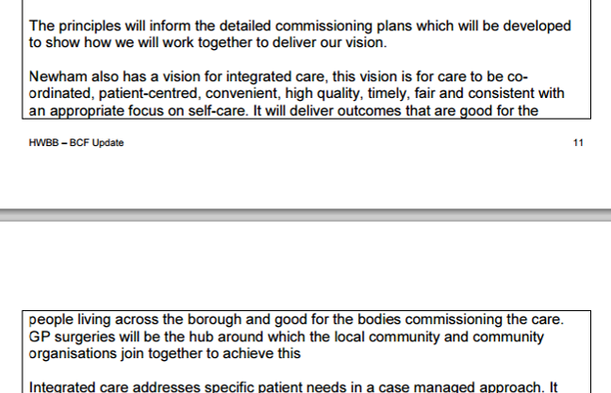

…All partners in Newham recognise that in a Borough with so many challenges and increasing need that the development of a Self Care/Prevention Strategy is vital. This has been recognised within the Joint Health and Well Being Board and Strategy and there is a commitment from all partners to develop a joint approach.

The implementation of integrated care will provide the following benefits:
• Improvement in health outcomes
• Appropriate levels of A&E attendances
• A reduction of (avoidable) emergency hospital admissions
• Reductions in number of bed days per 1000 patients
• Appropriate level of out-patient referrals
• Improvement in patient experience measures
• New integrated pathways of care e.g. for Diabetes, COPD, and CVD
• Improvement in self care

https://mgov.newham.gov.uk/documents/s87645/FINAL%20HEALTH%20AND%20WELLBEING%20BOARD%20REPORT%20BCF%20with%20comments.pdf

Norfolk

Scope range of community self-care support services including tele-coaching/peer support….

….Scoping options for improved use of telecare and telehealth….

….Optimum use of technology and equipment
Technology and equipment will be used to very best effect to deliver the aims of our strategy, supporting the successful management of complex conditions at home, enabling revised mix of staffing skills and to facilitate swift discharge. Our assumption will be that for an individual with complex care needs there is a beneficial technology to be applied….

….Housing support –The existing partnership work between health (including public health), housing and social care aligned to our Healthy Norwich initiative will be built on to ensure that people are well supported to live independently at home. This includes further development and improvement of a wide range of support
including supported housing, disability adaptations, community equipment services, assistive technology and the work of Home Improvement Agencies.

file:///C:/Users/New%20Dell/Downloads/healthwell010414agendapdf.pdf

North East Lincolnshire

Unable to locate current position as at 28 April 2014

http://www.nelincs.gov.uk/meetings/committee/107

North Lincolnshire

Undertake a review of the use of Telecare to support targeted provision to enable self-management, improve people’s experience and access, support people to remain competent and confident and focus on individuals in greatest need.

http://webarchive.northlincs.gov.uk/councilanddemocracy/committees/health-and-wellbeing-board/health-and-wellbeing-board-agendas-and-reports/health-and-wellbeing-board-special-meeting-14-february-2014/

North Somerset

Unable to locate current position as at 28 April 2014

North Tyneside

2015/16 - Increased use of telehealth & telecare - £ 486,578….

….Further social care interventions
A range of initiatives to strengthen the ability of social care to keep people well at home have been identified by North Tyneside Council. They are ….increased use of telehealth….

….Developing the range of assistive technology available and reducing the times for assessment and provision….

….In order to support a shift to more proactive care, implement telehealth across primary care, focusing on COPD and hypertension….

….In addition we are exploring the scope for additional support to social care, including….
increased use of telehealth.

Primary care provision of urgent care services as an alternative to A&E…
This is an additional element of the plan which aims to develop enhanced primary care services which can reduce the number of A&E attendances. Other factors which will help to reduce A&E attendances include : social marketing of appropriate pathways into services; self-care and education; support to carers; increased access to primary and community care within and out-of hours, including preventative healthcare and support to nursing homes; expanded role of primary care in the case management of people aged over 75; integration of services for older people across health and social care; alcohol specialist nurse support in A&E to support referral into appropriate pathways and reduce reattendances.

Savings of £69k are proposed; this is equivalent to reducing the number of A&E attendances which require no significant investigation or treatment (currently 11% of attendances) by 16%, or an overall reduction in A&E attendances of 1% per year. The initiative is specifically aimed to reduce attendances in cases where self-care, pharmacy advice, or a primary care consultation, may be appropriate.

Greater education on self-management of conditions, minor illnesses and following recovery from illness

http://www.northtyneside.gov.uk/pls/portal/NTC_PSCM.PSCM_Web.download?p_ID=551885

North Yorkshire

Increasing the reach of assistive technologies to support people at home and in care homes….

….The second largest proportion of funding is for prevention services and this is anticipated
to have a longer period before the impact is felt. We can evidence that we are placing
initial resources in services which deal with the immediate and pressing challenges of increased demand and balancing this with the need to invest in ways which prevent or delay people needing formal services. This includes Social Prescribing, Care Navigators, Falls Prevention, Carers Services, and Assistive Technology….

….Increase in take up of housing related solutions and assistive technology….

…..Promoting independence by improving reablement, integration with the NHS, extending the use of Assistive Technology and improving equipment services;

This plan describes how our shared investment will:

• Improve self-help and independence for North Yorkshire people;

…The County Council has embarked on a transformation programme for Adult Social Care which focuses on self-help, prevention, independence and integrated services

Improve health, self-help and independence for North Yorkshire people by:
o Implementing integrated Prevention Services across all localities
o Supporting Carers
o Improving access to housing based solutions including adaptations, equipment and assistive technology and extending our flagship Extra Care Strategy
o Ensuring everyone can access a comprehensive falls service

…Therefore our priorities in protecting Adult Social Services are to recognise the severe pressure the department is under and to provide sufficient funding to support the transformation programme which aims to reduce and delay demand, focus on prevention, self-help and independence and maintain current good performance on delayed transfers of care and customer satisfaction…

…The Council has an ambitious programme known as ‘2020 North Yorkshire’. This involves corporate activity to strengthen local community resilience, invest in a digital and telephone Customer Resolution Service, support self-help and increase the Council’s ability to generate income via commercial solutions…

The Health and Adult Services Transformation Programme includes:
• Reducing demand, investing in prevention and diverting people to self-help and community solutions;

Clinicians and professionals will be aligned in one service which will enable joint assessment to be coordinated via an accountable lead professional. The planning and delivery of care and support will be implemented by an integrated care plan which will proactively plan the self-management and care of high risk patients.

http://democracy.northyorks.gov.uk/committees.aspx?commid=27&meetid=2286

Northamptonshire

No Telecare/telehealth references – at 28 April 2014

https://cmis.northamptonshire.gov.uk/cmis5live/MeetingsCalendar/tabid/73/ctl/ViewMeetingPublic/mid/410/Meeting/2334/Committee/437/Default.aspx

Northumberland

Importance of high touch, personalised care supported by technology, especially telemedicine - enabling a sharing of information….

….Preventative services
These are services which are intended to reduce long-term demand on both health and social care services. They include "telecare" alarm and monitoring systems, and grant aid to voluntary and community sector organisations providing preventative services.

Person-centred services for people with long-term conditions…Increasing focus on supporting self-management of health conditions…

…Much stronger focus on self-care and setting personalised goals/ outcomes…

Delivers more planned care (previously unplanned) with higher proportion of high risk patients/ service users with comprehensive care plan and special patient notes to support these (includes self care – co-creation of personalised self-management action plans)

Education in self-management is provided during any hospital stay

http://committees.northumberland.gov.uk/aksnorthumberland/images/att17385.pdf
Nottingham

The additive elements of the Nottingham BCF are as follows….Development of the Telehealth programme

….Contractual requirements….
….Assistive technology: A new telehealth service will have been procured and be operational. Telecare expansion to targeted groups will be in place.

Local areas should identify which proportion of their population will be receiving case management and a lead accountable professional, and which proportions will be receiving self-management help - following the
principles of person-centred care planning. Dementia services will be a particularly important priority for better integrated health and social care services, supported by accountable professionals…

…Citizens will have greater choice and control over their lives and greater support in self care…

…People will have greater self-awareness of how to improve their own health and wellbeing through prevention and healthy lifestyles…

…Implementation of the self care pathway to support early intervention

http://committee.nottinghamcity.gov.uk/documents/s3191/3.BETTERCAREFUND.pdf

Nottinghamshire

Transforming Patient Satisfaction
These schemes focus on the range of services available to patients and service users, either utilising these services directly or to focus on the needs of carers. By developing a range of support either directly to people, or through a range of assistive technologies, training programmes to provider services or carers. These projects will enhance and develop the 3rd sector and a range of options for promoting self-care or alternative and innovative solutions to decrease dependency upon direct access to the acute sector or primary health and social care services.

….The success factors are….Increase in use of Assistive technology units.

http://bit.ly/S0KbtF

Oldham

No references to TC/TH as at 28 April 2014

Our collective aims are simple: The Commissioning Partners (NHS Oldham CCG & Oldham Metropolitan Borough Council) wish to harvest our collective skills, talents and resources in order that we improve:

1: the macro (Long Term Conditions (LTC) Urgent Care Population) health status of a given
population segment
2: the experience of LTC & Urgent Care for the individual (provided & self-managed)
3: to achieve this in a manner that demonstrates optimal resource management

This requirement spans the whole of the patient’s pathway experience from daily self-care, through core Primary Care into Community and Social Services, and subsequently into the Acute and Mental Health sector.

Themes running through the public conversations have centred on key issues concerning independence, self-reliance and integration. Specific citizen engagement will continue as the detail within the schemes associated with the Better Care Fund is developed.

People in Oldham will be independent, resilient and self-caring so fewer people reach crisis point. For those that need it, we will develop an integrated health and care system that enables people to proactively manage their own care with the support of their family, community and the right professionals at the right time in a properly joined up system. In a crisis, people in Oldham will know exactly what to do, who to contact, receive a rapid response and have their needs met in a completely organised, systematic and careful way.

Our aim is that people in Oldham will be independent, resilient and self-caring so fewer people reach crisis point.

http://committees.oldham.gov.uk/documents/s43214/Better%20Care%20Fund%20Submission%20Part%201%20-%20Oldham%20-%20Draft%20v2.docx.pdf

Oxfordshire

Equipment and assistive technology
As with family carers, there is extensive evidence that the use of equipment and assistive technology is an effective way to support independence and allow people to live at home for longer. We will continue to invest in this as an alternative to residential and domiciliary care provided by care workers where suitable….

….There is also evidence that this can help reduce admissions and represent savings in the wider system. A recent review showed that over 30% of calls to the emergency services for clients of the Alert Service in Oxfordshire (a countywide service providing telecare alarm equipment to vulnerable and older adults) were
handled by a mobile responder rather than needing to refer for an ambulance. This equates to a saving of over £300k per year, plus avoiding further costs for the NHS had the users been admitted to hospital….

We are therefore proposing the Fund is used to invest in the following areas….Equipment and assistive technology

No self care references

http://mycouncil.oxfordshire.gov.uk/documents/s24335/Better%20Care%20Fund%20Update.pdf

Peterborough

Home adaptations, telehealth and telecare: better development and utilisation of emerging and existing technologies to support independence, and reduce demand on acute / long term care sectors. We will invest in areas for which assistive technologies are proven (e.g. for people with chronic heart-failure, COPD / asthma) with a view to maintaining independence, and reducing unnecessary hospital admissions.

We will also promote empowerment and self-management, building on the philosophy of self-directed support, whether through development of personal health budgets, or associated planning mechanisms for those with long-term conditions.

http://democracy.peterborough.gov.uk/documents/s19648/8a.%20Better%20Care%20Action%20Plan%20Report.pdf

Plymouth

The following developments are planned for 2015/16…. Telecare and Telehealth will be part of the mainstream assessment process and offered where the need is identified….

….a strengthened social care offer based around the following priorities is required….Promotion of assistive technology (Telecare and Telehealth).

Emphasis towards self-management, health promotion and primary prevention, and community diagnostic service.

http://www.plymouth.gov.uk/mgInternet/documents/s53797/Plymouth%20BCF%20-%20Part%201%20-%20ver6%20210314.pdf

Poole

See Bournemouth entry

Responding to need – the ‘front-end’ of support such as easy to access points of contact, improved information and advice, reablement/ intermediate care, technology, accessible homes (via district councils).

http://www.bournemouth.gov.uk/CouncilDemocracy/Councillors/CouncillorCommitteeMeeting/BournemouthPoole,HealthWellbeingBoard/2014/02/05/Reports/Better-Care-Fund-and-Better-Together-Draft-Business-Case---Appendix-B--2-.pdf

Portsmouth

No details as at 28 April 2014

http://democracy.portsmouth.gov.uk/ieListDocuments.aspx?CId=150&MId=2445&Ver=4

Reading

Alongside extending practice hours, there are a number of technological initiatives we wish to deliver, for example, e-consults and/or Skype consultations, alongside an expansion of the range of services on offer at the weekend to include, for example, ultrasound or health screening programmes.

Promoting self care – We have already deployed a web based tool to promote joint care planning between individuals and doctors and will build on this to deliver further self care initiatives.

http://www.reading.gov.uk/meetings/details/3659/

Redbridge

We want more people to….Use telecare, telehealth and other assistive technology….

….Other supporting strategies - Telecare strategy, Carers strategy.

Through patient and service user workshops, interviews and surveys across Redbridge, we know that people want services that looks at their needs holistically and help them to self-direct their support as much as possible.

We want more people to:
• Be active and self-manage their health;

We want to reflect increasing use of the internet and smartphones to harness advanced web technologies for promoting self-care and providing advice and information to the residence of Redbridge in a faster and more creative way…

…By 2018, patient and service user will have one care and support plan; will be able to have personal care and health budget or direct payment to self-direct their care and health; will be able to liaise with one named co-ordinator at anytime; will be able to direct their care to achieve their personal goals with or without support from the local authority or local health service…

…Help people self-manage and provide peer support working in partnership with voluntary, community and long-term conditions groups...

…Undertake a full review of the use of technology to support primary and secondary prevention, enable self-management, improve customer experience and access, and free up professional resources to focus on individuals in greatest need. GPs will be at the centre of organising and coordinating people's care.

http://moderngov.redbridge.gov.uk/documents/s89541/BCF%20Template%20V%2013%200.pdf

Redcar and Cleveland

Unable to locate plan details as at 28 April 2014
http://bit.ly/1h5ZGpy

Richmond

By increasing the uptake of telecare solutions and developing and rolling out other assistive technology interventions in Richmond we can ensure that people use these systems to self-manage long-term conditions and get emergency attention 7 days a week. Our careline service operates 365 days a year and 24 hours a day and contacts a key person to check up on vulnerable adults in most instances rather than having ambulance services as a first port of call in an emergency. By increasing the number of elderly frail with a telecare alarm we can avoid more unnecessary hospital admissions.

Self-care plans that take account of potential deterioration and necessary emergency care will help to reduce
emergency hospital admissions by signposting to local NHS, voluntary or community organisations for support…

…Self-care plans will include an advanced care planning aspect to capture information on end of life care wishes for those with long-term conditions; this will include information on preferred place of death. By capturing these preferences we can ensure that end of life care wishes are met…

…Self-management
By promoting and educating people on how to self-manage health conditions we can prevent the need for emergency health services and help people to manage their conditions more effectively to delay progression

…The role of unpaid carers is key to helping us achieve our targets. Carers have a significant role in helping to keep people out of care homes, getting people out of hospital without delay and supporting people to self-manage and access the correct community services therefore avoiding emergency hospital admissions. In implementing actions from the Care Bill we will be providing more support to carers to enable them to continue in their caring role and look after their own health and wellbeing.

https://cabnet.richmond.gov.uk/documents/s49354/HWB%20BCF%20paper%20Appendix%201.pdf

Rochdale

We also have an integrated Falls Service which responds on a prevention basis as well as reacting to people who have already experienced falls. We intend to expand this as part of new locality teams.This is an important part of prevention, along with extended Telecare, Teleheath and medicine management support….

.…We will have an integrated health and adult social care response out of normal weekday hours and at weekends — this is already in development. We will also ensure carer support is available 24/7 though this new way of working, and through further extension of Telecare and Careline Services….

….Increased use of Telecare and Teleheath focused on specific patient groups, year on year….

….Deliver plan for Telecare and Teleheath services to further extend access, led jointly by RMBC and Pennine Community NHS Trust - Jul 2014….

….Alongside this the strong focus on Reablement and Telecare will remain, as we know that
this is delivering results and is critical to the whole system.

http://democracy.rochdale.gov.uk/documents/s23727/Rochdale%20MBC%20Heywood%20Middleton%20Rochdale%20CCG%20Better%20Care%20Fund%20Plan%20Part%201.pdf

Rotherham

BCF03 Joint call centre Incorporating telecare and telehealth….

….This workstream provides a joint vision for the development of telehealth and telecare services in Rotherham. It sets out the principles for care pathway development, maps current telecare provision and puts forward proposals for joint commissioning activity.

The overall objective of developing a joint telecare/telehealth strategy is to optimise the care of patients with long term conditions. Rotherham MBC and Rotherham CCG recognise that technology is an enabler for optimisation but not the whole solution. Pathways should be developed in conjunction with national guidelines and strategies for the management of long term conditions. All pathways should be systematically reviewed with clinicians in order to draw on their local expertise.

….Rotherham CCG and Rotherham MBC will work to together to develop telecare prescriptions for GP Practices participating in the case management programme. We will introduce integrated telecare and telehealth packages which can be offered as part of a self-management programme for patients with a long term condition. We will scope the potential for development of a joint telecare/telehealth hub. Specifically we examine the potential for combining the Rothercare Service with the Care Coordination Centre….

….The main benefit of this initiative is its potential to deliver improvement in outcomes for people who have a high dependency on health and social care services. A combined approach to care coordination, telehealth and telecare allows local practitioners to maintain contact with vulnerable patients. It can help improve the reach of health and social care, supporting those who are often ‘invisible’ from main acute services….

….This initiative is more likely to ensure that intervention is early and appropriate. It makes more efficient and effective use of available clinical teams by reducing unnecessary home visits. It involves people far more in the management of their own healthcare and could lead to significant reductions in A&E usage and unplanned admissions….

Key to the delivery of integrated person centred services, in the context of reduced revenue and increased demand for health and social care services, is a core offer of social care services including….Preventive services such as telecare/assistive technology, reablement, intermediate care – all designed to support independence

We will change the culture of staff from simply ‘doing’ things for people to encouraging and prolonging
independence and self-care…

…We will introduce integrated telecare and telehealth packages which can be offered as part of a self-management programme for patients with a long term condition…

…They are able to provide flexible, appropriate services that help people to self-manage…

…Condition management programmes: education, managing pain and fatigue, healthy eating, exercise, emotional support, support to self-care, understanding care pathways, self-help groups…

…GPs will benefit from being able to support patients to follow through on self-help activities

BCF10 Self-care and self-management

The purpose of this workstream is to ensure that self-management is embedded in all aspects of health and social care. A good system of self-management will support the development of knowledge, skills and confidence in self-care support. Health and social care services should support people with long term conditions to actively participate in care planning. Care plans should include actions for the person receiving support aimed at improving or maintaining their condition. High-risk patients with long term conditions
should have a person held record, which includes their care plan. Case managers should ensure planned follow up on goals. Scheduled appointments should be in place to plan care, treatment or support.

Rotherham will evaluate the current patient skills programme and reconfigure. We will bring all self- management programmes under a single banner “Rotherham Patient Skills Programme”. We will extend the current patient skills programme so that it supports patients on the GP case Management Programme. We will develop specialised psychological support services for people with long term conditions, so that they are
better able to self-manage.

Customers will only have to tell their story once, and will be able to work with their GP or other professional on developing a plan that reflects their needs, and also includes their self-care or self-management plan, plus a plan that informs, when needed, other professionals to ensure that they receive the care they need where they need it.

http://moderngov.rotherham.gov.uk/documents/s92718/Rotherham%20Better%20Care%20Fund%20Plan.pdf

Rutland

Develop the expansion of telehealth and telecare (remote access to healthcare support and equipment to assist people to remain in their homes for longer such as keysafes to enable carers to visit people who cannot get to their front doors easily)….

….Expand telehealth and telecare – plan for an integrated approach to telecare and telehealth provision to be in place.

RCC BCF 04 – 2015/16 - Telehealth & Telecare - £98k

We will invest in empowering local people through effective care navigation, peer support, mentoring and self-management to maximise their independence and wellbeing; and we will help identify and combat social isolation, as a major influence on overall health and wellbeing…

…We will invest in integrated community services that will provide a rapid response to support individuals in crisis and help them to remain at home. Reablement services will also work with individuals who have lost their independence through illness or accident and support them to build confidence, regain skills and, with appropriate information and support, to self-manage their health conditions and medication. The service will introduce individuals to the potential of assistive technologies and, where these are to be employed, will ensure individuals are familiarised and comfortable with their use…

…Rutland will use the BCF to:
Help people self-manage and provide peer support including improving access to advice and information and working in partnership with voluntary, community and long-term conditions groups…

…The model has a strong emphasis on early identification and prevention of avoidable deterioration, supported care planning and self-care support networks. It builds on the available services in the locality to support independence and ensures a co-ordinated community response to people with long term conditions…

…In line with our model people with long term conditions will be supported to maintain the maximum level of independence and self-care that they can and we will “step up” care when needed to support through period of crisis or increased need and “step down” care when the person stabilises or needs decrease.

http://www.rutland.gov.uk/pdf/Report%20No.%2082-2014%20Better%20Care%20Fund%20Appendix%20B%20-%20planning%20template%20part1.pdf

Salford

Currently unable to view documents at 28 April 2014
http://bit.ly/1h62L8U

Sandwell

Embracing new technology such as telehealth and telecare are fundamental to the success of this scheme alongside a radical redesign of existing pathways and supporting carers to ensure as many people as possible are managed outside the traditional health and social care system, their needs being met via the community. The role of Housing being integrated within the prevention platform will ensure that the range of needs can be met within a single point of access….

….The intended outcomes from this scheme are….Increase in use of telecare….

….There has been further investment in Reablement Services (STAR Team) to support people to regain their level of functioning to remain within or return to their own home. This is alongside investment in Telecare Technology to maximise individuals’ independence within their own home. We have also developed additional Extra Care Housing as an alternative to residential care.

The funding of £8.4 million currently allocated for social care with a health benefit through the section 256 transfer has been used by the council to invest in services such as reablement, telecare and home support. This level of investment will need to be sustained and potentially increased, in order to maintain this service level and to deliver 7 day services and meet the additional requirements of the Care and Support Bill.

To provide the necessary support to allow for greater self-care by individuals.

This scheme will require an enhanced user-led primary care offer which will focus on early identification and prevention, early targeted interventions, self-care, education, effective proactive management of vulnerable groups and 7 days working...

…Increased usage of selfcare programmes…

…There will be a range of commissioned services in place that are specifically intended to target those people who are able to remain independent within the community enabling self-care…

…Increased use of selfcare programmes…

…Initial demand and financial impact modelling makes assumptions on relative percentage shifts in activity over 3 years with re-investment in prevention, self-management, community based intensive services and primary care. Further validation by SMBC and the CCG is planned from April 2014, including testing assumptions on quantification of shift with providers…

…providing information and advice on self-care, and self management so people are able to look after their own health needs and wellbeing, and can keep fit, safe, healthy and active…

http://bit.ly/1h63qay

Sefton

We recognise the significant challenge this poses, and in 2014/15 we will develop a change programme to deliver, in a 5 to 10 year period, changed patterns of services which will see:
-Increased use of appropriate home technology, tele-health and telecare
-Participation of people in applied research studies, particularly in primary care and related
to the acceptability of technology….

….The new delivery will see roles and responsibilities change significantly in both the Council and the
provider. The size of this change cannot be underestimated as it is dependent on whole system change including assessment and review and health processes, the use of assistive technology, telehealth, system development, plus significant cultural change….

…Transforming adult social care — including increasing the use of assistive technology, developing a new model of reablement and scaling this up, increasing personal and community resilience and commissioning services and support that 'do with' people rather than 'do for' people.

The approach adopted to developing our Better Care Plan has been informed by the Council's significant budget pressures, which are compounded by our demographics and the dialogue that is taking place with the public around self care and self management…

…In seeking to deliver our 5 year ambition we will focus on:
• Early Intervention and Prevention
• Health promotion
• Self-care, self-help, self-management, with the longer term aim of reducing reliance on
public sector services

…We will provide care and services focused around the individual - there is no wrong front door - promoting early intervention and prevention, encouraging people to self-help where possible…

..Early intervention and prevention (reablement, falls, community equipment, early assessment, self-care)…

… Self-help, information and advice…

…maximise independence by providing appropriate support at home to those who need it and in the community, and empower all people to self-care and self-manage their own health and wellbeing.

…provide proactive and common case management, which avoids unnecessaryadmissions and readmissions to hospitals and care homes, and enable people rapidly to regain their independence after episodes of ill-health and self-manage their longterm conditions…

…We aim, through these delivery models, to achieve a 15% reduction in non-elective care. This level of reduction requires whole system change. We intend to use the Better Care Fund to help social care services align better with health and wellbeing services, and to collectively work together to promote and facilitate prevention, self-care and self-management...

…Where formal health and social care services are required, these will be focused on rehabilitation/reablement and regaining self-caring skills in the first instance to reduce the potential for a progression on to more specialist and nursing care services…

…To support these aims, the Local Authority will…design social care services and activities that are modern, flexible and sustainable with self care and self management at the core…

http://modgov.sefton.gov.uk/moderngov/ieListDocuments.aspx?CId=712&MId=7665&Ver=4

Sheffield

We will help more people to help themselves by offering professional support, physical therapies, and more innovative equipment and technology.

http://sheffielddemocracy.moderngov.co.uk/documents/s12745/Appendix%20a%20-%20Sheffield%20City%20Council%20Health%20and%20Wellbeing%20Budget%20Plans%202014-15.pdf
http://sheffielddemocracy.moderngov.co.uk/mgAi.aspx?ID=7991#mgDocuments

Shropshire

Those services identified for inclusion in the Fund in 2014/15 are identified as follows - Living Independently for Longer - Telecare

The council is committed to delivering on its statutory responsibilities, which will change and grow as the
Care and Support Bill is implemented and this may require changes to local policy, guidance and operating
models. It has recognised the importance of a range of prevention and early intervention approaches
including telecare, community equipment and reablement in keeping people independent.

This will include a focus on prevention, assistive technology and information and advice supporting people to be more self reliant and resilient within their local communities

https://shropshire.gov.uk/committee-services/documents/s2023/6%20HWBB%20BCF%20plan%20phase%202%20submission%20V6%202.pdf

Slough

The Better Care Fund will focus on the following interventions….Telecare and telehealth solutions to promote independence

….Projects under this programme are….Telehealth and telecare

Self-care, health and social care advice and information, advocacy, behaviour management and expectation...

…In addition, 4,400 people aged 65 and over living in Slough are estimated to be unable to manage at least one self-care activity in 2012…

…Encourage independence and self-reliance by building community capacity…

…Increase access to self-care for people with mental and physical health problems…

Self Care and Prevention
This programme will focus on the information, advice and support available to residents to manage their condition to remain as safe and independent for as long as possible. This will relate both to children and adults.
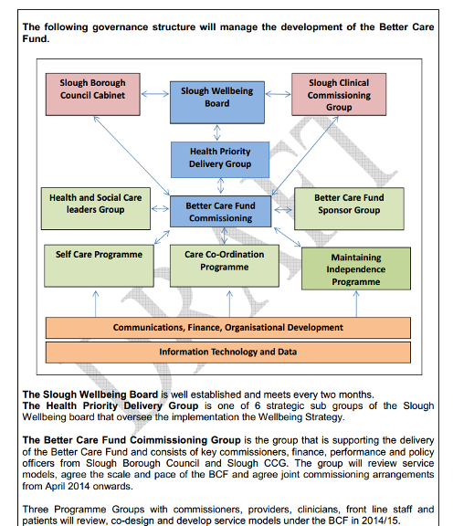

http://www.slough.gov.uk/moderngov/documents/s33225/Appendix%201%20-%20BCF%20Delivery%20Plan%20template.pdf

Solihull

Development of Telecare / Telehealth Service - To introduce relevant technologies to a number of health and
social care pathways to improve outcomes for customers and carers….

….Pilot telehealth within Community Health Services June 2014 – January 2015….

…..Develop telehealth model for roll out to Community Health Services March 2015.

Self management – patients better informed and supported to manage their own condition

http://eservices.solihull.gov.uk/mgInternet/documents/s5812/bcf-pln-temp1%20draft%20v16%202.pdf

Somerset

27 March 2014
We intend to undertake a full review of the use of technology to support primary and secondary prevention, enable self-management, improve customer experience and access, and free up professional resources to focus on individuals in greatest need. Specific examples would include telecare and telehealth to build confidence in individuals which results in decreased demand for social, primary and community care. Somerset
has over 500 people actively managing their health conditions by telehealth and our ambition is to significantly increase this number over the next year.

People in Somerset will be encouraged to stay healthy and well through a focus on healthy lifestyle choices and self-care.

People in Somerset will be encouraged to stay healthy and well through a focus on building support for people in our local communities and neighbourhoods, supporting healthy lifestyle choices to be the easier choices
and supporting people to self-care and be actively engaged in managing their condition. When people need to access care or support this will be through joined up health, social care and wellbeing services. The result will be a healthier population with access to high quality care that is affordable and sustainable...

…Care will be delivered in the most appropriate place to achieve safe and high quality care with excellent patient experience. Where possible this will be in local communities. For those with urgent care needs, NHS 111 will signpost people to the most appropriate service, or enable people to self-manage their condition…

…enabling the maximum number of people who self-manage at all levels of need…

We will use the BCF to:

Help people self-manage and provide peer support working in partnership with the voluntary, community sector.

We intend to undertake a full review of the use of technology to support primary and secondary prevention, enable self-management, improve customer experience and access, and free up professional resources to focus on individuals in greatest need.

Projects including early intervention, self-management tools and integration are all designed to protect the future of adult social care services whilst reducing the burden on primary and secondary health care.

http://www1.somerset.gov.uk/council/board39/March%202014/2014%20March%2027%20Item%205%20Appendix%20A.pdf

South Gloucestershire

27 March 2014

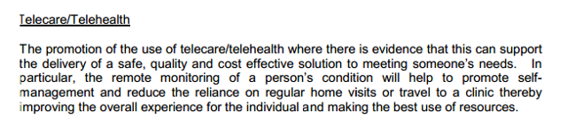

Development of self-care for people with long term conditions; recognising the experience of individuals living with a long-term conditions, strengthening the leadership within the community and voluntary sector; taking account of the community capacity in all our strategic and operational plans…

…Underpinning the model is the principle of effective self-care for each individual and the ability of society and organisations to provide support to individuals to achieve this...

…Enabling individuals to develop confidence and skills to manage their own health and wellbeing through improved information, knowledge and self-care

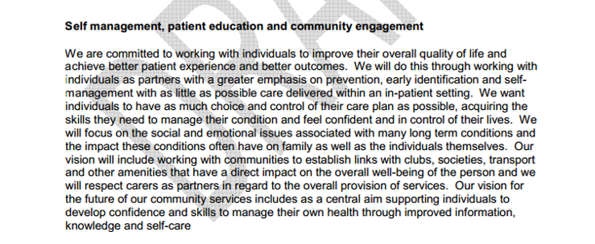

…Patient Education - Understanding the different approaches to behavioural change and their relevance to health promotion and self-care is key to changing patients’ behaviour in health promotion and disease prevention...

…To maximise the proportion of urgent care delivered through self-care and primary care services.

http://council.southglos.gov.uk/documents/s45703/Better%20Care%20Fund%20Plan%20Appendix%20A.pdf

South Tyneside

26 March 2014

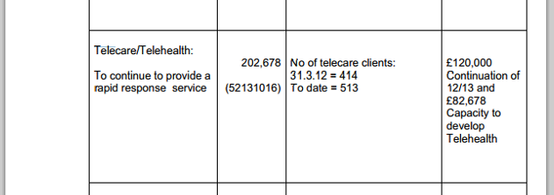

Self-Care – integration pioneer work…
…The development of a standardised self-care offer which will be offered at scale by health and social care professionals, as well as by non-traditional professional groups.

Additionally, as a pioneer site we have a specific workstream dedicated to the development and implementation of integrated approaches to self-care and as part of this we frequently engage with a range of health and social care providers.

… Self-care and self-support will be a golden thread throughout all of our service changes, and we will use the work we are doing to deliver our successful Pioneer bid to underpin how we implement the BCF

http://www.southtyneside.info/applications/2/councillorsandcommittees/committeemeeting.aspx?committeeid=835&meetingid=3148&periodid=26

Southampton

29 January 2014

Our vision is based on what people have told us is important to them. Through the above consultation and engagement routes, we know what people want is more choice and control, good quality services and for their care to be planned with them and their families/carers and coordinated by a key worker or case coordinator to simplify communication and provide consistency. They tell us that good information and advice along with good communication are key. They want us to make better use of IT and technologies such as telecare/telehealth as well as computer and mobile phone support. The people we talked to also highlighted the important role of the voluntary sector and the need to make staff in statutory services more aware of what is out there in the community. One key point that came out of several consultations was how much people value NHS services and the principles of the NHS constitution and so we are mindful of the need to ensure we protect and build on what is good….

….Strategic Context for Telecare and Telehealth in Southampton 2013 - Sets out our vision, aims and key principles for developing telecare and telehealth in Southampton and the model we propose to adopt. A business case is in development….

….Redesign of an integrated health and social care rehabilitation/reablement service for the city bringing together the following individually managed services….Telecare and telehealth….

For patients and service users, the changes we are making will mean….They will have better access to information and resources such as telecare/telehealth that help them manage their own condition at home….

….Use of new technologies is maximised -Increased use of telecare/telehealth….

….We will use the Better Care Fund for….Redesign of an integrated health and social care rehabilitation/reablement service bringing together City Care First Support, Brownhill House, RSH wards, Health and social care telehealth, Joint Rapid Response admission avoidance/discharge support service….

….Review telecare and telehealth services in the City, re local people are more aware of the ways in which they can use technology to retain their independence….

….maximise independence through improved re-ablement and access to telecare/telehealth services, to help people regain their independence and reduce the need for ongoing care.

Southampton City self management framework, 2013…Sets out how we will encourage, support and assist the wider development of self management with individuals and professionals in a wide range of care settings…

Person Centred - individuals will have maximum choice and control through person centred care planning and supported self management of their health and wellbeing…

…Joint workforce development / development of core generic skills, e.g. person centred planning, risk profiling, self management, care coordination, brief intervention skills, working with those with dementia and integrated care leadership…

…Introduction of a single point of access for integrated health and social care. This will include easy access city wide to good quality user friendly information that allows people to assess their own needs and choose the best solutions for themselves, when necessary, with help from trustworthy community based support. It will be staffed by people with the knowledge, skills and information to help people self manage and seek solutions for themselves or recognise the need to refer on for further assessment and intervention…

…develop a culture that promotes independence and self management as the default position…

…Increased use of self management approaches

Greater encouragement and support for self management and person centred care planning through community and early contact points

https://www.southampton.gov.uk/Images/Better%20Care%20Fund%20local%20plan%2010%20Feb%2013_tcm46-356258.pdf

Southend-on-Sea

No telecare/telehealth references as at 28 April 2014

http://minutes.southend.gov.uk/akssouthend/images/att24201.docx

Southwark

24 March 2014

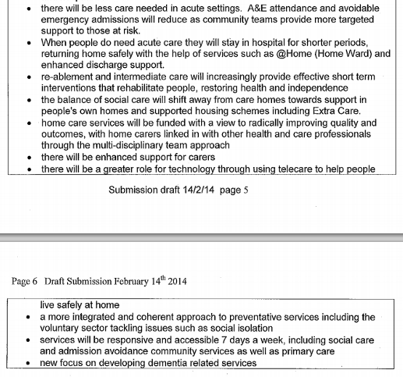

http://moderngov.southwark.gov.uk/documents/s45289/Appendix%202.2a%20Better%20Care%20Fund%20-%20draft%20submission.pdf

St Helens

20 March 2014

Continued and increased investment in Telecare to support health wellbeing and safety and also develop links with Telehealth opportunities. Other social care services for vulnerable adults with health and social care needs to continue to support a range of other smaller scale social care services which have an impact on health including Day Services, Challenging Behaviour Services, Sensory Impairment Services etc.

The approach targets patients with multiple long term conditions and provides a care plan aimed at enabling the patient to self manage their condition, identify disease progression and avoid unnecessary hospital admissions.

http://moderngov.sthelens.gov.uk/documents/s33047/V8%20DRAFT%20Better%20Care%20Fund%20planning%20template%20part%201%20-%206.3.14%20pre%20final%20submission.pdf

Staffordshire

13 February 2014

John is able to increase his ability to care for himself, and his GP is going to provide him with telehealth services, which monitor John’s diabetes and send the details straight to his GP. This reduces the need for John to travel to visit his GP and increases his sense of being in control of his disease. John’s GP surgery coordinates all his care needs and he has a single care record using his NHS number to make sure he only has to tell his
story once….

….A county-wide approach to telecare has just been launched as part of the BCF plan and this is expected to deliver savings to the NHS which will be quantified as part of the early stages of this work.

More support for those who can and want to self manage
http://moderngov.staffordshire.gov.uk/documents/s46657/Staffordshire%20BCF%20Appenix%20A%20v.9.8.pdf

Stockport

15 January 2014

We anticipate this will deliver from a system perspective (still to be quantified and agreed)….Increased use of telemedicine for individuals with heart failure….A reduction in non-elective admissions for people as a result of telemedicine.

7. Prevention, Independence & Self-care…Review of early intervention and self-care evidence Jul 13

http://democracy.stockport.gov.uk/documents/s35952/Better%20Care%20Fund%20Stockport%20planning%20template.pdf

Stockton-on-Tees

26 March 2014

So what do we mean by ‘go much further’? We would look at all of the current initiatives and identify the best way to ensure there is the appropriate level of integration with Social Care. It would include a suite of interventions e.g. OT, community nursing, social care, aids and adaptations, digital care (such as Telecare). It would also facilitate community and voluntary sector support and services in the community from a Social Care perspective. In additional to working with the community and voluntary sector it is important to work with private sector providers for example nursing and care homes to ensure that the care provided is consistent with the outcomes and ambitions of the Better Care Fund.

http://www.egenda.stockton.gov.uk/aksstockton/users/public/admin/kab14.pl?operation=SUBMIT&meet=24&cmte=NHW&grpid=public&arc=71

Stoke-on-Trent

13 March 2014

Stoke recognises the importance of prevention and early intervention; the aim being to support people at the earliest opportunity to ensure that they remain well, are engaged in the management of their own wellbeing, and wherever possible enabled to stay within their own homes. The provision of services such as community equipment, Extra Care housing, telecare and reablement are important services which help to achieve this aim. However, due to the additional requirements within the Care Bill and the need to prioritise our statutory responsibilities, Stoke may only be able to offer these interventions to people with eligible needs….

…Initially the BCF will focus on the following….Support to live at home – Assistive technology, digital health, major housing adaptations (DFGs), community equipment, Extra Care Housing, etc….

….Assistive technology/digital health
Stoke-on-Trent has a proven track record in developing ground-breaking technological innovations and complementary service approaches to make the most of the support and stability that can be gained from astute use of assistive technology solutions. This will continue to be prioritised, and embedded in the strategic thinking that underpins the work of the Better Care Fund.

More support for those who can and want to self manage

http://www.moderngov.stoke.gov.uk/mgconvert2pdf.aspx?id=60303

Suffolk

7 February 2014

No Telecare/telehealth references as at 28 April 2014

At a local level we are also developing neighbourhood teams as multi-disciplinary networks for pro-active health and social care, with shared information, assessment and care planning processes. They will cover a range of activities such as population risk stratification, self-care and carer support, active communities, integrated crisis response, case management and integrated care teams as well as discharge co-ordination. We have established our Multi-agency Safeguarding Hub matrix.

Will have access to a range of local services that focus on supporting people to self-care and supporting primary prevention…

…Our measures of health gain will examine a different system for health and social care where communities are much better connected to their citizens to support self-management of long term conditions and short term crises, where services are developed based on assessed need and where patients are treated as individuals and not illnesses…

…Services developed that promote recovery, independence and self-management

http://committeeminutes.suffolkcc.gov.uk/meeting.aspx?d=07/Feb/2014&c=Suffolk%20Health%20and%20Wellbeing%20Board

Sunderland

Unable to locate details as at 28 April 2014

http://bit.ly/1j7ha96

Surrey

3 April 2014

The local joint commissioning work programmes will deliver this by, for example….Establishing an integrated discharge network/model across services including rapid response, occupational therapy, reablement, telecare, home from hospital, equipment, transport etc….

Social care services will be protected…. Establishing an integrated discharge network/model across services including rapid response, occupational therapy, reablement, telecare, home from hospital, equipment,
transport etc….

….Use new technologies to give people more control of their care….

….Key enablers - Optimisation of new/existing technologies to give people more control of their care

Increasing support for health and social care self management and self care

http://mycouncil.surreycc.gov.uk/documents/s12977/Annex%202%20-%20Better%20Care%20Fund%20Template%20Part%201.pdf

Sutton

BCF 09 Integrated Community Equipment Service (ICES): The ICES pooled budget is used to deliver equipment through the Croydon Procurement Hub to meet health and social care needs. Currently the budget is £750k, but remains under pressure so may need to be increased. The advantage of inclusion in the BCF would
be that it helps integrate the assessments, access and delivery of equipment, adaptations (in BCF 08), and assisted technology (telecare) together with joint assessments of health and social care needs in BCF 01. Sutton would then experience efficient, holistic assessments and access to a wider range of supports to
promote their independence.

http://sutton.moderngov.co.uk/documents/s31380/Appendix%201%20BCF_schemes_detailed_description%20Final.pdf

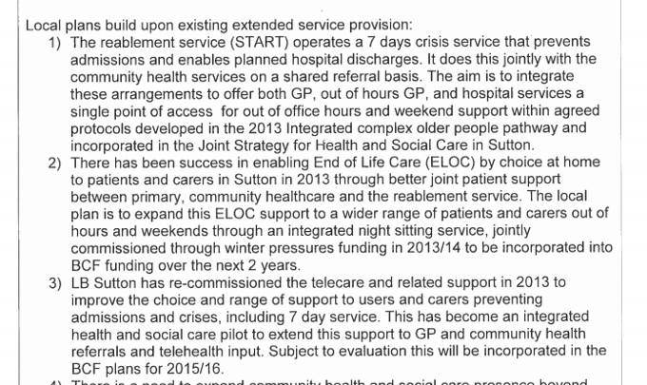

http://sutton.moderngov.co.uk/documents/s31384/Appendix%201%20BCF%20Planning.pdf

Swindon

12 March 2014

Telehealth and remote monitoring as appropriate and need locally determined….

….Capital allocations fund the joint Integrated Community equipment Store for children and adult services as well as investment in tele health and telecare. We will continue investment in technology to support self-care and prevention and enable for this a disability to live an independent as possible….

….Capital allocations
Capital allocations fund the joint Integrated Community equipment Store for children and adult services as well as investment in telehealth and telecare. We will continue investment in technology to support self-care and prevention and enable for this a disability to live an independent as possible….

….Home will mean a your own or family home, kept as your home, with us using new practice and technology that maintains the home environment.

increased prevention, personalisation and self-help and self-management…

…Prevention and self help…

…We understand the population of Swindon well down to each local area and at GP practice level. Preventative and self-help integrated services are in place locally engage and support you.

If you are older you are encouraged to engage with younger children and make a positive contribution. You are engaged in self-help groups, local activities and able to volunteer. Older people say that they feel safe in their community. Where possible the entrance to residential and nursing care is delayed and housing opportunities such as homes for life and extra care housing are used extensively.
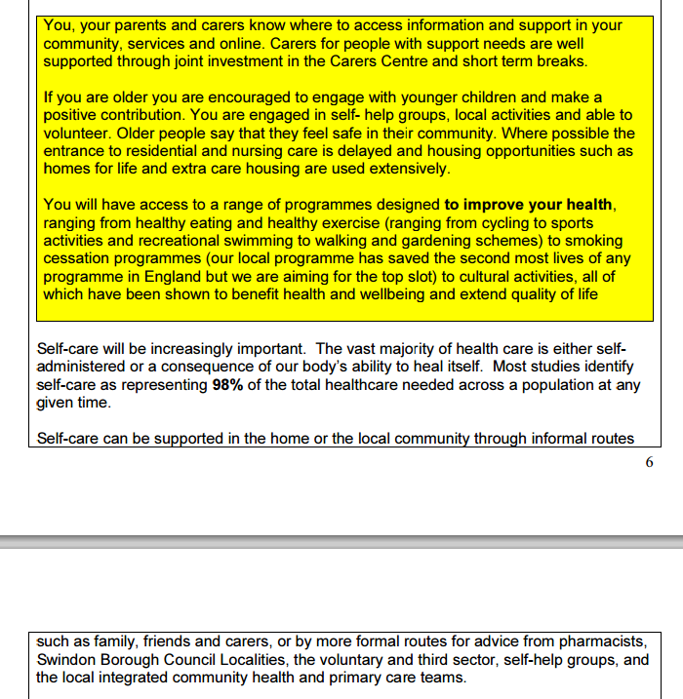

Self-care and prevention locally enhanced service models on a pilot basis to be put in place to test the N.E. London case worker model for long term conditions including older people. Reshaping of provision in the voluntary and third sector to improve health and well-being, improved advice and information so that people
can make plan and make choices for themselves

Alongside the link workers, we need to ensure that investment in the voluntary and third sector is aligned to support those in most need of self-care.

We will continue investment in technology to support self-care and prevention and enable for this a disability to live an independent as possible.

https://ww5.swindon.gov.uk/moderngov/documents/s65496/Better%20Care%20Fund%20Plan%20Appendix%201a.pdf

Tameside

Unable to find details as at 28 April 2014

http://www.tameside.gov.uk/healthandwellbeingboard/16jan14/agenda

Telford and Wrekin

Current expenditure on re-enablement and prevention through the s256 agreement provides resources for
Community Equipment and adaptations Telecare….

….Care of long term and other conditions will increasingly be based on a shift of responsibility from professional to citizen. The ideas of self-care and expert patient are not new, and as personal health budgets and appropriate assistive technology emerge we will explore opportunities to take the principles of self-care to the next stage.

Our Better Care Fund will be focused on two key themes…

…To develop community capacity where individuals abilities to self-manage long term conditions, and the enormous potential of communities to provide voluntary care and support are seen as valuable assets. We will strengthen the role of the voluntary sector, community networks, self help groups, and individuals in both
'patient' and 'caring' roles…

..More Self Help groups for people with Long Term Conditions to help them manage their own health…

…Improved levels of confidence in self care…

…Promote self-help and self-care wherever and for as long as possible…

…Community Support to facilitate self-help…

…Stronger communities – to strengthen communities, develop greater capacity for patients to “self-care‟, and to offer support to families and carers...

…Achieving cultural change within our community, encouraging and supporting self help and self care…

…A key element of our integrated model is to strengthen communities, develop greater capacity for patients to “self-care”, and to offer support to families and carers...

…Through this focus we will provide facilitation to communities and strengthen the ability of Self-Help groups in providing information, support and guidance...

…The ideas of self-care and expert patient are not new, and as personal health budgets and appropriate assistive technology emerge we will explore opportunities to take the principles of self-care to the next stage…

…We will increase the level of self-help and low level prevention to support the whole population This includes prevention programmes, reablement and assistive technologies, practical support in the home, equipment and adaptations, carer services and support where necessary to access residential and nursing home provision

http://apps.telford.gov.uk/demservice/DisplayDocument.asp?type=pdf&ref=16124

Thurrock
Technological solutions
Telecare is now embedded in all joint assessments to support service users to remain independent. Over the past year Telecare usage has increased - with an average of 18 installations each month, and is included in 39.9% of all council funded social care packages. Over the next year, Telecare will be expanded with a wider
range of equipment to support the changing needs of Thurrock’s population, including projects such as the digital befriending service currently being piloted – for example Age UK is using Skype and TVHD webcams to combat social isolation by connecting families and friends by video conferencing….

….Telehealth - Continuation of current telehealth service. Evaluation and future service development - £30k

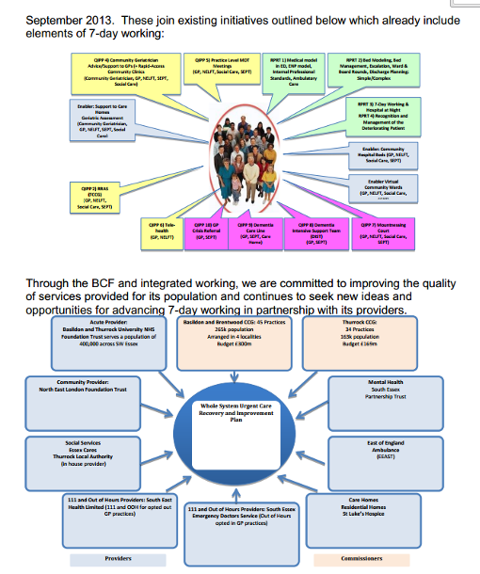

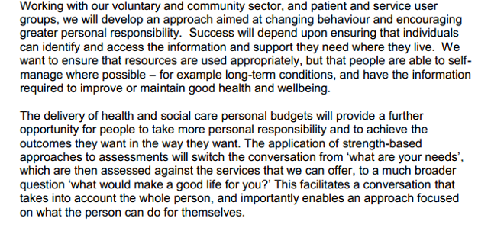

http://bit.ly/1fPiUhF

Torbay

12 February 2014

As part of this collaborative approach we will be seeking to optimise the current workforce capacity by continuing our pursuit of technology based solutions that complement traditional face to face consultations, so that not only is access extended in terms of timings but also in terms of styles.



Promoting self-care, prevention, early help and personalised care…

…The BCF fits with the existing priorities set out in the Health and Wellbeing strategy which takes the life course approach and identifies priorities such as those supporting a system of self-care for people with long term conditions, promoting independence and mental health.

Community Hubs will be centres of well-being where our population can receive co-ordinated support in relation to prevention, self-care, social care and medical support from primary and community care.

http://www.torbay.gov.uk/DemocraticServices/documents/s17635/Better%20Care%20Fund%20and%20Strategic%20Plan%20Appendix%201.pdf

Tower Hamlets

24 March 2014

Assistive Technology
The Local Authority has an established Assistive Technology (AT) project that was set up to implement a new approach to supporting people with Telecare/AT. Instead of AT being aimed mostly at people with low to medium level needs, it is now also offered to people with higher level needs, especially those with long term health conditions. People with dementia and patients on community virtual wards (CVWs) are of particular interest to the new provision. The variety of devices has been increased to cater for a wider range of
people’s circumstances and health conditions. Training has been provided to potential prescribers of AT, to make them familiar with the application of AT devices and solutions and to ensure they are aware of risks and ethical issues. The process for providing AT includes appropriate approvals for prescriptions as well as points at which reviews are done to check the suitability of prescribed devices. The current AT project is supported
through existing S256 monies and the success of the existing AT projects will be developed on through the BCF. This will be achieved through linking the work with ongoing work streams of the Health and Wellbeing Strategy.

Empower patients, users and their carers
• Enable patients and service users to live independently and remain socially active
• Establish education and self-care programmes for patients
• Personalise care to patients’ and service users’ needs and preferences

http://moderngov.towerhamlets.gov.uk/documents/s55388/BCF%20Appendix%201.pdf

Trafford

No detailed information of plan as at 28 April 2014

https://democratic.trafford.gov.uk/ieListMeetings.aspx?CId=260&Year=0

Wakefield

No Telecare/telehealth references as at 28 April 2014
Health and wellbeing workers, commissioned by public health, will be part of the integrated teams. Their role is to signpost older people and vulnerable adults to appropriate health and wellbeing services, such as stop smoking services or health trainers. They also promote self-care and can co-ordinate holistic support, such as Handy person services (an evidence based intervention to keep people in their homes and facilitate early discharge from hospital)…

Self-care…
…Self-management is an evidence based intervention for reducing non-elective admissions. It also
encourages patients and service users to take control of their health and wellbeing. The Care Closer to Home model embeds a number of self-care facilitators including a shared care plan, social prescribing and signposting to behavioural change programmes to encourage lifestyle change...

…Patients will be in control of their condition and supported to self-manage…

…People will also be connected more closely with their communities, encouraged to self-help and supported to have increased resilience.

http://mg.wakefield.gov.uk/documents/s56206/Better%20Care%20Fund%20planning%20template%20part%201%20final%20draft%2010%2002%2014.pdf

Walsall

No details available as at 28 April 2014.

http://www2.walsall.gov.uk/CMISWebPublic/Meeting.aspx?meetingID=2054

Waltham Forest

25 March 2014

The client / patient to be at the centre of decision-making, to support vulnerable people and empower self-care and self-management for people who want to live their lives…

…Services need to be planned with the client / patient at the centre of decision-making, both to respond to vulnerability and safeguarding needs and to empower self-care and self-management for people to live their lives…

…Care plans and budgets need to be personalised and tailored to individuals’ needs, their carers and families to empower self-management for people to live their lives…

http://democracy.walthamforest.gov.uk/documents/s39280/001%20Better%20Care%20Funding%20HWB%20report%20v9%200%20210319%20FINAL.pdf

Wandsworth

11 February 2014

Limited plan details - no Telecare/Telehealth references as at 28 April 2014
http://ww3.wandsworth.gov.uk/moderngov/ieListDocuments.aspx?CId=508&MId=4243&Ver=4

Warrington

No details available as at 28 April 2014.

http://cmis.warrington.gov.uk/cmis5/Committees/CURRENTCOMMITTEES/20132014/tabid/132/ctl/ViewCMIS_CommitteeDetails/mid/616/id/1272/Default.aspx

Warwickshire

11 February 2014

We will develop a joint assessment and care planning process building on the trusted assessor model and using technology in its wider capabilities….

….It will require investment in technology enabling people to identify and manage their own care or the care of those close to them. It will mean a different mind set to the potential of technology not just in the way we process our business but also in the way we deliver services….

….This means working with a belief that assisting older people within their communities is an important part of the task and that providers of this service can demonstrate person centred approaches that deliver the outcomes defined by customers. It means commissioning an outcomes based model for care at home that is predicated on the ability of older people to recover (albeit it different rates). It would have an emphasis of capturing community support, would utilise equipment and assistive technology and would expect access to housing grants and home improvements to align with discharge from hospital….

….Through the use of technology and access to equipment there would be an expectation that people would be able to return home much more quickly and not be diverted into residential and/or nursing care as the only option.

Radically change our approach to wellbeing and self-management…

…We want to move towards a model of integrated assessment of need across health, public health, housing and social care needs. This will begin with empowering the public to determine their own needs and to do this in advance of their need for more formal forms of support. We anticipate that this will also act as a tool to empower people to self manage their own care within the most appropriate environment…

…It means shifting from a model of dependency and direct provision to one of self management and care. It means people taking some responsibility for their own health and wellbeing and reducing the recourse to formal forms of support. Incorporated into this principle is the concept of community resilience and empowering communities to support local initiatives and forms of support eg; self management programmes for people with long term conditions, financial advice, housing improvement schemes, building local community enterprises, peer support groups for carers, supporting the growth of voluntary activity for
example through time banking. It will require investment in technology enabling people to identify and manage their own care or the care of those close to them. It will mean a different mind set to the potential of technology not just in the way we process our business but also in the way we deliver services. And the voluntary and community sector would need to reconfigure its offer to the public and build resilience to support our drive to invest in the army of informal carers.

http://bit.ly/1h6EkZ3

West Berkshire

Maximise the local people’s and their communities’ capacity to self care through implementation of the Care Act that enhances information advice, advocacy, carer support, with an overall preventative impact on intensive support and admissions.

The local definition of protecting adult social services is to focus upon prevention, early intervention and for health and social services delivery aimed at avoiding admissions to institutional care (especially care homes and hospitals) together with maximising people and their communities’ capacity to self care.

http://decisionmaking.westberks.gov.uk/documents/s31497/Item%209%20-%20Appendix%20A.pdf

West Sussex

No details available as at 28 April 2014.

http://www2.westsussex.gov.uk/ds/cttee/hwb/hwb300114age.pdf

Westminster

Tri-borough Plan

See Hammersmith and Fulham

http://transact.westminster.gov.uk/committee/index.cfm?c_docs=Health_and_Wellbeing_Board/2014/Better%20Care%20Fund%20Plan

Wigan

No details available as at 28 April 2014.

http://democracy.wigan.gov.uk/ieListMeetings.aspx?CId=488&Year=0&a=1

Wiltshire

A commissioning plan for intermediate care incorporating…. telehealth services….

….Concentrating on getting the right support to people when they need it - £3.39m in 2014-15
£6.89m in 2015-16 (this includes existing investment in single point of access, rapid response and telecare
response)….

….From the Better Care Fund, £9.18m is set aside in 2014-15 and 2015-16 to maintain services for vulnerable people based on current eligibility criteria, including funding to cover demographic growth. This will fund a range of services, including…. Telecare response services.

https://cms.wiltshire.gov.uk/documents/s71045/Better%20Care%20Plan%20report.pdf

Windsor and Maidenhead

This means local NHS teams will have a multidisciplinary team approach with a GP, Consultant Geriatrician and Social Care working combining expertise to provide more immediate and personalised services to help individuals stay in their own homes. This could involve by example, ensuring access to telecare, prevention advice on reducing falls in your own home and a nurse input to manage a long term condition such as diabetes….

….Good progress has been made in the development of our integrated primary care teams and a review is to be undertaken by the Kings Fund imminently to identify how these teams and case management should develop further to support a wider cohort of patients. Patients receiving this approach will be supported by telehealth and telecare where it can benefit them….

….Supporting people with long term conditions - Kings Funds review and further development of Integrated Primary Care Teams, with general practice at the centre….Implementation of telehealth and telecare
to support those with COPD and heart failure….

….Increase the number of people accessing telecare / telehealth (theme 2.1)

How will the target be achieved?
The target will be achieved by enhancing the successful provision of and additional investment in
community based services such as homecare and telecare, that enable people to live more independently for longer. A new approach to providing homecare through Outcome Based Commissioning will give a greater reablement focus to ongoing care packages as well as being the eyes and ears of health services. We are investing more in Community Equipment across Health and Social Care with a focus on responsible prescribing. Building on the successful Telecare programme this will be enhanced by Telehealth provision jointly commissioned with the CCG. We are focused on using beds as interim provision where necessary to allow short stays that are focused on reablement.

We will support people to understand their circumstances through ensuring they have the information they need to manage, having confidence in self care and their own skills

http://www.rbwm.gov.uk/minsys3.nsf/d9c360870262e3708025765d004cf06a/56d39e4081c5ce7e80257c9a004bc07b/$FILE/Agreement%20on%20Better%20Care%20Fund%20between%20Health%20and%20Social%20Care.pdf

Wirral

We will continue to develop and improve the following schemes as examples…. Assistive technology / telehealth….

….We already have a programme of work which is working towards….Developing more effective community interventions such as falls response and prevention services, assistive technology, community equipment, appropriate mental health and dementia interventions.

Over the next 5 years we will deliver a transformed service for the people of Wirral focusing on moving care from hospital to community based resources and supporting people in their own homes. There will be a focus on:

- Early intervention and prevention
- Health promotion
- Self-care and self help

…We will provide care and services focused around the individual - there is no wrong front door - promoting early intervention and prevention, encouraging people to self help where possible

Through movement of care to the community and supporting self care, signposting and early intervention we will reduce demand on downstream services such as acute care and long term social care. We will also use risk stratification to target integrated support for patients who are potential high users of health and social care services.

…• Encouraging self care and self help…

…The key success factors for delivery are:

• Improved outcomes for the people of Wirral, including positive experiences of care
• Implementation of integrated health and social care teams in the community
• Reduced demand on acute services
• 7 day access to a range of health and social care services
• Demand management through self care, signposting and utilisation of the third sector

…We will continue to develop and improve the following schemes as examples:

• Self help, information advice and support
• Self care
• Early intervention and prevention (falls, community equipment, early assessment)
• Integrated discharge team redesign

We are working with public health colleagues to retain a focus on early intervention and prevention and to ensure that a range of requirements are delivered through existing investments, for example supporting self care, alcohol services and falls prevention.

We will focus upon protecting and enhancing the quality of care and working collaboratively to promote
early interventions and self management wherever possible.

The Wirral Economy has an integration board which was being directed by a Chief Executive Steering Group chaired by the CCG Chief Officer and is now part of the Vision 2018 governance structure. The board was originally established to support the Department of Health’s Long Term Conditions Programme on Wirral which aimed to implement the 3 core areas of the programme, integrated teams, risk stratification and
self care support. The board membership has included both the CCG and Social Services and engaged all major providers (acute trust, community trust and the mental health trust). As a result of this work the Wirral Economy is advanced in implementing integrated teams and risk stratification and has also commissioned an online self care support service (Puffell).

http://democracy.wirral.gov.uk/documents/s50016558/BCF%20submission%20130214%20App2.pdf

Wokingham

Self-care can benefit people from making basic daily lifestyle choices through to people with long term chronic and complex conditions. Supporting people to self care requires better information, support to help with care co-ordination and planning, making best use of new technologies and assistive technology….

….Working towards these outcomes requires focus and planning to achieve the following….Making better use of technology.

The NHS 'Call to Action' day has also given very clear messages to inform the integration planning agenda. As well the improved levels of integration across health and social care, local people also called for preventative care being improved and incorporate more self care and education; ensure that the vital contribution of the voluntary sector is more highly valued and put greater more focus on developing community services, particularly for those with long term conditions and older people…

…Working towards these outcomes requires focus and planning to achieve the following:
• A greater emphasis on prevention and self-care;
• Patients being in control of their own care planning,
• Making better use of technology;

…Providing management and maintenance of people with long term conditions, including dementia, moving towards self-care…

6. Prevention and Supporting People to Self Care
The majority of people are themselves best placed to make decisions about their own health and care needs provided they have capacity and are supported with good information and advice. This work builds on national pilots as well as the model of support that promotes citizenship and personalisation. The focus of this element is on supporting people to have greater choice and control and ability to manage both their health and social care. This will form part of the development of long term conditions management and integrated personal budgets for health and social care for people to manage and co-ordinate their care and support arrangements.
Self-care can benefit people from making basic daily lifestyle choices through to people with long term chronic and complex conditions. Supporting people to self care requires better information, support to help with care co-ordination and planning, making best use of new technologies and assistive technology.

file:///C:/Users/New%20Dell/Downloads/Item%2065.00%20Better%20Care%20Fund%20Plan.PDF

Wolverhampton

Telecare/Community Equipment & Adaptations – 2014/15 £900k and 2015/16: £900k

http://bit.ly/1mRh4FC

Worcestershire

No details available as at 28 April 2014.

https://public.worcestershire.gov.uk/web/home/DS/Documents/Appendix/Health%20and%20Well-being%20Board/Agendas%20and%20Reports%202014/Tuesday%2C%2011%20February%202014/item%207%20Better%20Care%20Fund%20Apx%20B.pdf

York

No telecare/telehealth references as at 28 April 2014

To provide proactive and preventative healthcare and health promotion through, for example, self-care and measures of patient independence…

…Our preventative agenda aims to support people at the earliest opportunity by providing relevant information and advice in a timely and accessible way, signposting people to the most appropriate resource for their particular needs. We will encourage appropriate self-help options and only become more actively involved when requested or required. Supporting people to remain well, and facilitating the self-management of their own wellbeing and wherever possible enabling them to stay within their own homes is a key priority for us and our focus will be on protecting and enhancing quality of life by tackling the causes of ill-health and poor quality of life, rather than simply focusing on service options…

…We have innovated in some areas and are working hard to develop a person focussed approach for all service areas. This approach was used to establish more capacity within our reablement services that promote
independence and self-help…

…By improving access, assessment processes and introducing self-help options we believe we can work towards a 7 day service model. This will be an integral part of our development during the first year.

http://democracy.york.gov.uk/documents/s88516/BCF%20Master%20submission%20v25.pdf

Newsletter supplement prepared by Mike Clark (@clarkmike) and brought to you by the Telecare LIN on behalf of the HealthTech KTN and Technology Strategy Board. Newsletters and supplements are archived at www.telecarelin.org.uk. Disclaimer: “We provide this newsletter supplement for information purposes only and neither the Technology Strategy Board nor the authors accept any liability whatsoever for inaccuracies, errors or omissions therein or for any consequences arising therefrom.”



