December 2015 Newsletter

Welcome
Welcome to the December 2015 newsletter from the Telecare Learning and Improvement Network.
Over the last few months, we have been providing weekly headlines only since our Innovate UK funding ended in March 2015.
Our news service has been available since October 2005. Our Housing LIN and Telecare LIN membership database exceeds 40,000 people from around the world.
From January 2016 we will be back with a monthly Telecare LIN roundup as well as maintaining weekly headlines together with daily news via Twitter (follow @clarkmike and #TLINenews).
As in the past, we will be continuing to bring you an extensive curated coverage of digital health and technology enabled care references from the UK and around the world including telehealth, telecare, mobile health, telemedicine, ehealth, smart home technologies and Internet of Things. We will also be including more in the future on health informatics (including electronic health and care records), big data, artificial intelligence as well as health and care robotics.
Our December 2015 edition is an opportunity to update our member databases and renew our schedules ahead of bringing you a monthly roundup in the third week of each month from January 2016.
This month’s coverage includes winter pressures on health and care in the UK and new funding announcements including the spending review. There are new proposals and recommendations on digital Health and Care from England and Wales. There is coverage of the recent Technology enabled Care Conference and the dallas programme. The winning bids for the Long Term Care Revolution have been announced. There are 70 useful links from UK and around the world plus some new events for the start of 2016.

Contents

Welcome 1
1 Main news items 3
1.1 Spending Review Impact on Health and Care in the UK 3
1.2 Martha Lane Fox has set out key digital proposals for the NHS 4
1.3 A Digital strategy for Wales 5
1.4 TSA international technology enabled care conference 7
1.5 dallas – the first evaluation reports 10
1.6 Successful Long Term Care Revolution bids announced 11
2 This month’s news 12
3 Learning and Events 17
4 Other useful links 18

1 Main news items

1.1 Spending Review Impact on Health and Care in the UK
The Government has announced its spending plans for health and care in England through till 2020. The Spending Review also set out funding allocations for Scotland, Wales and Northern Ireland.
The winners include the NHS in England who will get a requested £8bn of additional funding (along with an extra £2bn already announced for this current year). There is some additional funding (£600m) for mental health.
The main losers include other parts of the Department of Health budget – impacting on public health and health education. Nurse training will move over to a student loan system in future.
Although the front-loading of funding was appreciated by many in the NHS, more detailed analysis has suggested that the figures are not as good as they initially look and that by the end of this decade we could be spending an even smaller amount on health and care as a percentage of GDP against rising demands.
We know there is a potential £2bn deficit from NHS providers (eg hospitals) for this financial year. We also know that there will be £1bn of additional pensions funding to be found from next April. The NHS will also have to find £22bn of efficiencies over the spending review period.
For social care, not much has been done to see off the twin challenges of possible care home and home care closures as the living wage takes effect next year and profits are further squeezed.
Local authorities can currently raise an additional 1.99% funding through council tax increases without a referendum. The Spending Review is allowing them a further 2% council tax increase specifically for adult social care if they want to use it.
The difficulty is that many authorities will only raise very small amounts via this route and some others may not wish to take the political decision to raise local taxation further. Examples from local authorities so far indicate that the additional 2% would be far outweighed by the savings to be made generally.
There is the possibility of some further social care funding by 2017 via the Better Care Fund and from that year, health and care will have to work up integration plans by 2020.
When it comes to technology, the spending review appears to provide an extra £1bn of funding over the period.
“The government will invest £1 billion in new technology over the next 5 years to deliver better connected services for patients and ensure that doctors and nurses have the information they need at their fingertips. By September 2018, 80% of clinicians in primary, urgent and emergency care will have digital access to key patient information. By 2020 integrated care records will give every health and care professional concerned with an individual’s care the information they need to provide safe and prompt care. The government will invest £10 million in expanding the Healthcare Innovation Test Bed programme. This facilitates partnerships between industry and the NHS to make healthcare more effective and efficient by testing combinations of new digital technologies and innovations in NHS services. The Test Bed programme will fund a testing site in every region”.
It is not yet clear yet how this additional funding will be shared out. It could be a new technology fund linked with digital roadmaps. It could be also be linked to free NHS Wi-Fi, digital inclusion and building the digital skills of NHS staff.
Links:
Spending Review and Autumn Statement 2015: key announcements bit.ly/1MCpXxr
Chancellor George Osborne's Spending Review and Autumn Statement 2015 speech bit.ly/1MCq38u
Local government funding at the Spending Review 2015 bit.ly/1MCqb80
Spending Review and Autumn Statement 2015: documents bit.ly/21fIgQJ
Department of Health's settlement at the Spending Review 2015 bit.ly/1Yuhdiu
Spending Review – Health and Social Care bit.ly/1YuoZZw
100+ spending review references - http://bit.ly/1PNZlNM

1.2 Martha Lane Fox has set out key digital proposals for the NHS
Four recommendations have recently been set out by Baroness Martha Lane Fox to the National Information Board covering digital health and the NHS:
- making sure those with the most health and social care needs, who are often the least likely to be online, are included first in any new digital tools being used across the NHS
- free wi-fi in every NHS building
- building the basic digital skills of the NHS workforce to ensure that everyone has the digital skills needed to support people’s health needs
- at least 10% of registered patients in each GP practice should be using a digital service such as online appointment booking, repeat prescriptions and access to records by 2017

The short report to the National Information Board also talks about free wi-fi allowing patients staying in hospital to self-monitor their conditions.
It also says that digital heath tools and information can help people to better manage their health and avoid unnecessary GP visits and hospital admissions.
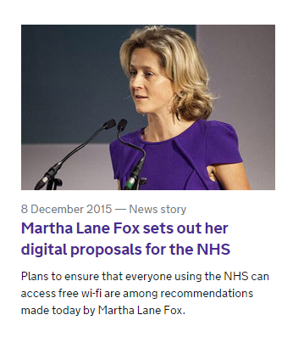
Health Secretary Jeremy Hunt has said:
“Creating an NHS which is digitally fit for purpose in the 21st century is a key priority for this government. New investment of £1 billion in health technology announced in the autumn statement will help us to achieve this - making sure that patients and staff can access the services they need, helping to free up time and reduce costs”.
The recommendations will now be considered by the National Information Board.
Links:
A digital NHS for everyone – Tim Kelsey and Martha Lane Fox
Martha Lane Fox sets out her digital proposals for the NHS
The National Information Board quarterly leadership summit video from 8 December 2015 is available as are the reports.

1.3 A Digital strategy for Wales
People will be able to have a consultation with their GP using a smartphone and monitor their own health via digital devices as part of a new strategy to put digital technology at the heart of Wales’s health and social care system.
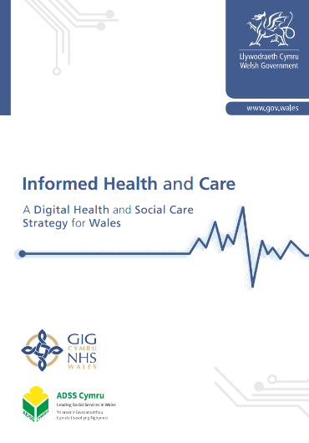
‘Informed Health and Care: a digital health and social care strategy for Wales’ sets out the Welsh Government’s five-year vision for the use of digital technology within both the Welsh NHS and in Wales’s social services.
Under the strategy, people in Wales can expect to:
- Connect online with health services to book appointments online, order repeat prescriptions and use the internet, email and video conferencing to connect with clinicians for virtual appointments and consultations in a way that suits them, potentially reducing delays and costs to the service and service users. Free Wi-Fi will also be made available at all NHS Wales hospital sites for patients, visitors and staff to use.
- Access their health records online to view their hospital appointments or details of GP visits, their prescriptions and test results; to add to their information, feeding in details they may have gathered from other sources, such as apps and wearable devices and record their preferences and thoughts about their care alongside their official notes. This will enable people to play a more active part in developing and improving the quality of their information and support them in managing their own health and well-being, in line with the principles of Prudent Healthcare.
- Use digital tools and smartphone apps to manage their own health and well-being and live independently, allowing people to routinely monitor their own conditions, such as diabetes or asthma, and daily tasks. The use of smart technologies and assistive technologies, such as sensors in people’s homes, will support more people to live independently for longer.
- Receive digital reminders and alerts about personal health and care, including medication or exercise reminders, appointment alerts and updates on where people are in their agreed care plan.
The strategy also sets out a vision where health and social care professionals have access to the digital tools in their workplace that they need to deliver safe, high-quality, efficient care.
Health and care staff will:
- Use technology routinely in all care settings to support them to do their jobs effectively: staff working in busy, often pressurised, hospital environments, or remotely in community settings and people’s homes will be able to access, collect, validate and transmit data easily and quickly using mobile devices such as smartphones and tablets and use other data-entry approaches such as voice recognition.
- Have access to an up-to-date record of care for their patient or service user, which must be accessible wherever and whenever it is needed, in the hospital, the community, GP surgery or in the home, and focused on the individual and not the disease, service or organisation where the care is being provided.

1.4 TSA international technology enabled care conference
This year’s International Technology Enabled Care Conference included a wide range of policy debates, plenaries, masterclasses and excellence awards. Led by TSA Chair, Andrew Gardner and Chief Executive, Alyson Scurfield, the conference was ably chaired by Paul Burstow (Care Minister 2010-2012).
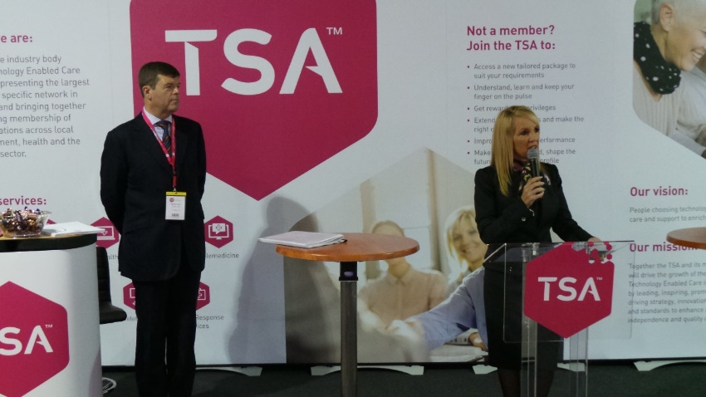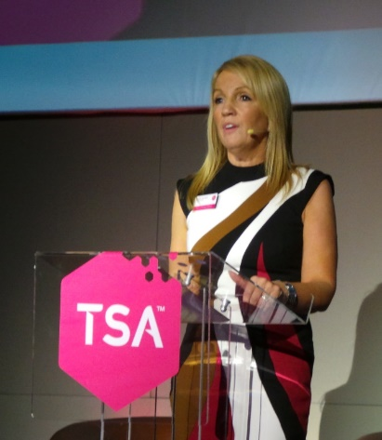
Paul Burstow (Conference Chair) with Alyson Scurfield (Chief Executive, TSA)
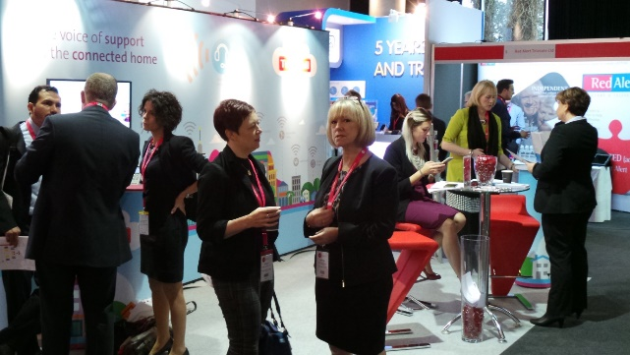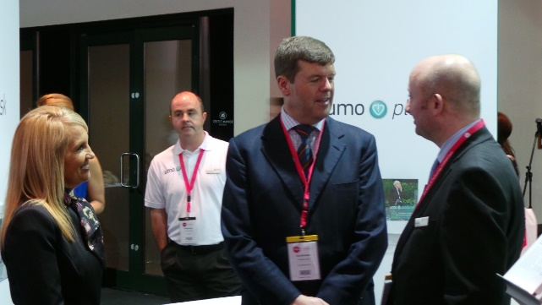
Paul Burstow and Alyson Scurfield tour the exhibition hall at #TECSConf2015
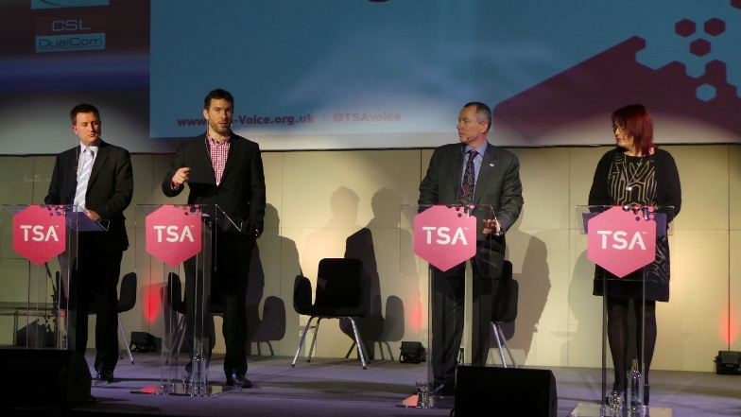
Left: Home countries policy debate and Right: Andrew Gardner (TSA Chair)
Through a video to more than 500 delegates attending the two-day industry conference at Celtic Manor Resort Hotel in Newport, South Wales, the Parliamentary Under Secretary of State for Life Sciences at the Department for Business, Innovation and Skills and the Department of Health, said: “We need to accelerate uptake of innovation into the NHS to help us to do two things – to deliver more health and care for every pound we spend; to do so in a way that makes the UK one of the world’s most attractive places to come and develop the health and care technology of the 21st century.
“A key issue is data, clinical information on real patients - in real time with real disease. The frontline NHS needs to embrace these technologies to help drive efficiency, productivity, patient safety and care.
“All health is digital’ - we need to let data flow and put information into the hands of patients. We need to move from healthcare ‘done to us’ to empowering ‘active healthcare citizens’. Over 60% of adults now own and use a smartphone but only 2% use them to access the NHS. Patients and users need compelling benefits in their hand - convenience, information and access.
“The National Information Board and Personalised Health and Care 2020 has set out milestones for digital records. NHS England says that unless we modernise care pathways the old model of treating chronic disease in hospitals is going to cost us an extra £30bn a year by the end of Parliament.
“By embracing digital technology we can diagnose earlier, treat smarter, keep people out of hospital, keep people fit, healthy and active and working and avoid the chronic disease cost burden which is going to swamp the NHS.
“Digital technology has transformed other walks of life from banking to travel agencies and education – they can and are beginning to do the same in health.
“My challenge to you as the innovators on the frontline is... focus on those innovations that don’t carry technological risk, deliver benefits to patients; inspire clinicians and patients to support this agenda and deliver tangible, frontline benefits to the health system and put those benefits in the hands of patients.
“This agenda isn’t just about digitalising the system for the benefit of the providers, It’s about empowering 21st Century healthcare citizens to have the responsibilities, the choice and the information in their hands that they need to take those steps to be active and to help take more responsibility for their health outcomes.”

Bionic Baylee and her father address the conference - http://bionicbaylee.com/
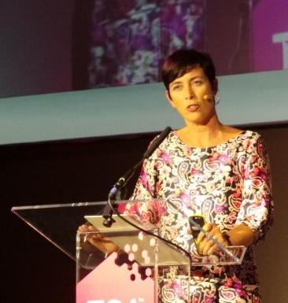
Matthew Warnes from ATEL and Alison Mlot from Innovate UK (programme)

Left: Conference chair Paul Burstow and Right: home nations panel discussing progress and future plans

Ray James from ADASS and Madeleine Starr from Carers UK

Peter Brown from Herefordshire Housing Group and Jeremy Porteus from Housing LIN
Twitter coverage of the Conference is available (16 Nov and 17 Nov). Presentations and videos will be available shortly.

1.5 dallas – the first evaluation reports
A number of recent events have explored the progress made in the £37m dallas programme designed to bring benefits to 169,000 people over a three year period. The programme ended in Summer 2015 and some reports and evaluations are now available on the DHACA website.
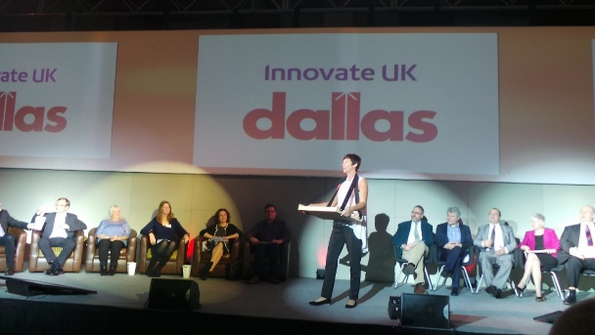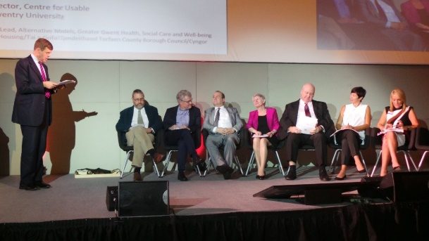
dallas panel sessions at the recent Newport event
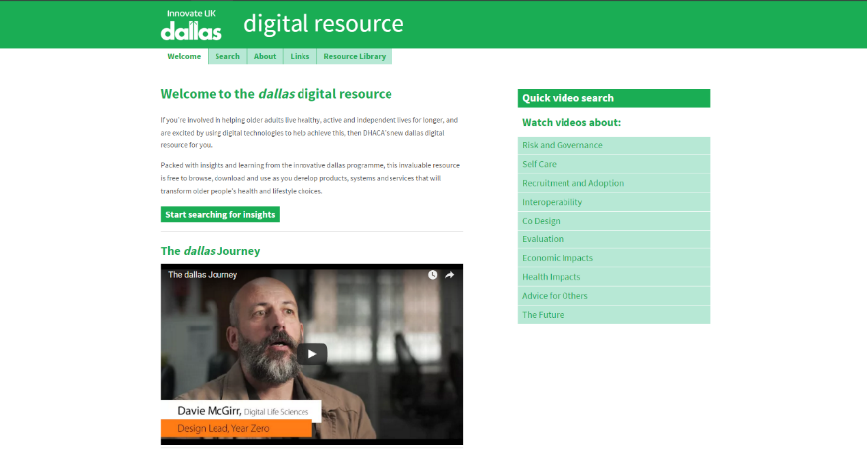
dallas resources on the DHACA website
Recently-published journal articles on dallas include:
- Implementation factors affecting the large-scale deployment of digital health and well-being technologies : a qualitative study of the initial phases of the ‘Living-It-Up’programme
- Implementing a national Scottish digital health & wellbeing service at scale : a qualitative study of stakeholders' views
- Delivering digital health and well-being at scale : lessons learned during the implementation of the dallas program in the United Kingdom

1.6 Successful Long Term Care Revolution bids announced
Over recent months, Innovate UK has been running a competition for a new two year programme called the ‘Long Term Care Revolution’. The two winners have now been announced.
The CHIRON consortium will receive £2m to develop a modular robotic solution that can be adapted to different assistive tasks. CHIRON's various components will be designed to be mixed and matched enabling the user to undertake a wide range of domestic and self-care tasks independently. The project will create a prototype that will lead to the development of a commercially viable product.

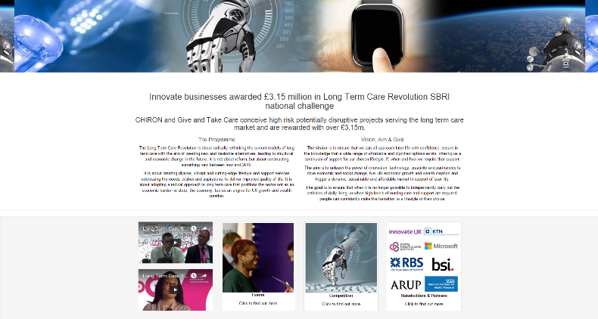
The second winner (awarded £1m) is the ‘Give & Take Care Project’ led by Professor Heinz Wolff. The project aims to solve the challenge of how affordable care can be provided in the context of increasing demand due to the ageing population and medical improvements.
People take part in ‘Give & Take Care’ through supporting or caring for an older person in their community. The hours of support the caregivers provide are recorded and they get credits - or ‘GATs’ – for each hour of care they have undertaken. They can then use their GATs in the future towards their own care or that of a friend or relative.

2 This month’s news
Here is a roundup of curated news links from the last month.
(i) NHS faces a double crisis this winter as financial day of reckoning nears (Guardian article).
(ii) The first Technology Charter for people with dementia in Scotland has been launched. The Technology Charter is a call to action, calling for the delivery of health and social care to people with dementia to incorporate and promote the use of technology; helping people with the condition to live healthier, safer, more active and more confident lives as valued citizens. It also seeks to raise public and professional awareness of how technology can enhance lives, promote independent living and assist and complement care and support.
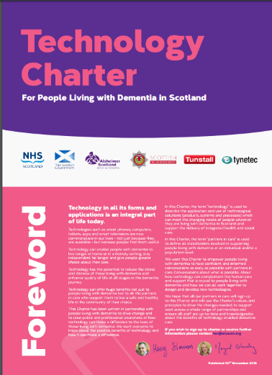
(iii) The 2015 TSA Crystal Award for Inspiring Change and Progress within Technology Enabled Care Services has been won by PA Consulting Group, for their Telecare partnership work with Hampshire County Council.
(iv) Crisis talks are taking place later between care home owners and council leaders amid mounting concern a large number of providers are preparing to pull out of the market (BBC News).
(v) Birmingham Children’s Hospital is using technology developed to monitor drivers in the McLaren Formula One racing team to keep track of the health of seriously ill children (Digital Health News).
(vi) What's so smart about smart meters? BBC News – smart meter roll out across the UK.
(vii) Is computerised CBT effective for depression? – trial results.
(viii) NHS24 in Scotland has withdrawn its new £117m computer system until the new year following implementation problems (Digital Health News).
(ix) Consultation is now complete for the NHS Mandate for 2016-2017 – what will be the role of technology? (Dept of Health).
(x) NHS discharge delays hit record levels – October figures published (BBC News).
(xi) Kent County Council has awarded the UK’s largest independent provider of telecare a five-year contract to help more than 7,000 vulnerable people in Kent stay living independently (24 Dash Article).
(xi) Vital care services for older and disabled people in England remain at risk - despite government attempts to protect the sector, care leaders say (BBC report).
(xii) Prescribing data from NHS GP practices across England can now be scrutinised online to see how responsive they are to cost-efficiency and patient safety recommendations.
(xiii) 'Patient Online - Access GP online services'- information from NHS Choices.
(xiv) Enhanced registered nurse care coordination with sensor technology: Impact on length of stay and cost in aging in place housing – study.
(xv) Mark Golledge of LGA outlines how digital can support the integration of health and care, tackle some of the long-term challenges and help to deliver person centred services.
(xvi) Coming up in 2016 - Better Care Events for learning and sharing success.
(xvii) Nominet Trust 100 - 'Winning tech inventions that help people live better' (Guardian article).
(xviii) The Tech house of the future: take a look around (Guardian article)
(xix) Should we be worried if our homes are soon smarter than we are? (Guardian article).
(xx) Article on health apps on smartphones and FDA requirements.
(xxi) Mental health apps may be promising, but they sorely lack regulation and quality reviews – Scientific American
(xxii) BBC News - Cambridgeshire's £800m NHS out-sourcing contract ends – BBC News.
(xxiii) Multiple Improvements Required To Create Compelling Health & Fitness Apps (PR Newswire).
(xxiv) From the U.S.: Virtual care for 60,000 emergency room & critical care patients per year.
(xxv) ‘Revealing the quiet revolution of 21st century healthcare' – George Freeman (DH Minister) - article.
(xxvi) 'Medication Adherence: Technology Helps, but Multifaceted Approach Needed' – iHealthbeat article.
(xxvii) Study: Home Rehabilitation Via Telemonitoring in Patients With COPD.
(xxviii) Could digital health tools help improve COPD management? – Med City News.
(xxix) 'From robo-toys to mechanical bears: your future carers may be robots' – Guardian article.
(xxx) Manchester wins £10m prize to become world leader in ‘smart city’ technology – DCMS.

(xxxi) Care homes are using digital devices to transform residents' lives at Christmas – Care Home News.
(xxxii) From NHS England: Patients will arrange 10m GP appointments & order 15m repeat prescriptions online this year'
(xxxiii) Why it matters that the chancellor won't fund council technology – Guardian article.
(xxxiv) Last winter saw the highest number of winter deaths since the turn of the millennium as respiratory diseases claimed thousands of lives (Telegraph article).
(xxxv) NHS England are to recruit for the new role of 'chief information & technology officer' following Tim Kelsey’s departure HSJ News.
(xxxvi) Is HSCIC sharing data of patients who opted out of care.data?' - Computing News.
(xxxvii) The Caring Home - A Consultation Document - via SH&BA
(xxxviii) Last few places remaining for Scottish Digital Health & Care Conference – booking.
(xxxix) Ambulance cardiac test could lead to quicker treatment for high risk patients (DHI Scotland).
(lx) Building a mobile NHS: How Skype is transforming patient care - South West London & St George's Mental Health NHS Trust (CBROnline).
(lxii) New NHS regulator has impossible task in face of spiralling funding crisis – Richard Vize at Guardian.
(lxiii) Record numbers of 'fit' patients stuck in hospital spark fears for NHS winter crisis Cuts to local social care blamed for lack of patient support as NHS England figures show targets for cancer treatment and ambulance response times missed (Guardian article).
(lxv)'Technology's biggest untapped market is elderly care' – New article from The Telegraph
(lxvi) How to evaluate and improve the quality of mHealth behaviour change tools' – slideshow from Jeremy Wyatt, University of Leeds.
(lxvii) Housing, residential, care service and equipment options for older people – via Which UK.
(lxviii) There has been more than 200 pieces of telemedicine-related legislation introduced in 42 US states.
(lxix) ‘2015: Cellular trumps landlines, WiFi in remote patient monitoring for the first time' - via MobiHealthNews.
(l) Dudley Council's gadget range will keep elderly relatives safe this Christmas' via Halesowen News
(li) '50 wearable tech gamechangers for 2016' – via Wareable.
(lii) ‘Putting a stop to the revolving door of care’ - Gillian Leng on new standard from NICE.
(liii) 'Robot revolution raises urgent societal issues not yet addressed by policy' – says Professor Noel Sharkey from Sheffield University.
(liv) OpenAI is a new $1 billion nonprofit dedicated to Artificial Intelligence – via The Next Web.
(lv) New from ILC – ‘The End of Formal Adult Social Care?' (also The future for adult social care services in England "looks bleak", a think tank has warned).
(lvi) Doctify is a healthcare review service looking to transform patient experience in the digital age (UK)' - via IBTimes.
(lvii) JMIR study now available: Health App Use Among US Mobile Phone Owners: A National Survey

(lviii) While half of Americans use a health app, just over a third wouldn’t pay for one – survey via iMedicalApps

(lix) Study finds that patients are unhappy when doctors spend a lot of time looking at a computer screen (WSJ article).
(lx) Smartphone-connected device use, focus on behavioral health, and better databases for health information analysis, are within the top 10 trends in healthcare for 2016, according to PwC's annual Health Research Institute report. (Mobihealthnews article).
(lxi) There is a new Interview with John Eaglesham from ADI Health on digital health.
(lxii) 'Crisis-hit NHS computer contract an 'exemplar of good practice' – NHS24 in Scotland via BBC News.
(lxiii) Vanguards – developing a blueprint for the future of NHS and Care Services (NHS England publication)
(lxiv) Chancellor George Osborne has signed a health devolution deal for London. The agreement will see the launch of five pilot schemes designed to transfer power over NHS services from Whitehall to local groups (BBC News).
(lxv) Aviva’s latest Health Check UK report includes a digital health survey'.
(lxvi) Some Blogs from eHealth Scotland for the recent eHealth Week are available (December 2015).
(lxvii) 'What makes integrated care work?' - Elisabetta Zanon on progress in the Basque Country – NHS Confederation article.
(lxviii) Chubb Community Care has launched an enhanced assisted living solution that protects individuals in their homes.
(lxix) A new £1m project called BOLD-TC (Better Outcomes for People with Learning Disabilities – Transforming Care), brings the video consultation service provided by v-connect together with local and remote vital sign monitoring to allow new models of care to be developed for people with learning disabilities. Funded by a Phase 2 development contract awarded by the Small Business Research Initiative (SBRI) Healthcare competition, BOLD-TC began in October 2015. Project partners include Sandwell Metropolitan Borough Council and Hft, the national learning disability charity.

(lxx) The Department of Health has announced that hospitals in England will get £1.8 billion for sustainability and transformation but they will have to meet strict conditions.
The £1.8 billion, part of a £3.8 billion front-loaded funding boost for next year, is designed to help trusts reduce their deficits and allow them to focus on transforming services to deliver excellent care for patients every day of the week.
The conditions include:
- agreeing with NHS England and NHS Improvement a strong and measurable recovery plan that shows how the trust will reduce deficits and break even within a reasonable timeframe, as well as a ‘control total’ for their 2016/17 budget
- developing a plan and reporting regularly on progress towards achieving the savings outlined by Lord Carter as part of his review into NHS productivity
- making further progress to reduce agency spend, along with a trajectory of how much spend will fall and regular reporting against this trajectory as part of the ongoing drive to employ fewer agency staff and more permanent staff to improve continuity of care for patients and improve safety
- agreeing with NHS England and NHS Improvement a credible plan for maintaining delivery of core standards for patients, including the 4 hour A&E standard, the 18 week referral to treatment standard and, for appropriate providers, the ambulance access standards
- setting out a clear and credible plan for achieving 7 day services for patients throughout the country by 2020
Sanctions will be included as part of the funding to ensure hospitals comply with the measures.
(lxxi) The NHS Mandate for 2016/17 has been announced - coverage of digital health and tech is in sections 2.13 and 7.2.

3 Learning and Events
Click on the links below for conferences and learning events over the coming months.
CES 2016 - Las Vegas, 6-9 January 2016 https://www.cesweb.org/
Digital Health Summit - Las Vegas, 6-9 January 2016 https://www.cesweb.org/Conference/Conference-Tracks/Digital-Health-Summit
DHACA Day VII - London, 11 January 2016 http://dhaca.org.uk/events/forthcoming-events/dhaca-day-vii/
Health 2.0 WinterTech – San Francisco, 13 January 2016 http://bit.ly/221ZKka
Building the European digital health environment –Turning best practice into mainstreamed implementation! - London, 18 January 2016 http://bit.ly/1Z7JwU3
dotMED Conference – Dublin, 12 February 2016 - http://www.dotmedconference.ie/UCL Festival for Digital Health – London, 22-26 Feb 2016 http://bit.ly/1QupmSC
Mobile World Congress – Barcelona, 22-25 February 2016 http://www.mobileworldcongress.com/
HIMSS 16 – Las Vegas – 29 February to 4 March 2016 http://www.himssconference.org/
Health 2.0 Europe – Barcelona, 10-12 March 2016 http://www.health2con.com/events/conferences/health-2-0-europe-2016/
SXSW 2016 – Austin, 11-15 March 2016 http://www.sxsw.com/
The International eHealth, Telemedicine and Health ICT Forum – Luxembourg, 6-8 April 2016 http://www.medetel.eu/index.php
Coming up in 2016 - Better Care Events for learning and sharing success.
- Tuesday 2nd February 2016, Birmingham
- Wednesday 3rd February 2016, Leeds
- Thursday 4th February 2016, Manchester
- Tuesday 9th February 2016, Newcastle
- Wednesday 10th February 2016, Cambridge
- Thursday 11th February 2016, Leicester
- Tuesday 23rd February 2016, London
- Wednesday 24th February 2016, Gatwick
- Thursday 25th February 2016, Reading
- Wednesday 2nd March 2016, Wellington
Full List: https://www.england.nhs.uk/2015/12/08/better-care-events/

4 Other useful links
Housing Learning and Improvement Network www.housinglin.org.uk Twitter: @HousingLIN
Telecare Learning and Improvement Network www.telecarelin.org.uk #TLINenews
Telehealth and Telecare Aware – daily news and comments www.telecareaware.com
DigitalHealth.net http://www.digitalhealth.net/

Newsletter prepared by Mike Clark (@clarkmike) and brought to you by the Telecare LIN
Disclaimer: “We provide this newsletter for information purposes only and TelecareLIN nor the authors accept any liability whatsoever for inaccuracies, errors or omissions therein or for any consequences arising therefrom.”

