

CSIP Telecare eNewsletter

September 2007

Welcome to the September 2007 CSIP telecare eNewsletter. The Care Services Improvement Partnership (CSIP) is responsible for providing general implementation support to organisations building their telecare and telehealth programmes.

If you are an organisation implementing telecare and have an interesting local telecare story for inclusion in a future newsletter then e-mail Mike Clark (newsletter editor, CSIP Networks) at telecare@csip.org.uk

If you or a colleague would like to receive future copies of the newsletter then all you need to do is register at http://www.icn.csip.org.uk/index.cfm?pid=12

CSIP telecare services have now moved to: www.icn.csip.org.uk/telecare

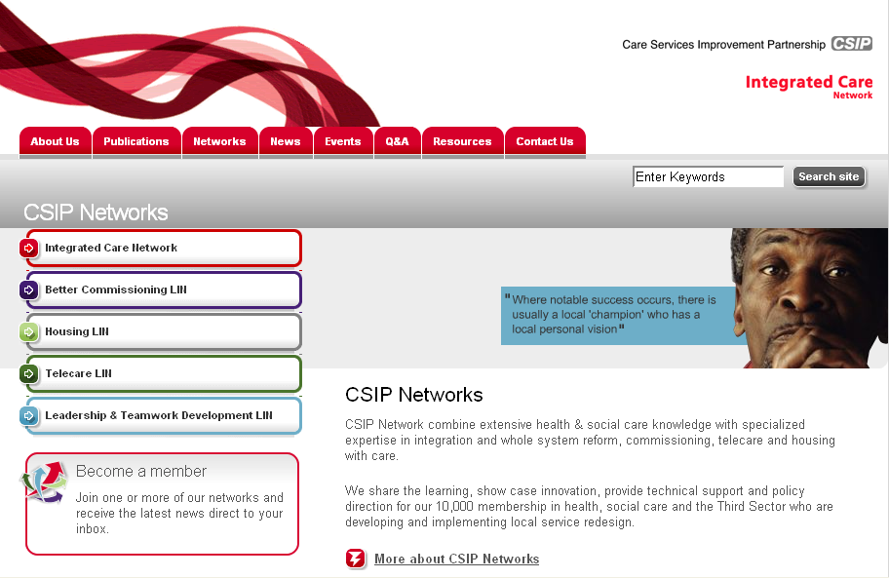

Here are some short cuts to get you to the new locations quickly:

www.icn.csip.org.uk/telecareguide
www.icn.csip.org.uk/telecarenewsletters
www.icn.csip.org.uk/telecarefactsheets
www.icn.csip.org.uk/telecareprofiles

Contents
1 Commissioning mainstreamed and sustainable services that include telecare and telehealth 3
2 Updating telecare profiles 7
3 ‘200 telecare outcomes’ from the PT Grant period 10
4 Whole System Demonstration sites - update 11
5 TSA Conference 2007 11
6 Delivering a Code ‘fit for the future’ of telecare in the 21st Century 12
7 Ensuring telecare equipment and services are ‘fit for purpose’ 14
8 Telehealth site update 15
9 Award winning telecare project – NHS PASA and the national framework agreement 16
10 NHS PASA NFA supplier updates from April 2007 review 17
11 Other news items 27
12Telecare progress 29
13 Telecare events 32
Appendix – social care authority telecare links 34

Item 1 looks at current progress in commissioning telecare services

Item2 covers the updating arrangements for telecare profiles including features from Lincolnshire and Leeds

Item 3 covers the upcoming arrangements for identifying 200 outcomes from telecare in England based on the two year PT Grant period

Item 4 provides a brief update on the Whole System Demonstrators.

Items 5 and 6 cover the TSA conference and review of the codes.

Item 7 provides a reminder of the importance on ensuring that local authorities and their partners are clear about the responsibilities when providing telecare.

Item 8 lists know sites for telehealth.

Item 9 recognises NHS PASA for their recent CIPS award for the telecare framework.

Item 10 updates the NHS PASA supplier information based on the April 2007 review.

Items 11 and 12 list other news items and telecare progress in some further areas.

Item 13 lists upcoming telecare events

The Appendix lists the current known telecare web sites for social care authorities.

The October 2007 newsletter will include:

Further information about proposed CSIP events for early 2008

Index of Telecare services in England

Charging survey

1 Commissioning mainstreamed and sustainable services that include telecare and telehealth

Update from Mike Clark, CSIP Networks

- Commissioning services from 2008

As we approach Q3 and Q4 of 2007/8, local authorities and their partners need to consider how telecare and telehealth are embedded as part of integrated health housing and social care services from 2008 onwards. Local authorities should have a clear idea for their areas on what works and what does not work and the best use of assistive technology for older people and in many areas for a wider range of users. This means a careful review of the care pathways where local evidence indicates that telecare can make a difference.
Where social care authorities decide not to directly commission telecare services from 2008, they will need to remember that users could request a direct payment or potentially an individualised budget that could include telecare and other AT solutions as part of a care plan. Appropriate support should be considered so that users, carers and other stakeholders can obtain independent advice under these circumstances.

Future services will predominantly see service users making decisions with appropriate independent support either using their own money or money provided through local authority services. Users, carers and their representatives need to be able to obtain telecare and other assistive technology from a range of service providers.

b) Getting the details right

Each month CSIP Networks deals with queries from across the country.

A great deal of progress has been made but there are still some basic areas where local authorities and their partners are having difficulties. Here are some of the common queries into the telecare mailbox.

Problem | Possible reason | Way forwards
Telecare not included in local area agreements and commissioning statements | Incomplete local review of where telecare could have the most impact | Review local and national information from the evidence available and agree business case. Include references in key policy and performance documents
Staff are trained but referrals are low | Practitioners are not engaged, care pathways have not been adjusted to include telecare options | Systematically review all care pathways and identify where telecare/AT has the most impact and is cost-effective
Too much paperwork (also often resulting in low referrals) | Duplicate paperwork leads to delays and D54 failures. Telecare assessments could be confused with ‘user assessments of needs’. | Care should be taken to avoid ‘assessing for a service’ rather than assessing user needs. Minimise paperwork. Ensure telecare protocols are fully integrated and duplication avoided
Records not synchronised (could lead to an inappropriate response in an emergency) | Duplicate systems, incomplete information sharing with service providers | Agree or review data sharing protocols. Ensure relevant care plans are shared and updated (subject to consents, need to know etc)
Unclear about charging (could lead to challenges by users) | Lack of comprehensive review of charging for telecare and telehealth services – Fairer Charging, Supporting People and other policies | Review all scenarios for telecare and telehealth provision. Consult as required by local policies. Put systems in place
Unsure about what is counted as telecare | For the CSCI count, pendant alarms are included and standalone items as well as upgrades are not included. The aim is for 160000 new users with telecare and not 160,000 existing users with upgrades.  (Note: PT Grant is not ringfenced– there is flexibility in use but the CSCI counting is specific) | Check the CSCI definitions in the Performance Assessment Handbook (see April and August 2007 newsletters for links)  Contact telecare@csip.org.uk for a response on your specific query

A fuller list of some of the challenges for telecare is available in the July 2007 newsletter.

*** CSIP Telecare eNewsletter - July 2007 (pdf - 183Kb)
http://icn.csip.org.uk/nl/?ln=69_1_1

*** CSIP Telecare eNewsletter July 2007 (doc - 1.01Mb)
http://icn.csip.org.uk/nl/?ln=69_1_2

c) Benchmarking your services

An additional spreadsheet is now available that includes the CSCI 2007 figures together with grant allocations, region and population figures from the 2001 Census.

Web link:
http://www.icn.csip.org.uk/telecare/index.cfm?pid=541&catalogueContentID=2339

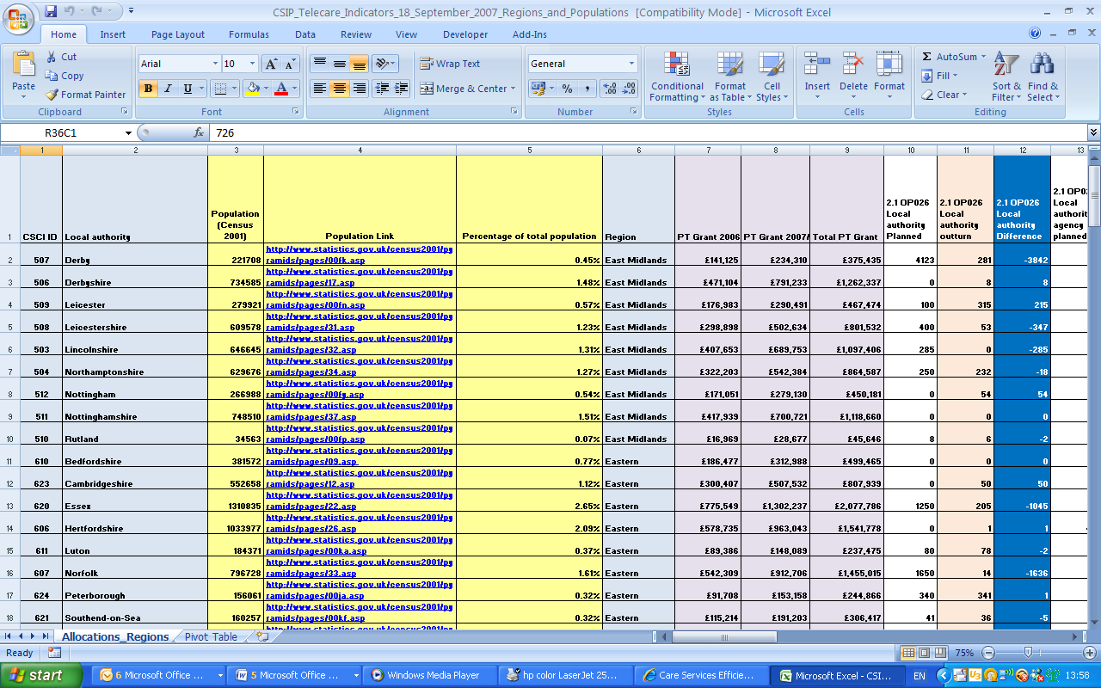

Simple calculations using Excel formulae are included together with an Excel pivot table for summarising the data.

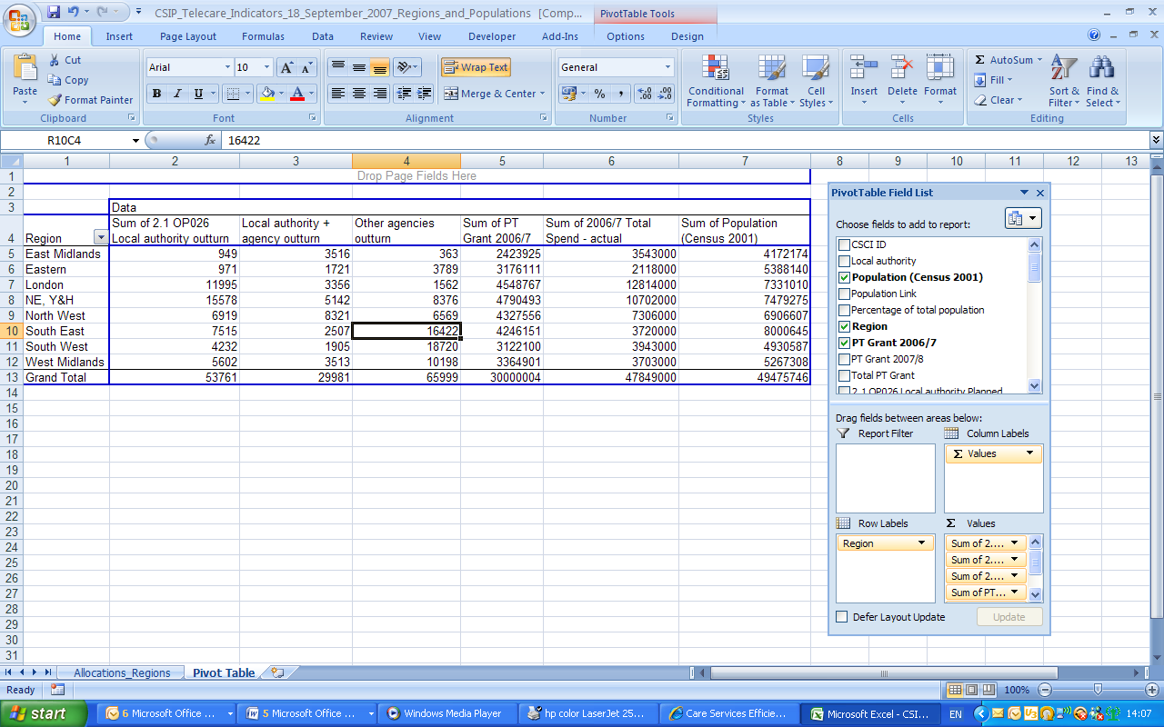

(Note screens will vary in different versions of Excel – version shown is Excel 2007)

Region | Sum of 2.1 OP026 Local authority outturn | Sum of 2.1 OP027 Local authority + agency outturn | Sum of 2.1 OP028 Other agencies outturn | Sum of PT Grant 2006/7 £ | Sum of 2006/7 Total Spend – actual £
East Midlands | 949 | 3516 | 363 | 2423925 | 3543000
Eastern | 971 | 1721 | 3789 | 3176111 | 2118000
London | 11995 | 3356 | 1562 | 4548767 | 12814000
NE, Y&H | 15578 | 5142 | 8376 | 4790493 | 10702000
North West | 6919 | 8321 | 6569 | 4327556 | 7306000
South East | 7515 | 2507 | 16422 | 4246151 | 3720000
South West | 4232 | 1905 | 18720 | 3122100 | 3943000
West Midlands | 5602 | 3513 | 10198 | 3364901 | 3703000
Grand Total | 53761 | 29981 | 65999 | £30,000,004 | £47,849,000

For more information about using CSCI figures contact Mike Clark at telecare@csip.org.uk

d) Locating your local telecare service

As we move into Autumn 2007, CSIP will be indexing all of the telecare services in England. We are starting with the social care authorities and then linking in other local authorities, housing associations and trusts, third sector providers, telecare flats and demonstration sites.

The index of sites, local service standards and contact details will be an important public reference point for users, carers and other stakeholders accessing telecare information. We will be identifying some of the most best sites in the ‘200 outcomes’ initiative, so take the opportunity to ensure that your local authority is providing information that is up-to-date and will meet the needs of users, carers and stakeholders.

We are starting with the social care authorities as they will have received Preventative Technology Grant.

The Appendix to this newsletter includes a list with available links as at September 2007.

If you have a link for inclusion, please let Mike Clark know at telecare@csip.org.uk

e) Finding CSIP information

From November 2007, CSIP will be re-indexing and refreshing some of the older telecare content. In addition, some newsletter items will be moved into factsheets.

These will run alongside the 150 telecare profiles which are also currently being updated.

Additional indexing will include A-Z facilities and map diagrams which show the main topics and sub-topics.

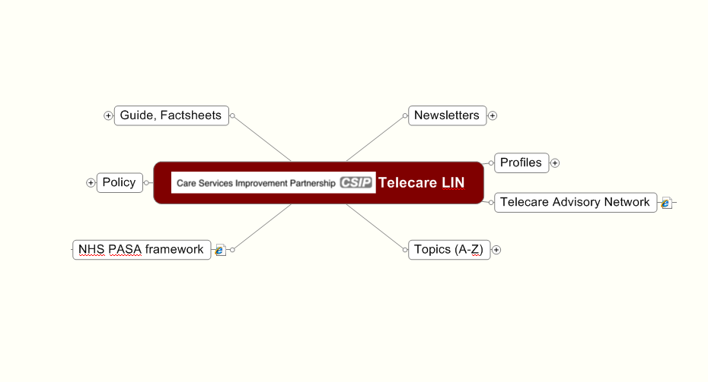

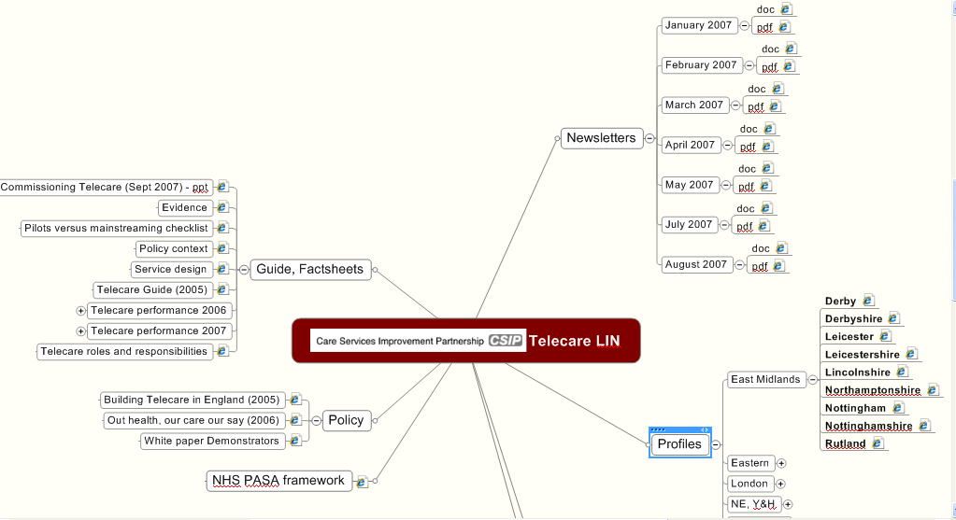

Example of topics expanded with clickable links

Previews will be available from early November 2007 – contact Mike Clark at telecare@csip.org.uk for more information.

2 Updating telecare profiles

CSIP is now updating all of the telecare profiles with CSCI information. Local authorities can include additional information in their profiles about their work and its impact on service users. This provides an opportunity for local authorities and their partners to refer to services that are not strictly covered by the CSCI count where progress is being made eg use of telecare for people with learning disabilities or care plans for people with dementia which include telecare and non-telecare items as part of an assistive technology package.

This type of information will also progress into the ‘200 outcomes from telecare programme’ (see elsewhere in this newsletter).

Thanks to Lincolnshire and Leeds amongst others for providing these updates.

Progress in Lincolnshire

Prepared by Deborah Shepherd (Deborah.Shepherd@lincolnshire.gov.uk)

Lincolnshire officially launched its Telecare services in May 2007, deciding that the right approach was to firstly agree what was needed, what already worked well and how to work jointly to make Telecare a mainstream service. Lincolnshire, being a large rural county with a population of 696,300, seven district councils and a recently formed PCT, had challenges to overcome to develop any new service.

The approach from the start has been to not just talk partnerships but to learn to trust the various organisations and people who represent them. This approach has worked well, and means that it is not just the select few who talk Telecare. Over 200 staff from health and Adult Social Care have been trained, with many more wanting places on the next courses.

There are four monitoring centres based within the county area, plus a number of housing providers who access other centres. Lincolnshire has an agreed installation charge with monitoring centres that covers us for any checks, adjustments and battery changes for 3 years. We have arranged training for all the monitoring centre installers - which we run on a regular basis as we find new equipment or installation problems to overcome. The monitoring centres have agreed a standard pricing structure and postcode coverage to ensure no one is “left out”.

All monitoring centres have been provided with a range of equipment to enable them to fit most things immediately. For complex installations we pay the contractors fee directly eg for electricians. We are linking into our home improvement agency to access contractors if the monitoring centre does not have their own in-house service.

For complex cases we work with our NHS Electronic Assistive Technology Service (EATS) who undertake joint visits with the referrer. Mostly the visit will result in the equipment been installed at the end of the visit - this also helps with training for staff).

We are now averaging around 4-6 referrals a day from an increasing number of sources within Adult Social Care and Health. This is in addition to referrals into local services directly for pendant alarms.

Since April 2007, we have 245 authorised referrals which are completed. Most installations are done within three days, although more complex arrangements which need help from the Electronic Assistive Technology Service, take longer. The majority of referrals result in an installation and a new service user benefiting from Telecare.

Over 110 of the people we have helped need Telecare as part of a falls reduction programme. Sixty-four referrals have been from intermediate care or hospital discharge services. Telecare in Lincolnshire is not restricted to just older people - we felt it was important to use it for people with a variety of disabilities - so we try to say yes!

Our aim has always been to take referrals directly from the public, or from people who know the individual, housing officers or third sector organisations. Awareness training and a variety of events to increase knowledge of Telecare has identified this as something that would be welcomed by individuals and advocates. Therefore, approval has been given to develop a self assessment tool with ADL Smartcare, which we hope to have available shortly.

Telecare is working with the primary care trust and actively involved in a Telehealth project in conjunction with the NHS Institute for Innovation and Improvement. Protocols have been agreed together with a project plan, and work is progressing to deploy the equipment, it is hoped to have twenty people on the programme by the end of November 2007.

Whilst we started Telecare with a very low base, limited knowledge, and different opinions on what was actually needed or already available, we have found the PTG has given us a great opportunity to develop strong partnerships. There is a friendly and very positive working relationship between the various agencies that is leading onto other new ideas.
We are looking forward to seeing our Telecare services and other initiatives go from strength to strength in the future, and look forward to working with partners and service users to make this a reality.

Summary of the Telecare Position statement in Leeds

Prepared by Jeanette Dowden (jeanette.dowden@leeds.gov.uk)

A Telecare Referral Service and installation of telecare equipment has been fully operational in Leeds since October 2006.

A full “in house” Leeds Telecare information pack is available online or hard copies provided to a wide range of colleagues, outlining:

- What Telecare is
- How much it costs service users
- The forms to complete for trained referrers to complete, to get a Telecare installation.

Over 400 Social Services/Health colleagues have been trained in Telecare Awareness. These include Occupational Therapists, Social Workers and a range of professionals from a number of partner organisations.

The Telecare Project Leader and two Technical Advisors are employed by Leeds City Council Social Care Department where the DH Preventative Technology Grant of £1.1 million is held.

Telecare equipment includes: fall detectors, smoke detectors, gas detectors, pill dispensers, movement sensors, bed occupancy sensors and anything tailored to an individual service user’s requirements to reassure the service user and/or carer they will remain safe.

Telecare equipment is linked electronically to Leeds City Council’s own response team, Care Ring, managed by the Neighbourhoods and Environment Department, with whom the Project Leader works in partnership, to deliver the Telecare Service.

Any alerts are automatically relayed to a named carer or the Response Team.

Telecare Leeds buys Telecare equipment from a number of PASA approved service providers and Telecare equipment is “tailored” to the individual service user’s requirements.

A multi agency Team of Council, Health, Police and Fire Service professionals meet monthly at a Project Board to monitor and direct the project, which has a two year Project Plan. Telecare is formally Project Managed to ensure effectiveness and evaluation. Telecare has supported the Leeds POPPS Programme by installing Telecare equipment to Intermediate Care Beds in Older People’s homes.

- Since October 2006 to date (end June 2007) 650 individual homes have had telecare items fitted
- approx 950 telecare referrals have been received, including 580 smoke detectors linked to Care Ring alarms
- Many more awareness/training sessions planned over the coming months

Work continues to extend Telecare awareness and training to a growing number of specialist Telecare Referrers.

3 ‘200 telecare outcomes’ from the PT Grant period

From November 2007 to April 2008, CSIP will be looking for 200 telecare outcomes from across England. That is one outcome from each social care authority and another 50 from suppliers, telecare service providers and other organisations (eg NHS PASA, TSA and research organisations carrying out evaluations etc).

This will link with five possible events in London, Birmingham, Taunton, Leeds and Manchester to be held in January/February 2008.

The main aim of the 2008 events is for organisations to share the impact on stakeholders in their own areas and hear what others are doing from neighbouring areas.

The 200 outcomes events are not about hearing ‘we have had problems with getting medication dispensers filled’ but that we have….:

- Redesigned and restructured services to include telecare options
- Developed new ways of partnership and integrated working through telecare and telehealth
- adjusted care pathways to include cost-effective telecare solutions
- identified implementation barriers and set out to overcome them
- made progress with learning disability and other service users who are now benefiting from telecare solutions
- overcome low referral rates
- Balanced FACS-eligible, preventative, targeted and self care approaches
- Worked with suppliers to develop innovative solutions to local problems
- introduced self-assessment and supported self-care/direct payments
- identified sensor configurations that are effective for dementia assessment and support
- obtained an initial evaluation on vital signs monitoring
- reviewed AT arrangements for preventative services to include telecare
- extended housing schemes with telecare support
- identified and overcome barriers to user acceptance of technology
- examined impact on carers
- established locally whether telecare has an impact on care home and hospital admissions etc

Further information about the events and programme will be included in the November 2007 newsletter.

4 Whole System Demonstration sites - update

Contributed by the DH Programme Team

After the successful selection of the 3 Whole System Demonstration sites in May 2007; Newham, Kent and Cornwall, the DH programme team are working with the sites, their delivery partners, project management partners and our evaluation consortia to develop the detailed implementation plans.

Planning activity on each site is covering key delivery areas; governance arrangements and roles & responsibilities, identifying target population, baselining evaluation criteria, procurement of Assistive Technology, communications & engagement of stakeholders, assessment & care planning, developing integrated teams, developing pathways and Assistive Technology referral & response protocols, rolling out new pathways and aligned Assistive Technology deployment, Integrating NHS & LA data sets, and capturing learning from this programme.

Robust and rigorous programme management practices are being employed at each site and centrally, in order that documentation records all the planning and implementation steps of the programme and captures learning and best practice to inform wider roll out for the future.

Main DH press release:
http://www.gnn.gov.uk/environment/fullDetail.asp?ReleaseID=286491&NewsAreaID=2&NavigatedFromDepartment=False
DH Long term conditions web page updated:
http://www.dh.gov.uk/en/Policyandguidance/Healthandsocialcaretopics/Longtermconditions/DH_4140328
DH Chief Executives Bulletin (Item 15):
http://www.dh.gov.uk/en/Publicationsandstatistics/Bulletins/Chiefexecutivebulletin/DH_074928

5 TSA Conference 2007

Update provided by Paul Gee, TSA

National Telecare & Telehealth Conference
Cardiff. November 6th – 8th 2007

The final programme for this event is now available at www.telecare.org.uk/nationalconference Residential packages are now fully sold, but there is availability of Day Delegate Passes (for just one or all three days).

Attendance promises to easily surpass the 2006 level of almost 400 delegates. A comprehensive Telecare & Telehealth agenda of keynote speakers is set out in parallel to a broad interactive workshop menu.

CSIP’s Nigel Walker and Judith Whittam will be speaking at the TSA Conference along with Claire Whittington (White Paper Long Term Conditions Demonstrator Programme). Mike Clark will also be available to answer queries on telecare implementation in England.

6 Delivering a Code ‘fit for the future’ of telecare in the 21st Century

Contributed by Marian Preece (TSA) and Angela Single (CI)

The Telecare Services Association (TSA)

The Telecare Services Association (TSA) is the representative body for the telecare industry within the UK, its mission is to ‘realise the potential of telecare’.

In its role as the trade association for the social alarms and telecare industry, TSA makes a major contribution to quality in the sector. The Code of Practice is at the heart of what TSA is all about – providing a robust quality framework to give structure to service providers and reassurance to commissioners and service users alike.

Currently, there are over 70 TSA member organisations compliant in one or more parts of the Code of Practice and there is significant growth potential going forward. TSA has recently appointed Choose Independence Ltd as its partner to undertake a complete review and update of its Code of Practice.

The TSA’s Code of Practice is seen as a tool for continuous improvement by those who embrace it and therefore will continually develop and grow. This major review is the next step in its development.

Choose Independence (CI)
Choose Independence (CI) Ltd is an ethically impartial and independent consultancy dedicated to supporting and enhancing the quality of life of individuals through the use of Telecare so that they can live as independent a life as possible.
Established in 2005 by its two senior partners, Angela Single and Jan Allwood, Choose Independence is able to bring their experience and expertise in the field of Telecare, Telehealth, health, housing, technical and product expertise, managing Telecare/Telehealth monitoring centres etc.
The aims of the Code of Practice review are:
- update it to reflect the major change in government policy/ funding which has brought Telecare provision into mainstream care and support services
- update it to reflect government policy in other key areas
- benchmark the TSA code against other leading industry codes of practice
- reflect the changes in assessment i.e. SAP and the essential importance of the need for assessment/ profiling of an individual’s needs and how Telecare can support those needs
- reflect the rapid changes in the use of, and range of, technology which can be used to support individuals in the community
- ensure the Code is presented in a user friendly format and one that is easy to navigate around
- develop a format that is easily updated in the future

A key element of the review work for CI is engaging with the wide range of stakeholders, including service providers, equipment suppliers, service users, commissioners, and Government Departments that have a direct interest in the structure and content of the Code. This is being achieved through:

- one to one meetings with some of the key stakeholders, including users and carers groups
- focus groups during September 2007
- a web-based questionnaire for members: http://www.zoomerang.com/survey.zgi?p=WEB226SUB82PKP
- TSA / CI hosted workshops for TSA members.

While there are a range of views on the future form and direction of the Code, it is clear from the key stakeholders that all see the need for the review, and have been keen to engage.

If you would like to give your views on what should be included in the code make sure you complete the web based questionnaire – it will only take a few minutes and will help to ensure the widest possible consultation and involvement.

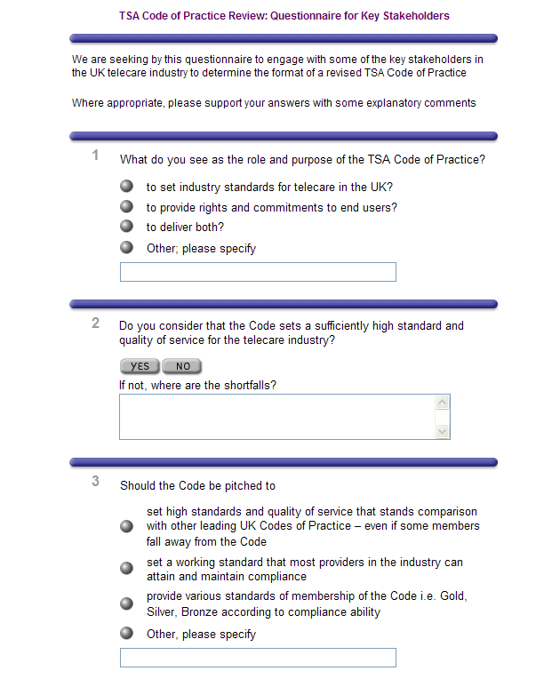

http://www.zoomerang.com/survey.zgi?p=WEB226SUB82PKP

The new Code is expected to be launched in the spring of 2008.

If you would like to have any more information on the Code work please contact Angela Single from CI - angela.single@ci-ltd.co.uk or Paul Gee from TSA - paul.gee@telecare.org.uk

7 Ensuring telecare equipment and services are ‘fit for purpose’

With a greater range of telecare and telehealth equipment now being purchased it is important to ensure that equipment and services are fit for purpose and continue to meet users’ needs.

This means having good systems in place for the specification, installation, tracking, testing, maintenance, upgrading, replacement and disposal of equipment. Particular care should be taken in ensuring that information is provided for users and carers who are self-purchasing and using direct payments where they will own the equipment.

Equipment and service configurations should be tested for the care pathways (eg falls, COPD, dementia support) and trialled with individual users as appropriate.
The NHS PASA framework provides high-level evaluation of the equipment but local authorities, housing associations, health trusts and third sector providers need to ensure that appropriate tests and checks are carried out using their own systems and service configurations. This is especially important with new sensor configurations and vital signs monitoring where service providers are still building their expertise.

Elsewhere in this newsletter you will see an article on the review of the TSA Code of Practice. Local authorities and their partners also need to be aware of the consumer safety legislation, MHRA medical device directive and alerts, 21CN and Continua Alliance.

For instance, glucose and blood pressure monitors could be subject to an MHRA alert which would mean recalling items with specific product codes – do you have the systems in place for track and trace? The roll out of new telephone networks (21CN) over the next five years will mean that you need to check your existing configurations to ensure that control centres receive the appropriate alerts – do you have a plan for checking your systems? Do you have the expertise for checking and recycling equipment as well as arranging safe disposal?

Service providers have an important responsibility to ensure that they build in quality assurance arrangements to meet the needs and requirements of commissioners and self-purchasers.

Web links:
NHS PASA: http://www.pasa.nhs.uk/PASAWeb/Productsandservices/Telecare/
MHRA: http://www.mhra.gov.uk
TSA: http://tsa.live.poptech.coop/information/42304/46704/bt21cn/
21CN: http://www.switchedonuk.org
BT Supplier Information Notes (SINs):http://www.sinet.bt.com
UK Transmission Plan http://www.nicc.org.uk
http://21cntestingdb.bt.com/ - an account needs to be set up for access
Continua Health Alliance: http://www.continuaalliance.org

8 Telehealth site update

Summary list of organisations in England implementing or piloting Telehealth
Note: CSIP does not endorse any particular suppliers of equipment or services. Supplier links are provided to give a fuller picture of telehealth projects. If you are aware of any other projects, evaluations errors or omissions in England, please contact Mike Clark via telecare@csip.org.uk
Barnsley:
http://www.telecare-events.co.uk/speakers.htm#brownsell and http://www.telecare-events.co.uk/pres/brownsell.pdf and http://www.barnsleyrd.nhs.uk/assistive.asp#313 http://www.docobo.co.uk/pressoffice_recent.php?ItemID=23
Birmingham:
OwnHealth with Pfizer - http://www.ehiprimarycare.com/news/item.cfm?ID=1811&displayMode=print
Cornwall - demonstrator site:
http://www.gnn.gov.uk/environment/fullDetail.asp?ReleaseID=286491&NewsAreaID=2&NavigatedFromDepartment=False
Guildford: http://www.networks.nhs.uk/uploaddb/commissioning/343_guildford_and_waverley_chronic_obstructive_pulmonary_disease.doc
Carlisle: http://www.tunstall.co.uk/splash/downloads/6_2_50Evaluation_Research_Doc_Telemedicine_CarlisleHA.PDF
Cheshire/Weaver Vale/West Cheshire PCT:
http://www.ehiprimarycare.com/news/item.cfm?ID=2152
East Riding: Under consideration
Greenwich: No links yet available
Great Yarmouth
http://www.gywpct.nhs.uk/Docs/News/11_04_2007_Telecare/Document/Telecare.pdf
Kent – demonstrator site: http://www.gnn.gov.uk/environment/fullDetail.asp?ReleaseID=286491&NewsAreaID=2&NavigatedFromDepartment=False
http://www.kent.gov.uk/SocialCare/health-and-wellbeing/telehealth/ and http://www.kent.gov.uk/SocialCare/health-and-wellbeing/telecare/default.htm
Leeds:
http://www.tunstall.co.uk/assets/literature/Leeds%20case%20study.pdf
Medway:
http://www.publictechnology.net/modules.php?op=modload&name=News&file=article&sid=4667
Lincolnshire: No links available
Milton Keynes:
http://www.tunstall.co.uk/news.aspx?PageID=14&NewsID=78
http://www.ukprwire.com/Detailed/Technology/Milton_Keynes_Launches_Advanced_Telehealth_Service_to_Improve_Care_for_People_with_COPD_7466.shtml
Newham – demonstrator site:
http://www.gnn.gov.uk/environment/fullDetail.asp?ReleaseID=286491&NewsAreaID=2&NavigatedFromDepartment=False
http://www.bjhc.co.uk/issues/v23-8/v23-8procter&single.htm
http://www.hoise.com/vmw/05/articles/vmw/LV-VM-09-05-6.html
http://www.newham.gov.uk/News/2007/May/MillionstohelpNewhamsvulnerable.htm
Nottingham:
http://www.nottinghamcity-pct.nhs.uk/EasySite/lib/serveDocument.asp?doc=14585&pgid=8679
http://www.tunstall.co.uk/news.aspx?PageID=14&NewsID=62
Norfolk:
http://www.gywpct.nhs.uk/Docs/News/11_04_2007_Telecare/Document/Telecare.pdf
http://www.norfolk.gov.uk/consumption/idcplg?IdcService=SS_GET_PAGE&ssDocName=NCC051194&ssSourceNodeId=&ssTargetNodeId=3572
Newcastle:
http://www.tunstall.co.uk/splash/downloads/6_2_22COPD_Newcastle_PCT.pdfMedway: http://www.tunstall.co.uk/detail.asp?ID=306 and http://www.tunstall.co.uk/splash/downloads/6_2_56Evaluation_research_telemedicine_Medway.pdf
Rotherham:
http://www.rotherhampct.nhs.uk/corporate/BoardPapers/200704/N1%20-%20Assistive%20Technology%20Strategic%20Capital%20Grant%20Cover%20Doc.doc
Sheffield:
http://www.sheffield.nhs.uk/ship/8-9-0906-5.php
Surrey:
http://www.docobo.co.uk/news_docobo.php?ItemID=1
Swindon:
http://www.swindonpct.nhs.uk/our_services/Telehealth.htm

9 Award winning telecare project – NHS PASA and the national framework agreement

Provided by Alison Long, NHS PASA (Alison.Long@pasa.nhs.uk)

Congratulations are in order for the NHS PASA telecare team winning the best public procurement project category at the CIPS Supply Management award ceremony on 20 September 2007.

Web link:
http://www.cipssmawards.com/winners07.asp

The project was the result of the Department of Health (DH) asking the agency to devise a national sourcing solution for telecare to support the delivery of government policy in health and social care - NHS PASA national framework agreement for telecare. DH is investing £80 million to develop the telecare infrastructure in England to enable individuals to live independently for longer.



NHS PASA Telecare Team with the CIPS Award

The members of the telecare project team who received the award were:

John Cooper COO
Marcus Brindle Director of agency and services
Neil Griffiths Strategic Commercial Advisor/Lead Category Manager
Paddy Howlin Telecare Category Manager (Telecare Project Lead)
Rachel White Sourcing specialist
Sui Yau Sourcing specialist
Catherine Askham Telecare team administrator
Claire Whittington Head of long term conditions, Directorate of Commissioning & System Management, Department of Health
Tim Ellis Whole system project manager, Directorate of Commissioning & System Management, Department of Health
Chris Kynaston Collaborative procurement manager, OGC

(Photograph provided by NHS PASA/CIPS)

The telecare project would not have been possible without the involvement of key stakeholders on the project management group, set up by NHS PASA, comprising representatives from Office of Government Commerce (OGC), Regional Centre of Excellence (South East), NHS Connecting for Health and the Care Services Improvement Partnership (CSIP).

The telecare team had competition from five short-listed organisations - 4 South Yorkshire Consortium, Department for Work and Pensions (two submissions), British Nuclear Group Sellafield and Merseyside Collaborative Group.

Special mention goes to Andy Gudgeon - NHS PASA category specialist - for his contribution to the success of the project. Andy was unable to attend the awards ceremony.

In July 2007, recorded sales through the NHS PASA agreement had reached £18 million (exceeding the estimated sales target of £9 million per annum).

Web link:
http://www.pasa.nhs.uk/PASAWeb/Productsandservices/Telecare/Telecarenews/Awardwinningtelecareproject.htm

10 NHS PASA NFA supplier updates from April 2007 review

In Autumn 2006, NHS PASA ran events in London and Leeds to introduce the national framework agreement for telecare. Information was provided about the framework suppliers in the CSIP newsletter. Following the April 2007 review, suppliers have again provided some update information.

Web links:
http://www.pasa.nhs.uk/PASAWeb/Productsandservices/Telecare/NFA.htm
Supplier Details: http://www.pasa.nhs.uk/pasa/Doc.aspx?Path=[MN][SP]/Products and Services/Telecare/Telecare_information_pack.pdf
LAC (2006)5 Preventative technology grant 2006-07 to 2007-08 - References to NHS PASA framework:
http://www.dh.gov.uk/en/Publicationsandstatistics/Lettersandcirculars/LocalAuthorityCirculars/AllLocalAuthority/DH_4131935

Note: CSIP does not endorse any particular suppliers of equipment or services. Purchasing and procurement arrangements are made by local authorities and their partners using the national framework as appropriate for their local areas.

Docobo News

doc@HOME Service Overview
doc@HOME is an integrated telehealth solution for the remote management of patients with a range of Long Term Conditions (also known as Chronic Diseases). It is the means for the collection and analysis of essential patient related data, permitting effective management through efficient interaction between clinicians and patients at home.

The doc@HOME service is designed to provide a systematic approach to the management of chronic disease in the home and other locations remote from the clinician’s office. Patient/Clinician interaction is typically via the Docobo HealthHUB, a fit for purpose, robust, handheld data collection unit which connects through a standard telephone line at the patients home to secure server. Healthcare Professional interaction with the doc@HOME service is via secure Web access using standard browsers, enabling patient management at a range of locations.
Changes in patient trends can be identified and notified to the authorised user. An authorised clinician can access the patient record on demand and send messages directly to the patient, for example, a request to visit the surgery or to change the frequency and/ or volume of medication.

doc@HOME is now in daily use… with NHS trusts across England - typically used by well managed teams with active involvement of senior management. In most cases the teams are not testing the technology, but rather learning about the process changes needed, and implementing service redesign in order to enable home management of patients with long term conditions. Nurses both in the acute sector and within the community are the main users and are embracing the new methods with enthusiasm.

New functionality includes…

1. Mobile phone Interface
The Docobo MobileHUB technology provides the means of using modern mobile phones as the data collection and feedback device used by the patient. Ideal for the patient who perhaps is younger or whose symptoms do not require the comprehensive monitoring provided by the Docobo HealthHUB versions, such as Asthma management programmes, type 2 diabetics, etc.
2. Multi patient operation… on a single HealthHUB allows use in care homes and with families where more than one family member needs monitoring. This functionality provides a very cost effective way of managing the collection of data in a range of care homes, with different questions set for each patient. Care Assistants can easily collect data from various patients, and removes the need for healthcare professionals to visit care homes for simple data collection.

NHS CfH Statement of Compliance has been granted to Docobo – enabling Docobo to connect directly to the NHSNet via the N3 connectivity. This enables NHS organisations the ability to keep their telehealth information within the NHSNet network, and supports Docobo’s mission to ensure patient data is delivered to the systems where clinicians want it.

UK wide WSD equivalent… Many of Docobo’s customers have expressed an interest to be involved in a UK wide evaluation of telehealth and it’s effect on patient care and health resources. With potential numbers using doc@HOME forecasted to be 500+ by the end of the year, a significant amount of data is being collected that will provide crucial evidence regarding benefit and usage of telehealth across the UK. A user group meeting is planned to develop this concept, and potential evaluation partners are sought. Many of these customers originally put in proposals for involvement in the WSD, and do not want their efforts in preparing those bids wasted.

Appreciated by patients…contrary to popular preconceptions, a large percentage of patients of all ages readily adopt and accept the addition of doc@HOME monitoring to the care they are receiving. Patients particularly respond to a 4 week record of their key vital signs fed back to them via the HealthHUB display, and actively monitor their medication compliance as a rolling % figure.

Successful application of PTG funding across the UK …is leading to the rollout of doc@HOME in a range of care settings. Sharing of data...between teams has become common place as acute and community based nurses, GP's and Consultants can all view patient progress via the secure web interface.

Two-way seamless link to community alarms…is now available as doc@HOME is able to receive key event information from community alarms centres for display to the healthcare team (i.e Mrs Brown fell last night”), and also raise standard “alarms” into existing community alarm systems. doc@HOME can gather both health and quality of life related data (e.g. “are you able to get dressed?”), so the opportunities for care staff to manage and respond to the whole picture become apparent.

Supplier Details: http://www.pasa.nhs.uk/pasa/Doc.aspx?Path=[MN][SP]/Products and Services/Telecare/Telecare_information_pack.pdf

Initial Attendo

We announced in July that UTC Fire & Security (UTCFS) acquired Initial Attendo, part of the Initial Electronic Security Group (IESG).

We are now pleased to announce that we are in the process of rebranding the business from "Initial Attendo" to "Chubb Community Care".
Chubb Community Care is part of Chubb, a UTC Fire and Security Company.

Chubb Community Care is one of the UK’s leading suppliers of telecare and telehealth solutions that support older and vulnerable people.

UTCFS is a $4.7 billion company with approximately 43,000 employees in more than 30 countries. Its global brands include Chubb, Kidde, Lenel, and Onity. The company’s parent, United Technologies Corp., is a top-performing, global, Fortune 50 company with an outstanding reputation and the resources to facilitate innovation and growth.

Together with our new parent, we look forward to strengthening our relationships with our customers and offering products and services to better meet customer needs.

Should you have any questions about this change in the ownership of IESG and what it means for you and your company, please do not hesitate to call me at 01254 688774.

Paul Shead
National Sales and Product Manager
Chubb Community Care
A UTC Fire and Security Company
Tel: 01254 688774 Fax: 01254 686460
pshead@iess.co.uk www.chubbcommunitycare.co.uk

Supplier Details: http://www.pasa.nhs.uk/pasa/Doc.aspx?Path=[MN][SP]/Products and Services/Telecare/Telecare_information_pack.pdf

Invicta

Since its introduction Invicta Telecare has offered monitoring services through the NHS PASA Strategic Framework for Telecare. Following the Review Gate we are now able to offer a complete Telecare solution. Working with partners at Initial, Cirrus Communications, Eclipse Nursecall Systems, Quietcare and Testway Housing we can provide an end to end service, including assessment, equipment supply, installation, and monitoring to all of the UK and mobile response services to a number of areas.

One of our most exciting developments over the last twelve months is our First on Sight mobile Response service in partnership with Testway Housing to complement our existing service in West Kent. With a successful blueprint now established we are looking forward to developing similar services throughout the UK.

As an independent monitoring centre we aim to give our customers the choice of equipment they procure for their clients. Our partnerships mean we can now provide a range of equipment at extremely competitive rates.

Cirrus Communications’ Smartcall unit is the first battery powered social alarm unit, offering complete flexibility to the user and immediately removing the expense of installing or repositioning power sockets to accommodate the base station. A range of Telecare sensors allow the unit to provide proactive monitoring.

Eclipse Nursecall’s Nursecom 55+ unit and assistive technology solutions include their innovative speech neck pendant allowing the user to communicate with the monitoring centre no matter where they are in their home. A configurable range of voice prompts make the unit ideal for users requiring a little more proactive support.

QuietCare’s monitoring system enables older people maintain safe, independent living 24 hours a day and can identify emerging health problems. By raising an alert to potential emergencies it enables people to age with privacy and dignity in their own home. Using a web based application designated carers can check on the wellbeing of their loved ones at any time of the day or night. An “at a glance” indicator system can alert them to any emerging health problems whilst an emergency can still be monitored by a monitoring centre if required. Far from replacing human contact, Quietcare is designed to make the contact more meaningful and provide peace of mind.

Our relationship with the partners above, together with our own team of trained installers and that of Initial Electronic Security Systems means, whatever equipment you chose, we can provide an installation service for you.

For more information about our products and services please contact …

Supplier Details: http://www.pasa.nhs.uk/pasa/Doc.aspx?Path=[MN][SP]/Products and Services/Telecare/Telecare_information_pack.pdf

The Just Checking System

Just Checking is a powerful assessment tool in the planning of care for people with dementia, living independently. Small movement sensors around a person’s home provide a 24 hour chart of activity, which is viewed via a password controlled website. The chart shows, for example, when a person gets up or goes to bed, what type of night they have, whether they visit the kitchen at mealtimes, and when they leave the house and for how long. The information provides a clearer assessment of the capabilities of the person, and helps with planning the level and timing of any care.

A self-contained kit, Just Checking is installed by OTs, CPNs and social workers themselves. The data can be viewed anywhere there is internet access; two or more members of a team can log on at the same time and discuss the case.

One in five of all councils with social services responsibilities are using the Just Checking system for assessment and care planning. The system is being used by:
- Social care teams
- Community mental health teams
- Hospital discharge teams
- Intermediate care teams
- Occupational therapists working in mental health

An example is Staffordshire County Council, which has equipped each of its reablement teams with the Just Checking system. When a person with dementia is first referred, often following hospital discharge, the system is installed in the person’s home. It helps the team to see what the person is doing for themselves in the familiarity of their own home, and to plan relevant support. It allows staff to view the effect of gradually reducing services as the person is ‘reabled’.

Community mental health teams are reporting that the system often shows that a person is managing better than expected and concerns about night-time activity have been allayed. Family carers are given a password so that they too can log on. If they wish to keep the system in place beyond the assessment period, they can rent or buy the system direct from the Just Checking. Some local authorities are providing family carers with the system as a means of supporting carers in their caring role.

www.justchecking.co.uk
Contact Celia Price 01564 741822

Supplier Details: http://www.pasa.nhs.uk/pasa/Doc.aspx?Path=[MN][SP]/Products and Services/Telecare/Telecare_information_pack.pdf

RSL STEEPER-Assistive Technology Division

RSL Steeper is the largest UK supplier of Prosthetics and Orthotics, providing both manufacturing and clinical services to the NHS, Originally founded in 1921.

Our Assistive Technology Division covers all aspects of Telecare and Telehealth in addition to our already established Environmental Control Systems which can help manage risks within the home, enabling people with limited and impaired mobility to perform a wide range of every day activities including door opening, locking systems, intercom, phone, DVD, television, radio, curtains, lights, CCTV, allowing greater levels of independence which in turn will reduce the reliance on carers and improve quality of life for the severely disabled and vulnerable.

Our focus is on clinical services and quality customer care. We have joined with key Telehealth and Telecare providers, and with this latest technology at our finger tips, we can offer an array of solutions which meet the needs of the individual. We are strongly supported by a skilled team of engineers and offer true choice of equipment and functionality designed to meet the shifting trend towards prevention and early intervention. By implementing this type of technology, promoting choice and independence, a reality is made of the white paper.

During the NFA Review Gate procedure in the early part of 2007, we were able to significantly reduce our prices, offering even greater value for money for the NHS and other clients.

As well as this, we have also added to our product range. In particular there are a number of innovative new additions to our Telehealth range. These products offer even greater levels of choice and flexibility to meet all remote health monitoring needs, at a cost which sits easily within most budgets.

We continue also to develop our Telecare range of solutions. In particular, this year has seen the launch of the Sayphone 21. This product provides a whole host of additional features, whilst retaining the cost of a “standard” dispersed alarm unit.

Supplier Details: http://www.pasa.nhs.uk/pasa/Doc.aspx?Path=[MN][SP]/Products and Services/Telecare/Telecare_information_pack.pdf

TBS GB Telematic and Biomedical Services Ltd

TBS GB Telematic and Biomedical Services is part of ITAL TBS, the European Leader in Medical IT & Telemedicine Services, Clinical Engineering and Endoscopy, providing to both public and private hospitals in the UK. Employing over 1000 personnel and operating in 8 European countries, The ITAL TBS group is already serving 30,000 users with telecare and telemedicine services.

TBS GB is focusing its NFA for Telecare provider status on the provision of long-term medical conditions such as Congestive Heart Failure (CHF), Chronic Obstructive Pulmonary Disease (COPD), Diabetes, Asthma and others, through an in-house developed innovative disease management programme. The service comprises of state-of-the-art telehealth equipment, call centre and medical intervention by our partners ChilversMcCrea, a leader in primary care provision. It promotes support to local Authorities, Residential Care facilities and hospitals with a view to enable both patients suffering from these diseases as well as older people to live safely and in improved health and environmental conditions. TBS GB’s Telehealth programme will improve quality and contain costs, by offering enhanced care delivery to people within their home.

Within the reviewed National Framework Agreement we are offering advanced telemedicine products for patient monitoring. We offer stand-alone systems for measuring ECG, weight, blood pressure, spirometry, pulse oximetry, blood glucose and blood coagulation (INR). Additionally, we are providing innovative Bluetooth equipment for self-monitoring and the award-winning “Butler” system as an emergency call unit and senior citizen mobile phone.

All devices are bundled with software packages, which allow healthcare operators to analyse the data and set up complete patient records necessary to manage chronic diseases. The patients’ data are accessible to clinicians through a standard web browser. Health professionals can view the results of the measurements, monitor developing trends, receive alerts to their mailbox or mobile phone and intervene when necessary.

Supplier Details: http://www.pasa.nhs.uk/pasa/Doc.aspx?Path=[MN][SP]/Products and Services/Telecare/Telecare_information_pack.pdf

Philips Medical Systems

Philips Motiva is an interactive healthcare platform that connects patients with chronic conditions, e.g. heart failure, diabetes, and COPD, to their healthcare providers – via the home television and a broadband internet connection.

Motiva automates disease management activities, and engages patients with personalized daily interactions and education delivered through the home television. The system enables healthcare providers to motivate behaviour change through user-friendly technology, helping them meet goals for improved patient compliance, telehealth program efficiency, and lower healthcare costs.
In addition to automated vital signs monitoring, patients are supported by:
- Educational material delivered as videos, with topics relevant to their individual healthcare needs
- Actionable feedback about vital signs measurements to help patients track progress toward personal goals
- Motivational messages from caregivers to help encourage healthy lifestyle choices for diet and exercise
- Health related surveys that evaluate patients’ comprehension, motivation, and self-efficacy levels; and provide subjective information to the remote caregiver about their current health status.
All members of the care team can access Motiva’s clinical application to review the patient’s guidelines-based care plan defined at enrolment, trended survey responses, and vital sign measurements. A care manager can monitor the health status of many patients, and is alerted if vital parameters or survey responses indicate a need for follow-up.
The Motiva care management platform holds the promise to enable:
- Better patient health – improved outcomes and enhanced quality of life
- Lower healthcare costs – remote monitoring leads to fewer admissions and shorter hospital stays*; engaging multimedia content helps promote patient self-care and behaviour change
- Improved clinical productivity – automation and customization can reduce the labour required to administer personalized disease management programs across broader patient populations
- Higher patient satisfaction – patients and their families can rest assured that their chronic condition is being safely monitored, in coordination with the patient's care team
Results from Achmea’s 200-patient trial of Motiva at Erasmus Medical Centre in Rotterdam are expected to be published by Dr. Aggie Balk in the near future.
* Cleland John GF, Balk Aggie, Janssens, Uwe, et al. Non-Invasive Home Telemonitoring for Patients with Heart Failure at High Risk of Recurrent Admission and Death: The Trans-European Network – Home-Care Management Systems study (TEN-HMS), Journal of the American College of Cardiology, May 17, 2005, Vol. 45, No. 10(1654-64).

Supplier Details: http://www.pasa.nhs.uk/pasa/Doc.aspx?Path=[MN][SP]/Products and Services/Telecare/Telecare_information_pack.pdf

Tunstall

Tunstall is delighted to introduce a range of new products and services to the NHS PASA electronic catalogue, offering its customers an increased choice of innovative new solutions, at the best possible prices. New solutions now available include:

Communicall Connect
Tunstall’s latest communication system for grouped housing is the most flexible, telecare enabled system on the market. Communicall Connect’s groundbreaking new features enable staff to easily change individual residents’ telecare settings, to adapt to their changing needs.

PNC5 – the most advanced monitoring centre platform in the world
PNC5 provides a fully updated, cutting edge solution that allows centres to share the responsibility of handing calls, whilst maintaining their own identity. Key new features include : new mobile alarm and mapping, call conferencing, Quick Address integration, mobile lone worker protection managed through interactive voice response, ‘telecare office manager’ integration, streamed video connectivity and Microsoft Vista compliance.

Sensory impairment solutions
Tunstall’s unique Vibrating Pager is linked to the Lifeline 4000+. When a telecare sensor is activated the wearer is alerted by the pager vibrating and lighting LEDs. This means that both visually and hearing impaired users can quickly be made aware of telecare alarms. Unlike some other systems, this pager solution doesn’t require a radio license, cutting down on vital administration time and costs.

Safe Socket™
Safe Socket™ is a unique device which uses a patented method to ensure that alarm calls generated from a Lifeline home unit are successfully communicated to the monitoring centre, even if an extension phone is left off-hook when the alarm is raised. Safe Socket ™ is simple to install, and avoids the additional installation time and cost of rewiring extension phone lines.

Mobile reassurance solutions
MobilAlarm and MobilAssist are pioneering mobile reassurance solutions for lone workers, older people and those with medical conditions. Advanced GPS and GSM functionality identifies the user and their location, to provide rapid assistance, outside of the home.

These groundbreaking new solutions complement and enhance Tunstall’s existing range, and ensure it can provide the complete package for any telecare or telehealth service.

Supplier Details: http://www.pasa.nhs.uk/pasa/Doc.aspx?Path=[MN][SP]/Products and Services/Telecare/Telecare_information_pack.pdf

Vivatec

Why work with Vivatec?
We are a well established team of specialists that ensure your successful implementation of Telecare. This means mainstream care services using the equipment to save lives and money, not equipment sat on shelves.

Over the years, and with the help of our customers, we have developed a tried and tested Implementation Plan that achieves these results and flags issues at a solvable stage. This plan works well across all types of technology.

We are not a manufacturer, so are free to supply whatever products our customers need. This is unique among the PASA supplier partners. At customer requests, we have sourced systems from the best worldwide suppliers. Some examples are below.

WristCare Home System - updated
Made in Finland, WristCare is a social alarm with a built in wellness sensor, but now in the form of a watch. Users can easily read the time using the large backlit display. WristCare supports Intermediate Care / Reablement, Community Matron and Mental Health services.

WristCare Nurse Call - updated
Using the same watches as the Home System, this Nurse Call is preferred in ExtraCare and Nursing Homes for its wandering detection and night time activity alerts. It now shares existing computer networks (LAN, CAT5, or WIFI) with other IT systems to reduce costs.

Wellness Data
Generated by WristCare, Wellness Data monitors how active a person is during the day and how well they sleep at night. Supported by automatic Alerts when there is a significant change, the data objectively measures care needs and outcomes. As such, Wellness Data is used to support Telecare business cases.

Remote Nurse Telehealth - new
With 5,000 US users, this up to date Telehealth system improves on old inflexible systems. It is available in single user and multi user formats to reduce costs. Crucially, staff can remotely edit the questions being asked, and the Vitals being measured, at any time via a web site.

T+ Medical - new
Designed for younger expert patients, this clinically validated Telehealth system works on almost any mobile phone. One Whole System Demonstrator site will support 1,000 people with it, at very low cost. The technology includes solutions for people with Diabetes, Asthma and Heart Disease.

Telehealth Solutions - new
A UK developed Telehealth system which is planned for use in one of the Whole System Demonstrators. It is uniquely able to communicate directly with a wide range of electronic patient records including national and practice based systems.

Supplier Details: http://www.pasa.nhs.uk/pasa/Doc.aspx?Path=[MN][SP]/Products and Services/Telecare/Telecare_information_pack.pdf

WEL

Following WEL’s appointment to the National Framework Agreement we have made good progress in implementing an integrated telecare service and developing the range of products and services we are able to offer through the NFA.

East Sussex County Council has contracted with WEL through the NFA for WEL to implement an integrated telecare service throughout the County, funded through the PTG. WEL is carrying out telecare assessments and we are working with the multi disciplinary team to agree support plans and packages of telecare equipment to meet individual requirements.

Each package includes the provision of appropriate equipment and ongoing monitoring and support charged at a weekly rate. This provides flexible and cost effective solutions for everyone. We have worked very closely with Tunstall Telecom in developing our package solutions. Tunstall are our main supplier of telecare equipment and infrastructure.

As part of the East Sussex telecare project we have developed a much better understanding of the impact of complex telecare in our monitoring centre. The need for individual protocols which can be activated when sensors alarm is now very apparent and we have upgraded our NFA monitoring and response specifications to reflect this.

WEL has also invested in a dedicated team of engineers who are able to install and maintain the most complex of telecare installations. Although the team’s primary purpose is to implement effective telecare locally we are happy to provide support to any organisations requiring assistance with their telecare programme.

Since January 2007 we have been working with the County Council, our local NHS Primary Care Trust and South East Coast Ambulance Service to implement a Falls Response Service funded through the Local Area Agreement. The team are equipped with Mangar Elk lifting equipment and trained as Community Responders. Through the NFA WEL is now offering a mobile response service with similar capabilities aimed at supporting housing and care providers.

In April we added telehealth products and services to our NFA contract. We are working in partnership with Cardiocom, a leading North American telehealth provider. Cardiocom are a successful North American telehealth provider and we are confident that their extensive knowledge and experience of all aspects of the industry (manufacturing, software development, implementing successful and enduring telehealth programmes for major health care providers and running a nurse monitoring centre) will help to provide us with the edge to develop effective mainstream telehealth services in the UK.

Outside of the NFA we are developing a revolutionary Care Monitoring Product, Care Pro, in partnership with our security industry partner, Over C. Care Pro exploits new mobile phone technology and wireless data networks. The system is based on Near Field Communication (NFC) and Tag Event Technology and enables care providers to remotely monitor and manage the delivery of domiciliary care in real time. The system also provides lone worker protection facilities.

During the year we have also engaged Bosch Care Solutions (telecare), Cirrus (maintenance) and SRS Possum as NFA supply partners. Bosch telecare, SRS Possum environmental controls and Cirrus maintenance services can now be purchased through WEL under the terms of the NFA.

Supplier Details: http://www.pasa.nhs.uk/pasa/Doc.aspx?Path=[MN][SP]/Products and Services/Telecare/Telecare_information_pack.pdf

11 Other news items

- Connecting Housing to the Health and Social Care Agenda (CSIP, September 2007)

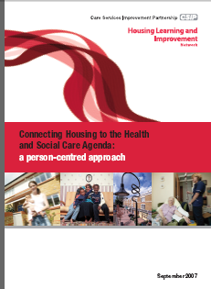

Web link:
http://www.icn.csip.org.uk/housing/index.cfm?pid=516&catalogueContentID=2333

- One stop housing and dementia web page

The CSIP Housing LIN has launched a new Housing and Dementia page.

It is intended to serve as the first port of call for people seeking information about meeting the needs of people with dementia in housing settings, and provides links to a wide range of information at a variety of sites.

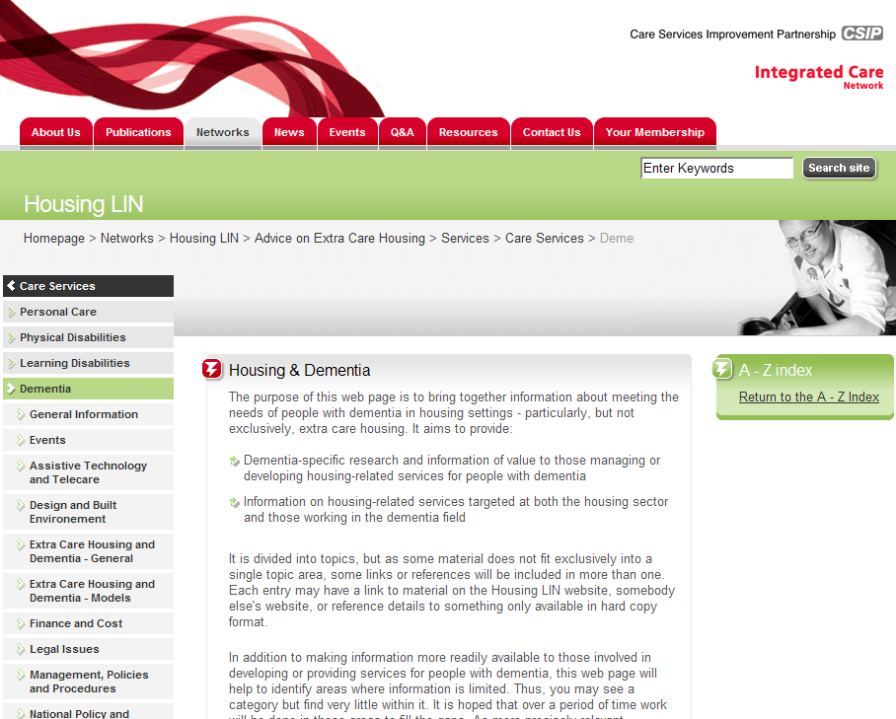

Web link:
http://www.icn.csip.org.uk/housing/index.cfm?pid=718

- Homes for the Future: More Affordable, More Sustainable - Housing Green Paper (August 2007)

This briefing outlines the background to and the contents of the Government's Housing Green Paper, published in July 2007.

The Government requires responses to the Green Paper by 15 October 2007.

Web link:
http://www.icn.csip.org.uk/housing/index.cfm?pid=522&catalogueContentID=2270

- Independence and Opportunity - Communities and Local Government Strategy for Supporting People (September 2007)
Housing LIN Briefing - This briefing gives an overview of the new Supporting People strategy, Independence and Opportunity: our Strategy for Supporting People (June 2007).

Web links:
http://www.spkweb.org.uk/NR/rdonlyres/4E92E1E2-B5EF-42B4-AD0C-FE5B68C4330B/12855/bm07024supportingpeoplestrategy.pdf
http://www.icn.csip.org.uk/housing/index.cfm?pid=522&catalogueContentID=2309

- Housing LIN Newsletter –September 2007

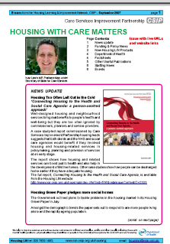

Web link:

http://www.icn.csip.org.uk/_library/Resources/Housing/Support_materials/Newsletter/Newsletter25.pdf

12Telecare progress

Bracknell Forest

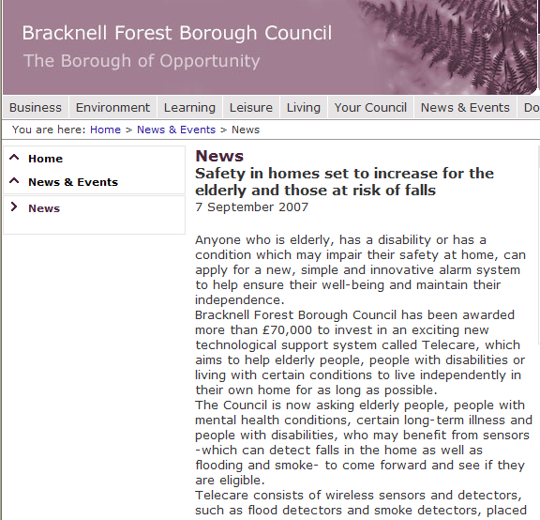

Web link:
http://www.bracknell-forest.gov.uk/news-and-events/news.htm?itemid=50510

Milton Keynes

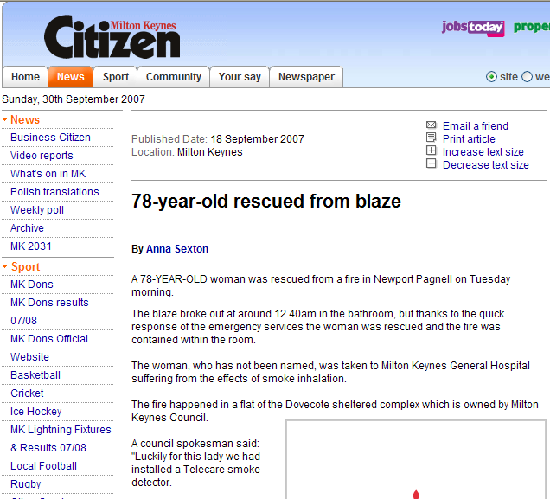

Web link:
http://www.miltonkeynes.co.uk/news/78yearold-rescued-from-blaze.3208749.jp

Stoke on Trent

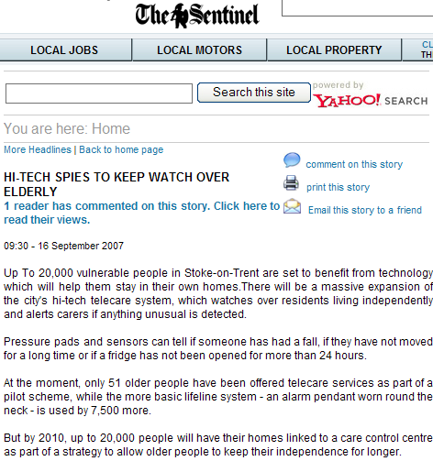

Web link:
http://www.thisisthesentinel.co.uk/displayNode.jsp?nodeId=158315&command=displayContent&sourceNode=238297&home=yes&more_nodeId1=238283&contentPK=18404900

Stockton-on-Tees

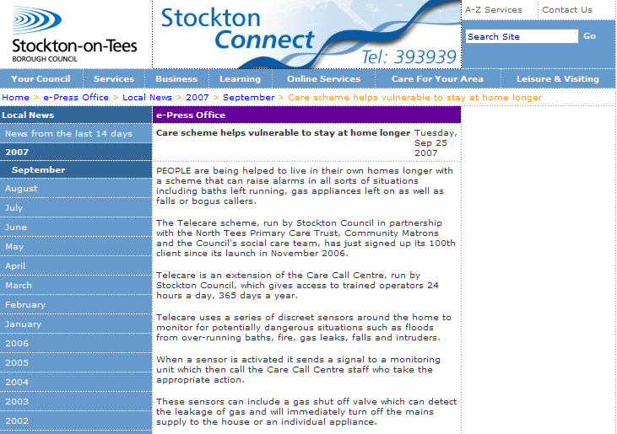

Web link:
http://www.stockton.gov.uk/pressoffice/localnews/year2007/september/careschemehelpsvulnerable

Wakefield

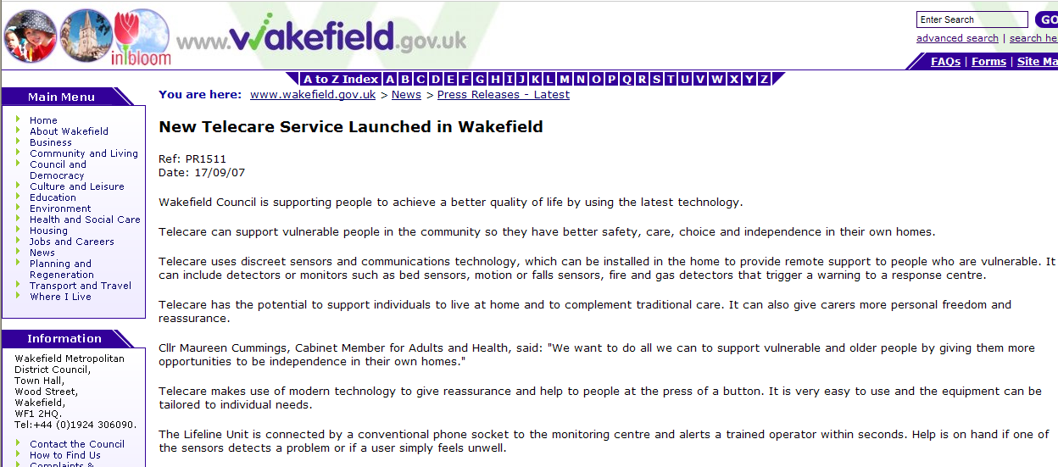

Web link:
http://publictechnology.net/modules.php?op=modload&name=News&file=article&sid=11532

13 Telecare events

- Regional Housing LIN dates for 2007:

Here is the list of the upcoming Housing LIN regional meetings:

London & South-East Region LIN - 4th October 2007, Maidstone
Yorkshire & Humberside Region LIN - 24th October 2007, Ripon
West Midlands LIN - 1st November 2007, Walsall
North West Region LIN - 15th November 2007, Ashton-under-Lyne

To register for these events go to: http://www.icn.csip.org.uk/housing/index.cfm?pid=167

Housing LIN Newsletter –September 2007

Web link:

http://www.icn.csip.org.uk/_library/Resources/Housing/Support_materials/Newsletter/Newsletter25.pdf

- Technology in Dementia Care

Promoting independence and well-being through telecare and assistive technology: a national perspective - Clare Skidmore, Extra Care Housing Programme Manager, Care Services Improvement Partnership Housing Learning and Improving Network

3 October 2007, Birmingham

Web link:

http://www.careinfo.org/conferences/tech07.pdf

- Joint commissioning in practice: working together effectively for health and well-being

Date: Thursday 1 November 2007
Venue: Cavendish Conference Centre, Central London

CSIP is proud to be working with Community Care and the NHS Institute to sponsor and promote this major conference that looks at implementing key ideas from the "Commissioning Framework for Health and Wellbeing".

The conference is intended for influential commissioning figures and senior managers in both Health and Social Care environments as well as providers of care interested in how markets will operate in the future.

Bob Ricketts and David Behan, both Directors General from the Department of Health, will be speaking alongside other key figures describing work in community involvement, joint commissioning issues, and the new guidance on developing strategic needs assessments (launched only a few days prior to
this event).

The event flyer, conference information page and booking form can all be downloaded.

Web links:
http://www.icn.csip.org.uk/_library/Final_brochure_-_CC.pdf
http://www.lexisnexis.co.uk/conferencesandtraining/gatehouse/gateconf_con/healthandwellbeing_011107.htm
http://www.lexisnexis.co.uk/conferencesandtraining/gatehouse/gateconf_con/gatecon_forms/healthandwellbeing_form_011107.asp

- Telecare Services Association (TSA) Conference – Cardiff, 6-8 November 2007

CSIP’s Nigel Walker and Judith Whittam will be speaking at the TSA Conference along with Claire Whittington (White Paper Long Term Conditions Demonstrator Programme).

The National Telecare & Telehealth Conference will take place in Cardiff, November 6th – 8th. The event which attracted almost 400 delegates last year will bring together the single largest gathering of Telecare & Telehealth professionals in the UK this year. With the interest generated by the Whole System Demonstrator Sites there will be significant focus on Telehealth with added international perspective.

Web link:

http://www.telecare.org.uk/event/42301/46596/tsa_annual_conference_2007.htm

- Fourth Annual Telecare and Assistive Technology Conference

CSIP’s Mike Clark will be presenting at the Laing and Buisson conference on 10 December 2007 in London.

Web link:

http://www.laingbuisson.co.uk/Portals/1/Assistive%20Technology%202.pdf

The Foundation for Assistive Technology (FAST) provides a full listing of forthcoming telecare events – see http://www.fastuk.org/services/events.php?pg=2. Suppliers also run telecare and telehealth events – check their web sites regularly for dates.

All previous telecare eNewsletters are available at: www.icn.csip.org.uk/telecarenewsletters

CSIP Telecare Services

You can send comments and questions about the CSIP Implementation Guide, factsheets or other resources or contact us via telecare@csip.org.uk. Also, use this mailbox to send in good practice examples.

If you or a colleague would like to receive future copies of the newsletter then all you need to do is register at http://www.icn.csip.org.uk/index.cfm?pid=12

Appendix – social care authority telecare links

Barking & Dagenham
http://www.barking-dagenham.gov.uk/9-council/emergency/comms-centre-careline.html
Barnet
http://www.barnet.gov.uk/index/health-social-care/services-for-older-people/telecare.htm
Barnsley
http://www.barnsley.gov.uk/bguk/Health_Wellbeing_Care/Services_for_Adults/Home_Care_Service/Telecare.htm
Bath and North East Somerset
http://www.bathnes.gov.uk/BathNES/healthandsocial/servicesforolderpeople/communityalarmsservice/
Bedfordshire
http://www.bedfordshire.gov.uk/HealthAndSocialCare/OlderPeople/CommunityAlarmServices.aspx
Bexley
http://www.bexley.gov.uk/service/bcsp/bell.html
Birmingham
http://www.birmingham.gov.uk/GenerateContent?CONTENT_ITEM_ID=260&CONTENT_ITEM_TYPE=0&MENU_ID=11953
Blackburn with Darwen
http://www.blackburn.gov.uk/server.php?show=ConWebDoc.16388
Blackpool
http://www.blackpool.gov.uk/Services/S-Z/Telecare/Home.htm
Bolton
http://www.boltonathome.org.uk/content/Careline_Service.htm
Bournemouth
Bracknell Forest
http://www.bracknell-forest.gov.uk/living/liv-forestcare/liv-lifeline-linked-services.htm
Bradford
http://www.bradford.gov.uk/health_well-being_and_care/care/adult_care/help_from_careline/
Brent
http://www.ealing.gov.uk/services/social_services/adult_services/services_for_older_people/emergency_alarm_network/
Brighton & Hove
http://www.brighton-hove.gov.uk/index.cfm?request=c1151908
Bristol
http://www.bristol.gov.uk/ccm/content/Health-Social-Care/Home-Care/alarms-lifeline-personal-alarms.en
Bromley
http://www.bromley.gov.uk/socialcareandhealth/olderpeople/care_link.htm
Buckinghamshire
http://www.buckscc.gov.uk/bcc/content/index.jsp?contentid=406272912
Bury
http://www.bury.gov.uk/HealthAndSocialCare/SocialServices/GeneralSupportCare/Carelink/default.htm
Calderdale
Cambridgeshire
http://www.cambridgeshire.gov.uk/social/older/faqemergalarm.htm
Camden
http://www.camden.gov.uk/ccm/content/policing-and-public-safety/safety-and-security-at-home/careline.en
Cheshire
http://www.cheshire.gov.uk/socialcareandhealth/adults/alarms_for_elderly_and_disabled.htm
City of London
Cornwall
Coventry
http://www.coventry.gov.uk/ccm/content/social-services-%26-housing-directorate/older-peoples-services/domiciliary-care-bureau/help-at-home/batch-23-313.en;jsessionid=ba1KI9of0QX7
Croydon
http://www.croydon.gov.uk/healthsocial/servicesforolderpeople/ccca/
Cumbria
http://www.cumbria.gov.uk/adultsocialcare/services/telecare4.asp
Darlington
Derby
http://www.derby.gov.uk/HealthSocialCare/SocialServices/GeneralSupportCare/DerbyCareLink
Derbyshire
http://www.derbyshire.gov.uk/Social_health/services_adults/telecare/default.asp
Devon
http://www.devon.gov.uk/index/socialcare/sc-partnerships/servicedevelopment/telecare.htm
Doncaster
http://www.doncaster.gov.uk/living_in_doncaster/homes_and_housing/community_alarms/alarm_service.asp
Dorset
http://www.dorsetforyou.com/index.jsp?articleid=364864
Dudley
http://www.dudley.gov.uk/index.asp?pgid=28202
Durham
http://www.durham.gov.uk/durhamcc/usp.nsf/pws/690AC1D66C881F8C8025723C0040ED85?opendocument
Ealing
http://www.ealing.gov.uk/services/social_services/adult_services/services_for_older_people/emergency_alarm_network/
East Riding of Yorkshire
http://www.eastriding.gov.uk/az/az_details?az_selected=612
East Sussex
http://www.eastsussex.gov.uk/socialcare/payingforservices/emergencyphone/default.htm
Enfield
http://www.enfield.gov.uk/socialcare/carers/Carers%20Emergency%20Card%20Scheme.htm
Essex
http://www.essexcc.gov.uk/vip8/ecc/ECCWebsite/dis/faq.jsp?channelOid=25860&guideOid=26355&oid=29673
Gateshead
Gloucestershire
http://www.gloucestershire.gov.uk/index.cfm?articleid=13059
Greenwich
http://www.greenwich.gov.uk/Greenwich/HealthSocialCare/CommunityCare/CareAtHome/GreenwichTelecare.htm
Hackney
http://www.hackney.gov.uk/text/index.htm/sr-social-services-pids/s-hah-community-alarm-services.htm
Halton
http://www2.halton.gov.uk/content/socialcareandhealth/independentliving/helpathome/telecare
Hammersmith & Fulham
http://www.lbhf.gov.uk/Directory/Health_and_Social_Care/Assistance_at_home/Care_and_scan_and_community_alarm_services/40213_Careline.asp
Hampshire
Haringey
http://www.haringey.gov.uk/index/social_care_and_health/accidents_and_emergencies/safe_sound_alarm.htm
Harrow
http://www.harrow.gov.uk/site/scripts/documents_info.php?categoryID=313&documentID=654
Hartlepool
http://www.hartlepool.gov.uk/site/scripts/download_info.php?fileID=1671
Havering
http://www.havering.gov.uk/index.cfm?articleid=4263
Herefordshire
Hertfordshire
http://www.hertsdirect.org/caresupport/carersupport/supportadcarers/carerass/servscarers/telecare/
Hillingdon
http://www.hillingdon.gov.uk/php/ebc.php?id=32
Hounslow
Isle of Wight
http://www.iwight.com/council/departments/wightcare/
Isles of Scilly
Islington
http://search.islington.gov.uk/scripts/htm_hl.pl?DB=islington&STEMMER=en&WORDS=alarm&ALL=&ANY=&EXACTB=0&PHRASE=&EXACTP=0&CATEGORIES=&SIMPLE=alarm&COLOUR=B1043A&STYLE=s&URL=http://www.islington.gov.uk/directories/page.aspx?dir=faq_details&docid=0901336c803
Kensington & Chelsea
http://www.rbkc.gov.uk/az/az.asp?orgid=1367
Kent
http://www.kent.gov.uk/SocialCare/health-and-wellbeing/telecare/
Kingston upon Hull
http://www.hullcc.gov.uk/portal/page?_pageid=221,52771&_dad=portal&_schema=PORTAL
Kingston upon Thames
http://e-contact.kingston.gov.uk/cuatozdisplay.asp?AtoZID=5073
Kirklees
http://www.kirklees.gov.uk/community/health-care/olderpeople/carephones.shtml
Knowsley
http://www.knowsley.gov.uk/health/social_services/general_support_care/alarms_for_elderly.html
Lambeth
http://www.lambeth.gov.uk/NR/exeres/AFD99C10-A55C-45A1-84C0-7209B8C86238.htm
Lancashire
Leeds
http://www.leeds.gov.uk/page.aspx?egmsIdentifier=395C0F29CD13E09880256E14002F4F11
Leicester
http://www.leicester.gov.uk/index.asp?pgid=8568
Leicestershire
http://www.leics.gov.uk/service.htm?initial=A&pid=313
Lewisham
http://www.lewisham.gov.uk/HealthAndSocialCare/GeneralSupportCare/HomeCareSupport/LinklineTelecareService.htm
Lincolnshire
http://www.lincolnshire.gov.uk/section.asp?docId=53450&catId=13276&pageTitle=Telecare%3A+21st+Century+Safety+In+The+Home
Liverpool
Luton
http://www.luton.gov.uk/internet/Council_government_and_democracy/Councils/Council%20Departments/Housing%20and%20social%20services/Disabilities/Tunstall%20Lifeline_1
Manchester
http://www.manchester.gov.uk/site/scripts/documents_info.php?documentID=1368&pageNumber=1
Medway
http://www.medway.gov.uk/index/community/communitysafety/medwaylifeline.htm
Merton
http://www.mascot-telecare.org.uk/our_services.asp
Middlesbrough
Milton Keynes
http://www.milton-keynes.gov.uk/community-alarm/
Newcastle upon Tyne
http://www.newcastle.gov.uk/core.nsf/a/yhn_ysccas
Newham
http://www.newhamhomes.com/Services/NewhamNetwork/AboutUs/newhamadvancedtelecareneat.htm
Norfolk
http://www.norfolk.gov.uk/consumption/idcplg?IdcService=SS_GET_PAGE&ssDocName=NCC050703&ssSourceNodeId=&ssTargetNodeId=3572
North East Lincolnshire
http://80.6.94.206/information/charities/carelink.htm
North Lincolnshire
http://www.northlincs.gov.uk/northlincs/socialcare/alarms
North Somerset
http://www.n-somerset.gov.uk/Social+care/Community+care/Older+people/carelink.htm
North Tyneside
http://www.northtyneside.gov.uk/serviceitem.shtml?p_ID=413
North Yorkshire
http://www.northyorks.gov.uk/public/site/NYCC/menuitem.72980bf1db3dfb9fd7428f1040008a0c/?vgnextoid=ea1f419c5bb41110VgnVCM100000420f1cacRCRD
Northamptonshire
Northumberland
http://pscm.northumberland.gov.uk/portal/page?_pageid=115,55156&_dad=portal92&_schema=PORTAL92&pid=313
Nottingham
http://www.nottinghamcity.gov.uk/www/telecare/default.asp
Nottinghamshire
Oldham
Oxfordshire
http://www.oxfordshire.gov.uk/wps/portal/publicsite/kcxml/04_Sj9SPykssy0xPLMnMz0vM0Y_QjzKL94k3Mg8FSZnFO8WHOepHogtZIoR8PfJzU_WD9L31A_QLckMjyh0dFQEnurQ-/delta/base64xml/L3dJdyEvd0ZNQUFzQUMvNElVRS82X01fMU9C?WCM_GLOBAL_CONTEXT=http://apps.oxfordshire.gov.uk/wps/wcm/connect/Internet/Council+services/Health+and+social+care/Older+people/Staying+in+your+own+home/SHC+-+OP+-+telecare+alarms
Peterborough
http://www.peterborough.gov.uk/page-12&Action=ServID&Param=36
Plymouth
http://www.plymouth.gov.uk/homepage/housing/privatehousing/alarmservice.htm
Poole
http://www.poole.gov.uk/go.php?structureID=U464b21165e6ed&ref=S464B278CE3B02
Portsmouth
http://www.portsmouth.gov.uk/living/435.html
Reading
http://www.reading.gov.uk/healthandsocialcare/communitycareservices/General.asp?id=SX9452-A780D086
Redbridge
http://www.redbridge.gov.uk/cms/social_care__health/adult_services/support_in_your_home/telecare.aspx
Redcar & Cleveland
Richmond upon Thames
http://www.richmond.gov.uk/home/health_and_social_care/adult_social_care/people_with_an_illness_and_physical_disability_needing_help_and_support/support_at_home_for_older_people/careline_emergency_alarms/telecare.htm
Rochdale
http://www.rochdale.gov.uk/health_and_social_care/home_care/community_alarm_services.aspx
Rotherham
http://www.rotherham.gov.uk/graphics/Care/Adult+Social+Service/RotherCare/
Rutland
http://www.rutland.gov.uk/pp/service/detail.asp?id=2411
Salford
Sandwell
http://www.laws.sandwell.gov.uk/ccm/content/social-care-and-health/storyboards/telecare-using-technology-to-promote-and-support-independence.en
Sefton
http://www.sefton.gov.uk/Default.aspx?page=3118
Sheffield
http://www.sheffield.gov.uk/index.asp?pgid=2362
Shropshire
Slough
http://www.slough.gov.uk/services/7675.aspx#q313%200
Solihull
http://www.solihull.nhs.uk/socialcare/adapthome_safe.asp
Somerset
http://www.somerset.gov.uk/media/78E/B6/Independent_Living_through_Telecare_Solutions.pdf
South Gloucestershire
http://www.southglos.gov.uk/NR/exeres/30f7983a-0287-453a-8e9b-19c239e8c1c0
South Tyneside
http://www.southtyneside.info/communitysupport/socialcare/personinvolvement/assistive_technology.asp
Southampton
http://www.southampton.gov.uk/health/olderpeople/careline.asp
Southend-on-Sea
http://www.southend.gov.uk/content.asp?content=78
Southwark
http://www.southwark.gov.uk/YourServices/SocialServicesSection/communitycare/Telecare.html
St Helens
http://www.sthelens.gov.uk/CMSWEB/item.do?parentID=100007&category=200003&itemid=313
Staffordshire
http://www.staffordshire.gov.uk/cgi-bin/MsmGo.exe?grab_id=388&page_id=7343104&query=alarm&hiword=alarm+
Stockport
http://www.stockport.gov.uk/content/health/socialcare/adultsocialcare/safeathome/
Stockton-on-Tees
http://www.stockton.gov.uk/citizenservices/comm_serv/commsafe/carecall/telecare/
Stoke-on-Trent
http://www.stoke.gov.uk/ccm/navigation/social-care/older-people/telecare---a-new-service/
Suffolk
Sunderland
Surrey
http://www.surreycc.gov.uk/SCCWebsite/sccwspages.nsf/searchresults/a35027651713ad7b8025718000316220?OpenDocument
Sutton
http://sutton.aprsmartlogik.com/cgi-bin/sutton/htm_hl.pl?DB=lbsutton&STEMMER=en&WORDS=telecar&ALL=&ANY=&EXACTB=0&PHRASE=&EXACTP=0&CATEGORIES=&SIMPLE=telecare&COLOUR=014A77&STYLE=s&URL=http://www.sutton.gov.uk/news/pressreleases2006/july06/pr943.htm#muscat_highlighter_first_match
Swindon
Tameside
http://www.tameside.gov.uk/corpgen/new/commalarm.htm
Telford & the Wrekin
Thurrock
http://www.thurrock.gov.uk/socialcare/adults/content.php?page=careline
Torbay
http://www.torbay.gov.uk/index/socialcare/help-in-your-home/community-alarm-services.htm
Tower Hamlets
http://www.towerhamlets.gov.uk/data/caring-for-you/data/older-people/data/alarm-services.cfm
Trafford
Wakefield
http://www.wakefield.gov.uk/cgi-bin/MsmGo.exe?grab_id=0&page_id=11977&query=alarm&SCOPE=www.wakefield.gov.uk&hiword=ALARMED%20ALARMING%20ALARMS%20alarm%20
Walsall
http://www.walsall.gov.uk/index/social_care_and_health/adults_and_older_people/community_alarms.htm
Waltham Forest
http://www.walthamforest.gov.uk/index/care/adults-and-older-people/helpinhome/communityalarm.htm
Wandsworth
http://www.careline.org.uk/section.asp?catid=21445&docid=3459
Warrington
http://www.warrington.gov.uk/Healthandsocialcare/Helpforadults/carecall.aspx
Warwickshire
http://www.warwickshire.gov.uk/web/corporate/pages.nsf/(DisplayLinks)/CABB693675350C4980256F0F00498874
West Berkshire
West Sussex
http://www.westsussex.gov.uk/ccm/content/social-care-and-health/adults/community-alarms.en
Westminster
http://www.westminster.gov.uk/healthandsocialcare/adultservices/homesupport/telecare.cfm
Wigan
http://www.wigan.gov.uk/Services/HealthSocialCare/HomeAdaptations/AssistiveTechnology.htm
Wiltshire
http://www.wiltshire.gov.uk/care-scan-community-alarm-services.htm
Windsor & Maidenhead
http://www.rbwm.gov.uk/web/social_home-care_alarms.htm
Wirral
http://www.wirral.gov.uk/LGCL/100010/200091/content_0001471.html
Wokingham
Wolverhampton
http://www.wolverhampton.gov.uk/health_social_care/social_services/home_care/elderly/Telecare.htm
Worcestershire
York
http://www.york.gov.uk/health/Services_for_older_people/Community_alarm_services/

