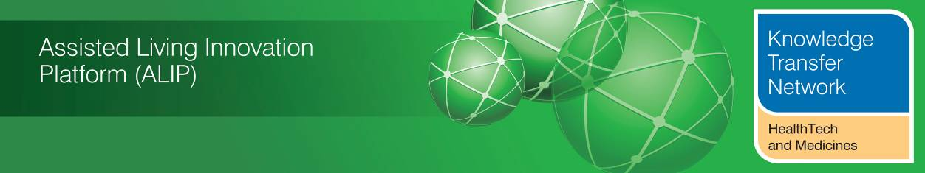
HEALTH & CARE INNOVATION EXPO - SUPPLEMENT
MARCH 2014

Welcome to an additional supplement from the Technology Strategy Board (TSB) Knowledge Transfer Network and the Telecare Learning and Improvement Network covering the Health and Care Innovation Expo 2014 held on 3-4 March 2014 in Manchester. Twitter coverage using #Expo14NHS has been Storified (3 March 4 March). Various articles and blogs relating to the Expo are referenced in this supplement.
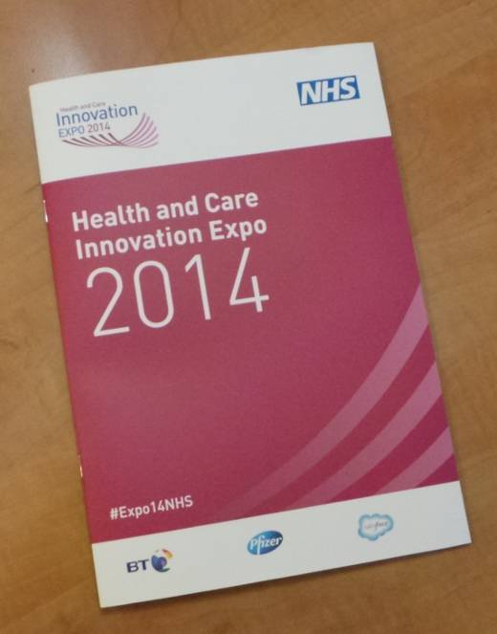

Newsletter supplement prepared by Mike Clark (@clarkmike) and brought to you by the Telecare LIN on behalf of the HealthTech KTN and Technology Strategy Board. Newsletters and supplements are archived at www.telecarelin.org.uk

Disclaimer: “We provide this newsletter supplement for information purposes only and neither the Technology Strategy Board nor the authors accept any liability whatsoever for inaccuracies, errors or omissions therein or for any consequences arising therefrom.”

1 General Scenes from the Health and Care Innovation Expo
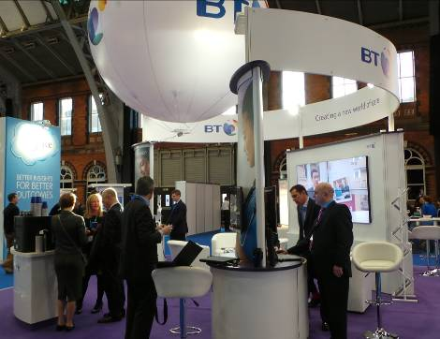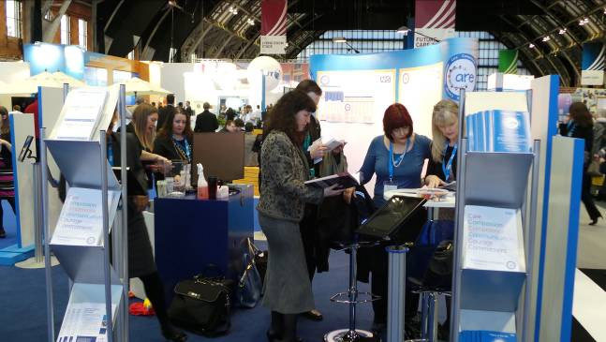
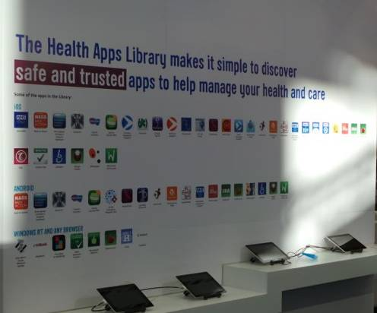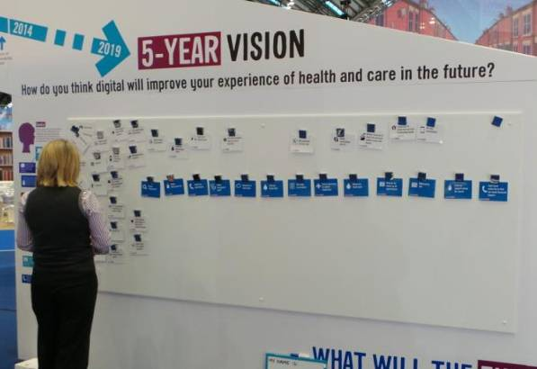
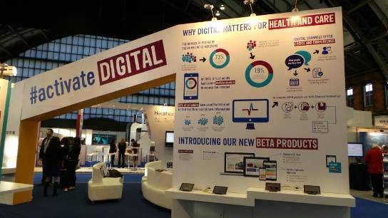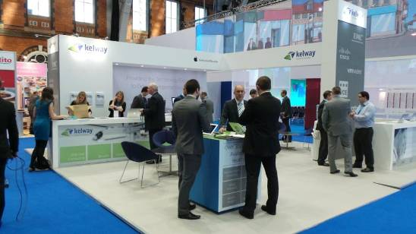
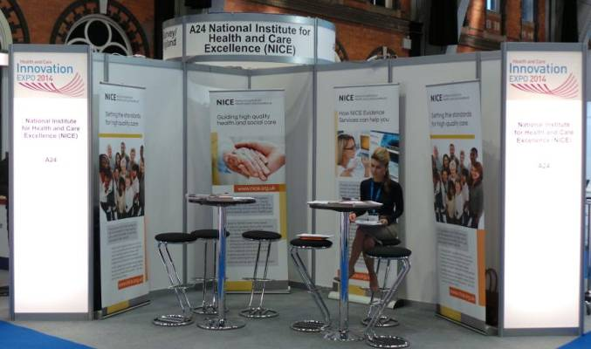
List of Expo exhibitors – also, NHS Choices Health Apps. More on Twitter (3 March 4 March)
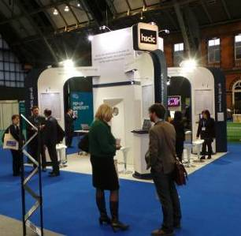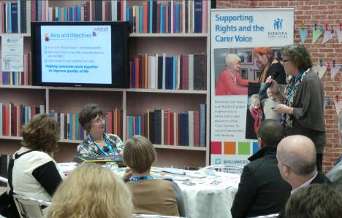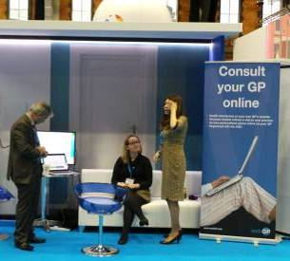
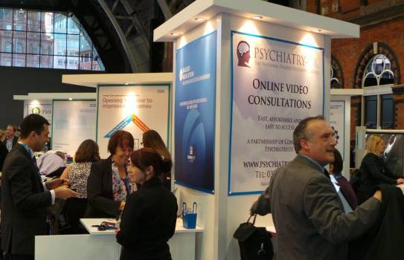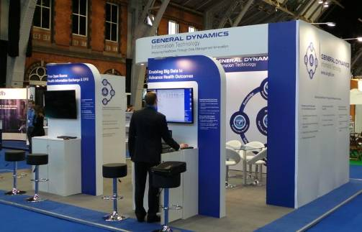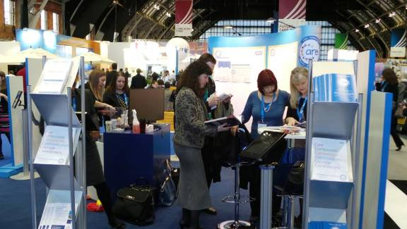
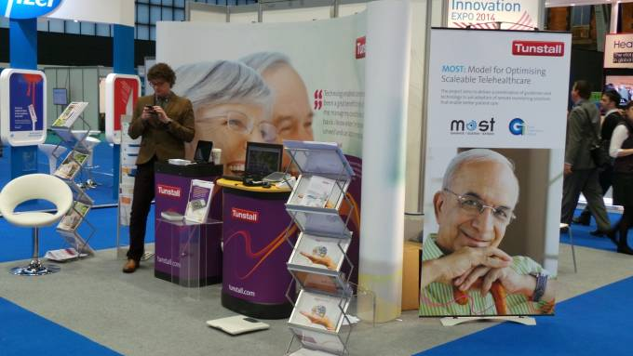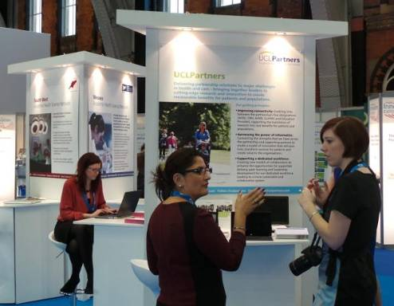
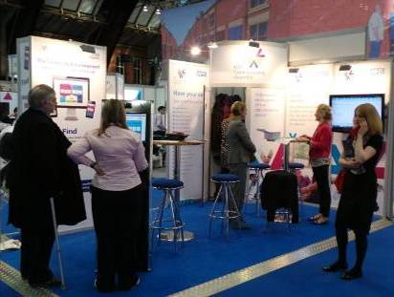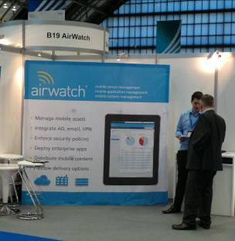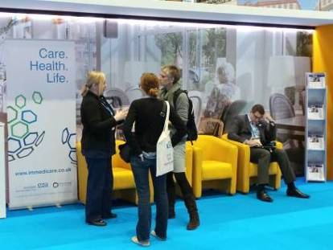
List of Expo exhibitors. More on Twitter (3 March 4 March)
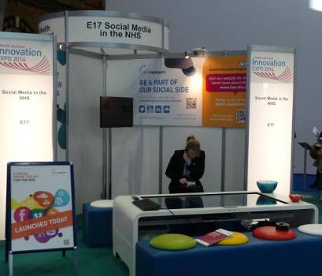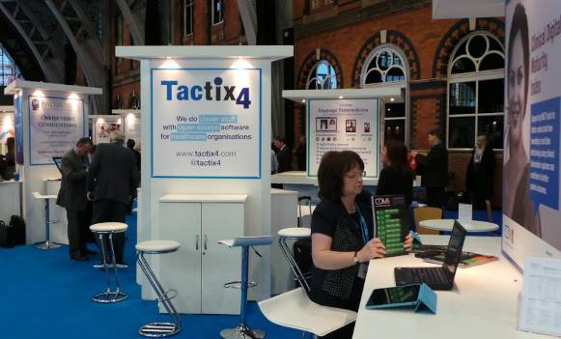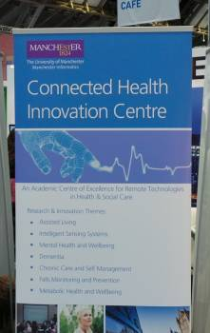
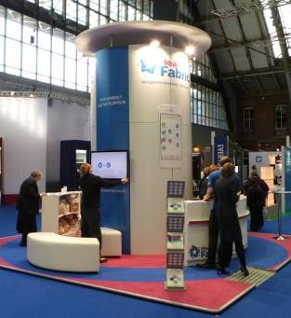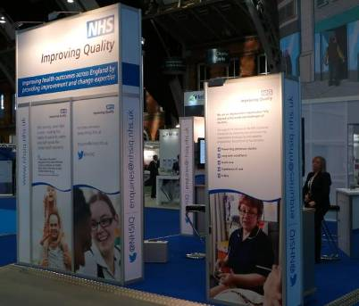
List of Expo exhibitors. More on Twitter (3 March 4 March)
2 The Patient Safety Debate
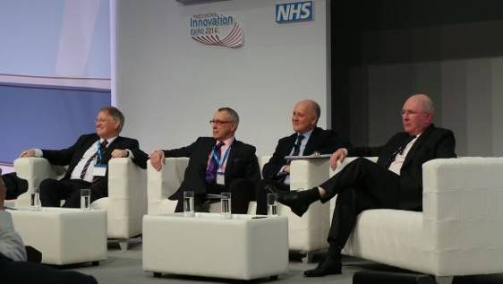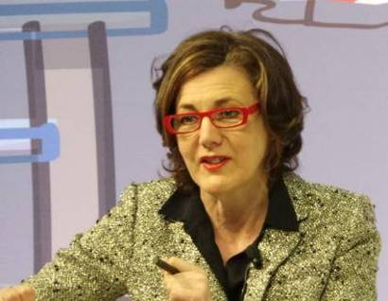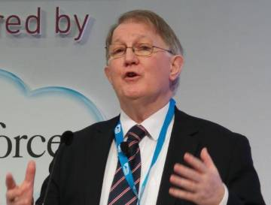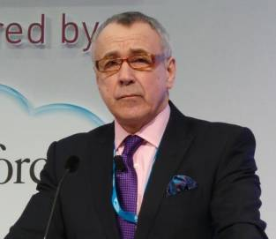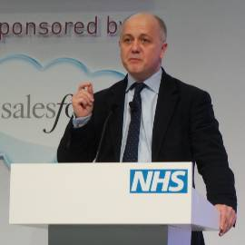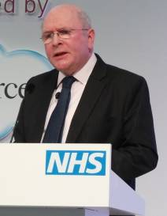
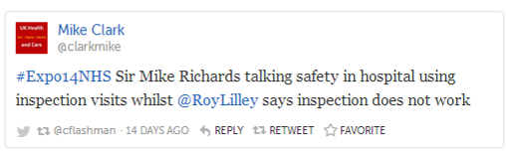 ……..More on Twitter (3 March 4 March)
Vivienne Parry chairs a lively opening session with Sir Mike Richards (CQC), Roy Lilley (nhsManagers.net), Tim Kelsey (NHS England) and Niall Dixon (GMC) on ‘Can we be sure our health and care system is safe?’
3 Is Self Care Revolutionary or Just Rhetoric?
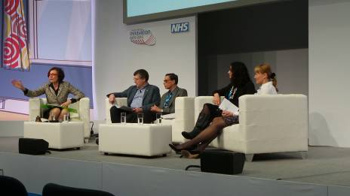
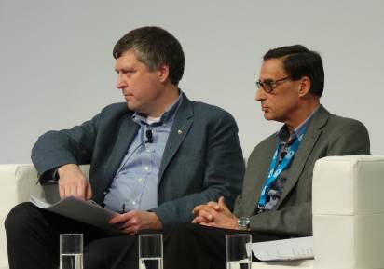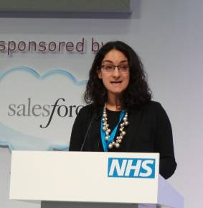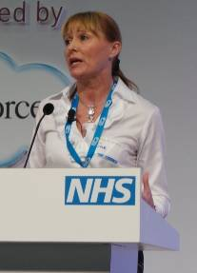
Ciaran Devane (Macmillan Cancer Support & NHS England), Colin Cheeseman (Parkinson’s UK), Halima Khan (Nesta) and Susan Summers (NHS England) consider the importance of self care.
“We need to help people be well and live well in the community - approaches to self management need to begin at the start of any treatment for long term conditions.” (Ciaran Devane – NHS England Article).
4 Panel Session - Telehealth
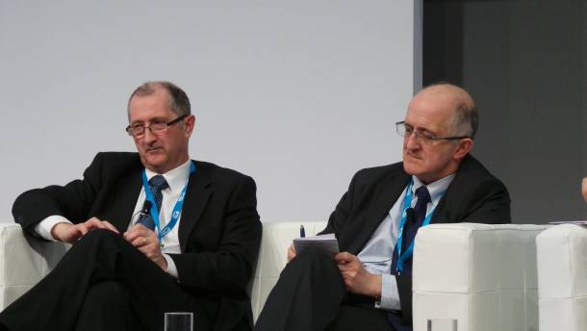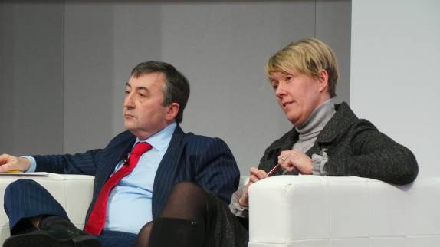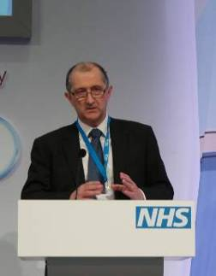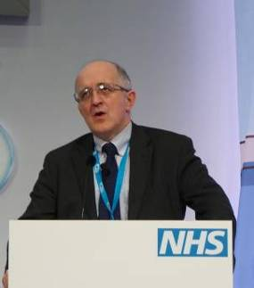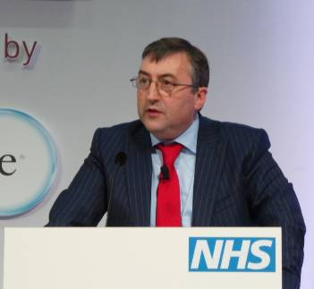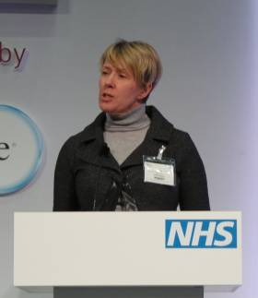
‘Has telehealth been too focused on technology?’ with Dr Richard Pope (Dynamic Health Systems), Dr Martin McShane (NHS England), Ian Dalton (BT Global Services) and Beverley Bryant (NHS England).
Dr Martin McShane (NHS England) said that putting people in control of their own care could be transformational - “We need to put person-centred care central to what we do. If we are really going to do this we need to make sure people are empowered and in control. We need to support professional collaborations and draw upon evidence. We need to work out how we plan, invest, monitor and improve services using resources to best effect. All this is enabled by digital technology and we need to re-engage hearts and minds regarding the potential telehealth can deliver. Technology systems need to allow people to say ‘I own my own care’. We need to look at the system levers that stop us getting pull across the system – I bet there isn’t a single healthcare professional that goes to work saying ‘how difficult can I make this for patients?’ We need training, education and narrative to deliver potential for technology enabled care systems.” (NHS England article).
5 Panel session – care.data
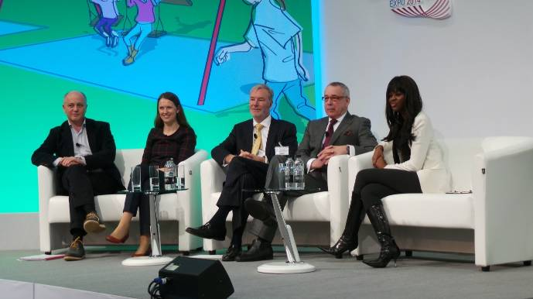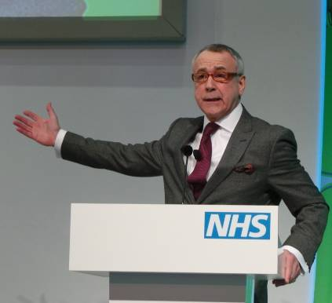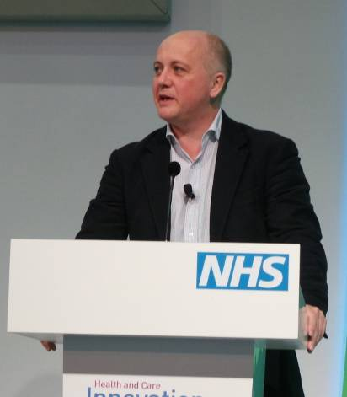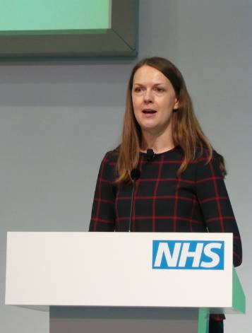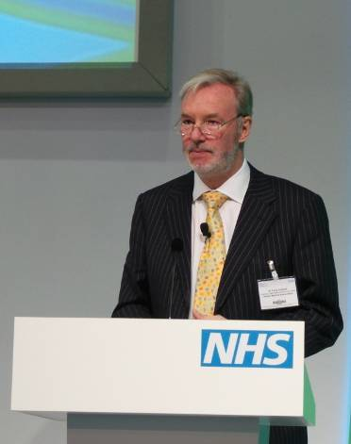
June Sarpong chairs a panel session on ‘Better Information, better care - care.data’ with Tim Kelsey (NHS England), Sarah-Jane Marsh (Birmingham Children’s Hospital), Dr Tony Calland (BMA) and Roy Lilley (nhsManagers.net).
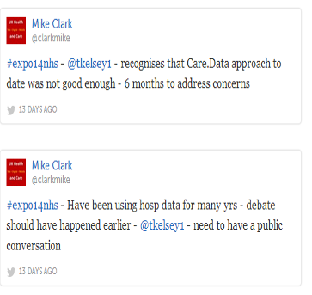 ……..More on Twitter (3 March 4 March)
Sarah-Jane Marsh, Chief Executive of Birmingham Children’s Hospital, spoke passionately about the role of data and information in safeguarding and patient safety. Sarah-Jane said the NHS must change the way it thinks about data, claiming, “Security trumps patient safety every time. It is our duty to challenge this principle. We can’t just assess the risk of doing something; we must also assess the risks of not doing something.” She challenged NHS England to explain the benefits to the public and said, “We must help people understand that this is not something we should just do for ourselves. In my mind, we must do this to help the generations of the future. We cannot afford to keep making the same mistakes.” (From NHS England Article).
6 Panel session – Social Media
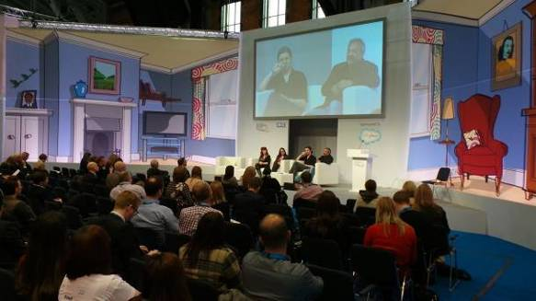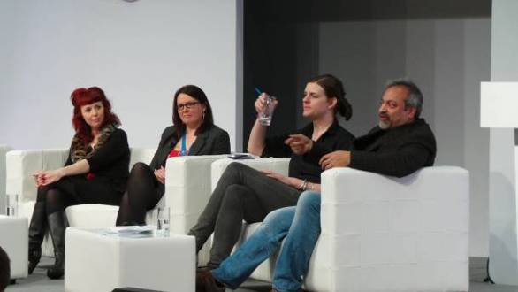
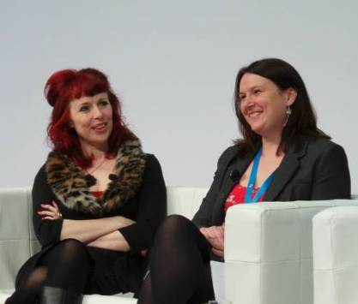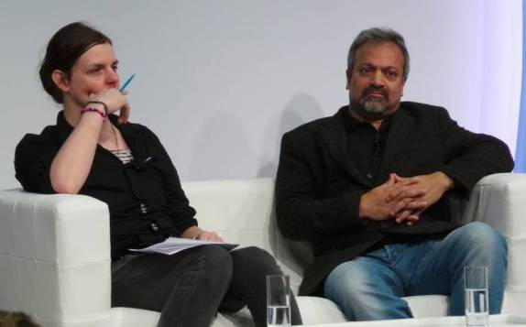
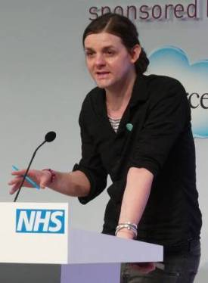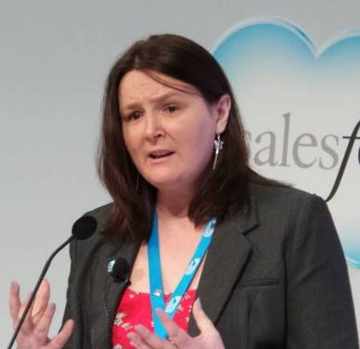
‘What is the role of social media in health and care?’ with Victoria Betton (@VictoriaBetton, mHealth programme), Teresa Chinn (@AgencyNurse, Founder of @wenurses) Mark Brown (@markoneinfour, Social Spider CIC and ‘One in Four’ Magazine).
Further links:
@WeNurses goes to Innovation Expo – Teresa Chinn
Mark Brown’s presentation at Connecting Social Care and Social Media website
7 More panel sessions
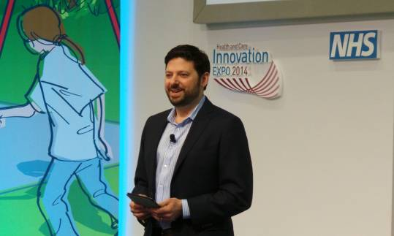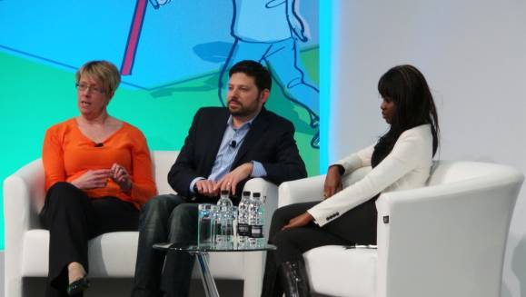
Bryan Sivak (US Department of Health & Human Services) with Beverley Bryant (NHS England) and June Sarpong covering ‘Technology that makes a difference’.
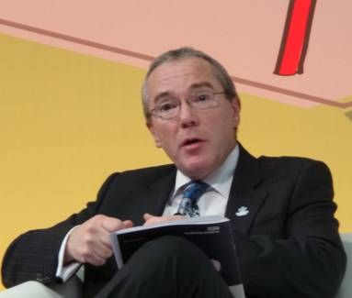 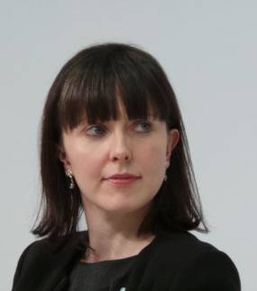 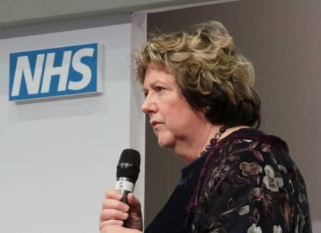
Professor Alistair Burns (NHS England), Beth Britton (Blogger & Dementia Campaigner) with Professor June Andrews (Dementia Centre, Stirling University) in the dementia panel session.

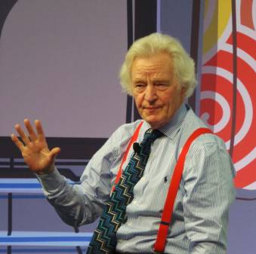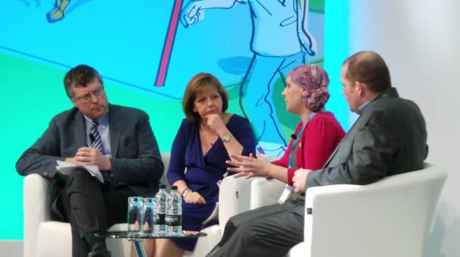
Sir Muir Gray (HSCDS) at the panel session on ‘Patient-centred personalised care’. Ciaran Devane (Macmillan Cancer Support), June Cummings (NHS England), Dr Kate Granger (Specialist Registrar, Cancer Patient and Campaigner) at the session on ‘Compassion and care’.
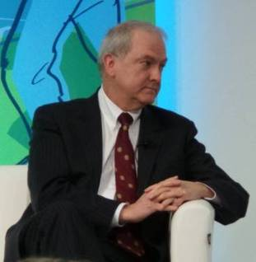 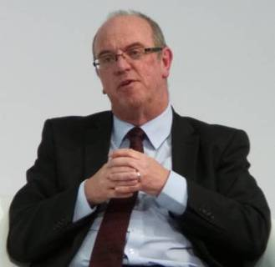
National Medical Director Sir Bruce Keogh (Left) and Chief Executive, Sir David Nicholson (Right) from (NHS England)
NHS England announcements during Expo:

Awarding outstanding contributions to health and care

Telehealth – looking beyond the technology

Lord Darzi challenges the NHS to translate what we know into clinical practice

Call for a fundamental change to thinking around mental health

Change is the key to NHS survival

NHS England launches Youth Forum at Health and Care Innovation Expo

People Powered Health

Transparency key to the future of the NHS

NHS England’s Medical Director’s challenge to NHS staff, industry leaders and politicians

The latest on NHS England’s five-year strategy for specialised services – James Palmer

Pledging to change the NHS at Health and Care Innovation Expo

“It’s the smallest things that can have the biggest impact on patient care.”

NHS Change Day closes in on pledge target

Sir David’s regret over Mid-Staffs hospital failures

Every patient has the potential to be a moderniser

Patients to benefit from £30 million Nursing Technology Fund investment

Bridging the digital divide

NHS England using technology to beat cost of missed appointments

Call to increase the diagnosis rate for patients with dementia

NHSCitizen: reflections and learning from Expo 14 – Olivia Butterworth
Guardian Coverage - 3 March 2014

8 Social Command Centre
Occupying a large stand at Expo was the (NHS England) and Salesforce Social Command Centre.
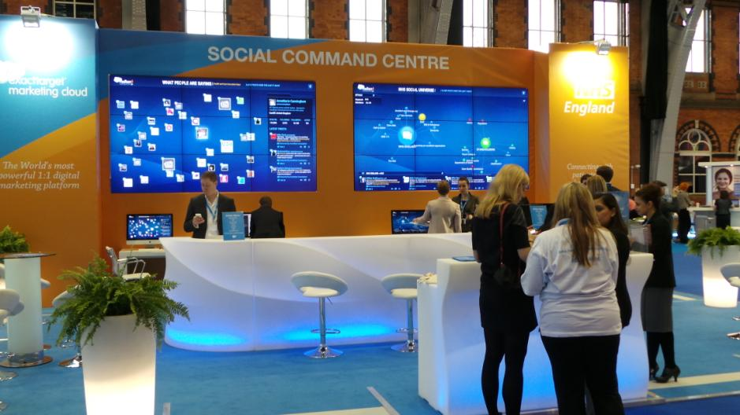
Using Radian 6 Technology and customised queries it is possible to carry out sentiment analysis in real time – ie what people are saying about the NHS or any health and care topic in terms of positive and negative commentary on a range of social media including Facebook, Twitter, LinkedIn, public forums etc. In future, this can be used to improve planning of consultations and track specific local problems as they arise eg in a hospital or care home.
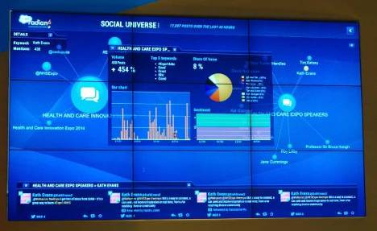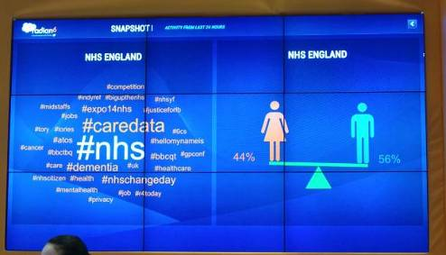
9 Change Day
The second Change Day accumulated over 300,000 pledges by 3 March and now stands at over 580,000 just before the 31 March close.
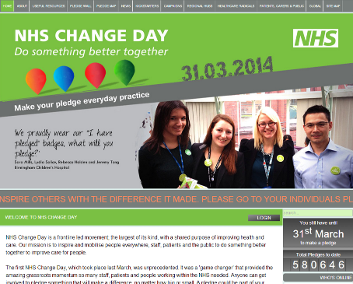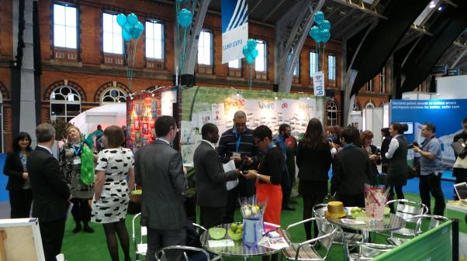
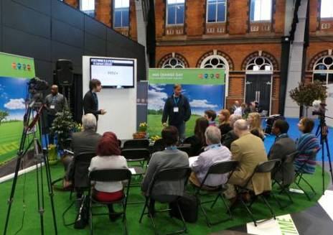 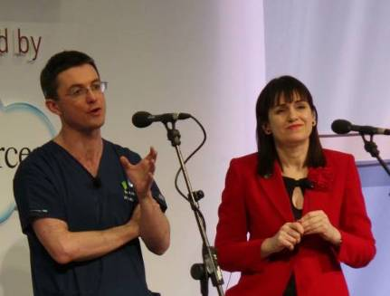 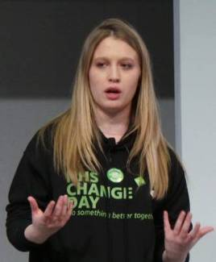
Damian Roland (@damian_roland), Helen Bevan (@helenbevan) and Pollyanna Jones (@PollyannaJones) amongst the prime movers behind #NHSChangeDay. Lewisham Hospital Choir (below) celebrate record numbers of pledges.
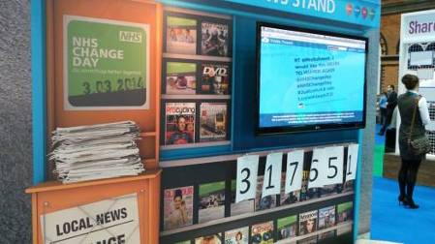
10 Dementia Café
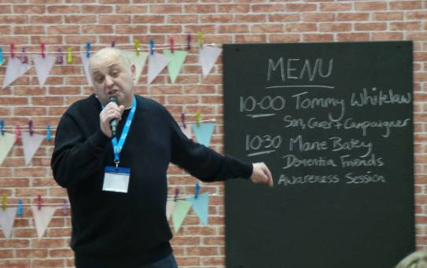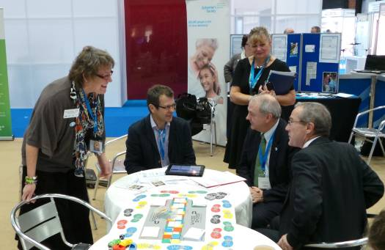
Left: Tommy Whitelaw (@tommyNtour) speaking at the dementia café. Right: Gill Phillips discusses the Whose Shoes (@WhoseShoes) package with Sir Bruce Keogh and Alistair Burns from NHS England.
11 NHS Citizen
.
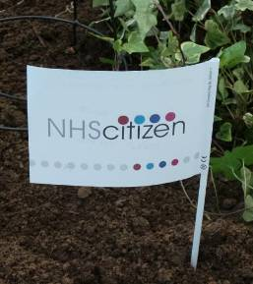 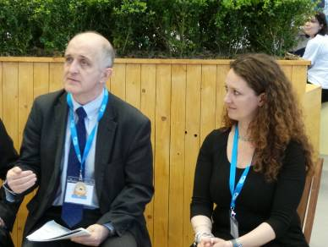 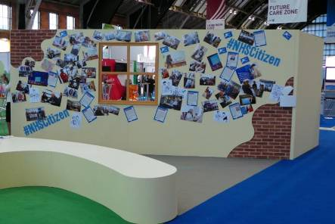
NHS Citizen was launched at the Expo - Dr Martin McShane and Olivia Butterworth from NHS England.
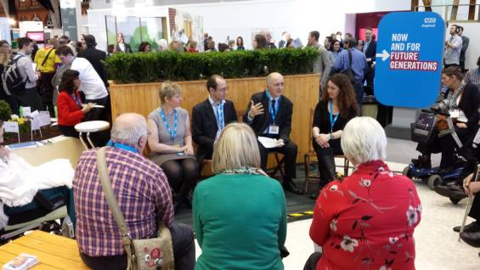 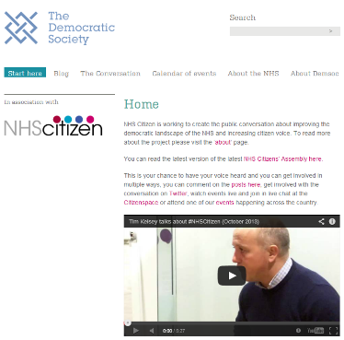

Newsletter supplement prepared by Mike Clark (@clarkmike) and brought to you by the Telecare LIN on behalf of the HealthTech KTN and Technology Strategy Board. Newsletters and supplements are archived at www.telecarelin.org.uk. Disclaimer: “We provide this newsletter supplement for information purposes only and neither the Technology Strategy Board nor the authors accept any liability whatsoever for inaccuracies, errors or omissions therein or for any consequences arising therefrom.”


